Chapter 12

Treatment Plans Related to Key Implant Positions and Implant Number
Carl E. Misch
Treatment plan options for abutments in partially edentulous patients are more often related to clinical experience and the art form of dentistry rather than science or clinical studies. The periodontal, endodontic, and structural health of the teeth adjacent to the edentulous space(s) is variable. As a result, there are more than 100,000 combinations of missing teeth and available bone in one dental arch.¹ The dentist uses past experiences and art to splint together the best abutment teeth available to replace the missing teeth. Hence, several different options may be present from one patient or doctor to another to replace the same missing teeth in an arch.
Implant dentistry has become the most predictable method to replace missing teeth. However, the doctor and the patient often have an incentive to do treatment that is faster, easier, and less expensive. As a consequence, treatment planning for implant dentistry is often driven by the existing bone volume in the edentulous sites. Faster, easier, and cheaper are only justified if the clinical outcome is as predictable and has fewer complications than other options. For example, in the mid 1980s, the most common treatment plan in the literature of completely edentulous patients was to place implants between the mental foramen in the mandible and anterior to the maxillary sinuses in the maxilla (with the number of implants related to the existing bone volume).² Full-arch fixed restorations were then cantilevered to the posterior regions of the jaws (Figure 12-1). This treatment plan is still popular today because bone grafting is often not required and the fees are lower than many other options. Yet often this treatment option has significant complications, especially when the opposing arch is natural teeth or implants and the existing bone volume is limited (Figure 12-2).
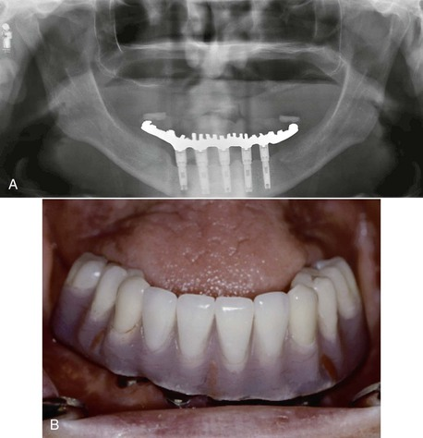
FIGURE 12-1 A, In the 1980s, the most common treatment plan for completely edentulous patients inserted four to six implants in the anterior region (depending on the existing bone volume). B, A full-arch cantilevered fixed restoration was then secured to the anterior implants.
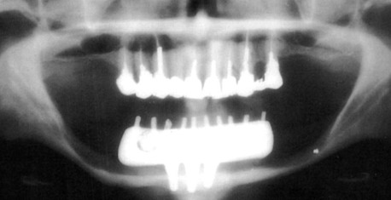
FIGURE 12-2 A recent treatment in which three anterior implants and a cantilevered fixed prosthesis were inserted into a severely resorbed mandible, opposing natural dentition in the maxilla.
Placing implants in existing bone volumes is often problematic. In partially edentulous patients, more than 6 mm of bone height is found in fewer than 40% of posterior maxillae and 50% of posterior mandibles.³ This percentage is further reduced in the posterior regions to fewer than 20% of completely edentulous patients in either arch. Therefore, the treatment plan without bone grafting often presented to the patient uses cantilevers from anterior implants or short implants in the posterior region. However, the posterior regions of the jaws have the greatest bite forces (which are generated on the cantilever), and the existing bone (to support short implants) in the posterior regions is less dense than the anterior regions.

Treatment Plan Rationale
When implants are inserted into abundant bone volume and allowed to integrate for 4 or more months before loading, the surgical success rate is over 98%. This success rate is not related to implant number, size, or design. However, when the implant is occlusal loaded with the prosthesis, the failure rate may be greater than three to six times the surgical failure rate. For example, a meta-analysis reveals 15% failure rates (with several reports above 30% failure) when the implant prosthesis is occlusal loaded with implants shorter than 10 mm or when they are placed in softer bone.⁴ This failure most often occurs during the first 18 months of loading and is called early loading failure. The primary cause of this complication in implant dentistry is related to biomechanical factors, with too much biomechanical stress applied to the implant support system or bone too weak to support the load.⁵ The biomechanical stress can be reduced by several methods (e.g., eliminating cantilevers and splinting together additional implants of adequate size).
Mechanical complications of the implant components or prosthesis outnumber surgical failures, and many reports are more frequent than early loading failures. Mechanical complications include abutment screw loosening, uncemented prostheses, and porcelain fracture.⁴ These complications are found more often in bruxism patients, in men, when the implant restoration is opposing another implant prosthesis, and with group function occlusion.⁶ All of these factors increase the amount of stress on the implant system (occlusal porcelain, cement, implant abutment screw, and implant–bone interface). Hence, mechanical complications are also related to biomechanical factors.
Biomechanical stress may also cause marginal crestal bone loss.⁷ Because the implant does not have a periodontal membrane as a tooth does, the stress to the implant–bone interface is mostly to the crestal marginal bone. When the stress is beyond the bone physiologic limit, resorption may occur. The bone loss may increase the risk of anaerobic bacteria and periimplantitis, or the surrounding soft tissues may shrink and result in poor cervical esthetics. Hence, biomechanical factors can lead to early loading failure, mechanical complications, marginal bone loss, or periimplantitis around an implant. As a consequence, a primary objective to develop a treatment plan in implant dentistry should be to reduce biomechanical stress in the system.

Treatment Fees and Economics
The doctor and patient are motivated to place implants without bone grafting because the cost is greater and the procedure is more difficult (and may be less predictable) than placing shorter or angled implants into existing bone volume. The discomfort after bone augmentation is usually more than what occurs after implant surgery. An extended healing time of 4 to 9 months may be necessary for the bone graft to mature compared with implant healing in native bone. The costs associated with bone augmentation are often greater than the fees related to implant insertion. In addition, there are usually more implants and more teeth replaced after bone augmentation compared with situations when implants are inserted into existing volumes of the bone and teeth are cantilevered to the posterior regions. More implants and more teeth replacements further increase the cost to the patient. As a consequence of these considerations, the doctor and the patient are both motivated to use existing bone volumes for implants and restore fewer posterior teeth in the prosthesis. In addition, the patient undergoes one surgery and therefore experiences less discomfort.
An example of the patient and doctor having an economic incentive to perform procedures with higher biomechanical risks is when a patient has four teeth missing in a posterior maxillary quadrant (two premolars and two molars), with a pneumatized maxillary sinus cavity. There are typically two treatment options. The first is to place two implants anterior to the sinus, which supports a three-unit prosthesis (with a first molar cantilever) (Figure 12-3). A second option is to perform a sinus bone graft and the insertion of three implants (in the first premolar, first molar, and second molar positions) and to fabricate a four-unit restoration.
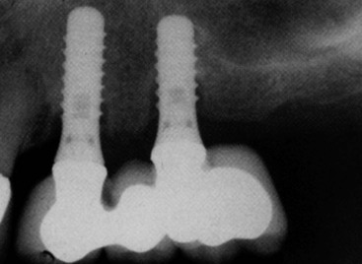
FIGURE 12-3 Two implants are inserted in front of the maxillary sinus and supports a cantilevered three-unit fixed partial denture. Note the bone loss to the third thread on the distal implant and bone loss to the second thread in the anterior implant.
The first treatment option in this example is half the fee of the second option because it does not require a sinus graft and has fewer implants and fewer teeth replaced. The typical fees associated with treatment in implant dentistry are related to the number of implants and teeth replaced. Hence, a three-unit fixed partial denture (FPD) supported by two implants is half the fee of a six-unit FPD supported by four implants. As a result, in a posterior maxilla, instead of posterior bone grafts and additional implants supporting a four-unit FPD, a three-unit FPD with a distal cantilever is often extended from two anterior implants, anterior to the maxillary sinus. The first option is also faster and easier because a bone augmentation is not required.
Although the first treatment option is less expensive and has less discomfort, treatment is not equivalent to the four-unit FPD with more implants. The second treatment option has three to four times better chance for long-term success because it does not cantilever a pontic in the molar region and has more implant support. Cantilevers increase the biomechanical force to the anterior implants. Therefore, there is an increased risk of an unretained prosthesis on the first premolar (because of a tensile force to the retainer and cement is 20 times weaker to tension compared with compression). This results with one implant (the second premolar) supporting all three teeth and the risk of overload and failure. In addition, the first option more often has more bone loss from occlusal overload related to the increased biomechanical stress as a result of the cantilever. In addition, the opposing mandibular second molar may erupt past the plane of occlusion with the first option (because it only has one molar), and each protrusive mandibular movement would result in a lateral premature contact on the maxillary prosthesis. This force direction increases the shear force and may even trigger parafunction. All of these increased risks of complications are related to the increased biomechanical stress.
Biomechanical-related complications often occur within the first few years of function. As a result, the patient expects the dentist to repeat the treatment for no charge. When the first option fails, the second treatment option may be selected, often from a different dentist, which is associated with a greater cost. As a result, the patient is more likely to bring litigation against the first treatment team in order to pay for the additional costs of the second treatment option.

Treatment Fees and Risk Factors
As a consequence of an increased risk of complications in the first treatment option (cantilevered prosthesis), the fees for this option should be more than the second treatment option. In other words, the fee for services rendered should not only be based on the sum of the number of implants and teeth in the prosthesis; it should also include the amount of risk associated with the treatment.⁸
A more basic example of charging for risk factors is the treatment for a crown on a maxillary central incisor implant compared with a mandibular molar implant. The time and technique for an anterior tooth soft tissue drape development, preparation, impression, and transitional prosthesis is greater than to restore a mandibular posterior implant. The risk that an anterior maxillary crown has to be redone because of gingival recession, shade selection, and so on is greater than the mandibular crown. Yet most dentists charge the same fee for both procedures. The maxillary anterior crown has more risk; therefore, the fee should be greater.
In conclusion, the treatment plan in implant dentistry should have a biomechanical rationale to decrease stress to the implant system. The fees for an implant treatment plan that has fewer implants or cantilevers should be greater than restorations supported by more implants or without cantilevers. The risks in dentistry are factors that should be included in the cost of most all procedures that are associated with greater complications. The implant and associated restoration is not a commodity in which the cost is solely related to the number of implants and prosthetic units.

Treatment Plan Sequence
Because the primary causes of complications in implant dentistry are related to biomechanics, Misch developed a treatment plan sequence to decrease the risk of biomechanical overload, consisting of the following steps⁹:
1. Prosthesis design
2. Patient force factors
3. Bone density in the edentulous sites
4. Key implant positions
5. Implant number
6. Implant size
7. Available bone in the edentulous sites
8. Implant design
This chapter considers the key implant positions for a prosthesis followed by the overall number of implants to support the restoration.

Abutment Options
Several treatment options are available for the adequate restoration of an edentulous segment. As a general rule, in a partially edentulous patient, implant-supported prostheses should be independent from natural adjacent teeth. There are biological and biomechanical factors that favor independent implant prostheses, and the greatest benefits are biological factors of less decay and endodontic risks. The incidence of decay when teeth are splinted together in a FPD accounts for 22% of the complications within 10 years (because the pontic acts as a plaque reservoir), whereas individual crowns have a less than 1% risk of decay within this time frame.^{10–12} When the adjacent tooth to the edentulous site is a natural tooth and an independent implant prosthesis is fabricated, there is less risk of decay on the tooth, and implants do not decay. A second common complication of teeth-supported fixed prosthetic restorations is endodontic-related factors that occur in approximately 15% of cases within 10 years. When independent prostheses are designed, implant abutments do not require endodontic procedures, and unsplinted natural teeth have less endodontic procedures, especially if they are not prepared for crowns. Therefore, the unprepared tooth has less risk of endodontic failure or fracture (Figure 12-4).
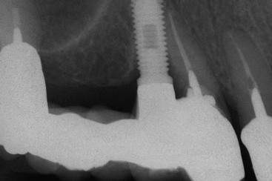
FIGURE 12-4 When an implant is joined to a natural tooth (in this x-ray, the first premolar implant is connected to the second molar), the pontic acts as a plaque reservoir, and the natural tooth is at increased risk of decay. There is also an increased risk of endodontic complications (e.g., failure or fracture) of the tooth because it is prepared for a crown and has a higher caries risk.
There are also biomechanical advantages for implant-supported independent prostheses.¹³ The tooth has physiologic movement of 28 microns apically and 56 to 108 microns in the horizontal dimension.¹⁴ Hence, a tooth joined to the implant (with much less movement) may act as a cantilever on the implant and increase biomechanical complications (Figure 12-5). As a consequence, when an implant restoration is joined to a natural tooth, an increased risk of abutment screw loosening, implant marginal bone loss, and unretained restoration may occur (Figure 12-6). In addition, independent implant prostheses may reduce or eliminate pontics between the tooth and the implant (by adding an additional implant next to the tooth). This simultaneously increases the number of abutments and distributes forces more effectively. The increase in abutment number decreases the risk of an unretained restoration, which is the third most common fixed prosthesis complication supported by natural teeth.^{10,11} Therefore, independent implant prostheses cause fewer complications and exhibit greater long-term success rates of the prosthesis and greater survival rates of the adjacent teeth.
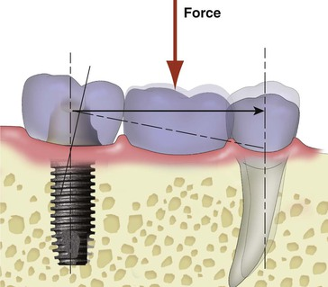
FIGURE 12-5 When an implant is joined to a natural tooth, the physiologic movement of the tooth may cause the prosthesis to act as a cantilever on the implant.
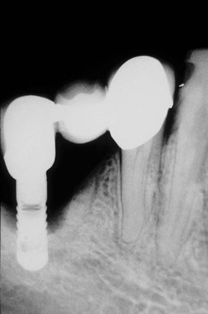
FIGURE 12-6 An implant joined to a tooth for a three-unit fixed prostheses may act as a cantilever and increase the risk of crestal bone loss around the implant. In this periapical radiograph, the implant has lost two thirds of the supporting bone.
In addition, the distribution of occlusal forces is optimized when independent implant prostheses are designed. This distribution of forces also decrease the risk of abutment screw loosening, unretained restorations, and marginal bone loss. As a result, the ideal treatment plan for a partially edentulous patient includes an independent implant restoration (Box 12-1).
Box 12-1
Independent Implant Prosthesis from Natural Teeth
1. Biological factors (most important)
a. Less decay of natural tooth abutment (interproximal hygiene)
b. Less endodontic factors (unprepared teeth have less endodontic complications)
2. Biomechanical factors
a. Abutment screw loosening risk
b. Unretained prosthesis (risk from implant)
c. Marginal bone loss risk (around implant)
d. More implants used as abutments (no pontic next to natural tooth)
1. Increase surface area load
2. Increased retention of prosthesis
3. Less risk of abutment screw loosening

Key Implant Positions
Implant dentistry may use implants that have ideal qualities of health. Rather than using a compromised tooth for support, the implant more often has an ideal clinical condition. However, some implant positions are more critical than others in regard to force reduction to the implant system. The maximum number of potential implants that may be used in a fixed prosthesis is usually determined by allowing 1.5 mm or more from each natural tooth and a 3-mm space between each implant and adding the diameter of the implant (Figure 12-7). This results with dividing the length of the span by 7 mm for the maximum number of implants (when the implants are 4 mm in diameter). Hence, a 21- to 27-mm span may have three implants, and a 28- to 34-mm span may have four implants. The key implant positions are implant sites that are more important than the others to reduce biomechanical forces. The key implant abutment locations mean that biomechanical complications will be increased when an abutment is not positioned in the site.¹⁵ Hence, even if a bone graft before implant placement is necessary, the additional training, surgery, costs, and time are warranted. After the final prosthesis is determined, the key implant positions for the prosthesis may be established.
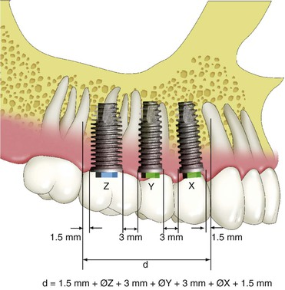
FIGURE 12-7 The maximum number of implants in an edentulous span may be determined by allowing 1.5 mm or more from an adjacent tooth and 3 mm between each implant and adding the diameter of the implants.
The key implant positions are determined with no limitations. In other words, the radiograph is used for diagnosis to determine the prosthesis and pathology but not the available bone and implant position. Rather, the dentist “pretends” the patient has all the available bone necessary to place the implant in the key sites, the patient has no financial limitations to do the ideal treatment, time is not an issue related to treatment, and the skill necessary to place (or augment and place) an implant in the key sites is present by the dentist or the referring team (Box 12-2).
Box 12-2
No Limitations to Ideal Treatment
Abutment-available bone
No financial limitation
Time of treatment is not a factor
c
There are four general guidelines to determine key implant positions for a fixed prosthesis in the edentulous site with multiple adjacent teeth missing¹⁵:
1. Cantilevers on prostheses designed for partially edentulous patients or complete edentulous maxillae should preferably be eliminated; therefore, the terminal abutments in the restoration are key positions.
2. Three adjacent pontics should not be designed in the prosthesis, especially in the posterior regions of the mouth.
3. When the canine is missing, the canine site is a key position, especially when other adjacent teeth are missing.
4. When the first molar is missing, the first molar site is a key implant position for all partially edentulous patients and completely edentulous maxillae (Box 12-3).
Box 12-3
Guidelines for Key Implant Positions for Fixed Prostheses
No prosthetic cantilevers
No three adjacent pontics in the prosthesis
Canine rule
First molar rule (for all partially edentulous patients and complete arch maxillae)

No Cantilevers
The first rule for ideal key implant positions is that no cantilever should be designed in the fixed prosthesis for partially edentulous patients or full-arch maxillary fixed restorations. Cantilevers are significant force magnifiers to the cement or prosthesis screws, prosthesis superstructure, abutment screws, implant–bone interface, and the implants.^{16,17}
iCantilevers on FPDs supported by teeth have a higher complication rate than prostheses with terminal abutments.^{9,12,18} The primary causes of traditional three-unit FPD failure with natural tooth abutments are caries and endodontic complications (often related to the tooth preparation or decay). The 5-year survival rate of the traditional FPD is often above 95%.¹¹ However, when a cantilevered three-unit FPD supported by two teeth is used to replace a missing tooth, the failure rate is over 25% within the first 5 years, and the complication rate increases to 40% by 10 years; the primary cause of failure is biomechanics.^{12,18}
When a load is placed on the cantilever portion of a prosthesis, the abutment farthest from the cantilevered pontic has a tensile and shear force applied to the cement seal because the tooth adjacent to the pontic acts as a fulcrum (Figure 12-8). Cements are 20 times weaker to tension and shear compared with forces in compression.¹⁹ Hence, with a cantilevered prosthesis, the cement seal breaks on the most distal abutment, and then the abutment often decays. The abutment closest to the cantilever becomes mobile or fractures (especially when endodontics was performed) because it is the only retained abutment for the prosthesis. These biomechanical-related complications usually occur in a relatively shorter period of time compared with biological complications (e.g., decay or periodontal disease).
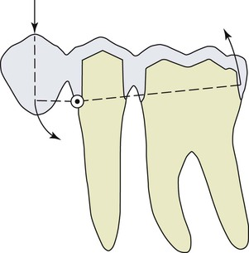j
FIGURE 12-8 When a compressive force is placed on a cantilever from two (or more) natural teeth, the closest tooth acts as a fulcrum, and the distal tooth from the cantilever has a shear and tensile load applied to the cement seal. In this example, the compressive load is applied to a first premolar, the second premolar acts as a fulcrum, and the shear and tensile load is applied to the first molar.
The maximum bite force in the anterior region approaches 25 lb, is increased to 100 lb in the region of the canine to premolar area, and further increases to 250 lb in the molar region. Cantilevers on the prosthesis are stress magnifiers to the implant system and may double the bite force.¹⁶ When cantilevers are used in the posterior molar regions, the greater bite force (up to five times greater than the anterior region) is further magnified by the cantilever and may increase the force on the implant system severalfold. For example, a bite force of 100 lb may exist on a premolar implant with no cantilever. When a cantilever is used to replace the molar, this force may be magnified by a 250-lb force on a cantilevered posterior molar pontic, which results in a 500-lb force on the anterior premolar abutment. Instead of 100-lb force on the premolar, the force may be five times greater (Figure 12-9).
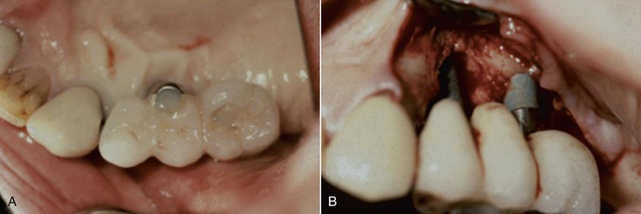
FIGURE 12-9 A, A cantilever prosthesis to the anterior from premolar and molar implants, replacing a first premolar. The bite force is magnified to the implant system because of the cantilever (both anterior and lateral) (left). B, The bone loss on the second premolar implant is greater because it is the fulcrum implant (right).
Teeth have more physiologic movement than an implant. The physiologic movement absorbs some of the tensile and shear force on the cement seal. In fact, cantilevered fixed prostheses survive best when the teeth are mobile because the cement seal less often breaks. Implant abutments have higher stresses applied to the implant system than the tooth system. Hence, the biomechanical risk factors of a cantilever are worse on implants than on teeth (Figure 12-10). Cement seal breakage, prosthesis screw loosening, and abutment screw loosening are at greater risk with implants. Bone loss is more often observed from biomechanical stress on implants than teeth. Teeth may become mobile, but when the force is reduced, the mobility decreases. The fulcrum implant may even fail or fracture as a consequence of the uncemented prosthesis.
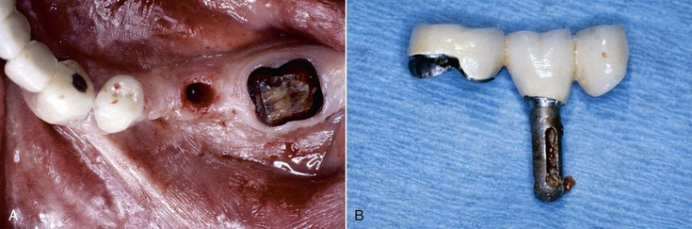
FIGURE 12-10 A, A three-unit fixed cantilever prosthesis (replacing a first premolar) was attached to a second premolar implant and a natural tooth first molar. The cement seal on the molar broke, and the molar has decay. B, The rigid implant has more biomechanical stress than a tooth and places more tensile and shear load on the cement seal of the distal abutment than the tooth, so it is more likely to become unretained. The implant then bears the entire load of the three-unit prosthesis, and the overloaded implant abutment lost bone, became mobile, and was lost.
The length of the cantilever is directly related to the amount of the additional force placed on the abutments of the prosthesis.^{16,20} When a 25-lb force is placed along the long axis of an implant, the implant system (i.e., crown, cement, abutment, abutment screw, implant body, implant marginal bone, and implant–bone interface) receives a 25-lb load. When a force of the same magnitude (25 lb) is applied on a 5-mm cantilever, the moment force on the abutment is increased to a 125-lb mm force (Figure 12-11).
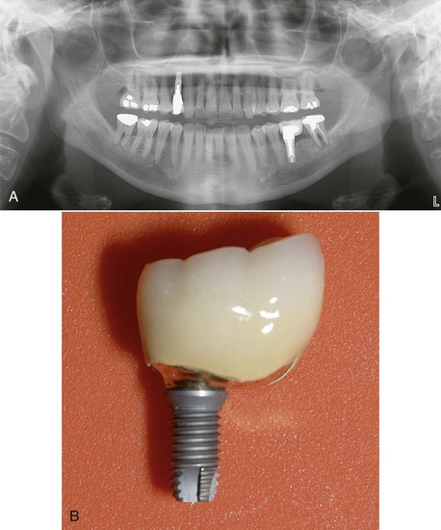
FIGURE 12-11 A, An implant was placed in the mesial root position to replace a first molar with a distal cantilever on the crown. B, An occlusal load to the cantilevered crown is increased to the implant. The implant failed within a few years.

One Missing Tooth
When one tooth is replaced with an implant, the implant should be inserted into the mesiodistal center of the site. As a general rule, the implant should be 1.5 to 2 mm from an adjacent tooth. Hence, a 4-mm implant requires 7 mm of space. When a molar (10–12 mm) is replaced, the implant should be larger in diameter to decrease the mesial and distal cantilever and placed in the mesiodistal center of the edentulous site. This decreases the biomechanical-related risks to the implant system (Figures 12-12 and 12-13).
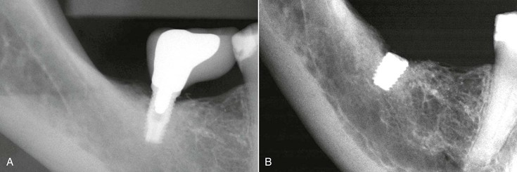
FIGURE 12-12 A, An implant was placed in the distal position to restore a first molar. A mesial 7-mm cantilever was used to restore the crown. B, The first molar implant fractured within a few years. Two implants should have been used to replace a molar tooth this large.
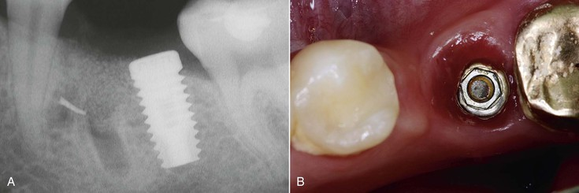
FIGURE 12-13 A, An implant was placed in a distal root position, and the crown was restored with a mesial cantilever. B, The abutment screw fractured three times within the first year. A larger-diameter implant should have been used in the mid mesiodistal position to restore this tooth.

Two Missing Teeth
When two adjacent teeth are missing, two implants should support the implant restoration. A trend in implant dentistry related to soft tissue esthetics is to have an ovate pontic cantilevered off one implant whenever two adjacent teeth are missing in the esthetic zone²¹ (Figure 12-14). The reason most often cited is that it is difficult to obtain an interdental papilla between adjacent implants.²² However, the biomechanical complications of uncemented prostheses, screw loosening, and increased force also increase the risk of marginal bone loss and implant fracture or failure (Figure 12-15). As a consequence, the soft tissue may be significantly affected (Figure 12-16). Interimplant papilla may be generated between two implants as long as the space between the implants is 3 mm or more and mm from adjacent teeth (Figure 12-17).^{23,24} As a result, whenever two adjacent teeth are missing and the space is 12 mm or more, two adjacent implants should be inserted even in the esthetic zone.
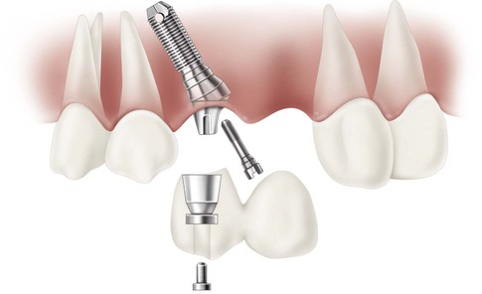
FIGURE 12-14 A two-unit cantilever from one implant has been suggested in the anterior esthetic zone to improve the soft tissue interimplant region.²¹
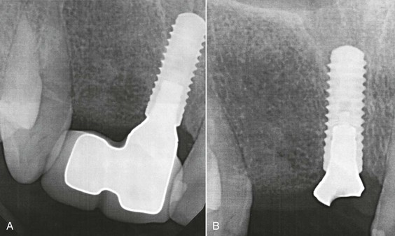
FIGURE 12-15 A, A two-unit fixed partial denture cantilever from a central incisor implant. B, The abutment fractured after the first year.
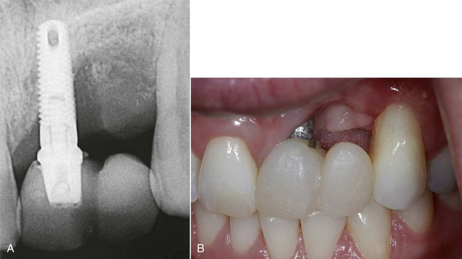
FIGURE 12-16 A, A two-unit cantilever from a central incisor implant. Note the bone loss on the distal aspect of the implant. B, The soft tissue receded and the soft tissue drape is compromised.
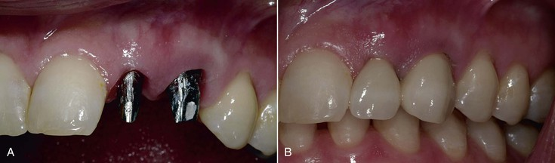
FIGURE 12-17 A, Two adjacent implants are placed in the esthetic zone to replace a canine and lateral incisor. The implants are 1.5 mm from each tooth and 3 mm apart. B, The two-unit prosthesis has fewer complications than a cantilever, and the soft tissue drape is within normal limits, when the base of the papilla is at least 3 mm wide.
To enforce the rule of no cantilever, the key implant positions indicate one implant per tooth when one or two adjacent teeth are missing with a span of more than 12 mm (when the implant diameter is 3 mm), 13 mm (when one implant is 3 mm and the other 4 mm), and so on (Figure 12-18). However, if the cervical region is not in the esthetic zone (high smile line in the maxilla or low lip line during speech in the mandible), it is more advantageous to place two implants in limited mesiodistal spaces (e.g., 10–11 mm) to avoid the increased biomechanical complications. The interimplant papilla will not be ideal under these conditions, but the biomechanical risks are greater than the esthetic risks when the region is out of the soft tissue esthetic zone (Figure 12-19).
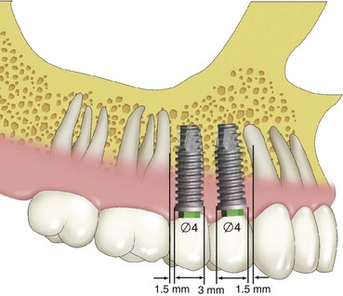
FIGURE 12-18 When two adjacent teeth are missing in the esthetic zone, the implants should be 1.5 mm from the teeth and 3 mm (or more) apart. This means a 12-mm space is required when the implants are 3 mm in diameter, and 14 mm is required for two 4-mm-diameter implants. A-P, anteroposterior.
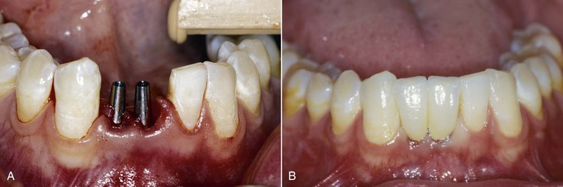
FIGURE 12-19 A, Two adjacent implants less than 3 mm apart, replacing two mandibular incisors out of the soft tissue esthetic zone. B, The two-unit prosthesis has a depressed interimplant papilla; however, the biomechanical risk complications are reduced.
When one of the two (or more) missing teeth include a molar, one of the terminal implants should be positioned 1.5 mm from the anterior adjacent tooth and the other terminal implant at the distal of the last molar, not in the middle of the molar. In this fashion, the 3-mm cantilever from the midmolar to the marginal ridge is eliminated when the implants are splinted together (Figure 12-20). When the implant is not positioned in the distal molar position, the size of the last molar should be reduced to eliminate the cantilever (Figure 12-21). The dental laboratory technician and dentist should be aware the last molar should be a premolar-size crown when the distal implant is positioned in the mesial to midmolar position.
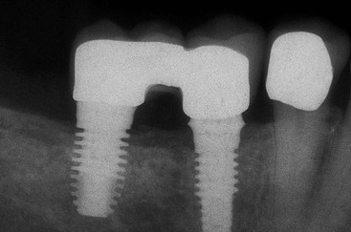
FIGURE 12-20 When two or more adjacent teeth missing include a molar, the distal implant is positioned in the distal of the molar (not the center). This eliminates the posterior cantilever when the implants are splinted together.
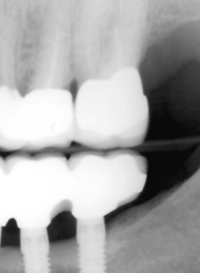
FIGURE 12-21 The full contour of the last molar should not be restored when the implant is placed in the mesial to midmolar position because the distal portion of the molar crown acts as a cantilever to the implant system. The last implant in this radiograph should have a premolar-size crown.

Cantilever Option.
When two adjacent teeth are missing in the esthetic zone anterior to the canines and the intratooth space is less than 12 mm, a cantilever may be an acceptable option. The most common time this clinical condition occurs is two adjacent incisors in the anterior mandible. When the cantilever on the prosthesis is represented by only a mandibular lateral incisor pontic, the ideal implant positions may not include the lateral incisor site. When a pontic replaces the lateral incisor, the soft tissue drape may be improved compared with an implant with less than 3 mm of space from the adjacent implant. The mandibular lateral incisor is the smallest tooth in the arch, so the cantilever is limited. y The anterior bite forces are lowest in the central and lateral incisor region. The occlusal force is in the long axis of a mandibular incisor tooth. The occlusal contact on the lateral incisor pontic should be eliminated to further reduce the risk of overload. As a result, the ideal implant position based on force and esthetics may be a larger-diameter implant in the central position (i.e., 4 mm diameter vs. 3 mm) and a cantilevered pontic to replace the mandibular lateral incisor. It should be noted that the cervical region of the mandibular incisors is rarely in the esthetic zone. Hence, a lack of interdental papilla is usually not a consequence.
When a maxillary lateral incisor and central incisor is missing, the intratooth space is almost always greater than 12 mm because a central incisor is usually 8 mm or more wide. Hence, two implants can almost always be inserted. Note: A two-unit cantilever should not be used from a canine implant because the force magnitude increases and the direction of force in the excursion also increases the force to the canine implant.
The fact that, on occasion, a cantilever may be acceptable when force factors are low and bone density is favorable does not negate the ideal goal that no cantilever should be designed in the prosthesis, especially in the posterior regions. Therefore, whenever the intratooth space is 12 mm or more, the terminal abutments at each end of the prosthesis are first designed in the treatment plan. When this option is not readily available, a larger-diameter implant size or greater implant surface area designs are indicated. In addition, the occlusal forces to the cantilevered portion of the prosthesis should most often be reduced or even eliminated.

Three Missing Teeth
When three adjacent teeth are missing, the key implant positions include the two terminal abutments, one on each end of the prosthesis (Figure 12-22). A three-unit prosthesis may be fabricated with only these abutments when most of the force factors are low to moderate and the bone density is favorable. A cantilevered restoration on multiple splinted implants may be compared to a class I lever.¹⁶ The extension of the prosthesis from the last abutment is the effort arm of the lever. The last abutment next to the cantilever acts as a fulcrum when a load is applied to the lever. The distance between the last abutment and the farthest abutment from the end of the cantilever represents the resistance arm, and the distance between the implants may be called the anteroposterior distance or A-P spread.
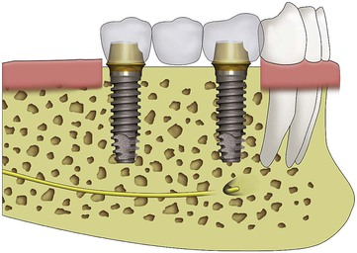
FIGURE 12-22 A three-unit prosthesis has key implant positions at each terminal end of the restoration.
The length (usually in millimeters) of the cantilever (effort arm) divided by the resistance arm represents the mechanical advantage. Therefore, when two implants are 10 mm apart with a cantilever or extension of 20 mm, the mechanical advantage is 2 (20 mm/10 mm). In this example, a 25-lb force on the cantilever results with a 50-lb tensile force on the farthest abutment from the cantilever (25 lb × 2 = 50 lb). The abutment closest to the cantilever (fulcrum) receives a compressive force equal to the sum of the other two forces, or, in this example, 75 lb (25 lb + 50 lb). In other words, the force on the cantilever increases the force on the implants by two to three times (Figure 12-23). Therefore, cantilevers magnify forces to all the abutments supporting the prosthesis.
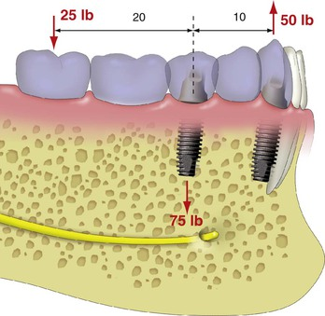
FIGURE 12-23 A cantilever on two implants may be considered a class I lever. When the implants are 10 mm apart, with a 20-mm cantilever, a mechanical advantage of 2 is created. Therefore, a load on the cantilever will be multiplied by 2 on the most distal implant, and the implant close to the cantilever receives the sum total stress of the two other loads.
As important as the increase in force magnitude, the greater load to the implant farthest from the cantilever is a tensile or shear type of force. As a result, any part of the implant system is at an increased risk of biomechanical failure (e.g., porcelain fracture, uncemented prosthesis, abutment screw loosening, crestal bone loss, implant failure, implant component or body fracture) (Figure 12-24). This is especially observed when parafunction or increased crown height space (CHS) exists²⁵ (Figure 12-25).
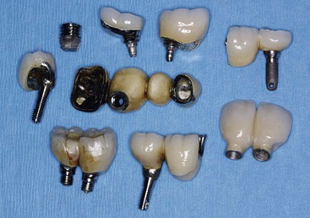
FIGURE 12-24 Cantilevers increase the force to the implant system. As a consequence, implant failure, fracture, abutment screw loosening, and unretained prosthesis may occur more often. (All of these cantilever-related failures were observed in one office over a 1-year period.)
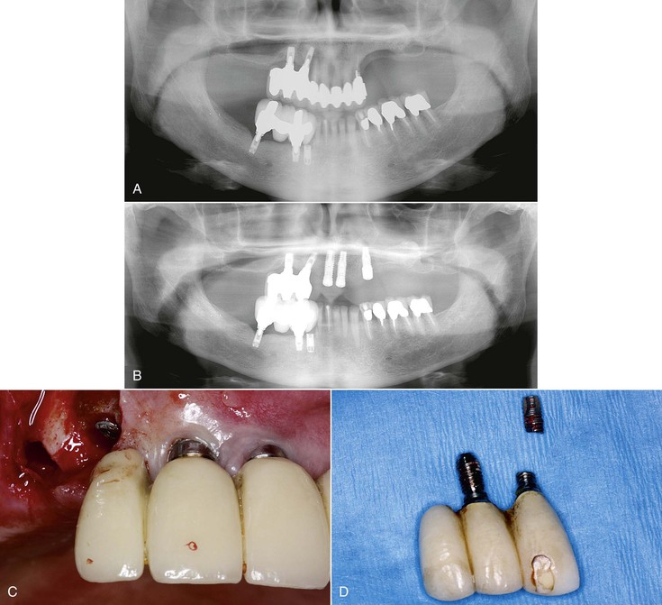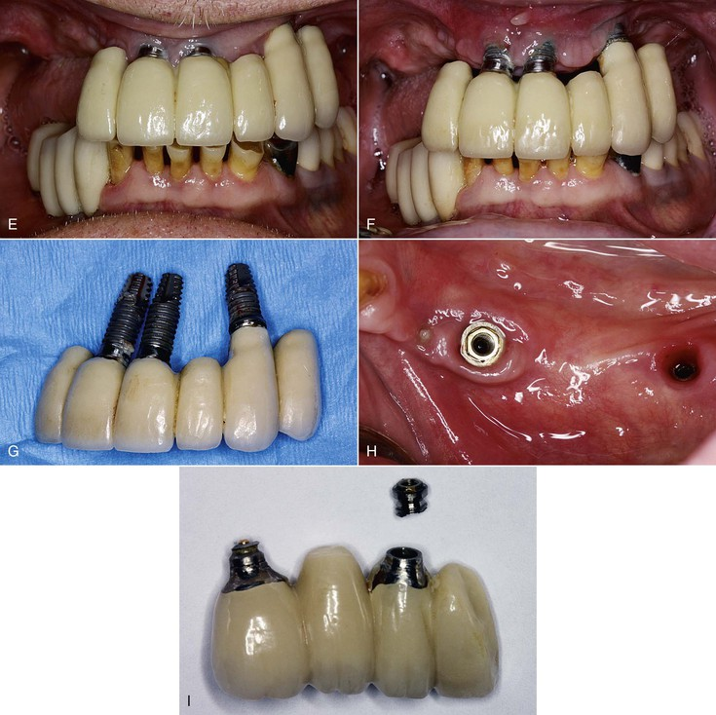
FIGURE 12-25 A, A panoramic radiograph of a maxillary and mandibular implant fixed partial denture (FPD) with cantilevers. B, A panoramic radiograph demonstrating the maxillary anterior teeth were extracted and replaced with 3 implants. C, The maxillary right cantilevered FPD fractured both supporting implants. D, The three-unit cantilever FPD and fractured implants. E, The anterior implants support a bilateral cantilevered six-unit FPD with a larger crown height. F, Bone loss started occurring on the implants. G, The three implants and six-unit cantilevered FPD failed. H, The four-unit cantilevered mandibular prosthesis fractured the two supporting implants (same patient). I, The four-unit cantilevered FPD with the two fractured implants.
To eliminate posterior cantilevers, a bone augmentation is often indicated. Most bone augmentation procedures are not as predictable as implant integration in existing bone volumes. Bone augmentation often requires an additional surgery before implant placement. Additional training is required to learn bone augmentation procedures, and the learning curve is longer and more difficult to become accomplished in these techniques. Complications related to bone augmentation are more common than implant surgery in existing bone volumes and may be more extensive and even debilitating to the patient. However, cantilevered implant prostheses have a more frequently observed biomechanical risk than the surgical risks of augmentation, and these risks can cause the loss of the entire implant support and prosthesis. In addition, bone loss from the implant failure may make the following bone augmentation procedures even more difficult to perform than when treatment was rendered in the original condition.

Four or More Adjacent Teeth Missing
When four adjacent teeth are missing, the terminal abutments are the key implant positions (Figure 12-26). Most often, an additional implant is required, especially when the missing teeth include a canine or posterior teeth or when the bone density is poor (Figure 12-27). Restorations of five to 14 units require the key terminal positions plus additional abutments regardless of force factors or bone density. The other guidelines to the key implant positions determine the most important additional sites for the implant placement.
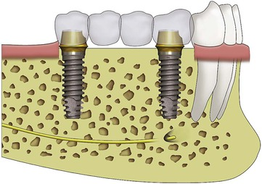
FIGURE 12-26 When four adjacent teeth are missing, the two terminal abutments are the key implant positions. Most often, an additional implant(s) is required.
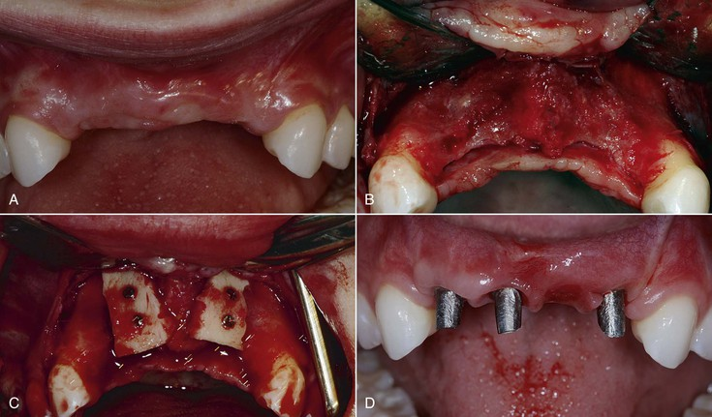
FIGURE 12-27 A, A young patient missing four anterior teeth, opposing natural teeth. B, The inadequate bone requires a bone augmentation for the key implant positions. C, The block bone grafts in situ. D, After healing, three implants are inserted. The two terminal implant positions (lateral incisors) are the keys. An additional implant is often required. Note the interimplant papilla is similar to the papilla around the ovate pontic.

Cantilever Options.
The ideal treatment plan should eliminate cantilevers in partially edentulous patients and in complete arch maxillae. However, in completely edentulous mandibles, a cantilever is often the most prudent treatment option. For example, in a completely edentulous mandible, available bone in the posterior regions may be insufficient for root form implant placement without advanced procedures (e.g., nerve repositioning, iliac crest bone grafts).
In addition, the dynamics of bone movement during opening and function is different for a mandible and maxilla. Upon opening, the mandible flexes distal to the mental foramen toward the midline. During heavy biting on the side of the jaw, the bottom of the mandible rotates to the buccal, and the crest slightly rolls toward the lingual, again, distal to the mental foramen^{26,27} (Figure 12-28). As a consequence, splinting a molar implant across the arch to the contralateral molar may cause discomfort and lateral forces on the implant sites. With implant prostheses, uncemented restorations, bone loss, and even implant failure have been observed when there was cross-arch splinting of molars.
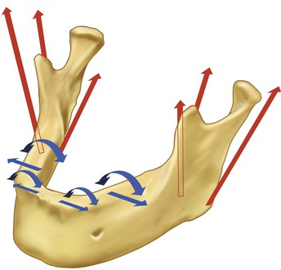
FIGURE 12-28 The mandibular bone has dynamic movement during function. Upon opening, it moves toward the midline. Heavy biting on one posterior side results with a torsion of the mandible with the inferior border rolling buccal and the crest moving toward the tongue.
An alternative treatment plan for a completely edentulous mandible may be to cantilever pontics from anterior implants. The biomechanics of an arch is more favorable, the bone density in the anterior mandible is adequate, and the direction of force to these anterior implants is along their long axis in centric occlusion² (see Figure 12-1). However, when terminal abutments are not designed in the treatment plan and a cantilever is planned, other force factors should be moderate to low, and implant surface area factors of the implant number, size, and design should be high to compensate for the increase in force. When this option is considered, the force factors of parafunction, CHS, masticatory dynamics, implant location, and opposing arch are closely scrutinized.²⁶ When the force factors are less favorable, the cantilever length should be reduced or eliminated or the implant number increased, the implant size increased, or the implant design surface areas increased.
In addition to patient force modifiers, the A-P distance (or A-P spread) of the most distal and most anterior implants in a full-arch mandible is also a factor. The A-P distance is determined by first drawing a line from the distal aspect of the most posterior implant on each side of the arch. A second line (parallel to the first) is then drawn through the middle of the most anterior implant. The distance between these two lines is called the A-P spread (or A-P distance). When the implants are in one plane (a square arch form) and the A-P spread is less than 5 mm, the cantilever option should rarely be used regardless of how low the patient force factors. When five or more implants are positioned around an ovoid or tapered arch and the A-P distance is greater than 7 mm, five different planes exist (central to laterals, bilateral canines, and bilateral premolar-molar) because of the arch form of the splinted implants (Figure 12-29). The posterior cantilever under these conditions may extend as far as two times the A-P distance when all five patient force factors are low and bone density is favorable (Figure 12-30). However, more than two pontics are rarely indicated on a posterior cantilever even under ideal conditions of a full-arch splinted prosthesis. Chapter 15 presents five different implant locations and number options for a fixed prosthesis in an edentulous mandible.
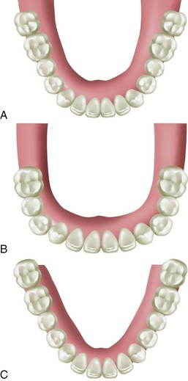
FIGURE 12-29 The mandible may have a square, ovoid, or tapering shape. The anteroposterior distance between the most distal implant on each side and most anterior implant is variable and directly related to the shape of the arch.
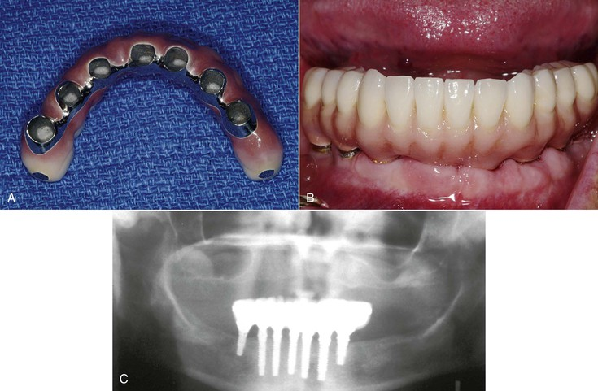
FIGURE 12-30 A, A tapering mandible with seven implants placed from mental foramen to mental foramen, with a limited posterior cantilever. B, The FP-3 fixed prosthesis in situ. C, A panoramic radiograph of the FP-3 prosthesis and implants in place.

No Three Adjacent Pontics
In most prostheses designs, three adjacent pontics are contraindicated on natural tooth abutments in the posterior regions of the mouth^{19,28–30} (Figure 12-31). The adjacent abutments are subjected to considerable additional force when they must support three missing teeth, especially in the posterior regions of the mouth. When three adjacent posterior teeth are missing between remaining teeth (and the third molar is absent), the terminal abutments are the second molar and the canine. The forces in the posterior regions are three to four times greater than the anterior region, and the force on the canine is two times greater than the anterior region. In addition, the canine receives a lateral load in most all excursions. The lateral load increases the intensity of the force and places the cement seal and porcelain under more tensile and shear loads.
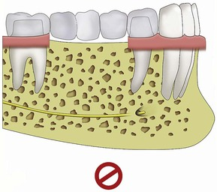
FIGURE 12-31 A posterior fixed prosthesis with three (or more) pontics is contraindicated with natural teeth abutments.
In addition to the greater loads applied to the abutment teeth, all pontic spans between abutments flex under load.³¹ The greater the span between abutments, the greater the flexibility of the metal in the prosthesis. A one-pontic span exhibits little flexure (8 microns or less with precious metal under a 25-lb load). A two-pontic span flexes eight times more than a one-pontic span, all other variables being equal. Although the metal flexure is more for the two-pontic prosthesis, the failure rate of three- or four-unit prosthesis supported by natural teeth is similar for the first 5 years because the cause of failure is mostly biological (e.g., caries) (Figure 12-32).
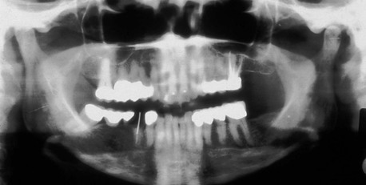
FIGURE 12-32 The most common cause of failure of a four-unit fixed partial denture on natural teeth is caries to an abutment. The second premolar is decayed as a consequence of the plaque reservoir found from the pontics of the restoration.
The metal between abutments for a three-pontic span flexes 27 times more than a one-pontic span if all other factors are equal²⁸ (Figure 12-33). In addition, the greater the load, the greater the flexure. Hence, in parafunction patients, the flexure is even greater. Metal flexure places shear and tensile loads on the abutments.³² The greater the flexure, the greater the risk of porcelain fracture, uncemented prostheses, and abutment screw loosening. As a result, not only is the magnitude of the force increased to the adjacent abutments when the prosthesis has three pontics (because they are supporting two abutments and three pontics), but the flexure of the metal also increases to a point that the incidence of complications makes the treatment plan contraindicated, especially when forces are greater (as in the posterior region) (Figure 12-34). As a result, a three-adjacent-pontic prosthesis has an increased failure rate compared with a one- or two-pontic fixed prosthesis. The increased failure rate of long span fixed prostheses is due largely to the increase in biomechanical complications (e.g., unretained restorations and fracture). As a consequence, many authors have stated that three pontics in the posterior regions are contraindicated for natural teeth^{18,26,28,29} (Figure 12-35).
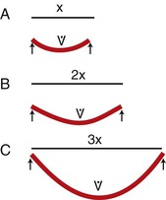
FIGURE 12-33 A, A one-pontic fixed partial denture (FPD) has minimal flexure of the metal. B, A two-pontic FPD flexes eight times more than one pontic span. C, A three-pontic FPD has 27 times more flexure than a one-pontic span.
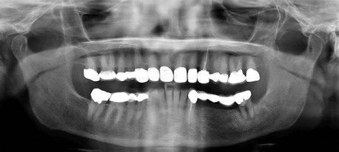
FIGURE 12-34 A panoramic radiograph with a five-unit fixed partial denture with three adjacent pontics. The cement seal on the molar separated, and the tooth decayed and has failed.
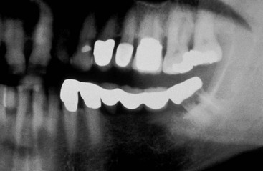
FIGURE 12-35 A panoramic radiograph of a six-unit fixed partial denture with three adjacent pontics. This is contraindicated because of biomechanical complications. The molar cement seal broke and the tooth has decayed and failed.
The flexure of materials in a long span is more of a problem for implants than natural teeth.³² Because natural roots have some mobility both apically and laterally, the tooth acts as a stress absorber, and the amount of material flexure may be reduced. Because an implant is more rigid than a tooth (and has a greater modulus of elasticity than a natural tooth), the risk for complications of increased load and material flexure are greater for an implant prosthesis. Because three posterior pontics are contraindicated in a natural tooth–fixed prosthesis, it is even more important not to have three pontics in an implant restoration¹⁵ (Figure 12-36).
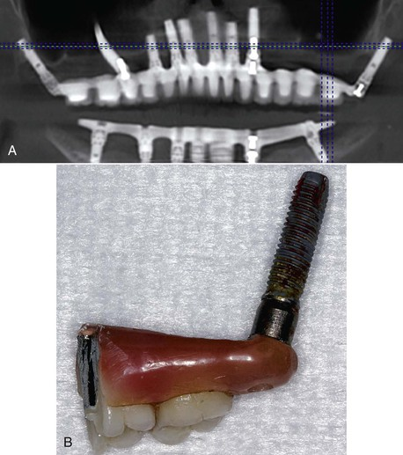
FIGURE 12-36 A, A panoramic radiograph with a maxillary and mandibular fixed prosthesis with three and four adjacent pontics. Bone loss is present on the most distal implants. B, The maxillary tuberosity implant was also mobile and failed.
The span of the pontics in the ideal treatment plan should be limited to the size of two premolars, which is 13 to 16 mm.¹⁵ When a molar is one of the teeth missing between existing teeth, the missing molar space alone may be 10 to 13 mm long. As a result, when a large second premolar and first molar are missing, this edentulous span is often treatment planned to replace three teeth, rather than two, and an additional implant is warranted in this span. This is especially appropriate for greater patient forces (i.e., moderate to severe parafunction) or softer bone types (i.e., D3 and D4). As a result of these guidelines, a maxillary edentulous arch missing 14 natural teeth may have as many as 18 potential implant sites if each molar is greater than 12 mm in width. Rarely are second molars replaced in the mandible; therefore, when 12 natural teeth are considered in a mandibular edentulous arch, 14 potential implant sites may be present.
To limit the effect of the complications of three adjacent premolar-size pontics, additional intraimplant key positions are indicated in prostheses missing five or more adjacent teeth. Therefore, when five to 14 missing adjacent teeth are to be replaced, key implant positions are located in the terminal abutments, and additional pier or intermediary abutments are indicated to limit the pontic spans to two premolar-size pontics. Following this rule, a five to seven premolar-size unit prosthesis has three key abutments (two terminal and one pier) (Figure 12-37).
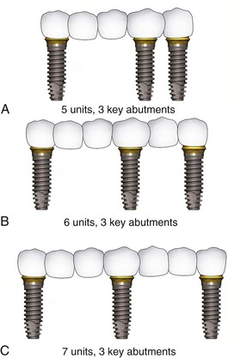
FIGURE 12-37 When five to seven adjacent teeth are missing, there are three key implant positions: the terminal abutments and another implant to limit the edentulous span to two teeth. Note additional implants are usually required, especially for six or seven missing teeth.
An eight to 10 premolar-size unit prosthesis has four key implant positions (two terminal and two pier). An 11- to 13-unit prosthesis has five key abutments (two terminal and three pier), and a 14-unit prosthesis has six key abutment positions. In addition to these key abutments, additional abutments may be required to address patient force factors and bone density. Rarely is the force factor situation favorable and bone density ideal enough in a maxilla to be fulfilled with solely key abutments for a fixed prosthesis replacing more than five teeth.

Three-Pontic Options
Angled forces to the premaxilla magnify the amount of the force to the implant system in both centric and excursive occlusal forces. Therefore, most maxillary anterior prostheses should also limit the number of pontics in the restoration. , when the three adjacent missing teeth are mandibular incisors. As long as implants are placed in the canine position, the number of pontics may be increased because of the long axis angle of force, the reduced bite force, and the good bone quality. However, when the dentate arch position is tapered and the three anterior pontics are cantilevered to the facial, an additional implant is indicated even in the anterior mandible.

Canine Rule
In any arch, certain positions are more important sites than others. In the dental arch, these more important positions are represented by the canine and the first molar^{33,34} (Figure 12-38). The canine root has more surface area in either arch compared with any other anterior tooth, and the molar has more root surface area than any posterior teeth³⁵ (Figure 12-39). The canine is a particularly interesting tooth. When a lateral force is placed on the natural canine and no posterior teeth are in contact, two thirds of the masseter and temporalis muscles do not contract, and the resultant force on the anterior teeth is less.³⁶ In addition, because the mandible acts as a class III lever, with the temporomandibular joint behind the muscles of mastication, the force applied to the anterior teeth is less when the posterior teeth do not occlude.³⁷ In other words, both biological and biomechanical factors make the canine position an important site in the dental arch.
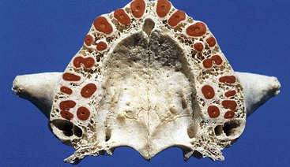
FIGURE 12-38 In a dental arch, the two most important biomechanical positions are represented by the canine and the first molars.
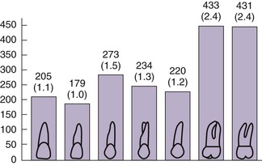
FIGURE 12-39 The canine has more root surface area than any anterior tooth and the first molar more area than any other posterior tooth.
A fixed restoration replacing a canine is at greater risk than nearly any other restoration in the mouth. The maxillary or mandibular adjacent incisor is one of the weakest teeth in the mouth, and the first premolar is often one of the weakest posterior teeth. As a consequence, when a canine is missing, a single tooth implant replacing the canine is the treatment of choice (Figure 12-40; Box 12-4).
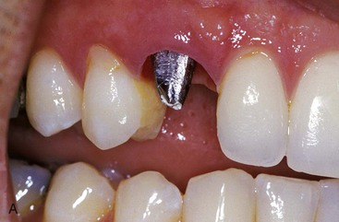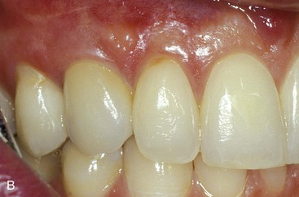
FIGURE 12-40 A, The lateral incisor is the weakest anterior tooth and the first premolar the weakest posterior tooth. They are poor abutments for a three-unit fixed partial denture option replacing a canine. B, A single tooth implant is the treatment of choice when a canine is missing.
Box 12-4
Arch Position
Canine

Most surface area of any anterior tooth
Canine-guided excursion of the mandible reduces masticatory muscle contraction
Canine and anterior teeth farthest from the temporal-mandibular joint (less force magnitude)
Adjacent teeth are less ideal for additional force
When two adjacent teeth are missing and include a canine, two implants are required. Even when a canine and lateral incisor are in the esthetic zone, it is better to reduce the size of the implants and place two implants with no cantilever rather than place a larger implant with a cantilever (see Figure 8-17). The implants should be at least 3 mm apart so the base of the interimplant papilla can support the soft tissue drape.
A traditional fixed prosthetic axiom on natural teeth indicates it is contraindicated to replace a canine and two or more adjacent teeth.^{18,26,28} Therefore, if a patient desires a fixed prosthesis, implants are required whenever the following adjacent teeth are missing in either arch: (1) the first premolar, canine, and lateral incisor; (2) the second premolar, first premolar, and canine; and (3) the canine, lateral, and central incisors. Whenever these combinations of teeth are missing, implants are required to restore the patient because (1) the length of the span is three adjacent teeth, (2) the lateral direction of force during mandibular excursions increases the stress to the prosthesis, (3) the magnitude of the bite force is increased in the canine region compared with the anterior region, and (4) an implant in the canine region with implant-protected occlusion (mutually protected occlusion) distributes reduced lateral loads during mandibular excursions (Figure 12-41).
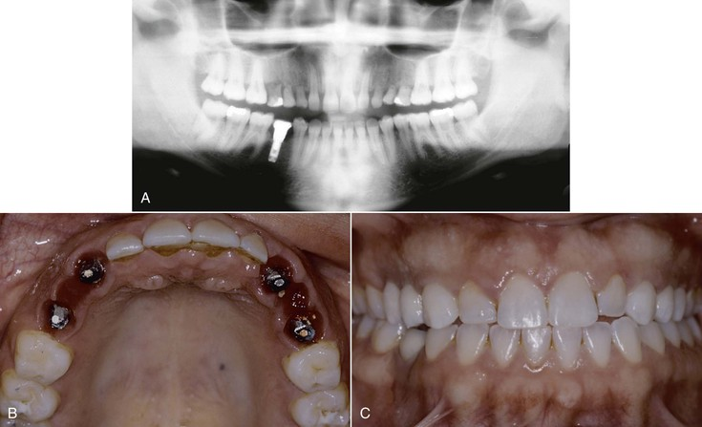
FIGURE 12-41 A, When the patient is missing a canine, a first premolar, and second premolar, it is contraindicated for a traditional tooth-supported fixed partial denture. This panoramic radiograph demonstrates the patient has these three permanent teeth missing on both sides of the arch. B, After the deciduous teeth were extracted, implants were inserted into the canine and second premolar position on each side. C, A bilateral three-unit fixed partial denture was cemented on the supporting implants.
The canine is a particularly important position for the occlusal scheme of the patient.³² Canine guidance or mutually protected occlusion is the primary occlusal format in most all fixed implant reconstructions or completely implant-supported removable restorations. The angled force of approximately 22 to 25 degrees in excursions should not be magnified on a canine pontic with an implant prosthesis supported by fewer implants.³⁸ Although the force reduction in excursions is not as great with an implant as with a natural canine tooth, there still is some force reduction as a consequence of the class III lever effect.^{37,39} Therefore, whenever the canine and two or more adjacent teeth are missing, the canine is a critical site along with the terminal positions of the span (Figure 12-42).
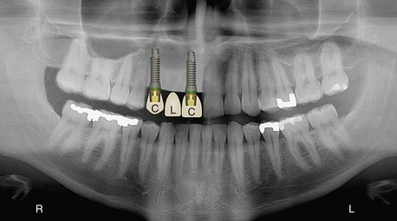
FIGURE 12-42 A panoramic radiograph of a patient missing a maxillary right canine, lateral incisor, and central incisor. The key implant positions are the canine and central incisor to support a three-unit fixed partial denture.
When the three adjacent teeth are the first premolar, canine, and lateral incisors, the key implant positions are the first premolar, the canine, and the lateral incisor when the overall intratooth space is greater than 19 mm because three implants with no cantilever reduce any increased force factor risks. The minimum implant sizes are usually 3.5 mm for the premolar and canine and 3 mm for the lateral incisor.
When the first premolar, canine, and lateral incisor are missing and the intratooth span is less than 19 mm, only two implants are used to support the prosthesis. In this scenario, it is better to place terminal abutments and have a canine pontic, especially when the prosthesis is within the esthetic zone. The size of the implants is slightly increased to compensate for the angled forces during a lateral excursion. In addition, the amount of the incisal vertical overbite is reduced to decrease the leverage effect on the canine. The incisal guidance should be as shallow as possible to decrease the force during excursions. However, it must be steep enough to separate the posterior teeth in the mandibular excursions.
When there are multiple missing teeth on each side of the canine site, the canine edentulous site is a key pier abutment position’. The canine position is a key implant position to help disocclude the posterior teeth in mandibular excursions. As a result, when four or five adjacent teeth are missing, including a canine and at least one adjacent posterior premolar tooth, the key implant positions are the terminal abutments and the canine position. For example, when the first premolar, canine, lateral, and central incisor are missing, the key implant positions are the first premolar and central incisor (terminal abutments) and the canine (canine rule) (Figure 12-43).
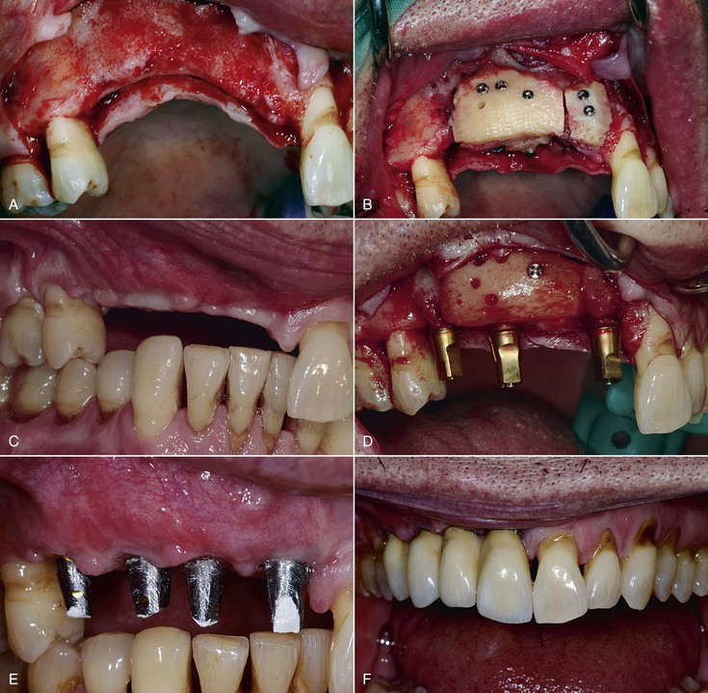
FIGURE 12-43 A, The patient is missing a maxillary central incisor, lateral incisor, canine, and first premolar. There is inadequate bone volume in the canine position. B, A block bone graft is positioned primary in the canine region. C, The block bone graft matures for 6 months. D, The key implant positions are the central incisor, canine, and first premolar. E, An additional implant was positioned in the lateral incisor region. (The patient is a man with deep vertical overbite.) F, A four-unit fixed partial denture was cemented in place.
When six or more adjacent teeth are missing, which include both canines, additional pier abutments (which limit the pontics’ spans to no more than two teeth) are also indicated. For example, when the first premolar to first premolar are missing, five key implants are indicated, especially in the maxillary arch—the terminal abutments, the canines, and an additional implant in one of the central incisor positions (Figure 12-44). The same five key implant positions exist for the one-tooth span of second premolar to second premolar (Figure 12-45).
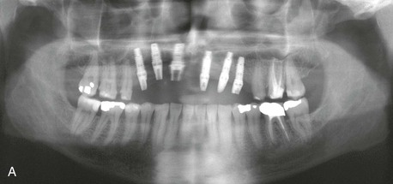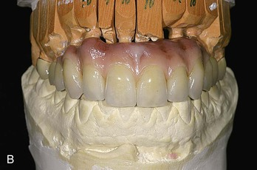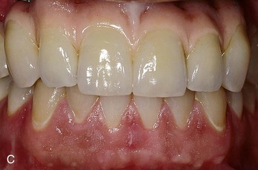
FIGURE 12-44 A, A panoramic radiograph of a patient missing eight anterior teeth—the premolar to first premolar. Six implants are inserted: the five key implants plus an additional one because of the large crown height space. B, A FP-3 fixed prosthesis was fabricated. C, The fixed eight-unit implant prosthesis in situ.
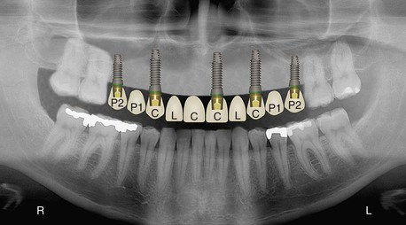
FIGURE 12-45 A panoramic radiograph of 10 anterior teeth missing. There are five key implants positions for this fixed prosthesis: the second premolars, the canines, and an anterior implant to limit the pontics to no more than two.
The canine position is also a key implant position in a full-arch prosthesis. In a three-dimensional finite element analysis, a comparison was made between full-arch fixed prostheses supported by four implants without a canine position and six implants including the canine position.⁴⁰ The six-implant model reduced its stresses between 7% to 29% when an implant was in the canine position dependant on the direction and position of applied load (Figure 12-46).
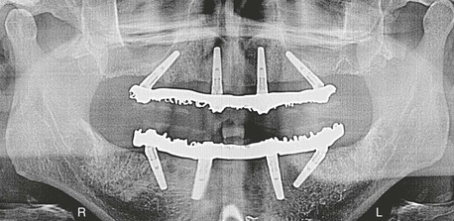
FIGURE 12-46 A panoramic radiograph of a fixed maxillary implant prosthesis with only four implants. There are four adjacent pontics, which include a canine. This is contraindicated for natural teeth (because of the length of the span and because of the missing canine). At least two additional implants are indicated (in the canine regions) to decrease the biomechanical stress to the prosthesis.
A Kennedy-Applegate class IV partial denture is often the least stable prosthesis of any arch condition. These patients have posterior teeth and are missing multiple anterior teeth, which crosses the midline. This type of partial denture acts as a lever, with the posterior teeth as fulcrums and the anterior removable prosthesis as a lever arm. When this prosthesis also replaces a canine, the restoration is even less stable. It rocks in all the mandibular excursions, especially during function (Figure 12-47). As a result, prosthetic guidelines indicate, whenever possible, a tissue bar or fixed prosthesis in the anterior region when restoring a class IV patient. When the restoration is also replacing missing posterior teeth (as the molars), the condition is even worse (because it rocks back and forth) and is often less stable than a denture.
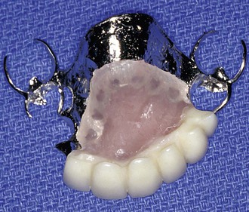
FIGURE 12-47 A Kenney-Applegate class IV partial denture (missing teeth span which crosses the midline) is one of the most unstable prosthetic devices. It rocks on the posterior teeth, which act as fulcrums.
The conditions for a class IV partial denture are made even worse when implants support the partial denture because the implants are more rigid. An implant overdenture is similar to a removable partial denture. When the anterior region (including canines) does not have implant support, the overdenture attachments loosen and routinely break (Figure 12-48). As a result, the restoring dentist attempts to make a rigid attachment system for the overdenture. However, when the prosthesis does not move during function, it is a fixed prosthesis. It therefore needs as many implants and key positions as a nonremovable fixed restoration (Figure 12-49).
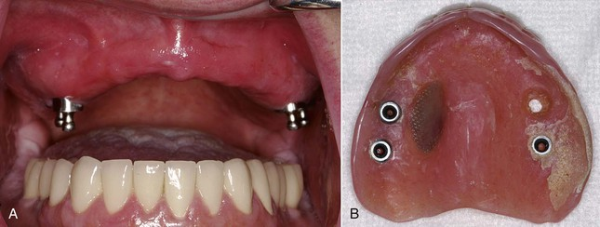
FIGURE 12-48 A, A maxillary overdenture with posterior implants; the patient is missing 10 anterior teeth. B, The overdenture rocks and is completely unstable. The attachments become loose and frequently fracture.
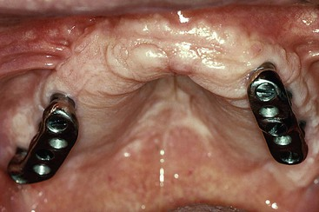
FIGURE 12-49 Maxillary overdentures that do not replace the canines are unstable during function. The restoring dentist fabricated two independent bars and rigid attachments (to reduce the anterior rocking). This patient constantly complained of attachment loosening and the need for replacement.
Because sinus bone grafting is very predictable, some treatment plan options for completely edentulous patients have used sinus grafts and molar implant placement for maxillary overdentures without implants in the anterior region. The consequence of this treatment when the canine positions are not used for support include overdenture complications, marginal bone loss around the implants, and implant failure (Figure 12-50). An implant in the canine position is a key position even for a maxillary overdenture.
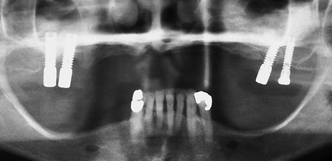
FIGURE 12-50 Bilateral sinus grafts permit posterior implants to be inserted to support a maxillary overdenture. This prosthesis was less stable during function than a maxillary denture.

First Molar Rule
The molars have the most root surface area of any natural tooth in the mouth and have two or three roots (see Figure 12-38). The biomechanical rationale for this condition is that the bite force doubles in the molar position compared with the premolar position in both the maxilla and mandible. In addition, the edentulous span of a missing first molar is usually 10 to 12 mm compared with a 7-mm span for a premolar. As a result, the first molar is also a key implant position.^{15,33,34}
As previously presented, cantilevers should not be used in partially edentulous patients to replace a first molar, especially when patient force factors are moderate to great (e.g., parafunction, opposing arch). The cantilever further increases the force of the molar region to the splinted abutments. As a result, uncemented restorations, bone loss, and failure are at greater risk (Figures 12-51 and 12-52).
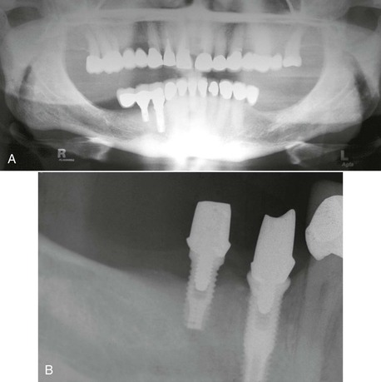
FIGURE 12-51 A, A distal cantilever from two premolar implants was used to replace a first molar. B, The cement seal broke, and the distal implant lost bone.
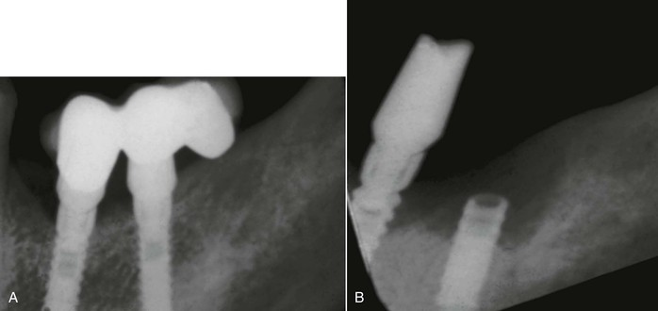
FIGURE 12-52 A, A periapical radiograph demonstrating two premolar implants used to support a distal cantilevered fixed partial denture (FPD) replacing a molar. B, The FPD became uncemented from the first premolar implant, and as a result, the second premolar implant fractured.
When a first molar is missing, a 5- to 6-mm-diameter implant is indicated in the mid mesiodistal position of the edentulous site when the molar is less than 12 mm wide (Figure 12-53). When a first molar implant is indicated in the maxilla, a sinus bone graft is most always required. The maxillary sinus expands rapidly after tooth loss. Hence, more often than not, the sinus floor should be altered and grafted in conjunction with a first molar implant insertion (Figure 12-54).
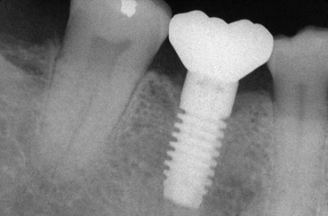
FIGURE 12-53 A 5- to 6-mm-diameter implant in the mid mesiodistal position is indicated to replace a first molar when it is less than 12 mm in width.
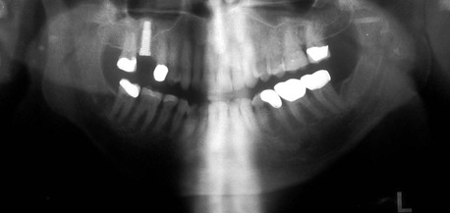
FIGURE 12-54 A sinus graft is most often required to place a first molar implant.
When two adjacent teeth are missing, including a first molar, the key implant positions include the terminal abutments, including the distal molar position (see Figure 12-20). When three posterior teeth are missing and include a first molar, a first molar implant is included. For example, in a patient missing the second premolar, first molar, and second molar, three key implant positions are required to restore the full contour of the missing molars teeth: the second premolar and second molar terminal abutments and the first molar pier abutment (Figure 12-55). A similar scenario is present when all four posterior teeth are missing—first premolar, second premolar, first molar, and second molar. The key implant positions are the terminal abutments (first premolar and second molar) and the first molar (Figure 12-56). In the maxilla, a sinus graft is most always indicated to replace these four adjacent teeth (Figure 12-57). When one implant replaces a molar (with a span of 10–13 mm), the implant should be at least 5 mm in diameter. When a smaller-diameter implant is selected in a molar space of 14 mm or more, the molar may be considered the size of two premolars, and two smaller-diameter implants may be selected.^{40,41}
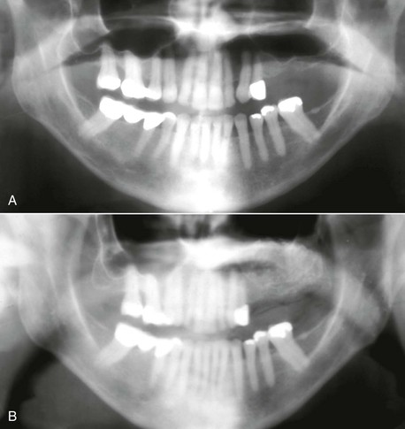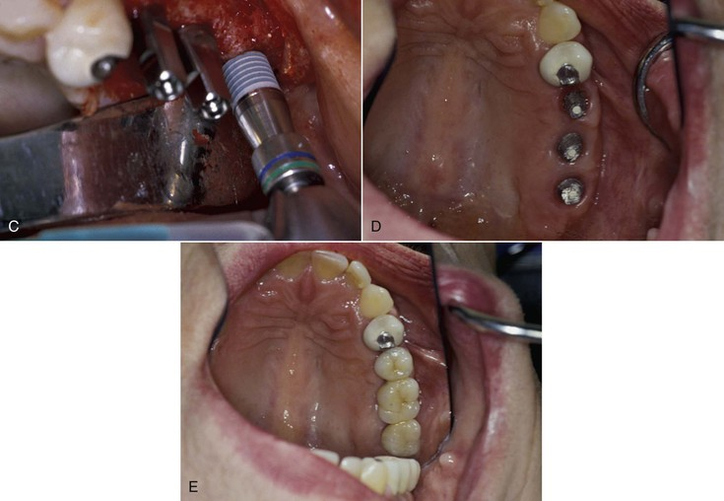
FIGURE 12-55 A, A panoramic radiograph of a patient missing the second premolar, first molar, and second molar. There is inadequate bone height because of the pneumatization of the maxillary sinus. B, A sinus graft restores the bone height to favorable limits. C, Three implants are inserted; the second premolar and the second terminal implants and a first molar implant. D, The three implants after integration. E, A three-unit fixed partial denture supported by three implants. Only the mesial half of the second molar is restored because there is no opposing mandibular second molar.
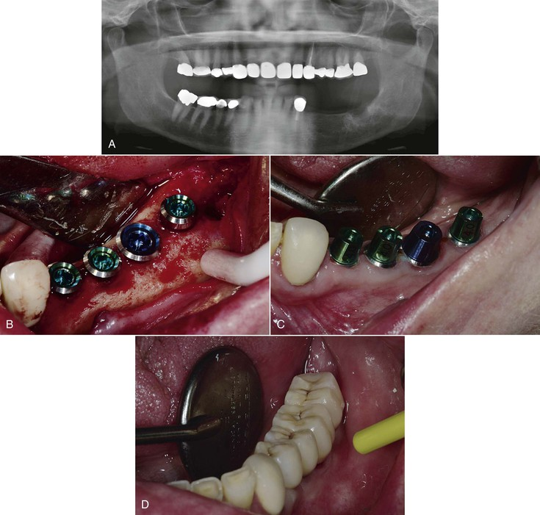
FIGURE 12-56 A, A panoramic radiograph of a patient missing mandibular first premolar to second molar. B, Four implants were used to restore the missing teeth. C, The key implant abutments are the first premolar and second molar (no cantilever) and the first molar. D, The four-unit fixed partial denture restores the missing teeth.
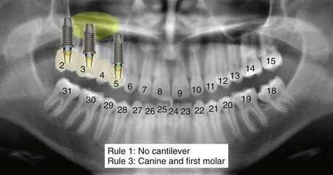
FIGURE 12-57 A panoramic radiograph replacing the first premolar to second molar. A sinus graft is most always required to place the molar implants.
It should be noted that when implants are inserted into existing bone volumes of the maxilla with a normal to large maxillary sinus, the third or fourth molar site (a tuberosity or pterygoid implant) and first (or second) premolar site are suggested in the literature, with pontics in the second premolar, first molar, and second molar site to avoid a sinus graft (Figure 12-58). This is not a biomechanically sound treatment option because of three adjacent pontics and no implant in the first molar position. One should wonder why so many dentists suggest third molar extractions, yet some implant dentists place third or fourth molar site implants. Why don’t these dentists orthodontically move the third molar tooth to the fourth molar site and fabricate a three-unit FPD if they desire a fourth molar abutment?
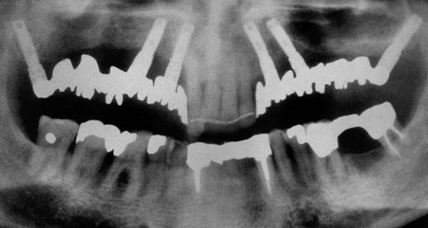
FIGURE 12-58 A tuberosity or pterygoid implant behind the maxillary sinus and an angled implant anterior to the sinus is suggested in the literature to support a fixed prosthesis without a sinus graft.
Four to six implants in the anterior maxilla have been suggested in the complete edentulous maxilla, with posterior cantilevers (Figure 12-59). Full-arch restorations for the edentulous maxillary arch should also have a first molar implant. In general, density of bone in the maxilla is less than the mandible in both the anterior and posterior regions. The anterior maxillary implants receive an angled load (compared with the anterior mandible) in both centric and mandibular excursions. The anterior maxillary arch usually has shorter implants than the anterior mandible because the vertical height of bone is less compared with the anterior mandible. The shorter implants have less surface area and higher stresses, especially in soft bone. Maxillary fixed restorations most often oppose an implant prosthesis (usually fixed) or natural teeth. This increases the force to the maxillary prosthesis. Therefore, the biomechanical risks associated with full-arch maxillary prostheses with a molar cantilever are greater than for mandibular restorations. A literature review of full-arch prostheses reports a three times higher implant failure rate in full-arch maxillary implant fixed restorations compared with mandibular full-arch implant restorations.⁴ Therefore, the treatment plan should be different for the two arches.
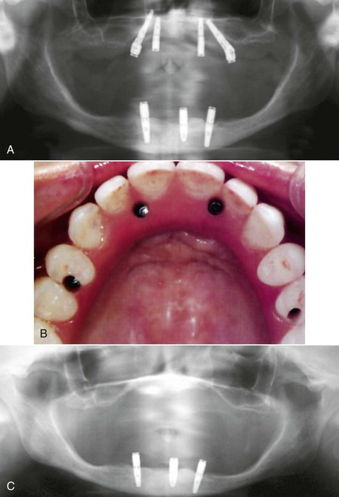
FIGURE 12-59 A, Four implants in an edentulous maxilla are suggested in the literature to support a fixed prosthesis. B, The fixed prosthesis supported by four anterior implants most often cantilevers the molars. In addition, there is also an offset cantilever to the facial in both the anterior and posterior regions. C, The failure rate of the maxillary implants usually causes additional bone loss. The maxilla may be unable to be restored without advanced bone grafts, more implants, and a new prosthesis.
The key implant positions for an edentulous maxilla are the distal of the first molars bilaterally, the bilateral canines, and an implant in one of the central incisor positions between the canines. This permits the five sections of an arch to be splinted together and take advantage of the biomechanics of an arch (Figure 12-60).
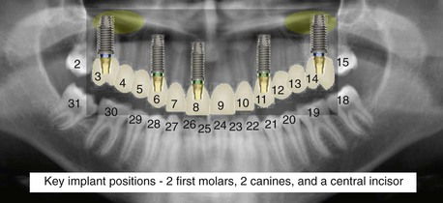
FIGURE 12-60 The key implant positions for an edentulous maxilla to support a fixed prosthesis (or RP-4 prosthesis) are the bilateral molars, the bilateral canines, and an implant in one of the central incisor positions.

Implant Number
In the past, the number of implants most often was determined in relation to the amount of available bone. This concept became popular in the mid 1980s when the Brånemark philosophy of osseointegrations was introduced for completely edentulous arches. In an edentulous arch, four to six anterior implants were used in available bone situations between the mental foramina in the mandible and anterior to the maxillary sinuses in the maxilla for a full-arch fixed prosthesis. The prosthesis cantilevered the molars from the anterior implant positions. Four implants were used in moderate to severe atrophic ridges for a fixed full-arch prosthesis.² This concept has been expanded to include zygomatic implants in the posterior regions, which engage the palate and the apical 4 mm of the zygomatic process (passing through the maxillary sinuses) (Figure 12-61). This treatment option does not consider the force magnifiers of CHS or the A-P distance (A-P spread) of the implants in relationship to the anterior cantilever replacing the anterior teeth. In addition, when four implants support a 12-unit fixed prosthesis, the position of the implants cannot follow the four key implant position rules and often have no implants in the canine positions and more than three pontics between the anterior implants or three pontics cantilevered from the most distal implants.
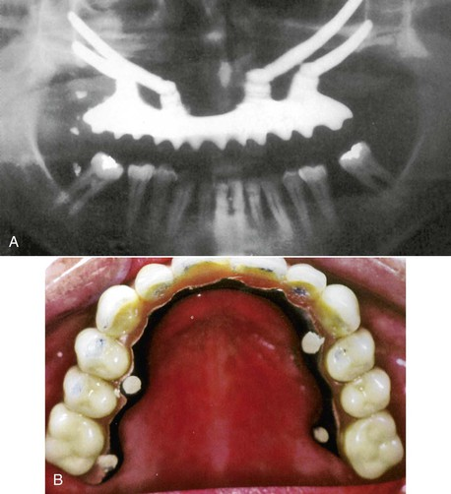
FIGURE 12-61 A, A panoramic radiograph of four zygomatic implants supporting a fixed prosthesis in the maxilla. B, The full-arch maxillary prosthesis is cantilevered to the facial, and there are six adjacent pontics in the anterior region, including a canine position.
In full-arch prostheses, studies comparing six implants to four- and three-implant abutments show better distribution and reduced stress on the six-implant system components (crown, cement, abutment, abutment screw, marginal bone, implant–bone interface, and implant components)⁴² (Figure 12-62). Silva et al.⁴⁰ evaluated with three-dimensional finite element analyses the difference in four versus six implants to support a full-arch cantilevered prosthesis.The cantilever length and crown height were similar in both models. The six-implant support model reduced the stress to the implant–bone regions between 7% to 29%, depending on the direction and position of the applied load.
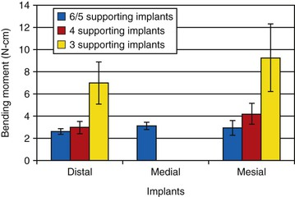
FIGURE 12-62 The more implants supporting a fixed prosthesis, the lower the bending movement and stress in the support system.⁴²
On occasion, four implants in the mandible between the foramen may be used to support a full-arch implant-supported prosthesis—fixed or RP-4. The implants are typically positioned in the first to second premolar positions and the canines. However, the other patient force factors should be low (e.g., no moderate to severe parafunction, crown height space less than 15 mm, older woman, and opposing a maxillary complete denture). In addition, the bone density should be favorable (D2). When all of these conditions are not present, consideration is given to the five key implant positions, and more implants are indicated when stress factors are moderate to severe.
When a full-arch fixed implant restoration is the treatment for a maxillary arch, the suggested number of implants by some authors is often the same as the mandible.² For example, “all on four” is a common treatment option presented to the profession in either arch along with similar fees for either arch to the patient⁴³ (Figure 12-63). Yet a literature review reveals the failure rate of the full-arch maxillary restoration is three times greater than the mandible.⁴ The hardness of the bone is related to its strength. The mandible more often has hard (strong) bone, and the maxilla more often has softer bone. In fact, the posterior maxillary bone may be five to 10 times weaker than the hard bone of the anterior mandible.⁴⁴ As a result, more implants should be used in the poorer-quality bone found in the maxilla. Increasing the implant number decreases the periimplant bone stress.⁴⁵
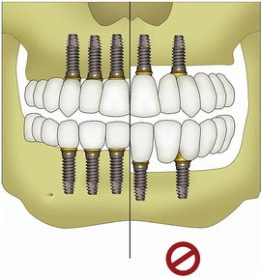
FIGURE 12-63 Full-arch implant fixed restoration by many authors uses the same number of implants in the maxilla and mandible. However, three times greater failure rates are observed in the maxillary arch.
The maxillary anterior arch receives a force at a 12- to 15-degree angle during occlusion and up to a 30-degree angle in excursions. A 15-degree angled force increases the force component on the implant by 25.9%, and a 30-degree force increases the force by 50%.³⁹ This is a biomechanical rationale for why maxillary anterior teeth are larger in size than the mandibular anterior teeth. Hence, the size or number of implants in the anterior maxilla should be greater than an anterior mandible.
The excursive forces in a maxillary restoration come from within the arch to push outside the arch. This force direction on the maxillary arch is more detrimental than in the mandible.⁴⁶ The mandible receives a force from outside of the arch toward the inside of the arch, which is the mechanism of force the Roman or gothic arch was designed to resist. As a result of these biomechanical issues, more implants should be used in maxillary compared with mandibular restorations. It is probably not a coincidence that there are more roots for the teeth in the maxillary arch compared with those in the mandibular arch.
The minimum number of implants used to support a restoration should include all of the key implant positions. Yet the number of implants in a treatment plan should rarely use a minimum number. There is no safety factor if an implant fails, the prosthesis becomes partially unretained, or the patient has a parafunctional episode. For example, if 25 patients receive four implants to support a fixed prosthesis, there would be 25 fixed prostheses and 100 implants in the report. This type of treatment planning may initially be less expensive for the patient, but an implant failure any time after implant surgery places the patient’s restoration at considerable risk. If each patient lost one implant with this implant number per prosthesis, the overall implant success would be 75%, but there would only remain three implants in each patient. As a result, all 25 fixed prostheses would be at risk of overload failure. If 20% of the implants fail (with one failure per patient), only five of the 25 patients would have four implants to support the restoration (only 20% of the patients would be restored with a fixed prosthesis)⁴⁵ (Table 12-1).
TABLE 12-1
Implants versus Prosthesis Success: Four Implants per Prosthesis for 25 Patients (100 Implants for 25 Prostheses)
Implant Number Success Rate | Prosthesis Number | Prosthesis Success Rate
100% | 25 | 100%
90% | 15 | 60%
80% | 5 | 20%
75% | 0 | 0%
If the 25 edentulous patients in this example have eight implants to support a full-arch, 12-unit fixed prosthesis, the risks of prosthesis failure is significantly reduced (Table 12-2). If each patient loses one implant, most likely all patients would still be able to function with their original prosthesis. Even if all 25 patients lost two implants, the 25 restorations may still function without risk (depending on the implant failure location). The additional implants also reduce the cantilever length and reduce the number of pontics in the prosthesis, providing more abutments for greater retention of the restoration, with reduced risk of screw loosening or uncemented prosthesis. As a general rule, it is better to err on the side of safety in numbers than on the side of too few implants. Therefore, when in doubt, add an additional implant to the treatment plan.
TABLE 12-2
Implants versus Prosthesis Success: Eight Implants per Prosthesis for 25 Patients (200 Implants for 25 Prostheses)
Implant Number Success Rate | Prosthesis Number | Success Rate
100% | 25 | 100%
87.5% | 25 | 100%
75% | 25 | 100%
Previous studies have shown that three abutments for a five-tooth span distribute stress more favorably than two abutments for the same span.⁴⁷ The one additional implant may decrease the implant reaction force by two times and reduce metal flexure fivefold. In addition, in the three-abutment scenario, moment forces are reduced. Comparative evaluations of implant number and size have also been made for stress distribution for three-unit fixed prostheses.⁴⁸ Increasing the implant number decreased the force to the implant–bone stimulant, more than increasing the implant size.
The cost of the implant surgery and prosthesis should not be solely linked to the number of implants. When the risks are reduced, the treatment fee should be less than when the risks are greater. Therefore, the four-implant option for a full-arch prosthesis should often have a greater fee than the eight-implant option.

Influence of Patient Force Factors
The additional number of implants, after the key implant sites are established, are related to the patient force factors and the bone density.^{16,33,34,45} Five patient force factors determine the amount of stress transmitted to the prosthesis. They are:
1. Parafunction
a. Bruxism (severe, moderate, mild, absent; this is the most important stress factor)
b. Clenching (force magnitude may be as great as bruxism)
2. Masticatory muscle dynamics
a. Sex (men have greater force)
b. Age (younger patients have greater force and live longer)
c. Size (larger patients have greater force)
3. Crown height space
a. Double the crown height and double the force with any angled load or cantilever (mesial, distal, facial, or lingual)
4. Arch position
a. Anterior regions: low forces
b. Canine and premolar: medium forces
c. Posterior regions: high forces
5. Opposing dentition
a. Denture: lowest force
b. Natural teeth: intermediate force
c. Implant fixed prosthesis: higher forces
Not all patient force factors have the same risk. Each of these five patient force factors may have a scale of 1 to 10 (Box 12-5). When the values are added together for a particular patient, an additional implant is added to the key implant positions for every 10 units. For example, a severe bruxer (10 units) with severe masticatory dynamics (7 units) in a posterior mandible (5 units) and opposing natural teeth (2 units) should have two to three more implants than the basic key positions. Implant size may also be increased to decrease the risk factors. Hence, two implants of larger diameter or three regular-diameter implants would satisfy most situations.
Box 12-5
Force Factor Risks
10-Point Scale

1. Parafunction
A. Bruxism
1. Severe 10
2. Moderate 7
3. Mild 4
B. Clenching
1. Severe 9
2. Moderate 5
3. Mild 3
2. Crown height space
A. Excessive 7
3. Masticatory dynamics
A. Severe (male, large, young) 7
B. Mild 3
4. Arch position
A. Maxilla
1. Posterior 5
2. Anterior 3
B. Mandible
1. Posterior 5
2. Anterior 0
5. Opposing arch
A. Complete implants 4
B. Natural teeth 2
When four or more adjacent teeth are missing, the key implant positions are often not enough support for the implant restoration unless all patient force factors are all low (e.g., parafunction, masticatory dynamics, CHS, opposing dentition and the missing teeth are only in the anterior and premolar regions of the jaw). Therefore, when multiple adjacent teeth are missing most often additional implants (besides the key implants) are added to the treatment plan, especially in the maxilla (Figure 12-64).
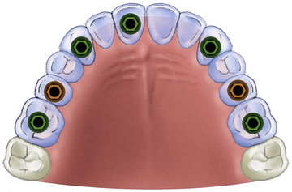
FIGURE 12-64 In an edentulous maxilla, the most common additional implant site is in the second premolar region. Hence, seven implants (or more) are most often used to support a fixed (or RP-4) prosthesis.
In conclusion, whenever the patient force factors are greater than usual, additional implants should be added to support the prosthesis. Of the patient force factors, severe bruxism is the most significant followed by clenching and CHS, region of the mouth, masticatory dynamics, and the opposing arch.

Influence of Bone Density
The additional number of implants after the key implant sites are established is also related to the density of bone.⁴⁹ The softest bone type (D4) has (1) the lowest strength and may be 10 times weaker than the most strong bone type on a scale of 1 to 10 for bone strength (D4 bone is a 1 or 2; (2) the greatest biomechanical mismatch with its modulus of elasticity compared with titanium; (3) the lowest bone–implant contact (~25%) and therefore higher stresses (Stress = Force/Area); and (4) strains in the bone are transmitted not only at the crest but also along the entire bone–implant surface.
The soft bone type (D3) has (1) a low bone strength, which is 50% weaker than hard bone (D2) (on a 10-point scale, its strength is a 3 to 4); (2) intermediate difference of modulus of elasticity compared with titanium; (3) low bone–implant contact (~50%); and (4) strain patterns at the crestal half of the implant.
The hard bone (D2) has (1) ideal strength (a 7 to 8 on a 10-point scale), (2) high bone–implant contact (~75%), (3) more stiff modulus of elasticity, and (4) strain patterns primarily at the crestal region of the implant. The hardest bone (D1) has the best biomechanical features of (1) strength (9 to 10 on a 10-point scale), (2) highest bone–implant contact (above 85%), (3) stiffest modulus of elasticity, and (4) strain values above the first thread.
As the bone quality is reduced, the number of implants to support the prosthesis should increase. The risk factor scale for bone density is inversely related to the strength of the bone scale. Hence, D4 bone is a 10, D3 bone is an 8, D2 bone is a 4, and D1 bone is a 2. When the implants are inserted into D4 bone, a larger-diameter or another implant is suggested, depending on the number of teeth replaced. Hence, a full-arch fixed restoration in the mandible with D2 bone may often have five implants, but in D4 bone, nine implants may be appropriate. Therefore, the total number of implants is related to the key implant positions plus the influence of the patient force factors and the quality of bone.
One of the most efficient methods to increase surface area and decrease stress is to increase the implant number.¹⁶ For example, when four adjacent teeth are missing from canine to first molar, the two implant key positions as terminal abutments for a four-unit implant prosthesis in the canine and first molar site represent inadequate implant support unless patient force factors are low, bone density is ideal, and implant size is not compromised. In most situations, three implants to replace four missing teeth is a more ideal implant number. When force factors are high and bone density is poor (i.e., posterior maxilla), four implants to replace four teeth is often appropriate.
In conclusion, the decision for the number of implants in the treatment plan begins with the implants in the ideal key positions. Additional numbers are most often required and are primarily related to the patient force factors or to bone density in the edentulous sites. For example, a young, large man who bruxes severely with greater than normal CHS in the posterior regions of the mouth opposing an implant restoration will require one implant for each missing root (two implants for each molar). Likewise, patients with moderate force factors and poor bone density (D4 bone) in the implant sites may also require this many implants.

Maximum Implant Number
In most situations, an implant should be positioned at least 1.5 mm from an adjacent natural tooth and 3 mm from an adjacent implant.^{21,22} Using these guidelines, each 4-mm diameter implant requires 7 mm of mesiodistal space (see Figure 12-7). Therefore, the maximum number of implants between adjacent teeth can be calculated by taking the crest module of an implant (e.g., 4.0 mm) and adding these dimensions. For example, an edentulous span of 21 mm is required for three adjacent implants 4 mm in diameter and 28 mm for four adjacent implants between two teeth. A space of 21 to 27 mm would have three implants. Commonly, implant-supported crowns in the posterior regions of the mouth are the size of premolars. This concept often permits the placement of two implants to replace an intratooth molar when the span is at least 14 mm (for 4-mm-diameter implants). When the missing molar is the most distal in the arch, a 12.5-mm span is required for two 4-mm-diameter implants (3 mm between each implant and 1.5 mm from the anterior tooth) because the 1.5-mm distance from the last tooth is no longer required.
There are several advantages of a 7- to 8-mm-wide premolar compared with a molar-size crown of 10 to 12 mm: (1) more implants may be used to restore the missing teeth; (2) implants may range from 4 to 5 mm in diameter, which are the most common sizes, and often the available bone has adequate buccolingual bone dimension in this region; and (3) the emergence of the premolar size crown contours on implants of this dimension more easily permit sulcular probing and hygiene.⁵⁰

Full-Arch Mandibular Fixed Prosthesis
As a general observation, the number of implants to replace all of the mandibular teeth ranges from five to nine, with at least four between the mental foraminae.^{24,51} When the implants are limited to sites anterior to the mental foraminae to support a fixed prosthesis, a cantilever must be designed. Cantilevers in the mandible should ideally be projected in only one posterior quadrant to increase the A-P distance and reduce the force to the implants (Figure 12-65). Therefore, whenever possible, at least one implant should be positioned in a first molar site.²⁶ When implants are positioned in four of the five open pentagon positions in the mandible, a cantilever is at a reduced risk of overload because of favorable dynamics of an arch, increased A-P distance, and usually a more favorable bone density. When seven or more implants are used in the edentulous mandible with bilateral molar implants, two separate restorations may be fabricated with no posterior cantilever to permit mandibular flexure and torsion.⁴⁸ Usually, the second molar is not replaced in the edentulous mandible.
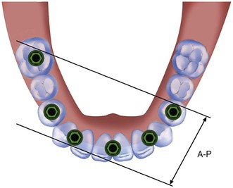
FIGURE 12-65 The anteroposterior (A-P) spread of implants is determined by drawing a line from the distal of the last implant on each side and a parallel line through the middle of the most anterior implant. When only one cantilever is used on the prosthesis, the A-P distance is large.

Full-Arch Maxillary Fixed Prostheses
The edentulous maxillary fixed prosthesis should usually not have a cantilever. The first seven ideal sites are often the bilateral first molars, bilateral second premolars, bilateral canines, and one implant between the canine positions⁴⁶ (see Figure 12-64). These positions satisfy the key implant positions and add an implant in the posterior region because the bone density is often poor. Additional implants in the bilateral second molar sites are a benefit to increase the A-P distance of the implants, which counters the anterior bite forces that may be increased from parafunction and so on (Figure 12-66). A greater number of implants are generally required in the maxilla to compensate for the less dense bone and more unfavorable biomechanics of the premaxilla and range from seven to 10 implants with at least three implants from canine to canine (Figure 12-67).
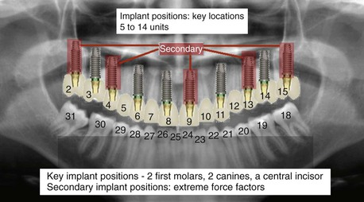
FIGURE 12-66 In the maxillary arch, secondary implants may be positioned to decrease the stress in soft bone or in patients with high force factors.
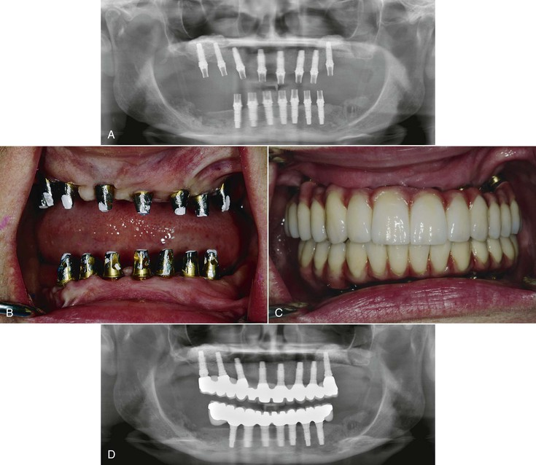
FIGURE 12-67 A, A panoramic radiograph of a maxillary bilateral sinus graft and maxillary and mandibular iliac crest bone grafts. Eight implants were used in the maxilla and seven implants in the mandible. B, An intraoral view of the maxillary and mandibular implants. C, FP-3 fixed restorations in situ. D, A panoramic radiograph of the implants and fixed restorations.

Splinted versus Independent Implant Crowns

Independent Crowns
The primary advantages for independent crowns are related to biological complications on natural teeth. A single crown has a caries risk of less than 1% within 10 years. However, when natural teeth are splinted together, decay at the interproximal margin often occurs at a rate of more than 20%.^{12,13} In addition, the endodontic risk is increased when crowns are splinted. Whereas a single crown has an endodontic risk of 3% to 5.6%, splinted teeth have an endodontic risk of 18%. Therefore, independent units reduce the incidence of complications and allow the practitioner to more readily treat these complications. However, implants do not decay or need endodontic therapy. As a result, independent units on implants would not be required to address these complications.
The primary perceived advantage of restoring implants as independent units is interproximal hygiene. When natural teeth crowns are splinted, interproximal aids are different to use. This is because the roots of the teeth are often less than mm apart. However, unlike natural teeth, which are often to 1 mm apart at the cervical region, the adjacent implants are usually 3 mm or more apart. Most interproximal aids (e.g., floss threader, proxy brush) can easily reach and clean an intraimplant region (Figure 12-68). Unfortunately, fewer than 8% of our patients floss daily, and an even lower percent use any interproximal aid when their natural teeth are splinted together.⁵² Because more than 90% of our patients do not floss and those that do can more easily use an interproximal device between implants, the perceived advantage of improved hygiene is not a relative concept for implant prostheses. In addition, implants do not decay and are less prone to bone loss from bacterial plaque than natural teeth.
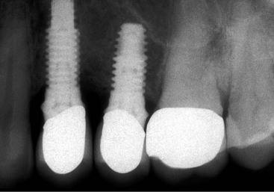
FIGURE 12-68 A perceived advantage of individual implant crowns is interproximal hygiene. However, because implant crowns are 3 mm or more apart, any hygiene aid has easy access.
A secondary advantage of separate dental units is the ability to replace a single unit to repair porcelain fracture. However, when dental implants are splinted together, the crown marginal ridges between the implants are supported by metal connectors; therefore, the porcelain is placed under compressive forces. As independent units, the margins of porcelain-to-metal crowns are most often placed over unsupported porcelain with shear loads, which increases the risk of porcelain fracture.
Another perceived reason for independent implant crowns is the complication found when the laboratory work is made on analogs and the casting splints the implants. When the laboratory-fabricated or -prepared implant abutments are placed in the mouth and the splinted casting delivered, the prosthesis often does not fit.⁵³ As individual units, the interproximal contacts can be modified to seat the individual crowns. The cause of casting misfit is related to impression material shrinkage, stone expansion, and analog variance of the abutment or implant body. This complication is corrected when the abutments are inserted into the implant bodies before the final impression and never removed. Instead of working on analogs, the laboratory works on stone dies, similar to natural teeth. There is no analog variance with this technique, and the stone expansion and die spacer coated on the stone dies permit a casting to seat passively on the implant abutments.
Another perceived advantage of independent implant units is if one implant fails, the doctor only has to replace one implant and crown. However, the implant failure often causes bone loss, which then requires bone augmentation, implant reinsertion, and crown refabrication. These procedures are usually more difficult to perform around existing teeth and implants than the original implants. This is especially true when the soft tissue is affected by the failure and must be returned to a normal appearance (Box 12-6).
Box 12-6
Perceived Advantages of Individual Crowns
1. Reduce biological complications (natural teeth)
a. Decay
b. Endodontics
2. Interproximal hygiene
a. Teeth to 1 mm apart
b. Implants 3 mm apart
3. Replace a single unit of prosthetic complications
a. Porcelain fracture (more likely to fracture)
4. Analog variance of components with dental laboratory–assisted prosthetics
5. Replace single unit if implant failure
a. Failure rate higher
b. Often must bone graft before reimplantation

Splinted Crowns
There are many advantages to splinting implants together. To maximally benefit from an increased number of implants, the implants should be splinted together. Splinted implants (1) increase the functional surface area of support, (2) increase the A-P distance (A-P spread) to resist lateral loads, (3) increase cement retention of the prosthesis, (4) ease to remove the prosthesis for abutment screw loosening, (5) decrease the risk of marginal bone loss,³⁹ (6) decrease the risk of porcelain fracture, (7) decrease the risk of abutment screw loosening, (8) decrease the risk of implant component fracture, and (9) make the complications of implant failure easier to treat. In other words, the entire system benefits.¹⁰
1. Splinted implants increase the functional surface area to the support system. When implants are independent, they cannot share the occlusal load from one implant to another.⁵⁴ As a consequence, with splinted implant crowns, the risks associated with the biomechanical overload to the implant system are reduced (occlusal porcelain, cement, or screw, which retains the prostheses, marginal bone, implant–bone interface, and implant components). If a maxillary second molar implant is connected to a maxillary first molar implant, it can share an occlusal load to the first molar even when the second molar has no direct occlusal load (Figure 12-69). As a consequence of splinting, implant survival may be greater. For example, Quiryman et al.⁵⁵ reported success rates of 90% for single implants, 97% for two splinted implants, and 98% for three splinted implants.
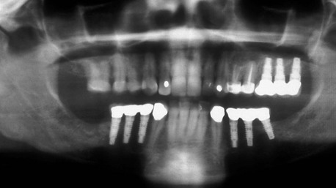
FIGURE 12-69 A maxillary fixed partial denture with three splinted implant crowns. The distal crown has no occlusal contact, but the occlusal load to the implant is distributed from the adjacent crowns.
2. An A-P distance between two or more implants is a benefit for any angled load or cantilever, especially when three or more implants are not in a straight line⁵⁶ (Figure 12-70). The biomechanics of an arch is of most benefit because there are five different planes connected together (bilateral molar, bilateral premolar, bilateral canines, and an anterior implant).⁵⁷ Rotational forces, angled forces, and cantilevers to the facial or lingual (offset loads) are all reduced when splinted implants are not in the same plane and receive a load compared with individual units.
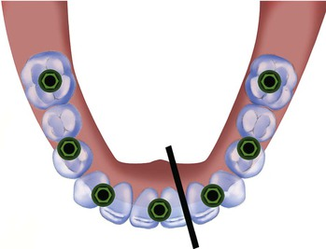
FIGURE 12-70 When three or more implants are splinted together, an anteroposterior spread is obtained, which improves the resistance to lateral loads.
3. Splinted dental units provide greater abutment surface area and resistance form, so the prosthesis has more retention. In addition, there is less force transferred to the cement interface. As a result, the restoration is less likely to become uncemented (Figure 12-71). This is especially significant when the abutments are short or lateral forces are present. Both cement retention and resistance are increased with splinted crowns. The prosthesis is less likely to become uncemented, so less hard cements may be used. This allows the restoration to be more easily removed when necessary.
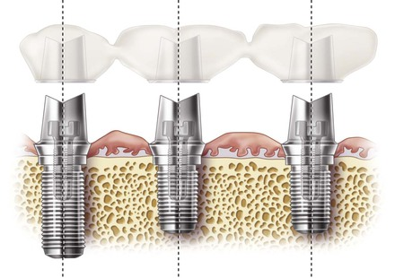
FIGURE 12-71 Splinted implant crowns have more abutment surface area, and improved retention and resistance form.
4. If a prosthesis does become partially retained or an abutment screw becomes loose, a splinted restoration is much easier to remove than individual units. The impact force to an individual crown that is mobile as a result of a loose abutment screw decreases the force to the cement seal, and it is difficult to remove the crown. In addition, attempting to engage a single crown margin is often difficult for the crown remover, especially when a subgingival margin is present. As a consequence, the crown may need to be cut off and destroyed to gain access to a loose abutment screw (Figure 12-72). Rather than attempting to engage a single crown margin, the crown remover needs to only engage the interproximal space of the prosthesis when crowns are splinted together (Figure 12-73).
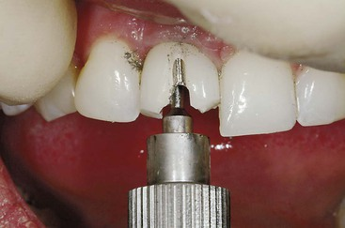
FIGURE 12-72 A loose abutment screw in an individual implant crown may need to be destroyed to gain access to the abutment screw.
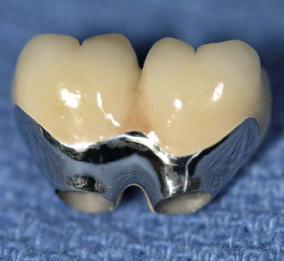
FIGURE 12-73 Splinted crowns may be removed with a crown remover more easily because it needs only to engage the interproximal regions, not the subgingival crown margin.
5. Splinted implants have less stress transmitted to the crestal marginal bone. Stress may be related to marginal bone loss around an implant. As a consequence, there is less risk of marginal bone loss (Figure 12-74).
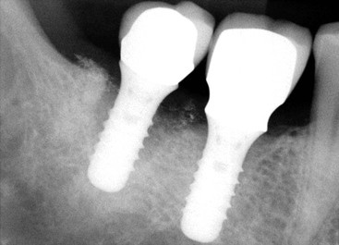
FIGURE 12-74 Individual implant crowns have more stress than splinted crowns, so crestal bone loss from occlusal overload is a greater risk.
6. Splinted crowns have less risk of porcelain fracture. The marginal ridges (and often buccal mandibular cusps) of implant crowns are usually unsupported by the metal work. As a consequence, the load on a marginal ridge is a shear load, with porcelain weakest to shear loads. In a report by Kinsel and Lin,⁶ porcelain fractures occurred in 35% of patients with implant crowns, especially when bruxing patients were restored in group functions (Figure 12-75). Splinted implant crowns have the metal connectors of the casting below the marginal ridges. Hence, the interproximal porcelain has a compressive force on the porcelain, and porcelain is strongest to compressive loads (Figure 12-76).
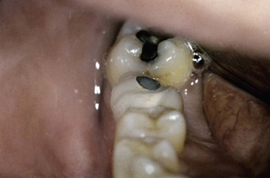
FIGURE 12-75 Individual implant crowns most often have unsupported porcelain on the marginal ridges and are more prone to fracture.
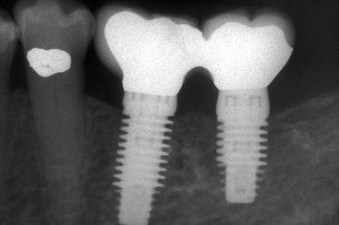
FIGURE 12-76 Splinted implant crowns have metal connectors under the marginal ridges between implants. Therefore, the marginal ridges of porcelain are supported.
7. Splinted implants reduce the risk of screw loosening. One of the highest prosthetic complications with single tooth or independent implant crowns is abutment screw loosening. In a review of the literature by Goodacre et al.,⁴ independent crowns had a screw loosening rate of 8%, with a range as high as 22%. In a report by Balshi and Wolfinger,⁴¹ single-tooth implants replacing a molar had 48% screw loosening over a 3-year period. When two implants were splinted together to replace a molar, the incidence of screw loosening was reduced to 8% over the same time period.
8. Splinted implants distribute less force to the implant bodies, which decreases the risk of implant body fracture. In a report by Sullivan and Siddiqui,⁵⁸ a 4-mm single implant replacing a molar had implant body fracture in 14% of the cases. In comparison, multiple implants splinted together report a 1% implant body fracture⁴ (Figure 12-77).
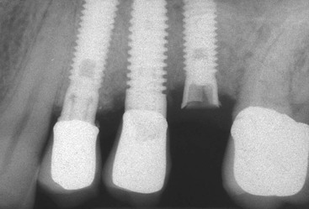
FIGURE 12-77 Individual implant crowns have greater strains during loading than splinted crowns and are more at risk of fracture.
9. If an independent implant fails over time, the implant may be removed, the site of bone grafted and the site reimplanted. This may require multiple surgeries over a 1-year period of time. In addition, a new crown must be fabricated. When multiple splinted implants have an implant that fails, the affected implant may often be removed and the implant crown converted to a pontic using the same prosthesis (Figure 12-78). As a result, rather than several surgical and prosthetic procedures over an extended period when independent units are restored, the problem may be solved in one relatively short appointment. As a consequence, of all the advantages of splinted implant crowns over individual units, the rule is to, whenever possible, keep natural teeth as independent units and, whenever possible, splint implant crowns together.
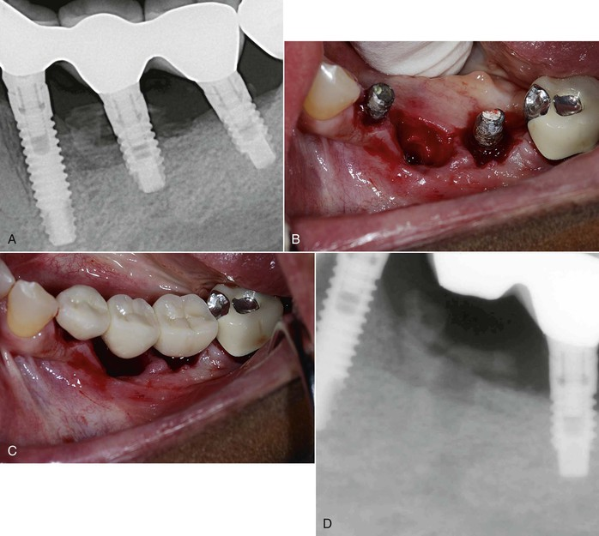
FIGURE 12-78 A, A periapical radiograph of a three-unit splinted crown had an implant with bone loss and exudate. B, The prosthesis was removed, and the center implant was extracted. C, The prosthesis was modified by filling the abutment and making it a pontic. D, A postoperative periapical radiograph of the three-unit fixed partial denture with improved periimplant health.
The exception to the splinted implant rule is a full-arch mandibular implant prosthesis. The body of the mandible flexes distal to the foramen upon opening and has torsion during heavy biting with potential clinical significance for full-arch implant prostheses.^{24,48} As a result, a full-arch mandibular implant prosthesis should not be splinted from molar to molar on the opposite sides. Therefore, full-arch mandibular restorations should have a cantilever or be made in two or three sections to accommodate the mandibular dynamics during function. The concept of flexure and torsion does not affect the maxilla, where all implants often are splinted together, regardless of their positions in the arch.

Summary
A biomechanical-based treatment plan reduces complications after implant loading with the prosthesis. To reduce stress conditions, there are key implant positions for a prosthesis replacing missing teeth in partially edentulous patients and full-arch maxillary prostheses: (1) no cantilevers should be ideally designed on the restoration, (2) three adjacent pontics should be eliminated, and (3) the canine and (4) first molar sites are important positions in an arch.
Increasing the number of implants is the most efficient method to increase surface area and reduce overall stress. Therefore, after the key implant positions are selected, additional implants are indicated to reduce the risks of overload from patient force factors or implant sites with reduced bone density. When in doubt of the number of implants required, an additional implant should be added. These implants, whenever possible, should be splinted together to further reduce the biomechanical complications.

References
1. Misch CE, Judy KWM. Classification of partially edentulous arches for implant dentistry. Int J Oral Implant. 1987;4(2):7–12.
2. Adell R, Lekholm U, Rockler B, et al. A 15 year study of osseointegrated implants in the treatment of the edentulous jaw. Int J Oral Surg. 1981;6:387–416.
3. Oikarinan K, Raustia AM, Hartilsainen M. General and local contraindications for endosseal implants: an epidemiological panoramic radiograph study in 65 year old subjects. Community Dent Oral Epidemiol. 1995;23(2):114–118.
4. Goodacre CJ, Bernal G, Rungcharassaeng K, et al. Clinical complications with implant and implant prostheses. J Prosthet Dent. 2003;90:121–132.
5. Misch CE. Consideration of biomechanical stress in treatment with dental implants. Dent Today. 2006;25:80–85.
6. Kinsel RP, Lin D. Retrospective analysis of porcelain failures of metal ceramic crowns and fixed partial dentures supported by 729 implants in 152 patients: patient specific and implant specific predictors of ceramic failure. J Prosthet Dent. 2009;101(6):388–394.
7. Misch CE, Suzuki JB, Misch-Dietsh FD, Bidez MW. A positive correlation between occlusal trauma and peri-implant bone loss: literature support. Implant Dent. 2005;14(2):108–116.
8. Misch CE. Risk factors and treatment fees for implant dentistry. Dent Today. 2010;29(8):58–63.
9. Misch CE. Stress treatment theorem for implant dentistry. Misch CE. Contemporary implant dentistry. ed 3. Elsevier Mosby: St Louis; 2008:68–91.
10. Goodacre CJ, Bernal G, Rungcharassaeng K, et al. Clinical complications in fixed prosthodontics. J Prosthet Dent. 2003;90:31–41.
11. Scurria MS, Bader JD, Shugars DA. Meta-analysis of fixed partial denture survival: prostheses and abutments. J Prosthet Dent. 1998;79:459–464.
12. Palmquist S, Swartz B. Artificial crowns and fixed partial dentures 18 to 23 years after placement. Int J Prosthodont. 1993;6:179–205.
13. Skalak R. Biomechanical considerations in osseointegrated prostheses. J Prosthet Dent. 1983;49:843.
14. Muhlemann HR, Sabdir LS, Rakeitshak KH. Tooth mobility: its cause and significance. J Periodontol. 1965;36:148–153.
15. Misch CE. Treatment plans related to key implant positions and implant number. Misch CE. Contemporary implant dentistry. ed 3. Elsevier Mosby: St Louis; 2008:147–159.
16. Bidez MW, Misch CE. Force transfer in implant dentistry: basic concepts and principles. J Oral Implantol. 1992;18(3):264–274.
17. Rangert B, Renouard F. Risk factors in implant dentistry. Quintessence: Chicago; 1999.
18. Pjetursson B, Tan K, Lang N, et al. A systematic review of the survival and complication rates of fixed partial dentures (FPDs) after an observation period of at least 5 years. Clin Oral Impl Res. 2004;15:625–642.
19. Dykema RW, Goodacre CJ, Phillips RW. Fundaments of fixed prosthetics. WB Saunders: St Louis; 1986.
20. McAlarney ME, Stavropoulos DN. Theoretical cantilever lengths versus clinical variables in fifty-five clinical cases. J Prosthet Dent. 2000;83:332–342.
21. Parel SM, Sullivan PY. Esthetics and osseointegration. DSI Publications: Chicago; 1990.
22. Tarnow DP, Cho SC, Wallace SS. The effect of interimplant distance on the height of interimplant bone crest. J Periodontol. 2000;71:546–569.
23. Gastaldo JF, Cury PR, Sendyk WR. Effect of the vertical and horizontal distances between adjacent implants and between a tooth and an implant on the incidence of interproximal papilla. J Periodontol. 2004;75:1242–1246.
24. Novaes AB Jr, Papalexiou V, Muglia V, et al. Influence of interimplant distance on gingival papilla formation and bone resorption: clinical-radiographic study in dogs. Int J Oral Maxillofac Implants. 2006;21:45–51.
25. Misch CE, Goodacre CJ, Finley JM, et al. Consensus Conference Panel Report: Crown-height space guidelines for implant dentistry. Implant Dent. 2006;15(2):113–118.
26. Misch CE. The completely edentulous mandible: treatments plans for fixed restoration. Misch CE. Contemporary implant dentistry. ed 3. Elsevier Mosby: St Louis; 2008:314–326.
27. Abdel-Latif H, Hobkirk J, Kelleway J. Functional mandibular deformation in edentulous subjects treated with dental implants. Int J Prosthodont. 2000;13:513–519.
28. Rosenstiel SF, Land MF, Fujimoto J. Contemporary fixed prosthodontics. ed 4. Mosby: St Louis; 2006.
29. Shillinburg HT, Hobo S, Lowell D, et al. Treatment planning for the replacement of missing teeth. Shillinburg HI, Hobo S. Fundamentals of fixed prosthodontics. ed 3. Quintessence: Chicago; 1997.
30. Tylman SD. Theory and practice of crown and fixed partial prosthodontics. Mosby: St Louis; 1965.
31. Smyd ES. Mechanics of dental structures: guide to teaching dental engineering at undergraduate level. J Prosthet Dent. 1952;2:668–692.
32. Bidez MW, Lemons JE, Isenberg BR. Displacements of precious and nonprecious dental bridges utilizing endosseous implants as distal abutments. J Biomed Mater Res. 1986;20:785–797.
33. Misch CE. Treatment plans related to key implant positions: three adjacent pontic rule. Oral Health. 2007;August:16–21.
34. Misch CE, Silc JT. Key implant positions: treatment planning using the canine and first molar rules. Dent Today. 2009;28(8):66–70.
35. Misch CE. Treatment plans related to key implant locations. The canine and first molar position. Oral Health. 2008;August:43–48.
36. D’Amico A. The canine teeth: normal functional relation of the natural teeth of man. J S Calif Dent Assoc. 1958;26:1–7.
37. Williamson EH, Lundquist DO. Anterior guidance: its effect on electromyographic activity of the temporal and masseter muscles. J Prosthet Dent. 1983;49:816–823.
38. Dawson PE. Posterior occlusion. Dawson PE. Functional occlusion: from TMJ to smile design. Mosby/Elsevier: St Louis; 2007:207–232.
39. Misch CE, Bidez MW. Implant protected occlusion: a biomechanical rationale. Compend Contin Dent Educ. 1994;15:1330–1343.
40. Silva GC, Mondonca JA, Lopes LR, et al. Stress patterns on implants in prostheses supported by four or six implants: a three-dimensional finite element analysis. Int J Oral Maxillofac Implants. 2010;25:239–246.
41. Balshi TJ, Wolfinger GJ. Two-implant-supported single molar replacement: interdental space requirements and comparison to alternative options. Int J Periodontics Restorative Dent. 1997;17:426–435.
42. Duyck J, Van Doosterwyck H, Vandersloten J, et al. Magnitude and distribution of occlusal forces on oral implants supporting fixed prostheses: an in vivo study. Clin Oral Implants Res. 2000;2(11):465–475.
43. Maló P, Rangert B, Nobre M. All-on-4 immediate function concept with Brånemark implants for completely edentululous maxillae: a 1-year retrospective clinical study. Clin Implants Dent Relat Res. 2005;7:88–94.
44. Misch CE. Density of bone: effect on treatment plans, surgical approach, healing, and progressive bone loading. Int J Oral Implantol. 1990;6:23–31.
45. Misch CE. Maxillary arch implant considerations: fixed and overdenture prostheses. Misch CE. Contemporary implant dentistry. ed 3. Elsevier Mosby: St Louis; 2008:367–388.
46. Wang TM, Leu IJ, Wang J, et al. Effects of prosthesis materials and prosthesis splinting on peri-implant bone stress around implants in poor quality bone: a numeric analysis. Int J Oral Maxillofac Implants. 2002;17:231.
47. Allahyar G, Morgano SM. Finite element analysis of three designs of an implant-supported molar crown. J Prosthet Dent. 2004;5:434.
48. Bidez MW, Misch CE: The biomechanics of interimplant spacing. Proceedings of the 4th International Congress of Implant and Biomaterials in Stomatology, Charleston, SC, May 24-25, 1990.
49. Misch CE. Key implant position and implant number: biomechanical rationale. Jakstad A. Osseointegration and dental implants. Wiley-Blackwell: Toronto, Canada,; 2009:32.
50. Misch CE. Bone density: a key determinant for treatment planning. Misch CE. Contemporary implant dentistry. ed 3. Elsevier Mosby: St Louis; 2008:130–146.
51. Misch CE. The implant quality scale: a clinical assessment of the health–disease continuum. Oral Health. 1998;88(7):15–20.
52. Segelnick S. A survey of floss frequency, habit and technique in a hospital dental clinic and private periodontal practice. N Y State Dent J. 2004;70:28–33.
53. Guichet DL, Yoshinobu D, Caputo AA. Effects of splinting and interproximal contact tightness on load transfer by implant restorations. J Prosthet Dent. 2002;87:528.
54. Yilmaz B, Seidt JD, McGlumphy ED, Clelland NL. Comparison of strains for splinted and nonsplinted screw-retained prostheses on short implants. Int J Oral Maxillofac Implants. 2011;26:1176–1182.
55. Quiryman M, Naert Z, van Steenberghe D, et al. A study on 589 consecutive implants supporting complete fixed prosthesis. J Prosthet Dent. 1992;8:655–663.
56. Rangert B, Jemt T, Jorneus L. Forces and moments on Brånemark implants. Int J Oral Maxillofac Implants. 1998;4:241.
57. Hobkirk JA, Havthoulas TK. The influence of mandibular deformation, implant numbers, and loading position on detected forces in abutments supporting fixed implant superstructures. J Prosthet Dent. 1998;80:169–174.
58. Sullivan D, Siddiqui A. Wide-diameter implants: overcoming problems. Dent Today. 1994;13:50–57.

