Chapter 34

Maintenance of Dental Implants
Jon B. Suzuki, Lynn D. Terracciano-Mortilla, Carl E. Misch
Implant dentistry has evolved into an evidence-based, clinical science with well-documented research to validate previously unsupported clinical practice procedures. Significant efforts that focus on the biology and biomechanics of implant dentistry helped develop and refine clinical techniques based on peer-reviewed findings. The evolution of research and understanding of biological concepts in implant dentistry has caused many areas of conflict and controversy. Innovative theories developed and techniques changed. In addition, sciences have spurred implant dentistry to new pinnacles of success.
The tremendous expansion of knowledge in this field has created new ideas and terminology that is redefined based on new principles.¹ In many instances, new research may contradict established paradigms. It may be confusing for clinicians to select correct protocols, procedures, instruments, and techniques. As materials and technique are further investigated, dogma may undergo criticism and controversy. Seasoned clinicians consistently update and modify techniques and instruments to maintain clinical excellence as technology and research advance.
One area of expansion of knowledge and conflict of views relates to the maintenance of dental implants. Early research explored techniques and instruments that were current for the methods and materials of that time. Although many of those implants still exist and are functional in patients, research and advances in technology have given us newer materials and advances in implant design and structure, minimizing previous challenges from a maintenance perspective.
An understanding of the mucoepithelial implant attachment is essential before commencing maintenance procedures. Controversies and parameters for probing and crestal bone loss are important for clinicians to recognize. There are anatomical and histologic differences between the attachment apparatus of teeth compared with implant osseointegration. The bacterial plaque biofilm challenges on these implant–tissue attachments may be significant to clinical success. This chapter explores the success and failure of implants and discusses the biological and engineering parameters that need to be considered when evaluating implants and periimplant tissues.
When the clinician understands the parameters of implants and teeth, specific maintenance plans may be established for the patient. Clinicians should inform patients of expectations and outcomes during treatment and demonstrate oral hygiene options appropriate during each stage. Patients need to recognize the importance of maintenance before the decision is made to commence implant therapy.² The ability of the patient to understand financial, time, and maintenance obligations is critical and should be made clear to the patient initially and during subsequent appointments. In addition to educating patients, clinicians should assess compliance to home care routines. Patients also should be competent to perform home maintenance procedures.³ As the acceptance and demand for dental implants increase, the need to understand the importance of maintenance as it relates to long-term implant success also increases.³ The role of the dental hygienist in implant maintenance and care is also increasing and becoming more defined³ (Box 34-1).
Box 34-1
The Role of the Dental Hygienist in Implant Maintenance
• Identify potential implant patients
• Education and motivation throughout treatment
• Development, continual assessment, and modification of patient-specific oral hygiene procedures
• Evaluation of prosthesis (components, attachments, mobility, and retention)
• Evaluation of periimplant tissue
• Probing
• Exposing clinically acceptable radiographs
• Removal of biofilms, soft and hard accretions
• Recommendation of oral hygiene implements
• Determine a patient-specific recall interval
• Co-therapist to identify potential problems and complications
• Documentation of implant(s) status
Implants and associated prostheses are different from natural teeth and may require adjunctive procedures and instruments for professional and patient care.⁴ Instruments must be effective at removing biofilms and accretions, and procedures performed by patients and clinicians should avoid damage to all components of the implant, abutment, restoration, and tissues.⁵ Establishment and maintenance of the soft tissue seal around the transmucosal portion of the implant enhances the success of an implant. This barrier is fundamentally a result of appropriate wound healing and connection of epithelial attachments. The maintenance of healthy periimplant tissues may contribute to implant success. In addition, tissues free of inflammation and a biofilm-free implant sulcus will support the patient's general and oral health.

Plaque Biofilm and Dental Implants
The differences between teeth and implants suggest that dental implants may increase susceptibility to inflammation and bone loss in the presence of bacterial plaque biofilm accumulation.⁶ Plaque biofilm and inflammation are established etiologic factors of periodontal disease. Sticky masses of bacteria with a polysaccharide matrix colonize on hard and soft surfaces in the oral cavity but can be disrupted and removed with mechanical debridement or chemical inactivation. If undisturbed, plaque biofilm matures. Current chemotherapeutics do not penetrate thick biofilm.
Rough implant surfaces have been reported to retain more biofilm than smooth surfaces,⁷ yet the rough surfaces result in greater bone–implant contact and are therefore favorable below the bone. Biofilm migrates and transitions from teeth to implants and from implant to implant.⁸ Similar to teeth, clinical findings of failing implants include inflammation, pockets, and progressive bone loss.⁹ Similarities of bacteria responsible for periodontitis, periimplant mucositis, and periimplantitis are now recognized.
When evaluating the periimplant microbiota, Lee et al. compared microbial changes between patients with a history of periodontal or periimplant infections and implants that have been in function for a period of time.¹⁰ This study reported that patients with a history of periodontitis had a greater impact on enhancing periimplant microbiota than implant loading time. One of the major influences on periimplant microbiota may be the presence of specific microbiota on remaining teeth. Although all implants were successfully osseointegrated, Porphyromonas gingivalis and Tannerella forsythia, red complex periodontal pathogens may colonize contiguous implants. Thus, it is important to emphasize to patients about their responsibility to control plaque biofilm consistently and effectively, especially if the patient has a history of periodontal disease.
Plaque biofilm development and maturation have similarities for natural teeth and dental implants. The gingival sulcus in periodontal health and the permucosal attachment of a successful dental implant are similar.⁷ In a study of biofilm from 18 edentulous patients with successful dental implants, facultative anaerobic cocci (52.8%) and facultative anaerobic rods (17.4%) were reported.¹¹ However, the pathogens P. gingivalis and spirochetes were absent, and minimal gram-negative rods (7.3%) were present.
Generally, pellicle, a naturally occurring glycoprotein in the saliva, first adheres to intraoral structures, including both teeth and implants. Gram-positive cocci bacteria are the first, “early colonizers” beginning with single cocci and progressing to streptococci forms (Box 34-2). Without adequate oral hygiene measures (i.e., brushing, flossing, and interdental cleaning), additional bacteria colonies, including gram-negative, rod-shaped bacteria, synergistically grow with the established gram-positive bacteria. The gram-negative bacteria are frequently facultative or strict anaerobic bacteria and are considered “late colonizers.” Many, if not the majority, of these gram-negative bacteria are black pigmented and are classified under a number of genera (e.g., Bacteroides, Prevotella, Porphyromonas, Fusobacterium spp.).
Box 34-2
Plaque Biofilm Development and Colonization
Acquired pellicle formation
↓
Bacterial adhesion
↓ ↓
Supragingival plaque biofilm colonization
Gram-positive streptococci, Actinomyces spp.
↓ ↓ ↓
Plaque biofilm maturation (gram-negative rods and filaments)
↓ ↓ ↓ ↓ ↓
Well-differentiated subgingival plaque biofilm (gram-negative anaerobes)
Periimplant mucositis is an inflammatory change of the soft tissue surrounding an implant. Periimplant mucositis around an implant is similar to gingivitis around a tooth. There is no loss of attachment for teeth with gingivitis, and there is no loss of bone for implants with periimplant mucositis. The primary etiology is plaque biofilm. Similar to gingivitis, periimplant mucositis is reversible when the plaque biofilm is removed.¹⁰ If allowed to progress, periimplantitis may result, which includes loss of bone and loss of osseointegration, similar to loss of attachment and bone with periodontitis.
Periimplantitis exhibits similar microbial flora as adult periodontitis.¹² Changes involve both the hard and soft tissues surrounding an implant. The implant may exhibit all the signs of periimplant mucositis as well as exudate, increased pocket depth, and bone loss. If left untreated, significant bone loss, infection, and mobility could result, leading to the failure of an initially integrated implant.
Plaque biofilm reported to be associated with failing dental implants consists largely of gram-negative rods.¹³ Clinically, failing dental implants are characterized by soft tissue inflammation, increased probing depths, increased mobility, and periimplant radiolucency. Specific pathogens in implant pockets greater than 6 mm include Aggregatibacter (Actinobacillus) actinomycetemcomitans, Prevotella intermedia, and P. gingivalis in more than one third of the sites, as confirmed by DNA analysis.¹⁴
More specific studies on plaque biofilm around dental implants suggest similarities between periodontal diseases and failing implants,¹⁵ but differences have also been reported.^{16,17} Spirochetes were not detected in plaque samples from well-maintained and clinically healthy implants.¹⁵ Higher proportions of staphylococci (15.1%) were reported than generally found in gingivitis (0.06%) and periodontitis (1.2%) sites.¹⁸ This finding suggests that staphylococci may be more significant in developing periimplantitis lesions than previously recognized.
Comparisons of plaque biofilms have been reported in a limited study of Brånemark and ITI (Straumann Institute) implants and are remarkably similar in controlled studies. Ten patients with Brånemark implants and 10 patients with ITI implants were evaluated, and the deepest pockets around the implants were sampled.^{17,18} After 3 and 6 months, several periodontal pathogens were cultured and isolated, including P. gingivalis, P. intermedia, Fusobacterium nucleatum, and various spirochetes. None of the implants were colonized by A. actinomycetemcomitans. Longer investigations extended microflora reports on dental implants in 19 patients.¹⁸ At 3 years, the osseointegrated implants were colonized predominantly by P. gingivalis, P. intermedia, and A. actinomycetemcomitans.
Natural dentitions with dental implants appear to increase the risk for implant infections compared with completely edentulous patients. This suggests that natural teeth may serve as a reservoir for periodontal pathogens, which may promote their colonization and growth to contiguous implants in the same oral cavity.¹⁹ Quirynen and Listgarten reported that proportions of coccoid forms (65.8%), motile rods (2.3%), and spirochetes (2.1%) in implant pocket areas were similar to the microorganisms in natural teeth (55.6%, 4.9%, and 3.6%, respectively).²⁰ On the other hand, fully edentulous patients exhibited more coccoid forms (71.3%), fewer motile rods (0.4%), and no spirochetes. They concluded that microflora in partially edentulous implant patients were potentially more pathogenic than in fully edentulous patients. Implant longevity for greater than 3 and 4 years appears to have greater numbers of bacteria colonized than implants in place for 1 or 2 years.²¹

Probing Depths
Probing depths around teeth are an excellent approach to assess the past and present health of natural teeth. The increasing sulcus depth around natural teeth is related to disease and bone loss.²² However, probing depth indices used to evaluate dental implants are more controversial because relating implant sulcus depth to health is not always directly related.
For natural teeth, the surrounding soft tissue has an average biological width of 2.04 mm between the depth of the sulcus and the crest of the alveolar bone.²³ It should be noted the biological “width” is actually a height dimension with a greater range in the posterior region compared with the anterior and may be greater than 4 mm in height.²⁴ In teeth, it is composed of a connective tissue (CT) attachment (average, 1.07 mm) above the bone and a junctional epithelial attachment (JEA) (average, 0.97 mm) at the sulcus base, with the most consistent value between individuals being the CT attachment (Figure 34-1).
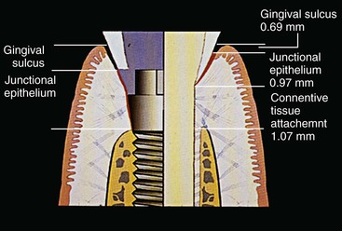
FIGURE 34-1 The natural tooth–tissue interface is usually composed of a sulcus, a junctional epithelial attachment, and a connective tissue attachment and is approximately 3 mm of tissue above the bone (right side of drawing). An implant has a sulcus and a junctional epithelial zone, and the tissue may be 2 mm to more than 8 mm above the bone (left side of drawing).
The sulcular regions around an implant and around a tooth are similar in many respects. The rete peg formation within the attached gingiva and the histologic lining of the gingiva within the sulcus are similar in implants and teeth.²⁵ A free gingival margin forms around a tooth or implant with nonkeratinized sulcular epithelium, and the epithelial cells at its base are also similar in teeth and implants, with junctional epithelial cells for both. However, a fundamental difference characterizes the base of the gingival complex around teeth. A tooth has two primary regions that make up of the biological width compared with one region in an implant (Figure 34-1).
When probing a tooth, the probe measures the sulcus depth, and may penetrate and measure the JEA.²⁶ The junctional epithelial “attachment” of a tooth is not a true attachment. A periodontal probe easily separates the hemidesmosomal close approximation of the epithelial cells. High-volume air from a syringe may dislodge the attachment. Plaque destroys this attachment. The placement of impression string in the sulcus displaces it. The mucopolysaccharide approximation of the hemidesmosome found in the junctional epithelium is not an attachment (Figure 34-2).
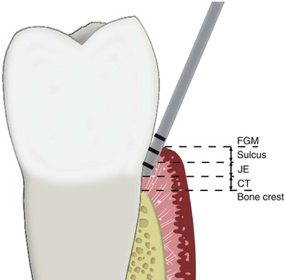
FIGURE 34-2 A dental probe will penetrate the sulcus and junctional epithelial attachment zone next to a tooth but not the connective tissue attachment zone. CT, Attached connective tissue; FGM, free gingival margin; JE, junctional epithelium.
The CT attachment zone of the “biological width” around a tooth prevents the probe from penetrating deeper into the sulcus and allows gingival fibers of the CT attachment zone to establish direct connection with the cementum of the natural tooth. This attachment acts as a physical barrier to the bacteria in the sulcus to the underlining periodontal tissues. Eleven different gingival fiber groups comprise the CT attachment zone observed around natural teeth and gingival tissues: dentogingival (coronal, horizontal, and apical), alveologingival, intercapillary, transgingival, circular, semicircular, dentoperiosteal, transseptal, periosteogingival, intercircular, and intergingival.²² At least six of these gingival fiber groups insert into the cementum of the natural tooth: the dentogingival (coronal, horizontal, and apical), dentoperiosteal, transseptal, circular, semicircular, and transgingival fibers. In addition, some crestal fibers from the periodontal fiber bundles insert into the cementum above the alveolar bone. These Sharpey fibers form a true attachment to the tooth, preventing a periodontal probe from invading the periodontal ligament (PDL) space and preventing or delaying the apical movement of plaque biofilm.
A systematic study has investigated the biological seal phenomenon of the soft tissue around dental implants.²⁵ Hemidesmosomes from the JEA region help contribute to a basal lamina–like structure on the implant, which can act as a biological seal.²⁷ However, collagenous components of the linear body cannot physiologically adhere to or become embedded into the implant body.²⁸ The hemidesmosomal seal has a circumferential band of gingival tissue to provide mechanical support against tearing.²⁹ However, the mucopolysaccharide layer is less adherent to an implant surface than natural teeth. The hemidesmosome of natural teeth has a lamina lucida and a lamina densa. The hemidesmosome next to an implant has a lumina lucia, lamina densa, and sublamina lucida (which is less adherent).³⁰
According to Cochran et al., the biological width for implants is 3.3 mm,³¹ but unlike the biological width dimension for teeth, sulcus depth was included. In an implant gingival region, two of the gingival fiber groups are located around a tooth (circular and periosteogingival fibers), and no periodontal fibers are present.³² These fibers do not insert into the implant body below the abutment margin as they do into the cementum of natural teeth. Instead, the collagen fibers around an implant run parallel to the implant surface, not perpendicular as with natural teeth. Hence, the implant only has a junctional epithelial “attachment” system.
The gingival and periosteal fiber groups are responsible for the CT attachment component of the biological width around teeth. These fiber groups are not present around the transosteal region of an implant. The “biological width” around the abutment–implant connection is not analogous to the CT attachment of teeth. The biological seal around dental implants can prevent or minimize the colonization of bacteria and endotoxins into the underlying bone. However, the seal does not constitute an attachment component of the biological width similar to the one found with natural teeth.
A dental probe introduced into an implant sulcus may proceed past the junctional epithelial close approximation of the tissue, and the probe may proceed to the crestal bone (Figure 34-3). The CT zone for an implant has two fiber groups, and neither inserts into the implant. As a result, with an implant, the probe goes beyond the sulcus, through the JEA, and through the type III collagen CTs and extends closer to bone.²⁶ Because the probe penetrates deeper next to an implant compared with a tooth, dental clinicians have the potential to cross-contaminate the implant sulcus with bacteria from a diseased periodontal site during probing or scaling.
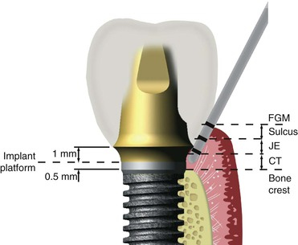
FIGURE 34-3 A probe next to an implant will penetrate the interface down to the bone. CT, Attached connective tissue; FGM, free gingival margin; JE, junctional epithelium.
The benefit of probing the implant sulcus has been challenged in the literature because sound scientific criteria for the rationale are lacking. The location of the probe tip subgingivally for a tooth depends on the pressure used, the presence of inflammation, and the angle at which the probe is introduced in the sulcus depth between the junctional epithelium and the root surface. The correct pressure recommended for probing is 20 g, yet conventional probing often exerts a force more than five times this level, and this varies greatly. Pressure-sensitive probes have been made available to address these issues but are rarely used in a clinical practice.³³ However, these pressures on probing issues are less important for probing next to an implant because the probe depth is limited by the bone, not a CT attachment.
The potential for damage to the fragile hemidesmosome attachment to the implant or marring of the implant surface exists during probing. In addition, reports in the literature suggest that the reproducibility of attachment level measurements may be questionable and independent from the instrument used to perform the measurements.^{34,35} Many of these variables are similar for dental implants. In addition, unlike natural teeth, fixed implant prostheses with subgingival margins of crowns often have wide emergence profiles, which make probe positioning difficult around selected implant bodies.
Unlike natural teeth, the implant sulcus depth may be a reflection of the original soft tissue thickness (i.e., biotype) of the area before implant placement. The posterior maxillary tissue can be thicker than 4 mm after tooth extraction and subsequent bone volume loss before implant placement. As a result, the tissue above the bone before implant insertion may be 4 mm thick or more. As a result of greater tissue thickness before surgery and greater probing depth compared with teeth, the probing depth next to a healthy implant may be greater than that of healthy natural teeth.
When the tissues have a thick biotype, gingivoplasty to reduce the flap thickness and pocket depth may be performed at the initial surgery. The advantage of the reduction in tissue thickness at this time is that the tissue heals and matures as the bone–implant interface develops. However, thinning the flap during the initial surgery may cause greater loading of the implant body during healing from an overlying soft tissue–borne temporary prosthesis. After initial bone healing, the stage II uncovery surgery also may correct tissue thickness.
The presence of deep pockets is not always accompanied by accelerated marginal bone loss.³⁶ Stable, rigid, fixed implants were reported with pocket depths ranging from 2 to 6 mm. Healthy, partially edentulous implant patients consistently exhibit greater probing depths around implants than around teeth. An increasing probing depth next to an implant is a more significant sign than a probing depth unrelated to a time interval because it generally reflects bone loss except in cases of gingival hyperplasia or hypertrophy. Probing using fixed reference points on the abutment or crown margin allows evaluation of crestal bone loss versus tissue hypertrophy.
Despite the limitations, charting the attachment level in implant permucosal areas does aid the dentist in monitoring these regions. As the sulcus depth increases, the oxygen tension decreases. The bacteria in an implant sulcus are similar to those of natural teeth.³⁷ A toothbrush and daily hygiene procedures cannot clean a sulcus greater than 2 mm.³⁸ Sulcus depths greater than 5 to 6 mm have a greater incidence of anaerobic bacteria.^{37,39} As a consequence, this sulcus depth often requires gingivectomy or bone revision surgery. As a general rule, to enable the patient to perform effective daily hygiene, the ideal implant sulcus should be maintained at less than 5 mm.
The monitoring of early crestal bone loss is most important during the first year of stress accommodation of the bone. Minor bone changes are clinically easier to observe with a periodontal probe than with radiographs. Early bone loss may occur on the facial aspect of the implant; radiographs only demonstrate the mesial and distal regions. Changes in crestal bone levels warrant close monitoring and early intervention. Patient education to reduce parafunctional stress on the implant system, the use of parafunctional appliances, and other stress-reducing methods are required when early crestal bone loss beyond the first thread is detected.
Despite the uncertain clinical implications of pocket depth increases, probing is an appropriate method to assess potential deleterious changes in the periimplant environment and should be performed every 3 to 4 months for 1 year after prosthesis delivery. After this time, if crestal bone levels are stable, probing is still relevant. Probing also reveals tissue consistency, bleeding, and exudate. Therefore, probing is important not only to measure increasing sulcus depths but also to allow the dentist to evaluate several periimplant parameters at the same time and at the same sites.
Clinical concern has been raised regarding selection of probes for implant evaluation. It has been argued that different metal types (e.g., stainless steel, titanium) should not come into contact because of a risk of metallic contamination of the two metals and the resulting galvanic corrosion that may develop and cause crestal bone loss. As a result of this concern, the suggestion has been made that only titanium surgical instruments be used to contact the implant and that only titanium or plastic instruments be used to probe or scale the implant (Figure 34-4).
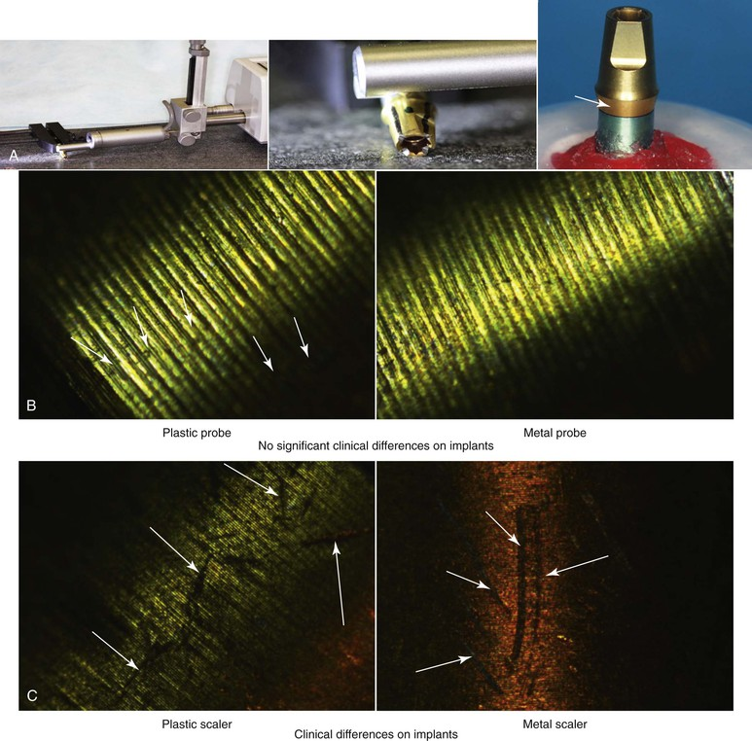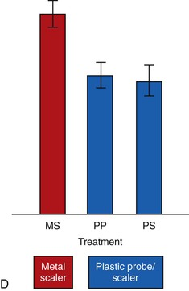
FIGURE 34-4 A, A study evaluated the effects of probing and scaling an implant abutment made of titanium alloy. (From Falkhravar B, Khocht A, Jefferies SR, Sazuki JB: Probing and scaling instrumentation on implant abutment surfaces: an in vitro study, Implant Dent 21: 311–316, 2012.) B, No significant difference in surface condition was found between plastic and metal probes. C, A clinical difference was observed with plastic versus metal scalers. D, Metal scalers (MS) altered the surface of the implant abutment; plastic probes (PP) and plastic scalers (PS) did not significantly alter the interface.
Touching the surface of the abutment subgingivally with a stainless steel instrument is not a clinical concern (Figure 34-5). However, scratching the surface may contribute to plaque biofilm colonization following the direction of the scratch (Figure 34-6). Plaque biofilm follows the direction of scratches on a titanium plate even though right angles and a maze pattern may be scratched onto the surface. Therefore, when probing almost to the bone level around the implant, clinicians should avoid scratching the surface because plaque that forms at the surface may follow the scratch subgingivally to the bone level. This is particularly important during scaling procedures or during the removal of cement below a crown margin. When possible, one should use semicircular strokes, parallel to the sulcus or crown margin, to scale the implant above the bone. If a scratch on the implant body occurs, plaque will not have a direct “highway” below the tissue.
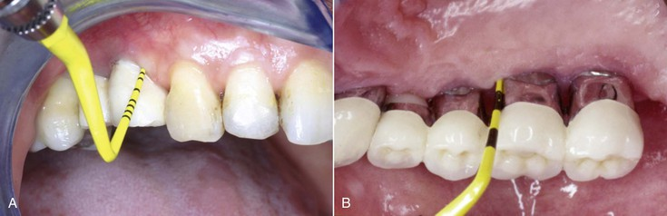
FIGURE 34-5 A plastic or metal probe may be used to assess probing depth next to an implant. Proper probing technique is shown using a resin-covered periodontal probe (Colorvue; Hu-Friedy, Chicago).
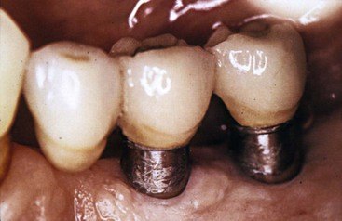
FIGURE 34-6 Scratching the implant surface may contribute to plaque biofilm colonization that follows the direction of the scratch.

Bleeding Index
Gingival bleeding when probing around teeth correlates with sulcular inflammation and the plaque index. Easily ulcerated sulcular epithelium represents inflammation from plaque biofilm and is the primary cause of bleeding upon probing. A bleeding index is an indicator of sulcus health. Bleeding also can be provoked by undue pressure on the probe.
Controversy surrounds the issue of using bleeding and gingival health as an implant health indicator.²⁷ Unlike a natural tooth, implant success in the first few years is related more often to biomechanical equilibrium than to gingival health. Compared with a natural tooth, soft tissue inflammation from bacteria may be more restricted to supracrestal bone because of the lack of a periodontal membrane or fibrous tissue between the implant and the bone interface. As a result, the bleeding index may not be an important factor when evaluating the early implant quality of health.
The correlation between gingival health and implant success appears in part to be related to the cervical surface condition of the implant. It has been stated with dental implants, there is no evidence that gingivitis is a precursor of progressive bone loss.⁴⁰ Gingivitis and deep sulcular pockets were not accompanied by accelerated bone loss.³⁶ Both of these reports evaluated a machined-surface titanium screw design (e.g., Nobel Biocare).
In contrast to the previous reports with machined-surface implants, correlations were reported between gingival sulcus depth and implant failure.⁴¹ The implant design evaluated in this report had an intramobile element with a larger implant body abutment crevice and a roughened, titanium plasma spray body (IMZ, Germany). A similar correlation between implant failure and gingival health status was observed when a porous titanium alloy microball surface was exposed above the bone (Endopore, Canada).^{42,43}
In addition to the surface condition of the implant, other studies show a correlation to gingival health and implant health.⁴⁴ One study identified elevated levels of proteolytic enzymes in an implant sulcus with inflammation and bleeding on probing as predictors of implant disease.⁴⁴ Other studies reported that plaque and gingivitis around implants were correlated.^{36,45} Another study concluded that the gingival bleeding index is correlated highly with plaque index and the crevicular fluid index.⁴⁶
The dentist already is encouraged to probe the sulcular region to evaluate crestal bone loss around the implant. Periodontal probing is less demanding and more commonly used than the determination of gingival sulcular fluid volume index. One may observe the bleeding index while probing for sulcus depth and therefore readily record it to evaluate gingival health (Figure 34-7).
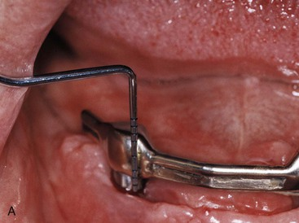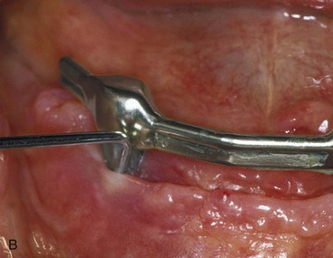
FIGURE 34-7 A, A dental probe may assess bleeding upon probing, which is a sign of mucoimplantitis or periimplantitis. B, A probing depth of several millimeters is present and indicates periimplantitis.
Regardless of whether gingival health is relative to implant success, all dentists agree that the ideal soft tissue condition around an implant includes an absence of inflammation. Radiographic bone loss and increased pocket depth have been correlated with sulcular bleeding.⁴⁶ Therefore, the gingival status around an implant should be recorded and used to monitor the patient's daily oral hygiene. However, surrounding soft tissues around implants have fewer blood vessels than around teeth. Therefore, inflammation is typically less often observed around implants than around teeth.^{28,31}
The most common bleeding gingival index adapted from teeth and applied to implants is the Loe and Silness Gingival Index.²² When used on teeth, this index scores gingival inflammation from 0 to 3 on the facial, lingual, and mesial surfaces of all teeth. The symptom of bleeding comprises a score of at least 2.
The gingival index scores may be adapted on implants to record gingival inflammation on the facial, lingual, and mesial surfaces. The facial and lingual are already probed to evaluate bone loss that cannot be seen on a radiograph. Because the bleeding index evaluates inflammation, the Loe and Silness Gingival Index is adequate for implants, and because fewer implants typically are used to restore a region compared with the presence of natural teeth, the clinician also may evaluate the distal surface when bleeding is present because the implants are more than 2 mm apart and access often is unobstructed.
When the sulcus depth is less than 5 mm and the bleeding index increases, use of chlorhexidine rinses and irrigation often is indicated along with other professional and home care methods. Sulcus depths in excess of 5 to 6 mm have a greater incidence of bleeding and may require gingivectomy or gingivoplasty surgery to modify an anaerobic environment.
During the first year of clinical examinations for periimplant tissues, the dentist should ideally record the color, form, and consistency of the gingival tissues. Also, bleeding on probing and probe depths should be determined for all sites. After 1 year of stable recording probing depths, the recordings may not necessarily be individually recorded at maintenance appointments. Instead, they may be correlated with radiographic observation for the mesial and distal surfaces. Removal of the prosthesis for more accurate probing and evaluation is not indicated unless warranted by signs of disease activity (e.g., bleeding upon probing, erythema). Repeated removal of a screw-retained fixed prosthesis causes wear of the screw attachment system and causes more frequent partially unretained restorations over the long term.

Crestal Bone Loss
The marginal bone around the implant crestal region is usually a significant indicator of implant health. Unlike natural teeth, the causes of crestal bone loss around the implant are multifactorial and may occur at different time periods: surgical bone loss, initial “biologic width” bone loss, early loading bone loss, intermediate-term bone loss, and long-term bone loss. Each time period may have a different cause for the bone loss. The early loading bone loss, intermediate-term, and long-term bone loss are most important to evaluate at implant maintenance appointments.
The level of the crestal bone is modified from the crestal position of the implant at the stage II uncovery surgery. After the implant is connected to a permucosal element, the marginal bone may be lost during the first month from (1) the position of the abutment–implant connection or (2) the crest module design of the implant. The abutment–implant connection will cause 0.5 to 1.0 mm of bone loss when it is at or below the bone. When the abutment is attached to the implant body, approximately 0.5 to 1 mm of CT forms apical to this connection. This bone loss may be caused by an “implant biologic width.” An implant originally placed 2 mm above the bone and another countersunk 2 mm below the bone have different initial bone loss histories after the abutment is attached to the implant.⁴⁷ Therefore, whenever possible, the implant should be inserted at or above the bone crest to avoid an increase in the sulcus depth around the implant related to the crestal bone loss after abutment placement.
In addition to the abutment–implant connection cause of bone loss, when smooth metal is below the abutment–implant connection and extends onto the neck of the implant, additional bone loss will occur in direct relation to the smooth metal region. The bone levels will most often reside at the first thread or at a roughened surface after the first month a permucosal element or abutment extends through the soft tissue³¹ (Figure 34-8).
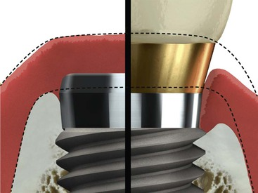
FIGURE 34-8 When the implant is covered with soft tissue, bone often resides at the crest of the implant (left). When the implant is uncovered and an abutment is added, the bone often recedes to the first thread of the implant body (right).
When the implant receives an occlusal load, crestal bone loss may occur beyond the first thread or rough surface of an implant⁴⁸ (Figure 34-9). The periodic hygiene appointments should evaluate and monitor crestal bone loss. If bone loss beyond the first thread or rough surface condition occurs, occlusal stress reduction is considered. This includes an occlusal adjustment and retainer (night guard) in a parafunctional clinical situation.
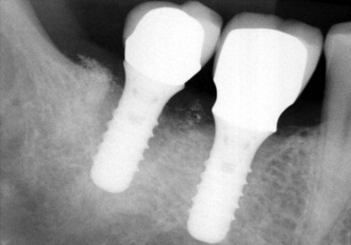
FIGURE 34-9 When the implant is occlusal loaded, the bone loss may extend beyond the first thread or rough surface of an implant.
The intermediate- and long-term bone loss around implants is most often periimplantitis. Daily hygiene procedures coupled with professional maintenance appointments are necessary to reduce this condition. Surgical correction is indicated when the oral environment is conducive to the bacteria-related loss of bone.

Patient Oral Hygiene
Reduction of supragingival plaque by removal with toothbrushes significantly reduces the amount and composition of subgingival microbiota around teeth. This reduction should translate to a decreased risk of periodontal disease initiation or recurrence. Furthermore, the decreased prevalence of periodontal pathogens in supragingival plaque lowers potential reservoirs of these species.⁴⁹
The absence of adequate keratinized mucosa in endosseous dental implants, especially in posterior implants, was associated with higher plaque accumulation and gingival inflammation but not with more annual bone loss regardless of the implant's surface configurations.⁵⁰ The implant type, with the presence or absence of keratinized tissue, may be a challenge for oral hygiene procedures for many patients. The clinician should stress the importance of adequately performing plaque control and select products and procedures that are well suited to the needs and ability of the patient.
Patients rely on clinicians to suggest or recommend products for oral hygiene procedures. As with most patients, the “tell, show, do” method of home care instruction is important. Documentation in the patient record regarding recommendations and instructions as well as the patient's compliance and effectiveness are important to evaluate their relationship to long-term success for each patient.^{51,52} When choosing and recommending implements for oral hygiene, the clinician should take into consideration the location, length and angulation of abutments, superstructure design, anatomical limitations, patient habits, motivation, and manual dexterity of each patient.⁵³
Contributing factors that may influence product selection are plaque and calculus accumulation and the general health of the patient (and diseases and medications). To avoid patients becoming discouraged and poorly motivated, it is wise to keep oral hygiene instructions simple.⁵⁴ Remember that partially edentulous patients exhibit higher pathogenic bacterial counts than edentulous patients, which may cause seeding of pathogenic bacteria from one site to another.⁵⁵
The final prosthesis should allow for access by the patient and clinician to keep the areas plaque free.⁵⁶ The clinician should instruct the patient in the use of toothbrushes (power is preferred), floss (with threading devices if necessary), tufted brushes, interdental brushes (with coated wires), toothpicks, and oral irrigators (Figure 34-10). Patient instructions may include the use of antimicrobials such as cetylpyridinium chloride (Crest Pro-Health, Procter and Gamble, Cincinnati, OH) or chlorhexidine gluconate, 0.12% or 0.2% (Peridex, Omni-3M, West Palm Beach, FL) because of substantivity and ability to inactivate oral bacteria.⁵⁷ Chlorhexidine gluconate or cetylpyridinium chloride may be used as a rinse or applied site specific with brushes or cotton swabs.
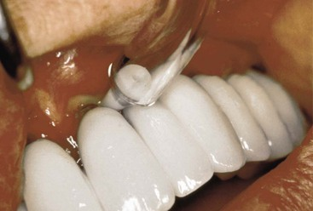
FIGURE 34-10 Antimicrobial irrigation with Pik Pocket (Water Pik, Inc., Fort Collins, CO).
If oral irrigation is used, the patient should be instructed to use the lowest setting and direct the irrigation flow through the contacts to avoid excessive pressure to the implant tissue cuff. Incorrect excessive pressure may alter tissue adaptation and induce bacteremia around the implant.⁵⁸ Additionally, clinicians should recommend that the patient be gentle yet thorough after surgery to avoid complications of healing from aggressive hygiene procedures.

Instrument Selection
Maintaining a smooth surface of titanium without pits and scratches can prevent plaque accumulation.⁵⁹ Instrument selection should depend on tip designs that are not bulky (to avoid unnecessary tissue manipulation), and the design should facilitate manipulation by the clinician (Figure 34-11). A clinician may also evaluate the prosthesis design, location of deposits, and tenacity of calculus to help select appropriate instruments.
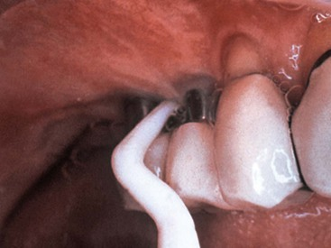
FIGURE 34-11 Plastic (resin-filled), Teflon, and carbon carbide materials may be used on implant scalers. Pictured is a resin (unfilled) curette (Implacare; Hu-Friedy, Chicago, IL).
Metallic ultrasonic and sonic scalers have been reported to gouge titanium.⁶⁰ A plastic or rubber sleeve (Dentsply International, York, PA) over an ultrasonic scaler is safe and does not damage titanium⁶¹ (Figure 34-12). After the removal of calculus, polishing with a rubber cup and toothpaste, fine prophy paste, commercial implant polishing pastes, and tin oxide have been shown be safe for titanium surfaces.^{62,63} A rubber point or soft unitufted rotary brush may also be used.
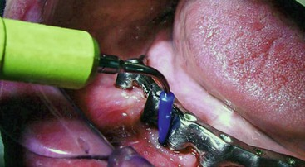
FIGURE 34-12 An implant insert may be used on a cavitation device to decrease the risk of damaging the implant surface (Softip; Dentsply, York, PA).
Although the use of ultrasonic tips with plastic sheaths or implant safe designs has been proven effective, plastic sleeves on ultrasonic scalers may leave particles embedded in the implant coating.⁶⁴ Conventional ultrasonic scalers with nonmetal tips are also suitable for implant maintenance.⁶⁵ Air polishers are effective and safe for maintenance procedures around implants.
The primary purpose of instruments used is to thoroughly remove plaque and calculus. Plastic curettes and air-powder-water spray do not alter implant surfaces, but these instruments may leave deposits.⁶⁶ These deposits should be removed by irrigation to avoid any adverse tissue healing.
Stainless steel–tipped instruments have been found to be detrimental to a smooth titanium surface.⁶⁷ A variety of nonmetallic plastic-, graphite-, nylon- or Teflon-coated instruments are available and have been proven to be safe to use on titanium implant surfaces.^{58–64,66–68} Improved gingival and soft tissue architecture result from scaling with these instruments. Although research demonstrates titanium curettes and rubber cups with flour of pumice to be suitable for cleaning implant surfaces,^{69,70} a review of the literature found titanium curettes caused a roughening of the implant surface in all studies.⁶⁵
Nonmetal instruments such as resin curettes (Implacare II; Hu-Friedy, Chicago; see Figure 34-11) and rubber cups seem to be the instruments of choice for the treatment of a smooth implant surface, especially if the preservation of surface integrity is the primary goal. Similarly, for rough implant surfaces, nonmetal instruments and air abrasives are the instruments of choice, especially if surface integrity needs to be maintained. Metal instruments and burs are recommended only when the removal of the coating is required.

Implant Maintenance Procedures
As dental implants become more widely used as a replacement for missing teeth, clinicians will certainly see increases in clinical problems in complex cases.⁷¹ Frequent recall visits after implant placement and restorations are necessary for evaluation and establishment of good oral hygiene after treatment. Healthy tissue should be free of inflammation whose primary etiology is plaque and calculus formation. Implant probings may be taken with metal or plastic probes as long as the surface of the implant is not scratched (see Figure 34-5) (Colorvue; Hu-Friedy, Chicago). The recall visit is also a time to detect potential problems to encourage early intervention if problems arise.
Unlike the attachment to the porosities of cementum with teeth, adherence and tenacity of calculus around implants is usually less binding. This can minimize the chance of traumatizing the tissue and permucosal seal during procedures to remove deposits. With adequate oral hygiene, subgingival calculus should be minimal if present at all. Because titanium usually does not have calculus embedded in it, adequate oral hygiene should prevent the accumulation of heavy accretions. If crestal bone loss has occurred, the type of implant surface or coating exposed may encourage plaque or calculus adherence.
Healthy implant tissues may have a tight seal and can create challenges while scaling. Because the permucosal seal is more fragile than a normal tooth sulcus, using short, exploratory working strokes with light pressure is important. Depending on the location of the calculus, a horizontal stroke is preferred while avoiding tissue trauma.⁷² When an instrument must be used subgingivally to remove calculus or excess cement, insertion and instrumentation should be gentle, and light strokes should be in a semicircular pattern. Attention to carefully placing the blade under the deposit and drying calculus or cement may make detection and removal easier and more comfortable for the patient.
Poor tissue tone (i.e., flaccid, friable tissue) around an implant abutment can harbor food, plaque, and calculus and increase the occurrence of inflammation and infection. If maintenance and hygiene procedures cannot adequately improve tissue tone, surgical correction may be necessary to reduce chronic inflammation and infection.
Hygiene procedures performed by the clinician and patient may be limited by prosthetic designs that have bulky restorations and inadequate embrasures, preventing ready access to the implant–gingival margin interface area.⁷³ Because loss of osseous support is a factor in implant failure, problems that may arise from a prosthesis that is difficult to maintain should be considered in the treatment planning phase.⁷⁴ Periodic occlusion monitoring is also important to detect discrepancies indicating that occlusal changes are needed.⁷⁵

Chemotherapeutic Agents
Chlorhexidine gluconate has been shown to reduce plaque in the oral cavity and around dental implants.⁷⁶ Long-term use of antimicrobials, including chlorhexidine gluconate 0.1% (United States) or 0.2% (Europe) or cetylpyridinium chloride, may be used with brushes and floss to minimize staining. With newer generations of chlorhexidine, it is significant to note that alcohol in chlorhexidine serves to preserve and stabilize the solution.⁷⁷ Studies have shown a decrease of antimicrobial benefits in preparations that are alcohol free.⁷⁸
If the clinician uses subgingival irrigation, the cannula should be carefully inserted in the periimplant tissue to avoid gouging the surface. Care should be taken to avoid inserting the cannula to the base of the implant sulcus to prevent fluid distention into surrounding tissues.⁷⁹ Chlorhexidine gluconate has been proven to be a useful irrigant.⁸⁰
A study on nonsurgical mechanical treatment on sites with periimplantitis lesions with microencapsulated minocycline (Arestin; Orapharma, Horsham, PA) and 20% chlorhexidine gel (available only in Europe) found reductions of pocket depths and bleeding on probing for up to 12 months.⁸¹ Local antibiotic therapies have also proved successful in the treatment of periimplantitis⁸² and successful management (off-label use) of periimplantitis using microencapsulated minocycline.⁸² Systemic antibiotics may be useful to treat infection. Assessing the problem, complication, or condition to be treated is as important as knowing the cause.⁸³ It is wise to use a neutral sodium fluoride in a patient with dental implants because certain acidic fluorides may alter titanium.^{84,85}

Implant Quality of Health Scale: A Clinical Assessment of the Health–Disease Continuum
The criteria for success in implant dentistry remain complex. The vast majority of clinical studies reporting success and failure do not qualify the type of success achieved. Instead, the term success primarily has been used interchangeably with survival of the implant. The term failure has been used to indicate the implant is no longer present in the mouth. Nearly all reports in the prosthetic literature also report survival as success.
What is success for a natural tooth? In the periodontal literature, a quality of health is presented, and well-established guidelines based on clinical criteria describe the ideal health of natural teeth. The general term success in implant dentistry should be replaced with the concept of quality of health, with a health–disease continuum describing the status of implants.
Success criteria for endosteal implants have been proposed previously by other authors, including Schnitman and Shulman,⁸⁶ Cranin et al.,⁸⁷ McKinney et al.,⁸⁸ Albrektsson et al.,⁸⁹ and Albrektsson and Zarb.⁹⁰ As Box 34-3 shows, the report by Albrektsson et al. was specific for implants with rigid fixation and is used widely today.⁹¹ An implant quality of health scale with five levels has been established by James and modified by Misch.⁹¹ The James-Misch scale also proposes management modalities corresponding to these five levels. In 2007, a consensus conference in Pisa, Italy (sponsored by the International Congress of Oral Implantologists; www.icoi.org) modified the James-Misch scale to four conditions that describe success, survival, and failure.⁹²
Box 34-3
Criteria for Implant Success⁸⁹
• An individual, unattached implant is immobile when tested clinically.
• A radiograph does not demonstrate any evidence of periimplant radiolucency.
• Vertical bone loss is less that 0.2 mm annually after the first year of service of the implant.
• Individual implant performance is characterized by an absence of persistent or irreversible signs and symptoms such as pain, infections, neuropathies, paresthesia, or violation of the mandibular canal.
• In the context of the foregoing, success rates of 85% at the end of a 5-year observation period and 80% at the end of a 10-year period are the minimum criteria for success.
Ideal clinical conditions for natural teeth include absence of pain, less than 0.1 mm of initial horizontal mobility under lateral forces of less than 100 g, less than 0.15 mm secondary mobility with lateral forces of 500 g, absence of observed vertical mobility, periodontal probing depths of less than 2.5 mm, radiographic crestal bone height 1.5 to 2.0 mm below the cementoenamel junction, intact lamina dura, no bleeding on probing, no exudate, and absence of recession or furcation involvement on multirooted teeth (Box 34-4).⁹² Many of these same criteria are listed as ideal conditions for dental implants.^{86–90}
Box 34-4
Ideal Clinical Conditions of Teeth
• Absence of pain
• Less than 0.1 mm initial horizontal mobility under lateral forces less than 100 g
• Less than 0.15 mm secondary mobility with lateral forces of 500 g
• Absence of observed vertical mobility
• Periodontal probing depths less than 2.5 mm
• Radiographic crestal bone height 1.5 to 2.0 mm below the cementoenamel junction
• Intact lamina dura
• No bleeding on probing
• No exudate
• Absence of gingival recession
• Absence of furcation involvement on multirooted teeth
The American Academy of Periodontology has defined five periodontal types for diagnosis and treatment of natural teeth.⁹³ The American Academy of Periodontology's categories of disease do not indicate strict success or failure but rather a range from health to disease. This classification allows a clinical approach to treatment in each category. A similar scale for implants has been established as an aid to diagnosis and treatment that also proposes management approaches according to the signs and symptoms.⁹⁴
The James-Misch scale presented for implant quality of health based on clinical evaluation was supported by the International Congress of Oral Implantologists in 2007⁹² (Table 34-1). This quality of health scale allows the implant dentist to evaluate an implant using the listed criteria, place it in the appropriate category, and then treat the implant accordingly. The prognosis also is related to the quality scale.
TABLE 34-1
Health Scale for Dental Implants
Implant Quality Scale | Clinical Conditions | Treatment
I. Success | No pain or tenderness upon function  0 Mobility  <2 mm radiographic bone loss from initial surgery  Probing depth, <5 mm  BOP = 0 to 1  No exudate history | Normal maintenance
II. Survival (satisfactory health) | No pain  0 mobility  2–4 mm radiographic bone loss  Probing depth, 5 to 7 mm  BOP = 0 to 2  No exudate history | Reduction of stresses  Shorter interval between hygiene appointments  Gingivoplasty  Annual radiographs
III. Survival (compromised health) | 0 mobility  Radiographic bone loss >4 mm (less than of implant body)  Probing depth, >7 mm  May have exudate history  No pain upon function | Reduction of stresses  Drug therapy (antibiotics, antimicrobials)  Surgical reentry and revision  Change in prosthesis or implants
IV. Failure (clinical or absolute) | Any of the following:  Pain upon function  Mobility  Radiographic bone loss > length of implant  Uncontrolled exudate  No longer in mouth | Removal of implant

BOP, Bleeding index.

Group I: Optimum Health
Group I represents implant success with optimum health conditions. No pain is observed with palpation, percussion, or function. No mobility is noted in any direction with loads less than 500 g of implant movement (IM). Less than 2.0 mm of crestal bone has been lost since the placement of the implant. This bone loss is typically a result of the “implant biologic width” below the abutment connection and surface of the implant. The implant has no history of exudate, and no radiolucency is present around the implant body (Figure 34-13, A-C). The probing depth is equal to or less than 5 mm and is stable after the first year. Ideally, the bleeding index is 0 to 1. Group I implants follow a normal maintenance program every 6 months. The prognosis is very good to excellent.
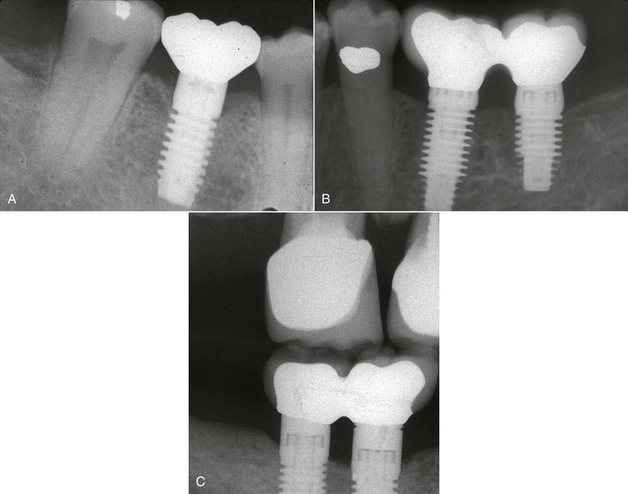
FIGURE 34-13 A and B, Group I represents optimum health conditions around an implant. Less than 1.5 mm of crestal bone loss occurs during the first year of occlusal loading from the time of prosthesis delivery. C, A vertical bitewing radiograph can be obtained to assess mesiodistal bone levels.

Group II: Satisfactory Health
Group II implants exhibit satisfactory health and are stable but show a history of or potential for clinical problems. No pain or tenderness is observed on palpation, percussion, or function. No observable mobility exists in the horizontal or vertical direction with loads less than 500 g. Crestal radiographic bone loss is between 2 and 4 mm from implant placement (Figure 34-14, A, B). The most common cause is the early loading bone loss related to the amount of occlusal force and the density of the bone. The probing depths may be as much as 5 to 6 mm because of the original tissue thickness and marginal bone loss but are stable. Bleeding upon probing index is often 1 or even 2. These implants may be considered to have periimplant mucositis. The treatment indicated for group II implants consists of a stress reduction protocol for the implant system, shorter intervals between hygiene appointments (e.g., 9 months), reinforcement of oral hygiene instructions, annual radiographs until the crestal bone has stabilized, and gingivoplasty or sulcus reduction procedures where indicated. The prognosis is good to very good depending on the depth of the implant sulcus.
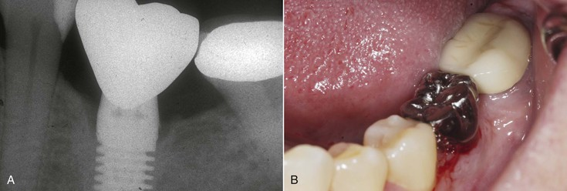
FIGURE 34-14 A, Group II represents satisfactory health around an implant. This implant has lost 2 mm of crestal bone. B, The implant crown has bleeding upon probing index of 2.
For pockets less than 6 mm in depth, the following can be concluded⁹⁵:
1. Mechanical therapy alone or combined with chlorhexidine results in the clinical resolution of periimplant mucositis lesions.
2. Histologically, both treatments result in minimal inflammation compatible with health.
3. The mechanical effect alone is sufficient to attain clinical and histologic resolution of mucositis lesions.

Group III: Compromised Survival
Group III implants are classified as compromised survival and exhibit a slight to moderate periimplantitis and compromised health status. Periimplantitis is defined as an inflammatory process affecting the tissue around an implant that results in loss of supporting bone.⁸³
Group III implants are characterized by radiographically evident vertical bone loss, periimplant pocket, bleeding on probing (plus occasional suppuration), and mucosal swelling and redness but no pain upon function (Figure 34-15, A). These implants warrant more aggressive clinical therapy. No pain is apparent in function, but tenderness may be slight on percussion or function. No vertical or initial horizontal mobility (IM-0) is evident. Greater than 4 mm of crestal bone loss has occurred since implant insertion but less than half the length of the implant. Greater than 7 mm and increasing probing depths are also present, usually accompanied by bleeding when probing. Exudate episodes may have lasted more than 1 to 2 weeks and may be accompanied by a slight radiolucency evident around a crestal region of the implant.
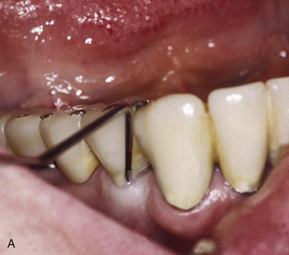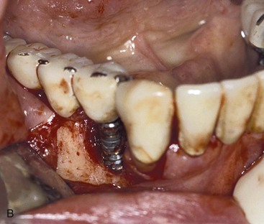
FIGURE 34-15 A, Group III implants have a compromised health status and warrant a surgical procedure to decrease the risk of further deterioration. Probing on the facial of this implant indicates a 6-mm pocket, and exudate is present. B, This implant required surgical reentry to decontaminate the surface of the implant and remove the noxious elements. A reduction of thread depth and a bone graft or apical-positioned flap was indicated.
Group III implants warrant aggressive surgical and prosthetic intervention. Stress factors are also addressed. The prosthesis may be removed in nonesthetic regions or the bar may be removed under overdentures during the surgical therapy. Modification of the occlusal scheme and methods to decrease the forces in the afflicted regions after hard and soft tissue surgical treatment include decreasing cantilever length, occlusal adjustment, and occlusal splint therapy.
In cases of rapid bone changes, the prosthesis design may be modified completely from a fixed to a removable restoration to stress relief and soft tissue support. Additional implants to support the restoration may be indicated, especially if the patient is unwilling to wear a removable prosthesis.
Systemic and topical antibiotics and local chemical agents such as chlorhexidine are indicated in the presence of exudate. However, this method is usually of short-term benefit if the causative agents of implant failure are not eliminated. Bacterial culture and sensitivity tests (Oral Microbiology Testing Service, Temple University, Philadelphia; www.temple.edu/dentistry/omts) may be indicated, especially if existing signs and symptoms do not subside within a few weeks.
Surgical management most often consists of soft tissue removal or exposure of a portion of the implant (Figure 34-15, B). Bone grafts may be used along with these approaches around the implant. A three-step approach is implemented for this category in the following order: (1) antimicrobial therapy (local or systemic), (2) stress reduction, and (3) surgical intervention. The prognosis is good to guarded, depending on the ability to reduce and control stress after the surgical corrections have improved the soft and hard tissue health.

Group IV: Clinical Failure
Group IV of implant health is clinical or absolute failure (Figure 34-16). The implant should be removed under any of these conditions: (1) pain on palpation, percussion, or function; (2) greater than 0.5 mm of horizontal mobility; (3) any vertical mobility; (4) uncontrolled progressive bone loss; (5) uncontrolled exudate; (6) more than 50% bone loss around the implant; (7) generalized radiolucency; or (8) implants surgically placed but unable to be restored (sleepers). Implants that are surgically removed or exfoliated are also in the category of failure.
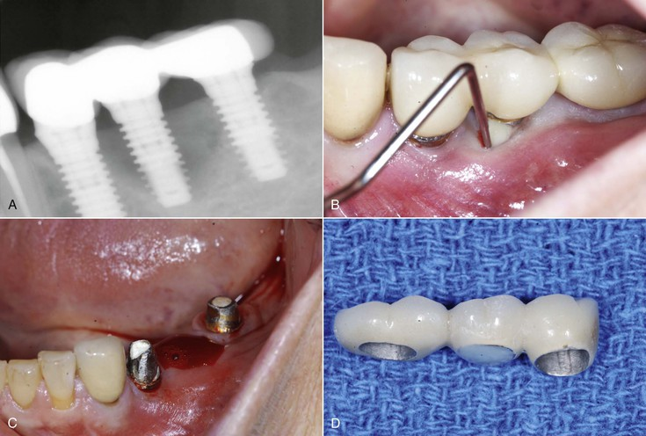
FIGURE 34-16 A, Implants in group IV represent clinical failure and implants no longer in the mouth. The center implant in this radiograph is an implant with more than 50% loss; it is category IV. B, The implant should be removed when group IV exudates are present. C, The implant is removed from the site. The implant now is converted to group V (absolute failure). D, The prosthesis is modified to become a three-unit fixed partial denture.
This category also includes implants surgically removed or exfoliated and no longer in the mouth. The remaining edentulous area often is treated with autogenous or synthetic bone graft procedures, which are performed to replace the missing bone. After the favorable bony conditions are restored, implants may be inserted again with a good prognosis (see Fig. 34-16).
The terminology for implant failure often is confusing, with different terms describing similar situations. Terminology for implant failure using the time period of failure has been suggested as a primary criterion.⁹⁶ Many implant failures are not described ideally by the time of the complication and are not addressed in this nomenclature.
Occasionally, the patient will not permit removal of the implant. Regardless of whether the patient returns for implant removal, the implant is recorded as a failure in all statistical data. The patient should be warned against the irreversible damage to the surrounding bone with implants retained in this condition. Consideration should be given to their removal because future treatment may be compromised.

Repair of Ailing, Failing Dental Implants
I. If an active infection (purulence, bleeding, swelling) is present with radiographically visible bone loss and the disease process is continuing, the following steps should be implemented:
A. Reflect the tissue and degranulate the defect (metallic curettes are acceptable).
B. If the implant is hydroxyapatite (HA) coated and the HA is undergoing resorption and has changed color and texture, remove all the HA until the metallic surface is visible. Use of ultrasonics such as Cavitron (Dentsply, York, PA) is recommended. Use of hand curettes is slow, and use of air abrasives is dangerous because of the potential of air emboli in marrow spaces.
C. Detoxify the dental implant with citric acid or etching gel applied with a cotton pledget or camel's hair brush. Thirty seconds per surface is sufficient. The supersaturated citric acid solution (40%, pH 1, crystals mixed with sterile water) will last in the refrigerator for about 1 year.
D. Graft with freeze-dried bone or alloplast if completely detoxified. Graft with an alloplast such as HA or bioglass if not completely detoxified.
E. Protect the graft with a membrane for guided bone regeneration if needed. Resorbable membranes (e.g., Alloderm or Memloc [BioHorizons, Birmingham, AL]) are acceptable.
F. Leave the repaired implant out of function and “covered” for 10 to 12 weeks.
Note: If the surface of the implant is metallic (titanium, Ti-6Al-4V, titanium plasma spray), go from step A to step C.
II. If no active infection is present and if an HA-coated implant in place looks intact without continuing resorption (e.g., bone loss from traumatic occlusion, overloading, off-axis loading), the following steps should be implemented:
A. Reflect the tissue and degranulate the defect with metallic curettes.
B. Detoxify the HA surface with citric acid (40%, pH 1) or etching gel for 30 seconds per surface. Flush and irrigate with sterile water or sterile saline to stop the demineralization process of the acid. Thirty seconds of acid application will detoxify and “freshen” the surface.
C. Continue with grafting, guided bone regeneration materials, and procedures as noted previously for treatment of the “infected” implant.
Note: The only difference is that removal of the HA is not necessary because the coating is relatively noncontaminated and still capable of biological healing.
Important: Do not use tetracycline on intact HA because it changes the calcium–phosphate ratio of HA. Do not leave citric acid on HA surface for more than 1 minute; it continues to “resorb the surface.”

Implant Crown Esthetic Index
An implant crown esthetic index was developed as an objective tool in rating esthetics of implant-supported single crowns and adjacent soft tissues.⁹⁷ The important item of esthetics is rarely included in evaluation studies. Esthetics can be rated in both a subjective and an objective manner. A subjective method is the use of questionnaires, which must be completed by the patient.
An objective method with a rating score, which has to be carried out by a professional observer, has never been described in the field of dental implants. An index was introduced to assess the height of interproximal mucosa adjacent to single-implant restorations but did not account for entire periimplant contour and surface structure.⁹⁸ An objective rating score, with a division in different items, provides insight into the esthetic result of a specific treatment and facilitates analysis to improve surgical or prosthetic treatment. It is also possible to compare the esthetic result as a function of time to analyze the stability of a treatment procedure.
The nine selected items are⁹⁷:
1. Mesiodistal dimension of the crown. The mesiodistal dimension must be in harmony with the adjacent and contralateral tooth; a judgment can be given on a 5-point rating scale (grossly undercontoured, slightly undercontoured, no deviation, slightly overcontoured, grossly overcontoured).
2. Position of the incisal edge of the crown. The position must be in harmony with the adjacent and contralateral tooth; a judgment can be given on a 5-point rating scale (grossly undercontoured, slightly undercontoured, no deviation, slightly overcontoured, grossly overcontoured).
3. Labial convexity of the crown. The convexity of the labial surface of the crown must be in harmony with the adjacent and contralateral tooth; a judgment can be given on a 5-point rating scale (grossly undercontoured, slightly undercontoured, no deviation, slightly overcontoured, grossly overcontoured).
4. Color and translucency of the crown. The color and translucency of the crown must be in harmony with the adjacent and contralateral tooth; a judgment can be given on a 3-point rating scale (gross mismatch, slight mismatch, no mismatch).
5. Surface of the crown. The labial surface characteristics of the crown, such as roughness and ridges, must be in harmony with the adjacent and contralateral tooth; a judgment can be given on a 3-point rating scale (gross mismatch, slight mismatch, no mismatch).
6. Position of the labial margin of the periimplant mucosa. The labial margin of the periimplant mucosa must be at the same level as the contralateral tooth and in harmony with the adjacent teeth; a judgment can be given on a 3-point rating scale (deviation of 1.5 mm or more, deviation less than 1.5 mm, no deviation).
7. Position of mucosa in the approximal embrasures. The interdental papillae must be in their natural position; a judgment can be given on a 3-point rating scale (deviation of 1.5 mm or more, deviation less than 1.5 mm, no deviation).
8. Contour of the labial surface of the mucosa. The contour of the mucosa at the alveolar bone must be in harmony with the adjacent and contralateral tooth; a judgment can be given on a 5-point rating scale (grossly undercontoured, slightly undercontoured, no deviation, slightly overcontoured, grossly overcontoured).
9. Color and surface of the labial mucosa color (redness) and surface characteristics (presence of attached mucosa) must be in harmony with the adjacent and contralateral tooth and must have a natural appearance; a judgment can be given on a 3-point rating scale (gross mismatch, slight mismatch, no mismatch).
Use of the adjacent and contralateral teeth as a reference, rather than the generally accepted rules for shape and position of teeth, has been standardized. Penalty points were given to each of these items if not matching to the desired situation: 1 penalty point for minor (slight) deviations and 5 penalty points for major (gross) deviations. The total score leads to a judgment about esthetics (Box 34-5). It should be noted that one major deviation automatically leads to a poor esthetic result and can never be accepted as moderate or satisfactory in this aspect of care.
Box 34-5
Esthetic Scale
0 points = Excellent esthetics
1 or 2 points = Satisfactory esthetics
3 or 4 points = Moderate esthetics
5 or more points = Poor esthetics

Summary
Implant success has broad definitions in clinical practice. A range from health to disease exists for both teeth and implants. The primary criteria for assessing implant quality are inflammation, pain, and mobility. The presence of either pain or mobility greatly compromises the implant; removal usually is indicated. Probing depths may be related to the presence of local disease or preexisting tissue thickness before the implant was inserted. An increasing probing depth is more diagnostic and signifies bone loss, gingival hyperplasia, or hypertrophy. The most common causes of bone loss during the first few years of function are related to factors of stress and retained cement. The bleeding index is observed easily and indicates inflammation of the gingiva. However, implant health status is not as related to sulcular inflammation as would be the case with a natural tooth.
Implant failure is easier to describe and may consist of a variety of factors. Any pain, vertical mobility, uncontrolled progressive bone loss, or generalized periimplant radiolucency warrants implant removal. Implant quality factors were established by the International Congress of Oral Implantologists (2007) into an implant quality scale that not only assesses the implant health–disease continuum but also relates treatment and prognosis to the existing conditions.

References
1. Jalbout Z, Tabourian G. Glossary of implant dentistry. International Congress of Implantology: Upper Montclair, NJ; 2004.
2. LeBeau J. Maintaining the long-term health of the dental implant and the implant borne restoration. Compend Cont Ed Oral Hygiene. 1997;3(3):3–9.
3. Strong S, Strong S. The dental implant maintenance visit. J Pract Hygiene. 1995;4(5):L29–L32.
4. Koutsonikos A, Fedcrio J, Yukna R. Implant maintenance. J Pract Hygiene. 1996;5(2):11–15.
5. Terracciano-Mortilla L. Hygiene and soft tissue management. Babbush C. Dental implants: principles and practice. Saunders: Philadelphia; 2001.
6. Meffert RM. Maintenance of dental implants. Misch CE. Dental implant prosthetics. Mosby: St Louis; 2005.
7. Berglundh T, Lindhe J, Ericsson I, et al. The soft tissue barrier at implants and teeth. Clin Oral Implants Res. 1991;2:81–90.
8. Bollen CM, Papaioanno W, Van Eldere J, et al. The influence of abutment surface roughness on plaque accumulation and peri-implant mucositis. Clin Oral Implants Res. 1996;7(3):201–211.
9. Quirynen M, deSote M, van Steenburghe D. Infectious risks for oral implants: a review of the literature. Clin Oral Implants Res. 2002;13:1–19.
10. Lee KH, Maiden MF, Tanner AC, Weber HP. Microbiota of successful osseointegrated dental implants. J Periodontol. 1999;70(2):131–138.
11. Lindquist LW, Rockler B, Carlsson GE. Bone resorption around fixtures in edentulous patients treated with mandibular fixed tissue–integrated prostheses. J Prosthet Dent. 1988;59:59–63.
12. Mombelli A, Mericske-Stern R. Microbiological features of stable osseointegrated implants used as abutments for overdentures. Clin Oral Implants Res. 1990;1:1–7.
13. Mombelli A, Van Oosten MAC, Schurch E, Lang NP. The microbiota associated with successful or failing osseointegrated titanium implants. Oral Microbiol Immunol. 1987;2:145–151.
14. Becker W, Becker B, Newman MG, et al. Clinical and microbiologic findings that may contribute to dental implant failure. Int J Oral Maxillofac Implants. 1990;5:31–38.
15. Mombelli A. Microbiology of the dental implant. Adv Dent Res. 1993;7:202–206.
16. Rams TE, Feik D, Slots J. Staphylococci in human periodontal diseases. Oral Microbiol Immunol. 1990;5:29–32.
17. Mombelli A, Marxer M, Gaberthuel T, et al. The microbiota of osseointegrated implants in patients with a history of periodontal disease. J Clin Periodontol. 1995;22:124–130.
18. Leonhardt A, Adolfsson B, Lekholm U, et al. A longitudinal microbiological study on osseointegrated titanium implants in partially edentulous patients. Clin Oral Implants Res. 1993;4:113–120.
19. George K, Zafiropoulos GG, Murat Y, et al. Clinical and microbiological status of osseointegrated implants. J Periodontol. 1994;65:766–770.
20. Quirynen M, Listgarten MA. The distribution of bacterial morphotypes around natural teeth and titanium implants ad modum Brånemark. Clin Oral Implants Res. 1990;1:8–12.
21. Silverstein L, Kurtzman D, Garnick J, et al. The microbiota of the peri-implant region in health and disease. Implant Dent. 1994;3:170–174.
22. Lindhe J, Karring T, Lang N. Clinical periodontology and implant dentistry. Munksgaard: Copenhagen; 2000.
23. Gargiulo A, Wentz F, Orban B. Dimensions and relations of the dentogingival junction in humans. J Periodontol. 1961;32:261–268.
24. Vacek JS, Gher ME, Assad DA, et al. The dimensions of the human dentogingival junction. Int J Periodontics Restorative Dent. 1994;14:154–165.
25. James RA, Schultz RL. Hemidesmosomes and the adhesion of junctional epithelial cells to metal implants: a preliminary report. J Oral Implantol. 1974;4:294.
26. Ericsson I, Lindhe J. Probing at implants and teeth: an experimental study in the dog. J Clin Periodontol. 1993;20:623–627.
27. Listgarten M, Lang NP, Schroeder HE, et al. Periodontal tissues and their counterparts around endosseous implants. Clin Oral Implants Res. 1991;2:81–90.
28. Berglundh T, Lindhe J, Ericsson I, et al. The soft tissue barrier at implants and teeth. Clin Oral Implants Res. 1991;2:81–90.
29. Ono Y, Nevins M, Cappetta M. The need for keratinized tissue for implants. Nevins M, Mellonig JT. Implant therapy. Quintessence: Chicago; 1998.
30. Steflik DE, McKinney RV, Koth DL. Ultrastructural (TEM) observations of the gingival response to the single crystal sapphire endosteal implant. J Dent Res. 1982;61:231.
31. Cochran DL, Herman JS, Schenk RK, et al. Biologic width around titanium implants: a histometric analysis of the implanto-gingival junction around unloaded and loaded submerged implants in the canine mandible. J Periodontol. 1997;68:186–198.
32. Abrahamsson I, Berglundh T, Lindhe J. The mucosal barrier following abutment disreconnection: an experimental study in dogs. J Clin Periodontol. 1997;24:568–572.
33. Rams TE, Slots J. Comparison of two pressure sensitive periodontal probes and a manual periodontal probe in shallow and deep pockets. Int J Periodontics Restorative Dent. 1993;13:521–529.
34. Best AM, Burmeister JA, Gunsolley JC, et al. Reliability of attachment loss measurements in a longitudinal clinical trial. J Clin Periodontol. 1990;17:564–569.
35. Page RC. Summary of outcomes and recommendations of the workshop on CPITN. Int Dent J. 1994;44:589–594.
36. Lekholm U, Adell R, Lindhe J, et al. Marginal tissue reactions at osseointegrated titanium fixtures. II. A cross-section retrospective study. Int J Oral Maxillofac Surg. 1986;15:53–61.
37. Rams TE, Roberts TW, Tatum H Jr, et al. The subgingival microflora associated with human dental implants. J Prosthet Dent. 1984;5:529–534.
38. Stefani LA. The care and maintenance of the dental implant patient. J Dent Hygiene. 1988;62:447–466.
39. Becker W, Becker BE, Newman MG, et al. Clinical microbiologic findings that may contribute to dental implant failure. Int J Oral Maxillofac Implants. 1990;5:31–38.
40. Adell R, Lekholm U, Rockler G, et al. Marginal tissue reactions at osseointegrated titanium fixtures. I. A 3-year longitudinal prospective study. Int J Oral Maxillofac Implants. 1986;15:39–52.
41. Kirsch A, Mentag P. The IMZ endosseous two phase implant system: a complete oral rehabilitation treatment concept. J Oral Implantol. 1986;12:576–589.
42. Deporter HS, Friedland B, Watson P, et al. A clinical and radiographic assessment of a porous surface titanium alloy dental implant in dogs. Int J Oral Implantol. 1987;4:31–37.
43. Deporter DA, Watson PA, Pilliar RM, et al. A histological evaluation of a functional endosseous, porous-surfaced, titanium alloy dental implant system in the dog. J Dent Res. 1988;67:1190–1195.
44. Jepsen S, Ruhling A, Jepsen K, et al. Progressive peri-implantitis. Incidence and prediction of peri-implant attachment loss. Clin Oral Implants Res. 1996;7:133–142.
45. Quirynen M, Naert I, Teerlinck J, et al. Periodontal indices around osseointegrated oral implants supporting overdentures. Schepers E, Naert J, Theunier G. Overdentures on oral implants. Leuwen University Press: Leuwen, Belgium; 1991.
46. Steflik DE, Koth DC, McKinney RV Jr. Human clinical trials with the single crystal sapphire endosteal dental implant: three year results, statistical analysis, and validation of an evaluation protocol. J Oral Implantol. 1987;13:39–53.
47. Herman JS, Cochran DL, Nummikoski PV, et al. Crestal bone changes around titanium implants: a radiographic evaluation of unloaded non-submerged and submerged implants in the canine mandible. J Periodontol. 1997;68:1117–1130.
48. Misch CE, Suzuki JB, Misch-Dietsh FD, et al. A positive correlation between occlusal trauma and peri-implant bone loss—literature support. Implant Dent. 2005;14:108–116.
49. Haffajee AD, Smith C, Torresyap G, et al. Efficacy of manual and powered toothbrushes (II). Effect on microbiological parameters. J Clin Periodontol. 2001;28(10):947–954.
50. Chung DM, Oh TJ, Shotwell JL, et al. Significance of keratinized mucosa in maintenance of dental implants with different surfaces. J Periodontol. 2006;77(8):1410–1420.
51. Wilken E. Clinical practice of the dental hygienist. ed 7. Williams & Wilkins: Philadelphia; 1994.
52. Humphrey S. Implant maintenance. Dent Clin North Am. 2006;50:463–478.
53. Terracciano-Mortilla L. Hygiene and soft tissue management. Babbush C. Dental implants: principles and practice. Saunders: Philadelphia; 2001.
54. Kracher CM, Smith WS. Oral health maintenance of dental implants: a literature review. Dent Assist. 1998;67(5):2–15.
55. Garber DA. Implants—the name of the game is still maintenance. Compendium. 1991;12(12):878–880.
56. English C. Hygiene, maintenance, and prosthodontic concerns for the infirm patient: clinical report and discussion. Implant Dent. 1995;4:166–172.
57. Briner WW, Grossman E, Buckner RY, et al. Effect of chlorhexidine gluconate mouthrinse on plaque bacteria. J Periodont Res. 1986;16:44–52.
58. Fakhraver B, Khocht A, Suzuki JB. Probing and scaling instrumentation in implant abutment surfaces: an in vitro study. Implant Dent. 2012;21:311–316.
59. American Academy of Periodontology. Position paper. Maintenance and treatment of dental implants. American Academy of Periodontology: Chicago; 1995.
60. Hallmon W, Waldrop T, Meffert R, Wade B. A comparative study of the effects of metallic, nonmetallic, and sonic instrumentation on titanium abutment surfaces. Int J Oral Maxillofac Implants. 1996;11:96–100.
61. Baily G, Gardner J, Day M, Kovanda B. Implant surface alterations from a nonmetallic ultrasonic tip. J West Soc Periodontol Periodontal Abstr. 1998;46(3):69–73.
62. Sato S, Kishida M, Ito K. The comparative effect of ultrasonic scalers on titanium surfaces: an in vitro study. J Periodontol. 2004;75(9):1269–1273.
63. Brookshire FV, Nagy WW, Dhuru VB, et al. The qualitative effects of various types of hygiene instrumentation on commercially pure titanium and titanium alloy implant abutments: an in vitro and scanning electron microscope study. J Prosthet Dent. 1997;78(3):286–294.
64. Hempton TJ, Bonacci FJ, Lancaster D, Pechter JE. Implant maintenance. Dimen Dent Hygiene. 2011;9(1):58–61.
65. Augthun M, Tinschert J, Huber A. In vitro studies on the effect of cleaning methods on different implant surfaces. J Periodontol. 1998;69(8):857–864.
66. Ramaglia L, di Lauro AE, Morgese F, Squillace A. Profilometric and standard error of the mean analysis of rough implant surfaces treated with different instrumentations. Implant Dent. 2006;15(1):77–82.
67. Meschenmoser A, d’Hoedt B, Meyle J, et al. Effects of various hygiene procedures on the surface characteristics of titanium abutments. J Periodontol. 1996;67:229–235.
68. Mengel R, Buns CE, Mengel C, Flores-de-Jacoby L. An in vitro study of the treatment of implant surfaces with different instruments. Int J Oral Maxillofac Implants. 1998;13(1):91–96.
69. Technique for implant polishing. J Pract Hygiene. 1997;35.
70. Sato S, Kishida M, Ito K. The comparative effect of ultrasonic scalers on titanium surfaces: an in vitro study. J Periodontol. 2004;75(9):1269–1273.
71. Yukna R. Optimizing clinical success with implants: maintenance and care. Compend Contin Educ Dent. 1993;15:554–561.
72. Hultin M, Komiyama A, Klinge B. Supportive therapy and the longevity of dental implants: a systematic review of the literature. Clin Oral Implants Res. 2007;18(suppl 3):50–62.
73. Steele D, Orton G. Dental implants: clinical procedures and homecare considerations. J Pract Hygiene. 1992;June–July:9–12.
74. Yukna R. Optimizing clinical success with implants: maintenance and care. Compend Contin Educ Dent. 1993;15:554–561.
75. English C. Hygiene, maintenance, and prosthodontic concerns for the infirm patient: clinical report and discussion. Implant Dent. 1995;4:166–172.
76. Yukna R. Optimizing clinical success with implants: maintenance and care. Compend Contin Educ Dent. 1993;15:554–561.
77. Siegrist AE, Gusberti F, Brecx M, et al. Efficacy of rinsing with chlorhexidine digluconate in comparison of phenolic and plant alkaloid compounds. J Periodont Res. 1986;21(16):60–74.
78. Arweiler N, Boehnke N, Sculean A, et al. Differences in efficacy of two commercial 0.2% chlorhexidine mouthrinse solutions: a 4-day plaque regrowth study. J Clin Periodontol. 2006;33:334–339.
79. Minichetti J, Colplanis N. Considerations in the maintenance of the dental implant patient. J Pract Hygiene. 1993;2(5):15–19.
80. Felo A, Shibly O, Ciancio S, et al. Effects of chlorhexidine irrigation on peri-implant maintenance. Am J Dent. 1997;10:107–110.
81. Renvert S, Lesse J, Dahlen G, et al. Topical minocycline spheres versus topical chlorhexidine gel as an adjunct to mechanical debridement of incipient perio-implant infections: a randomized clinical trial. J Clin Periodontol. 2006;33:362–369.
82. Salvi GE, Persson GR, Heitz-Mayfield LJA, et al. Adjunctive local antibiotic therapy in the treatment of peri-implantitis, II: Clinical and radiographic outcomes. Clin Oral Implants Res. 2007;18(3):281–285.
83. Mombelli A, Lang NP. Antimicrobial treatment of peri-implant infections. Clin Oral Implants Res. 1992;3:162–168.
84. Probster L, Lin W. Effects of fluoride prophylactic agents on titanium surfaces. Int J Oral Maxillofac Implants. 1992;2(7):390–394.
85. Toumelin-Chemla F, Rouelle F. Corrosive properties of fluoride containing odontologic gels against titanium. J Dent. 1996;24(1-2):109–115.
86. Schnitman PA, Shulman LB. Recommendations of the consensus development conference on dental implants. J Am Dent Assoc. 1979;98:373–377.
87. Cranin AN, Silverbrand H, Sher J, et al. The requirements and clinical performance of dental implants. Biocompatibility of dental materials. CRC Press: Boca Raton, FL; 1982. Smith DC, Williams DF. Biocompatibility of dental materials. vol 4.
88. McKinney RV, Koth DC, Steflik DE. Clinical standards for dental implants. Clark JW. Clinical dentistry. Harper & Row: Harperstown, PA; 1984.
89. Albrektsson T, Zarb GA, Worthington P, et al. The long-term efficacy of currently used dental implants: a review and proposed criteria of success. Int J Oral Maxillofac Implants. 1986;1:1–25.
90. Albrektsson T, Zarb GA. Determinants of correct clinical reporting. Int J Prosthodont. 1998;11:517–521.
91. Misch CE. Implant quality scale: a clinical assessment of the health-disease continuum. Oral Health. 1998;88:15–25.
92. Misch CE, Perel ML, Wang HL, et al. Implant success, survival, and failure: the International Congress of Oral Implantologists (ICOI) Pisa Consensus Conference. Implant Dent. 2008;17(1):5–15.
93. Council on Dental Care Programs. Reporting periodontal treatment under dental benefit plans. J Am Dent Assoc. 1988;17:371–373.
94. Misch CE. Implant success or failure: clinical assessment in implant dentistry. Misch CE. Contemporary implant dentistry. Mosby: St Louis; 1993.
95. Trejo PM, Bonaventura G, Weng D, et al. Effect of mechanical and antiseptic therapy on peri-implant mucositis: an experimental study in monkeys. Clin Oral Implants Res. 2006;17:294–304.
96. Jividen G, Misch CE. Reverse torque testing and early loading failures: help or hindrance. J Oral Implantol. 2000;26:82–90.
97. Henry JA, Meijer K, Stellingsma K, et al. A new index for rating aesthetics of implant supported single crowns and adjacent soft tissues—the Implant Crown Aesthetic Index: a pilot study on validation of a new index. Clin Oral Implants Res. 2005;16:645–649.
98. Jemt T. Regeneration of gingival papillae after single implant treatment. Int J Periodontics Restorative Dent. 1997;17:327–333.

