Chapter 36 Keys to Bone Grafting and Bone Grafting Materials
Carl E. Misch, Francine Misch-Dietsh
To satisfy the ideal goals of implant dentistry, the hard and soft tissues need to present ideal volumes and quality. The alveolar process is affected so often after tooth loss that augmentation is usually indicated to achieve optimum results, especially in the esthetic zones. Augmentation is also required relative to functional conditions of the implant treatment plan, because a reduction of stress at the crestal bone region and a greater resistance to screw loosening and fatigue fracture occurs with larger-diameter implants. Therefore an improved understanding of biomechanical requirements for long-term prosthesis survival and the increasing use of implants in esthetic restorations often require ridge reconstruction before implant placement for complete or partially edentulous patients. This is especially true in the surgical placement of maxillary anterior implants, which is usually critical for ideal esthetics, phonetics, and function. As a result, treatment methods to improve the recipient bone dimensions to optimize success should be considered, especially in the premaxilla.

ALVEOLAR RESORPTION
In the anterior regions of the mouth, the labial cortical plate over the natural teeth is much thinner than its lingual counterpart. Periodontal disease creates infrabony defects on the lingual aspect of the supporting bone but often causes complete loss of the labial alveolar process. Dehiscence of the labial plate may also occur as a consequence of tooth eruption, orthodontic therapy, parafunction, trauma, vertical root fracture, apicoectomy, ill-fitting crown margins, subgingival tooth preparation, and extractions. The facial plate of bone is also first to remodel or resorb after tooth extraction, disease, or trauma, and it does so to a greater extent than the lingual cortical bone.
In the anterior maxilla, the alveolar bone is rapidly recontoured after the loss of the natural teeth, even in the presence of an intact alveolus after extraction. There is a 25% decrease in volume during the first year and a 40% to 60% decrease in width within the first 3 years after tooth loss.^{1,2} This resorption is primarily at the expense of the facial dimension, as the lingual contour undergoes resorption only when more advanced atrophy occurs. As a result, an 8-mm-wide anterior ridge may remodel to less than 3 mm within 5 years after extraction.^{3,4} In the posterior regions, the rate of initial bone loss is often greater than in the anterior regions. However, because the initial posterior ridge dimension is twice the width, even a 50% bone loss often leaves adequate volume to place 4-mm-diameter implants. As a consequence of these dimensional changes, the remodeled labial cortex is more medial than its original position.

SURGICAL KEYS TO BONE GRAFTING
Consistent bone grafting results for volume have been difficult to achieve, often because similar techniques are used, regardless of the patient’s existing conditions, the volume of bone, and the region of the augmentation. Specific elements (keys) need to be present for successful bone grafting.⁵ The doctor should evaluate the existing condition and alter the grafting technique and materials in function of each treatment performed. In other words, bone grafting is very much like opening a combination safe that requires at least seven of 11 different numbers. If only five or six numbers are correct, the safe will not open. The more numbers used to open the “safe” of successful bone grafting, the more predictable the growth of sufficient bone volume for implant placement.
The keys to bone grafting are local factors that affect the prognosis of the procedure and include: absence of infection, soft tissue closure, space maintenance, graft immobilization, regional acceleratory phenomenon (RAP), host bone vascularization, growth factors, bone morphogenetic proteins (BMPs), healing time, defect size and topography, and transitional prostheses. Several of these keys are interrelated; often, one key affects another and may form a cascade toward failure or success. The surgeon should attempt to provide all these elements, but especially those factors missing in the bone augmentation site.
Graft materials such as collagen, autogenous bone, demineralized freeze-dried allograft (DFDB), and calcium phosphate materials also are necessary elements for bone grafting procedures. The purpose of this chapter is to present these keys and materials as a basis for the methods presented within this book for predictable intraoral bone grafting for implant dentistry.

Surgical Asepsis/Absence of Infection
Bone and graft materials resorb at different rates under normal pH conditions, based upon porosity, size, and crystallization. However, all graft materials rapidly resorb through solution-mediated resorption in conditions of low pH (Figure 36-1). The hydroxylapatite crystal of bone (or enamel) is dissolved into calcium and phosphate components at a pH of 5.5 or less. For example, the enamel of a tooth is composed of 95% dense, crystalline hydroxylapatite.
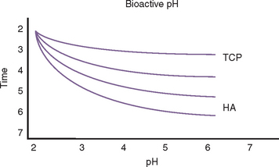
Figure 36-1 Bone graft materials resorb at different rates under normal pH conditions. However, when the pH is low, all graft materials (including bone) resorb rapidly through a solution-mediated resorption. TCP, Tricalcium phosphate; HA, hydroxyapatite.
Lactobacillus acidophilus bacteria produce a pH of 5.5, and when bacterial plaque and bacteria remain in enamel for more than 5 days, a solution-mediated resorption occurs, which is seen as a radiolucent zone on the radiograph. Infections within the bone often create a pH of less than 2. As a result, when a tooth becomes nonvital, a solution-mediated resorption occurs at the apex and a radiolucency at the apex of the tooth with an endodontic lesion may occur within a few days. Therefore bone grafting in the presence of infection, or infected bone grafts after surgery, increase the risk of insufficient volumes of bone formation and may even cause recipient bone loss (Figure 36-2). Before bone grafting, all evidence or potential causes of infection should be eliminated.
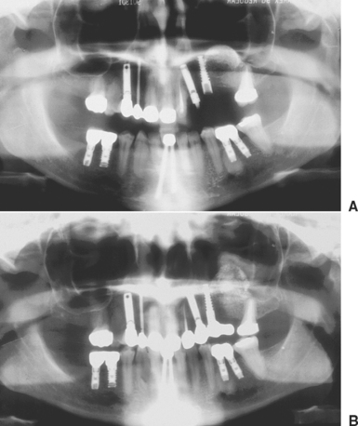
Figure 36-2 A, A panoramic radiograph of a sinus graft immediately post surgery. The radiopaque portion of the right sinus is from the mineralized, ceramic graft material which was inserted onto the maxillary floor. B, A postoperative panoramic radiograph of the same patient after a maxillary sinus infection, 2 weeks after the sinus surgery. The graft shows evidence of solution-mediated resorption of the graft material as a result of the infection.
Contamination of the bone graft may occur from endogenous bacteria, lack of aseptic surgical technique, or failure of primary soft tissue closure. Graft materials that fall into the oral cavity may be contaminated by saliva and should be thoroughly irrigated before use or discarded. The lack of primary soft tissue closure or incision line opening places the graft at significant risk. Barrier membranes or fixation screws that become exposed often become contaminated by bacteria. The bacteria invade the graft site and cause local inflammation with resultant decrease in bone formation.⁶⁻¹⁰
A blood supply within the graft is required for the normal distribution of an antibiotic to the site. Because no blood supply is present early on in the graft material, when bacterial contamination is a greater risk (i.e., sinus grafting), antibiotics may be added to the alloplastic material and autograft. Although tetracycline is often used in periodontal bone grafting to improve collagen formation, it chelates calcium and arrests the bone formation process.¹¹⁻¹³ Instead, parenteral penicillin, cephalosporin, or clindamycin may be mixed into the graft material, as these antibiotics do not affect the bone regeneration process (Figure 36-3). Tablets or capsules for oral administration of antibiotics are not used in the graft site, as these often contain fillers of no benefit to the graft site.
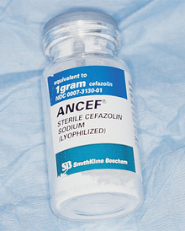
Figure 36-3 A parenteral form of cefazolin sodium (Ancef) may be added to the graft material when the site has been contaminated or become infected in the early healing process. This provides increased levels of the antibiotic at the site, even though vascularization is incomplete.

Soft Tissue Coverage (Submucosal Space Technique) and Flap Design
Primary soft tissue closure is a mandatory condition for the success of grafting procedures other than socket grafting. It ensures healing by primary intention and requires minimal soft tissue collagen formation and soft tissue remodeling. It also minimizes postoperative discomfort. It is a necessary step for predictable bone regeneration. Even when socket grafting is performed without primary closure after extraction of a tooth, the epithelium covers the healing socket before bone forming in the crestal region.
Incision line opening during initial healing is the most common postoperative complication in intraoral bone grafting.¹⁴⁻¹⁶ As a result, the graft is contaminated or lost, vascularization is delayed or eliminated, and bone growth is impaired.⁸⁻¹⁰,¹⁷⁻²⁰ The reason incision line opening is more common during bone grafting, compared with implant surgery, is that the overlying tissue must be advanced over a larger volume of bone and the tension on the incision line may pull the soft tissues apart. In addition, the soft tissues are poor in local growth factors under the reflected flaps that lie over a graft material or barrier membrane, rather than the host bone.
There are general guidelines to reduce the incidence of incision line opening.²¹ The primary incision should be in keratinized tissue whenever possible. Not only does this reduce the initial intraoral bleeding, but it severs smaller blood vessels and reduces postoperative edema, which may add tension to the incision line. The crestal incision is designed more lingual, especially in the maxilla, as this places a greater amount of keratinized tissue onto the thinner facial flap and minimizes tearing of the tissue during suturing. Vertical relief incisions are designed away from the graft site directly on the host bone and create a broad-based flap^{21,22} (Figure 36-4, A to C).
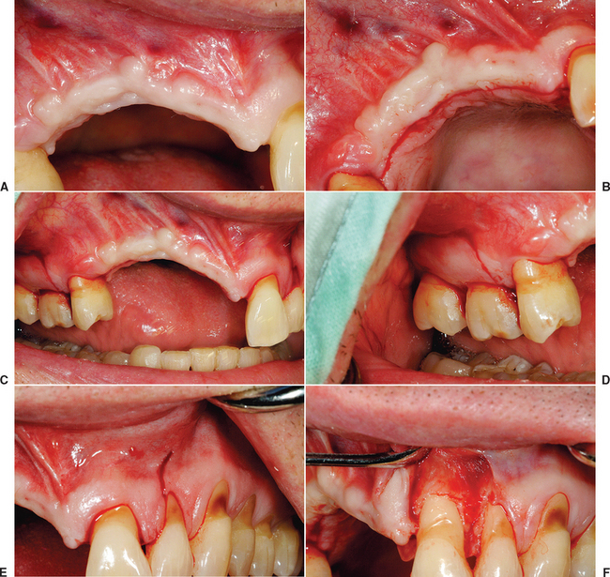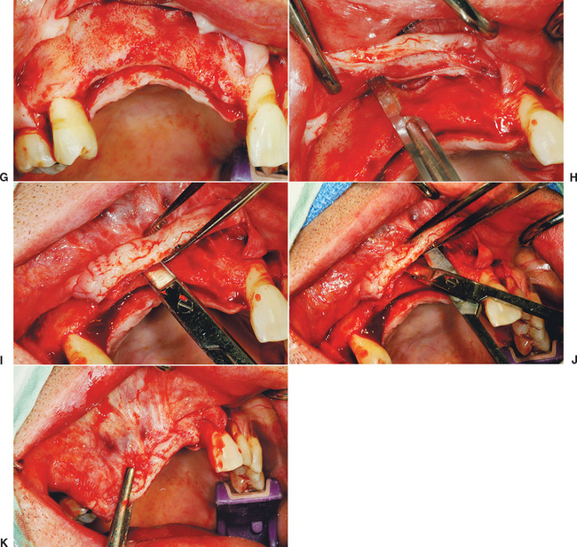
Figure 36-4 A, The site of the bone augmentation should ideally have adequate zones of attached keratinized tissue. B, The crestal incision is made in the attached keratinized tissue and slightly toward the palate. Incisions in attached keratinized mucosa minimize bleeding during surgery and edema post surgery, as smaller blood vessels are present compared with those in mobile, unkeratinized mucosa. A greater surface of keratinized tissue on the facial aspect provides a band of more tenacious tissue on the more mobile facial tissue flap. The risk of sutures tearing through the soft tissue during postoperative swelling or flap movement during function is therefore minimized. C, The larger the bone augmentation site, the farther distal the vertical release incisions. This increases blood supply to the reflected flap and minimizes tension on the incision line postoperatively. It also places the vertical release incisions on the split-thickness reflected sites away from the graft site. D, The vertical release incisions are made more distal from the augmentation site, as the size of the graft site increases. This gives more tissue to the reflected flap and improves the blood supply. The more distal incisions also ensure the wound margins will be on host bone, not over the graft site. E, The vertical release incision does not extend beyond the mucogingival junction and into the mobile alveolar mucosa, as larger blood vessels would be severed, increasing bleeding, flap retraction during initial healing and scar formation at the incision line. F, The reflection of the flap is split thickness away from the graft augmentation site, to improve early vascularization and reduce retraction of the flap. G, The full-thickness facial flap is reflected from the host bone 5 mm above the height of the mucogingival junction. H, A scalpel makes one incision parallel to the crestal incision, 1 to 2 mm deep, and extends the full length of the flap, 3 to 5 mm above the MGJ. I, A tissue pick-up may be positioned on the facial flap, with the end of the beak at the height of the mucogingival junction. When the flap is reflected, the lingual aspect of the tissue pick-up transfers the height dimension to the internal aspect of the flap. A soft tissue scissors (i.e., Metzenbaum) is pushed into the facial flap for approximately 10 mm with the blades closed, parallel to the surface mucosa. The thickness of the facial flap is approximately 3 to 5 mm. J, The tissue scissors are opened, once at the proper depth. This blunt dissection does not sever any blood vessels or nerves to the facial flap but does create a submucosal space or tunnel. K, Once the submucosal space or tunnel is created over and beyond the vertical release incisions, the facial flap may be advanced over the graft for primary closure, without tension.
The blood supply to the reflected flap should be maintained whenever possible. The primary blood supply to the facial flap, which is most often the flap reflected for a bone graft, is from the unkeratinized mobile mucosa. This is especially true where muscles of facial expression or functional muscles attach to the periosteum. Therefore these vertical release incisions are made to the height of the mucogingival junction, and the facial flap is reflected only 5 mm above the height of the mucogingival junction. Both these procedures maintain more blood supply to the facial flap. In addition, incisions and reflection in the mobile alveolar mucosa increase flap retraction during initial healing, which may contribute to incision line opening and may increase risk of scar formation and delayed healing of the incision line as a consequence of reduced blood supply (see Figure 36-4, D, E).
The soft tissue flap design should also have the margins of the wound over host bone, rather than on the bone graft or barrier membrane. The host bone provides growth factors to the margins and allows the periosteum to regenerate faster to the site. The margins distal to the elevated flap should have minimal reflection. The palatal flap and the facial tissues distal to the reflected flap should not be elevated from the palatal bone (unless augmentation is required), because the blood supply to the incision line will be delayed. In addition, the unreflected flap does not retract during initial healing, which could place additional tension on the incision line. The soft tissue reflection distal to the graft site is split thickness to maintain some of the periosteum on the bone around the incision line. This improves the early vascularization to the incision line and adhesion of the margins to reduce retraction during initial healing (see Figure 36-4, F, G).
Primary wound closure should be without tension. Past techniques to expand tissue primarily used a more apical tissue reflection and horizontal scoring of the periosteum parallel to the primary incision. This is usually effective for primary closure when less than 5-mm advancement of the flap is necessary.
A submucosal space technique, developed by Misch in the early 1980s, is an effective method to expand tissue over larger grafts (greater than 15 × 10 mm in height and width).⁵ The full-thickness facial flap first is elevated off the facial bone for only 5 mm above the height of the vestibule. One incision with a scalpel, 1 to 2 mm deep, is made through the periosteum parallel to the crestal incision and 3 to 5 mm above the vestibular height of the mucoperiosteum. This shallow incision is made the full length of the facial flap and may even extend above and beyond the vertical release incisions (see Figure 36-4, H). Care is taken to make this incision above the microgingival junction; otherwise, the flap may be perforated and delay soft tissue healing. Soft tissue scissors (i.e., Metzenbaum) are used in a blunt dissection technique to create a tunnel apical to the vestibule and above the unreflected periosteum. The scissors are closed and pushed through the initial scalpel incision approximately 10 mm deep, then opened. This submucosal space is parallel to the surface mucosa (not deep toward the overlying bone) and above the unreflected periosteum. The thickness of the facial flap should be 3 to 5 mm, because the scissors are parallel to the surface (see Figure 36-4, I, J). This tunnel is expanded with the tissue scissors several millimeters above and distal to the vertical relief incisions.
Once the submucosal space is developed, the flap may now advance the distance of the “tunnel” and drape over the graft, to approximate the tissue for primary closure without tension (see Figure 36-4, K). In fact, the facial flap should be able to advance over the graft and past the lingual flap margin by more than 5 mm. Then the facial flap may be returned to the lingual flap margin and sutured. This soft tissue procedure is performed before preparing the host region and harvesting the donor site. Access to the facial tissues is easier before graft placement, and particulate graft and membranes barrier are not dislodged during the soft tissue manipulation when it is performed before bone grafting.
The submucosal space technique is very effective to achieve tension-free closure over large graft sites. However, a side effect of the procedure is the loss of vestibular depth, especially when grafting for residual ridge height. In addition, a lack of keratinized tissue also may exist on the facial region of the grafted site, because the original facial tissue is now part of the crestal region after bone augmentation. As a consequence, soft tissue grafts or vestibuloplasties may be required after bone grafting when within the esthetic zone. It is suggested that these procedures be delayed for at least 4 months to allow regeneration of the blood supply to the soft tissue and the underlying bone. When necessary, these soft tissue procedures can be associated with implant placement or implant uncovery procedures, or even prior to the bone graft. To have mature tissue for the soft tissue advancement procedures, the soft tissue graft should be done 3 months or longer before the bone graft.
Platelet-rich plasma (PRP) may be placed over the bone graft to provide an additional source of transforming growth factor beta (TGF-β) and vascular endothelial growth factor (VEGF), which promote collagen formation and blood vessel growth (Figure 36-5).
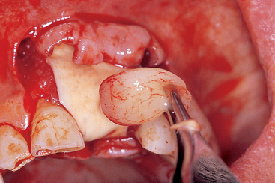
Figure 36-5 Platelet-rich plasma (PRP) may be applied to the graft site prior to soft tissue closure. TGF-β and VEGF are released from the PRP and may contribute to vascularization and early soft tissue healing.
Suture material selection should be made in function of the type and size of the bone grafting.²³⁻³⁰ Silk has been shown to release less tension during early retraction of the flap from healing and to elicit greater inflammation and may contribute to incision line opening more often than synthetic materials.^{26,27} Therefore it is not recommended for bone augmentation procedures. Chromic gut causes inflammation, loses tension, and resorbs too quickly to maintain soft tissue approximation over an augmented site. Therefore it is not recommended when the tissues are advanced for a bone augmentation.²⁹ Polyglycolic acid (PGA, Vicryl) shows the mildest tissue reaction and maintains sufficient tension over the first 2 weeks to be used for most bone graft procedures.²⁸ In larger-size bone grafts, the soft tissue is often approximated for primary closure with nonresorbable sutures (e.g., Prolene, Gore-Tex). Resorbable sutures usually lose 50% of their tensile strength after 14 days and may be associated with a delayed incision line opening (Figure 36-6). Each penetration of the tissue by the suture causes an approximate 1-mm devital zone and the need for repair. When the sutures are too close to the margin, the devital zone may include the incision line. The nonresorbable sutures remain in place for 2 or more weeks to enhance soft tissue maturation.³⁰
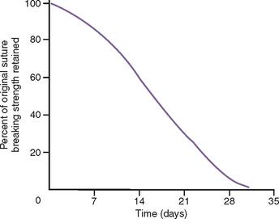
Figure 36-6 Vicryl sutures lose 50% of their strength 2 weeks after the initial surgery. As a result, a delayed incision line opening may occur if tension on the incision line from flap retraction during initial healing or from muscle pull during function/parafunction is present.
The selection of a specific suture design also follows basic principles.^{23,24} Interrupted sutures should be used 3 to 5 mm from each side of the tissue margin and 3 to 5 mm apart, and are appropriate in short spans of edentulous spaces (Figure 36-7). Too many sutures or too much tension impair the blood supply to the incision line and increase the risk of incision line opening. Because the tissues are passive while in place, sutures are not required to obtain the soft tissue closure. Soft tissue spans necessitating four or more interrupted sutures are best approximated with continuous nonlocking sutures. This suture design places less tension on the sutures and soft tissue and allows faster vascularization of the reflected soft tissue flaps.
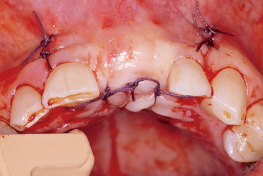
Figure 36-7 Interrupted (or continuous) sutures should be 3 to 5 mm from the incision line margin and 3 to 5 mm apart. They are used to passively approximate the tissues. Too many sutures delay vascularization to the flap and slow the healing process.
Horizontal (or vertical) mattress sutures allow greater tension to be applied on the soft tissue closure without risk of tearing the soft tissue flap. It should be emphasized that they are not used to obtain primary closure when tension on the soft tissue flaps is present at surgery. The tissues should rest passively together before suturing. However, during function/parafunction movement of the tissues, the tension on the incision line may be reduced with a horizontal mattress suture. They are often used in the mandible when the floor of the mouth is in proximity to the lingual flap and the tissue is thin. They may also be used on a facial flap with a strong muscle pull on the soft tissue. In addition, horizontal mattress sutures avert the soft tissue margin and ensure primary closure without epithelium entrapment. A combination of a few horizontal mattress sutures with a continuous suture may be indicated to close large soft tissue spans.
No particulate graft material should be present in the incision line during initial primary closure, as this will delay soft tissue healing. Therefore, once the tissues are sutured, the incision line is inspected for any bone graft particles between the soft tissue margins.
Gentle pressure is then applied to the reflected soft tissue flaps for 3 to 5 minutes. This pressure may reduce postoperative bleeding under the flap, which may cause “dead spaces” and delayed healing. Any stagnant blood under the flap is “milked” from under the soft tissue by gentle pressure. This also allows the fibrin formation from the platelets to help “glue” the flap to the graft site.
Systemic corticosteroids may be administered before and after surgery to decrease soft tissue edema, as edema has been shown to contribute to incision line opening. Incision line opening has been associated with postoperative smoking^{16,31-33}; therefore patients are instructed not to smoke until the incision line has healed. If a removable soft tissue-borne interim prosthesis is used, it should not contact the grafted area. When possible, a fixed transitional restoration is designed to reduce complications of incision line opening and graft micromovement during healing.

Space Maintenance
Space maintenance in the area of the bone graft site is paramount to the bone formation process. The space of the graft site refers to the anatomical size and contour of the desired augmentation, and maintenance refers to the fact the space must exist long enough for bone to fill the desired region. A barrier membrane is a sheet of material that covers the potential bone graft site and prevents the overlying soft tissue from growing into the graft site. A barrier membrane technique without graft material underneath has been suggested for ridge augmentation.^{18,34-38} However, collapse of the space under the membrane may impair the desired size and contour. A fixation screw, elevated above the host bone level to the height/width of the desired bone volume, may support a barrier membrane and is called a tent screw. When the space under the barrier membrane is only air or blood, the initial quality of bone is poor for many months. Tent screws, titanium-reinforced membranes, and graft material beneath the membrane have been advocated to maintain the desired space during the augmentation process.³⁹⁻⁴⁷ Space maintenance may be provided in a socket or sinus cavity by resorbable graft material. However, if the material resorbs too rapidly compared with the time required for bone formation, the site may fill with connective tissue rather than bone. Therefore the space or contour and size of the augmentation should remain until the bone graft has formed enough new bone to maintain the space itself.
The space for bone regeneration may also be provided by a graft material, as an autograft or alloplast “in excess.”⁴⁸ The “barrier by bulk” concept by Misch applies to situations in which the graft site is overcontoured by several millimeters with a resorbable alloplast.⁵ As bone grows below the alloplast, the invading fibrous tissue only invades the superficial alloplast layer. When the soft tissue is reflected to insert the implants, the top layer of fibrous tissue and alloplast is removed, and the new regenerated bone underneath remains (Figure 36-8). This technique works best when larger graft volumes still allow primary soft tissue closure and in the absence of pressure of the soft tissue. The use of soft tissue-borne provisional prostheses is discouraged for all augmentation procedures because the graft size may be modified and the graft may become mobile.
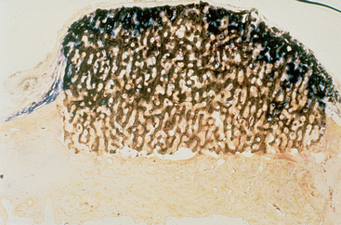
Figure 36-8 A “barrier by bulk” technique uses a graft material to maintain the space for a bone augmentation. In this picture, an alloplast (hydroxylapatite) block was placed on top of the bone and only soft tissue covered the site. After 4 months, the block biopsy was made and stained. The soft tissues stained blue and bone stained brown. Note the soft tissue invaded the block several millimeters, and bone grew into the porous block many millimeters. Removing the top layer of the graft material would remove the soft tissue and leave the rest of the site augmented with bone and the slowly resorbing graft material.

Graft Immobilization/Stability/Fixation
An implant with movement greater than 150 μm during healing does not integrate to the bone. A loaded implant may move as much as 100 μm during initial healing and develop a direct bone implant interface. However, this process occurs through bone remodeling and is less demanding on mobility. Even bone remodeling has its limits relative to micromovement. Changing the volume of bone is bone modeling and requires a more rigid interface during the bone formation process. Micromovement as low as 20 μm may be too much for bone modeling and may result in a nonfixated graft or fibrous encapsulation.
Graft stabilization is paramount to obtain a predictable bone augmentation. This ensures initial blood clot adhesion with its associated growth factors⁴⁹⁻⁵⁶ (cytokines such as interleukin-1, interleukin-8, tumor necrosis factor, and growth factors such as plateletderived growth factor [PDGF], insulin-like growth factor, and fibroblast growth factor [FGF]).⁵³⁻⁵⁶ The granulation tissue that develops after blood clot stabilization is the initial mechanism for bone modeling and remodeling.^{53,54} If pieces of a particulate graft material or block bone grafts are mobile, they cannot develop a blood supply for new bone formation. Instead, the graft becomes encapsulated in fibrous tissue and often sequestrates. Likewise, when barrier membranes or fixation screws become loose or mobile, fibrous tissue will encapsulate them. Therefore, for barrier membranes or particulate graft materials to work most effectively, no loads should be placed on the soft tissue over the graft, which may cause movement of the graft.
Barrier membranes may be immobilized to the graft site by bone tacks. As a result, when the soft tissue over the barrier membrane moves, the barrier membrane remains fixated. A tent screw placed under the barrier membrane can prevent movement to the graft site when the overlaying soft tissue is loaded. A block bone graft fixation with bone screws maintains a rigid interface more effectively than particulate grafts (Figure 36-9). A fixed transitional prosthesis, which protects the graft site, is the better option to limit graft movement during the augmentation process, especially with a “barrier by bulk” technique of particulate graft materials. When possible, soft tissue-bone removable restorations should have rest seats and clasps to prevent loading the soft tissue (Figure 36-10).
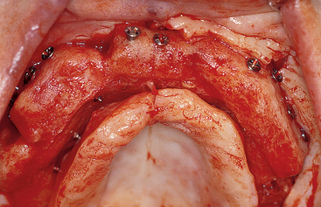
Figure 36-9 Block bone grafts from the iliac crest are fixated to the resorbed maxilla with fixation screws. These devices immobilize the graft during the bone modeling process.
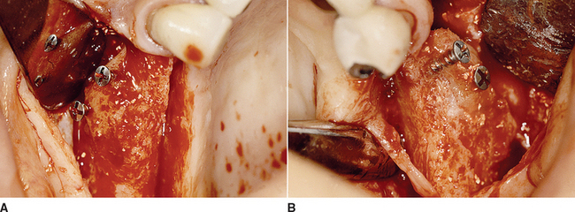
Figure 36-10 A, Upon reentry, the particulate bone graft resorbed and provided inadequate volume for implant insertion. B, The other side of the patient underwent height resorption that included part of the block bone graft. Bone width was maintained because the fixation screw protected the inferior portion of the graft.

Regional Acceleratory Phenomenon
The RAP is the local response to a noxious stimulus and describes a process by which tissue forms faster than the normal regional regeneration process.⁵⁷⁻⁶¹ By enhancing the various healing stages, this phenomenon makes the healing process occur two to 10 times faster than normal physiologic healing. The RAP begins within a few days of injury, typically peaks at 1 to 2 months, usually lasts 4 months in bone, and may take 6 to more than 24 months to subside.⁵⁵⁻⁵⁷ The duration and intensity of the RAP are directly proportional to the type and amount of stimulus and the site where it was produced. For bone injuries, the degree of remodeling activity varies depending on the extent of bone injury, the quantity of soft tissue involved in the injury, and the configuration of the bone fracture or trauma.
Noxious stimuli of sufficient magnitude, such as fractures, mechanical abuses, and noninfectious inflammatory injuries (including dental implant procedures), can evoke an RAP. Bone grafting surgery and internal fixation procedures also produce an RAP.⁵⁷ In animals, an RAP has been shown to exist after mucoperiosteal surgery on mandibular bone, with a clear correlation between quantity and quality of the noxious stimuli and degree of the RAP response.⁶²⁻⁶⁴ When bone graft augmentation is required on both the buccal and lingual aspects, the RAP is created on both sides of the ridge. The host site during a bone graft procedure should be decorticated by drilling holes in the cortical bone. These holes provide access for trabecular bone blood vessels to the graft site, expedite revascularization, and bring growth factors to the graft site.^{65,66} The marrow provides differentiated cells that evolve into osteoclasts and osteoblasts. The surgical trauma increases the RAP process, which, among other factors, includes the platelets released from the damaged vessels, which release PDGF and TGF, and increase the availability of osteogenic cells in the graft site. The penetrating holes in the cortical plate also improve graft union to the host bone, which is important when implants are placed within the seam of the donor and host site region.
The host bone decortication process may use a 20:1 low-speed hand piece at 2500 rpm with a bone drill designed for fixation screws to perforate the host bone with holes 3 to 5 mm apart and should be performed under copious amounts of saline irrigation to prevent surgical heat trauma, which delays healing (Figure 36-11). Excess heat transfers several millimeters within the bone and causes thermal necrosis, which could damage bone and blood vessels needed for repair. When injury to the bone is due to a pathologic process (e.g., arthrofibrosis, neuropathic soft tissue problems, rheumatoid phenomena, secondary osteoporosis, excessive heat), the RAP is either delayed or not initiated, and a complete healing process may not occur. When the RAP is inadequate, the result is a slow callus formation that is replaced by lamellar bone. This process contributes to the formation of biologically delayed unions and nonunion.
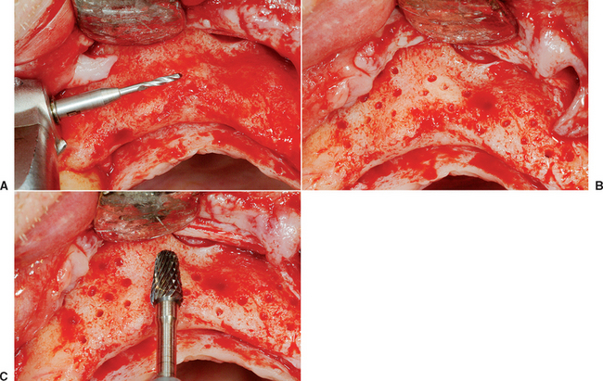
Figure 36-11 A, A low-speed hand piece (2500 rpm), similar to a root form osteotomy, may use a bone drill designed for fixation screws, with copious amount of saline irrigation. B, The holes perforate the labial plate every 3 to 5 mm to set up a regional acceleratory phenomenon (RAP) for bone repair at the graft-host bone interface. C, After the holes prepare the surface, a large pear-shaped drill may be used to recontour the host site to receive the graft and ensure no fibrous tissue remains on the host bone interface to the graft. This also increases the RAP.
The increased rate of new formation of bone caused by the RAP does not result in a change in bone volume. In other words, the RAP in and of itself is usually restricted to bone remodeling.⁶⁷ In addition, RAP is more evident in cortical bone because the normal turnover of bone cells is 2% compared with 18% for trabecular bone. Biochemical agents, such as prostaglandin E₁ and bisphosphonate, also appear to facilitate the RAP.^{62,68}
The RAP is usually accompanied by a systemic response, defined as the systemic acceleratory phenomenon (SAP), that demonstrates a metabolic response similar to the local response.⁶⁹ Inadequate RAP is also associated with several systemic medical conditions, including diabetes mellitus, peripheral neuropathies, regional sensory denervation, severe radiation damage, and severe malnutrition.

Host Bone Blood Vessels
Nutrient blood vessels must provide nourishment to an autologous bone graft to keep the transplanted cells alive. These vessels may arise from two primary sources. The host cortical bone contains very few arterioles, whereas cancellous bone has an intensely vascular network. For the blood vessels to penetrate into the autologous bone graft site, the cortical bone should be perforated or removed. This is especially important in the mandible, where the cortical plate is thicker compared with the maxilla.
The host bone blood vessels that grow into a bone graft are of primary importance for predictable bone augmentation.⁷⁰ These arteries can grow rather rapidly, compared with other tissues. Fibrous tissue may grow 1 mm each day, whereas woven bone grows at a rate of 60 μm each day. It would appear then that fibrous tissue would always win the race to fill a bony void. Yet, bone forms in an extraction socket when surrounded by walls of bone. One primary reason is that the blood vessels from the surrounding walls grow rapidly into the void and determine what type of tissue will form in the extraction site. The maxillary sinus region forms bone predictably, almost regardless of the type of alloplast or allograft material. This is in part because the antrum is surrounded by bone, and the primary source of revascularization of the graft comes from the adjacent bony walls.
Blood vessels from bone that enter the graft site provide pluripotential perivascular cells that have the capability to become osteoblasts. Monocysts in the blood form osteoclasts, which precede the blood vessel into the bone graft site by forming cutting cones, which resorb devital bone and graft material. As the osteoclasts resorb the graft material, the blood vessel can grow into the site. As importantly, the sides of the blood vessel carry osteoblasts, but only when the vessel comes from the host bone (Figure 36-12). Not only is the blood vessel needed to help the autograft maintain vitality, it is also needed to repopulate the area with osteoblasts to grow new bone. It has been postulated that the surface fibroblasts, if left to migrate within the graft, not only invade the space, but also may inhibit osteogenesis by contact inhibition.⁵⁶
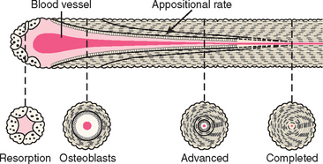
Figure 36-12 When a blood vessel grows into the graft site and comes from bone, several favorable factors occur. The osteoclasts precede the blood vessel, resorb the graft, and allow the blood vessel to grow into the space. The blood vessels from bone bring osteoblasts along the sides to repopulate the graft site with bone-forming cells. Blood vessels from the soft tissue do not populate the graft site with osteoblasts.
A tooth extraction socket fills with bone because the blood vessels from bone form granulation tissue in the site and prevent the epithelial cells from migrating into the site. Four to 6 months are then needed for the socket to replace the area filled with the blood clot (initially) and granulation tissue (later) with bone.⁷¹
One effective method to increase the amount of host blood vessels in a graft site is to decorticate the host site with a rotary drill.⁷² The blood vessels from the trabecular bone are then able to invade the graft site from below and bring pluripotential cells. To permit blood vessels from the bone to enter the graft site, there should be spaces available between the graft particles. When autogenous bone is used as a graft material, the trabecular bone graft provides these open spaces, whereas cortical bone, which presents a denser surface, takes longer to revascularize. Spaces are also necessary when alloplasts are included in the bone graft site.
When an alloplast is placed upon a decorticated ridge and covered with soft tissue (without a barrier membrane), the bone from below the graft grows four times faster into the graft voids than the fibrous tissue grows down into the graft (Figure 36-13). This is because the blood vessels from bone grow rapidly into the region, and once they invade the site, bone follows.
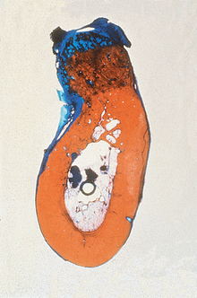
Figure 36-13 A bone graft site is decorticated and a “barrier by bulk” technique is used with an alloplast (in this case particulate hydroxyapatite) and covered with fibrous tissue. After 4 months, a block section was obtained and stained. The soft tissue is stained blue and the bone red. Note the bone grew up into the graft material four times farther than the soft tissue grew down into the graft. This is because the blood vessels grow faster than the fibrous tissue, and when the vessels come from bone, bone cells repopulate the graft and form bone. (note: The same mechanism occurred in Figure 36-8.)
An alloplast placed upon host cortical bone forms fibrous tissue around the graft, as no host bone blood vessels are able to grow into the graft material (Figure 36-14). The key to whether bone or fibrous tissue forms in the bone graft site is the host blood vessels.
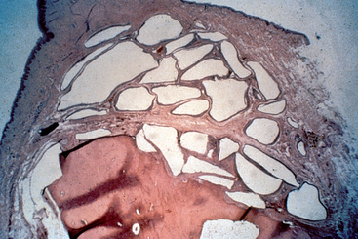
Figure 36-14 An alloplast (hydroxyapatite) placed on top of the bone that is not decorticated was covered with soft tissue and allowed to heal 4 months. A block section reveals the particles are surrounded with fibrous tissue. Because the bone blood vessels do not grow into the graft site, no bone around the particles is observed.

Growth Factors
Bone growth factors can enhance formation and mineralization of bone, induce undifferentiated mesenchymal cells to differentiate into bone cells, and trigger a cascade of intracellular reactions and the release of a number of additional bone growth factors and cell-enhancing factors. These growth factors bind to specific receptors on the surface of target cells. More than 50 known growth factors have been identified and categorized, with some specific to the functions in bone healing (Box 36-1). These constitute a separate group of proteins because of the way they can be produced and their mode of action. They are, however, part of the large superfamily of TGF-β.⁷³ Bone growth factors are primarily present in bone matrix and released during remodeling or after trauma. They act on the local osteoprogenitor differentiated cells and therefore have limited areas of action.⁷⁴ In contrast, BMPs, although also found in extracellular bone matrix, are osteoinductive and can trigger the differentiation of mesenchymal cells into osteoblasts.⁷⁵
Box 36-1 Growth Factors
1. Platelet-derived growth factor (PDGF)
2. Fibroblast growth factor (FGF)
3. Transforming growth factor (TGF)
4. Insulinlike growth factor (IGF)
5. Platelet-rich plasma (PRP)
6. Bone morphogenetic proteins (BMP)

Platelet-Derived Growth Factors
Platelet-derived growth factors are produced by activated macrophages and stored in platelets and bone matrix.⁷⁶ Platelets are the greatest source of this growth factor and may be further divided into different types, AA, BB (homodimers), and AB (heterodimers). These factors have the characteristics of a wound hormone, acting as a chemoattractant and recruiting mesenchymal cells into the wound.^{77,78} The activated platelets also enhance hemostasis by attracting additional platelets to the site, which release thrombin, thromboxane A₂, and adenosine diphosphate. Howes et al. used demineralized bone powder with PDGF in older rats to generate an increased production of mRNA for collagen II, alkaline phosphatase activity, and calcium content of the demineralized bone compared with controls without PDGF.⁷⁹ PDGFs increased cartilage and bone formation in the graft site. They have also been shown to activate collagenase within the latter stages of wound healing, which remodels collagen to promote soft tissue wound healing.
The primary roles of PDGFs in bone modeling and remodeling are to (1) increase the number of cells necessary for bone formation (including osteoblasts) at the repair site; (2) trigger capillary formation through its potent mitogenic activity; (3) enhance site debridement; and (4) provide a continued source of growth factors for bone repairs.⁸⁰ PDGF mixed with autologous bone grafts can accelerate mineralization by as much as 40% during the first year.^{79,81-89} PDGF combined with other growth factors (such as IGF)⁹⁰ have shown promising results in periodontal regeneration with guided bone regeneration (GBR).⁹¹ Further research targets the use of PDGF combined with IGF to enhance the implant-bone interface.⁹²

Fibroblast Growth Factors
Fibroblast growth factors are stored in the extracellular matrix of bone and have many of the same functions as PDGFs. FGFs can stimulate the proliferation of osteoblasts, resulting in the net formation of bone. In addition, they are a potent angiogenic factor.⁹³ However, FGF-β needs to be in the presence of bone to be effective and is more effective when used in combination with PDGF. Research on the potential benefits of FGF is ongoing but has yielded varied results, with some studies showing bone abnormalities⁹⁴ or no bone growth at all.⁹⁵

Transforming Growth Factor Beta
The super family of growth factors is TGF-β, with more than 47 known varieties. TFG-β includes cytokines that contribute to connective tissue repair and bone regeneration. Bone is the body’s most abundant storage site for TGF-β, which acts as a weak mitogen for human osteoblastic cells.⁹³ TGF-β also induces chemotaxis and stimulates extracellular matrix formation in osteoblastic cells and may inhibit osteoclast formation.⁹³
TGF-β₁ activates fibroblasts to form procollagen, which deposits type 1 collagen within the wound^{77,90} and is therefore credited with the enhancement of soft and hard tissue repair. PDGF and TGF-β₁ assist in soft tissue healing and bone mineralization; therefore they can be mixed with grafting materials into the bone graft site and applied to the top layer of the graft.

Insulin-Like Growth Factors I and II
Insulin-like growth factors I and II (IGFI, II) mimic insulin in several ways. They are fabricated in the liver and travel through the blood stream. IGF has been shown to act as a chemotactic factor for mesenchymal progenitor cells derived from bone marrow.⁹⁶
PRP is a volume of autogenous plasma that has a platelet concentration above baseline⁹⁷ (1 million platelets/μL versus normal average of 200,000 platelets/μL). It is a concentrated autogenous source of seven growth factors that are “native growth factors in their biologically determined ratios”⁸⁸ (contrary to recombinant growth factors, which are high concentrations of synthesized growth factors in the laboratory) (Box 36-2). It is not osteoinductive by itself, cannot induce bone formation alone, and therefore needs to be in the presence of bone or DFDB. However, it is a benefit to soft tissue healing also, and because soft tissue closure and blood supply are important keys to bone grafting, it is also a secondary benefit even when autologous or DFDB bone is not present.
Box 36-2 Growth Factors in Platelet-Rich Plasma
1. PDGF aa
2. PDGF bb
3. PDGF Fab
4. TGF-β1
5. TGF-β2
6. VEGF
7. Epithelial growth factor
PDGF, Platelet-derived growth factor; TGF, transforming growth factor; VEGF, vascular endothelial growth factor.
It has been observed that 90% of the growth factors of PRP are released within 10 minutes of clot activation and the remainder within 1½ hours. This is a very short time in the scheme of bone augmentation, which is a 4- to 9-month process. It is to be considered primarily a “spark” that ignites a process of cell enhancement features, which are then able to continue the process.
On the other hand, soft tissue healing is a process that is 90% complete within several weeks. The PRP influence is more noteworthy in this shorter time frame. As a result, the use of PRP should not influence the time of implant insertion into a graft if applied to an implant, nor should not be a major factor is when the device is prosthetically loaded. A study by Gerard et al. in dogs found PRP increased the amount of bone formation in a graft site at the 1- and 2-month time in load.⁹⁸ However, at 6 months, the control and PRP bone grafts had similar vital bone percentages (Figure 36-15). However, PRP may decrease incision line opening and enhance soft tissue maturation at a clinical rate that is advantageous to the general scope of the implant procedures for a bone graft.
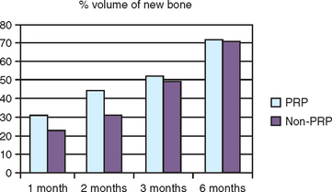
Figure 36-15 A bone graft with platelet-rich plasma (PRP) has greater vital bone cell percent for the first few months, but after 6 months, the control and PRP grafts are similar.

Preparation of Platelet-Rich Plasma
Specific steps and materials are to be used to produce PRP of a concentration of at least 1 million platelets/μL in a 5-mL volume.⁸⁶ Whole blood is primarily composed of red blood cells (RBCs) (almost 50%), white blood cells (WBCs), platelets, and serum. Red blood cells are needed for oxygen and nutrients to the cells. However, stagnant RBCs lyse and the pH is reduced, with the risk to kill vital bone cells.
In a study by Marx, iliac crest osteoblasts were stored in whole blood and in saline 9%. After 3 hours, 97% of the bone cells stored in saline 9% were still alive, whereas only 85% of cells in whole blood were vital. The stagnant RBCs in whole blood withdrawn from a vein or a normal blood clot are a deterrent to bone cell survival.⁹⁹ When a blood clot forms, 94% of the clot consists of RBCs, 6% platelets, and less than 1% WBC. In comparison, a PRP clot is 94% platelets, 5% RBCs, and 1% WBCs (Figure 36-16).
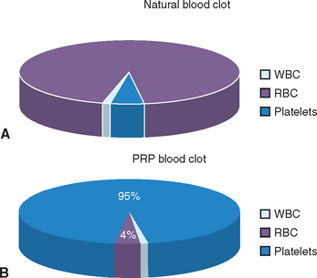
Figure 36-16 A, A regular blood clot that forms in the region of surgery is 94% RBC and 6% platelets. B, When a PRP concentrate forms a blood clot, 94% are platelets and only 5% are RBCs. WBC, White blood cell; RBC, red blood cell; PRP, platelet-rich plasma.
The first spin of the double centrifugation technique separates red blood cells from plasma containing platelets, WBCs, and clotting factors. The RBCs are separated from this first process and respun in the centrifuge. The second spin separates platelets and WBCs from the plasma and produces PRP. When the plasma is physically separated from the PRP, the plasma represents the platelet-poor plasma (PPP). One-spin techniques are ineffective at separating PRP from the PPP and produce too low a platelet count. The higher the number of platelets collected, the higher the concentration of growth factors (Figure 36-17).
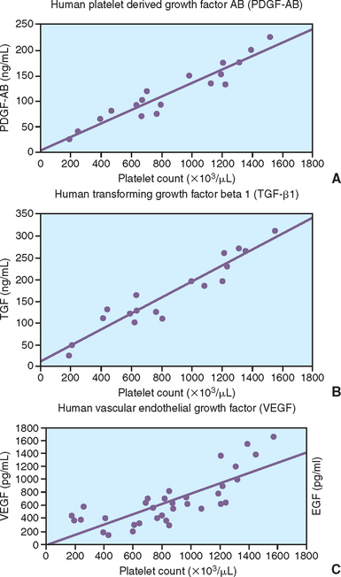
Figure 36-17 A, The greater the number of platelets/mL, the greater the amount of PDGF. B, The greater the number of platelets/mL, the greater the concentration of TGF-β. C, The greater the number of platelets/mL, the greater the concentration of VEGF.
The PRP factors have a threshold prior to making a difference in the bone and soft tissue healing process. When the threshold amount is not achieved, no difference in clinical result is obtained. Unfortunately, the threshold of making a difference in the healing process is different from one person to the next. The higher the concentration, the more likely a difference will be observed in the rate of healing. The lower the concentration of platelets, the less likely a difference will be observed.
Typically 20 to 60 mL of blood is drawn from the patient to produce a sufficient PRP volume for dental use. Once the PRP is ready for use, it should be clotted (which activates the platelets) at the time of use, because once activated, platelets start secreting growth factors immediately (90% within the first 10 minutes, 100% in 30 minutes). Therefore, an anticoagulant (such as citrate dextrox-A [ACD-A]) is incorporated into the blood at withdrawal from the vein, which may keep the PRP uncoagulated for as long as 8 hours. However, PRP is best used when produced and then within 1 to 3 hours.
PRP is not a barrier membrane. Barrier membranes prevent soft tissue from invading the bone graft site for at least several weeks or months. PRP does not prevent fibroblasts from invading a bone graft site over an extended time frame. However, it may be applied to a barrier membrane. Because it also has fibrinogen, it provides added benefits to soft tissue, acts as a hemostatic agent, and has the ability to reduce postoperative pain and edema. Bone formation where PRP is added to the graft may increase in rate, quality, and volume (Figure 36-18).⁸⁰⁻¹⁰²
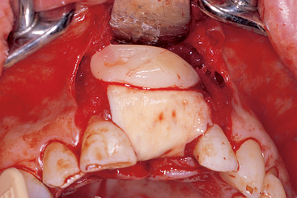
Figure 36-18 Platelet-rich plasma (PRP) is not a barrier membrane, as it does not prevent soft tissue from growing into a bone graft site for several weeks to months. However, it may be applied to a barrier membrane (e.g., Alloderm) and assist in the soft and hard tissue healing process.

Bone Morphogenetic Proteins
Bone morphogenetic proteins are distinct from growth factors in that they can be found in extracellular bone matrix and can induce mesenchymal cell differentiation into chondroblasts or osteoblasts.⁷⁵ However, they do not have mitogenic properties.¹⁰³ Urist first identified BMPs and showed their role in inducing ectopic bone formation with DFDB.¹⁰⁴⁻¹⁰⁶
BMP represents a collective term that now regroups more than 15 proteins (BMP-1 through BMP-15), many of which have been purified and cloned. For example, recombinant (concentrated) human BMP-2 (rhBMP-2) and others have been produced and have been shown to induce a complete sequence of endochondral ossification in decreased time, even for large defects.¹⁰⁷⁻¹¹³ Recombinant technology permits the synthesizing of BMP-2 and BMP-7 in larger quantities. A primary advantage is that although isolating BMP from cadaveric bones yields only 0.1 mg BMP per kilogram of bone, rhBMP-2 can be readily produced for widespread use. Areas of application that are being developed for the use of recombinant human BMP include large bone grafting sites, such as the maxillary sinus,^{114,115} large periodontal defects,¹¹⁶⁻¹¹⁸ and the bone-implant interface.^{119,120} Giannobile et al. have reported on novel delivery systems for these BMPs to enhance periodontal and oral rehabilitation.^{121,122}
Recombinant BMP-7 (OP-1) has been developed in the orthopedic field for very large bone defects. Most of the literature has concentrated on long bones of endochondral origins, and dental applications appear remote.¹²³
In conclusion, there are four methods to increase bone and tissue growth factors during bone augmentation:
1. The PRP collected from the patient’s blood may benefit the bone formation process and/or laid on top of the graft and membrane to promote soft tissue healing.
2. The use of autologous bone in the graft site can increase PDGF, FGF, TGF-β, IGF, and BMPs, as all are stored in the bone and released during the augmentation process. The BMP in an autograft primarily has an effect to provide growth factors at 2 weeks and with a peak at 6 weeks.
3. A third method to introduce growth factors at a bone graft site is to use an allograft in the graft site.⁹⁰ The DFDB from cortical bone contains a higher percent of BMP than trabecular bone, and therefore is the material of choice. However, the amount of BMP in commercial bone bank allografts is very small (0.001 mg) and is not a very significant factor.
4. A fourth method to increase the growth factors in the graft site is by the RAP process, which triggers a release of growth factors into the site.
All four of these methods are typically used in the bone augmentation process, especially when other key elements are scarce.

Healing Time
Adequate time must be provided for the graft to resorb and regenerate new bone volume. The amount of time required is variable and depends on local factors, such as the number of remaining walls of bone, the amount of autogenous bone in the graft, and the size of the defect. Larger grafts, less autogenous bone in the graft, and fewer bony walls surrounding the site increase the amount of healing time. In addition, systemic diseases such as diabetes, hyperparathyroidism, thyrotoxicosis, osteomalacia, osteoporosis, and Paget’s disease may all affect the healing response. It is usually best to err on the side of safety. As a general rule, 4 to 6 months are recommended when graft volumes are less than 5 mm in dimension. Graft volumes more than 5 mm in dimension often require up to 6 to 10 months.
Often, a premature reentry gives the impression the bone graft did not work, and alloplast materials still represent the majority of the graft. Although this may be correct, it is not unusual that an additional healing period of several months would have allowed reentry in a successful graft site (Figure 36-19). Time frames may be shortened when additional keys to bone grafting are incorporated. As a general rule, the surgeon should provide enough keys to bone grafting to permit reentry in less than 8 months. If more than half the graft is from autogenous origin, a prolonged healing period of more than 1 year is often not beneficial and may result in bone resorption of the newly grafted site. On the other hand, some dense bovine calcium phosphate materials may require more than 2 years to be resorbed and replaced by bone.
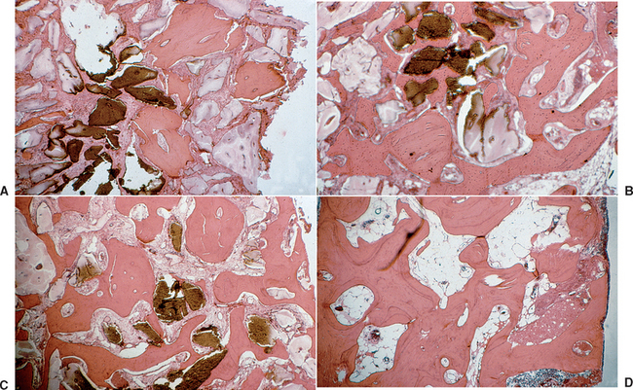
Figure 36-19 A, A combined autologous, demineralized freeze-dried bone (DFDB), and alloplast (bovine hydroxyapatite [HA]) graft, was placed as a sinus graft, and a biopsy was taken at 2 months. Most of the core biopsy is allograft and alloplast. B, Another core biopsy from the same patient after a 4-month healing period. Note most of the DFDB has been resorbed, and more vital bone is present. C, The same sinus graft patient had another core biopsy taken at 8 months. Almost all the DFDB and most of the bovine HA has resorbed and been replaced by vital bone. The bone is beginning to form a trabecular pattern. D, A core biopsy taken at 12 months in the same patient and graft site. All the sinus graft has been replaced by vital bone, and the bone structure is similar to a normal posterior maxilla.
(Courtesy S. Wallace.)

Defect Size and Topography
The size of the defect is a factor in the healing time, the vascularization, and the transitional prosthetic options. It is also a factor for the graft material selection. The larger the bone defect in width and height, the longer the period of bone maturation before implant insertion. The larger the bone defect, the more autologous component needed in the graft. This relates to the creeping resorption and vascularization requirement for a larger graft site. The larger graft sites may require a removable restoration, as fixed transitional spans of four or more teeth are very prone to fracture and uncementation.
On the other hand, when a graft site is small, it is not unusual to insert the implant in the correct position and graft the site at the same time as implant insertion. When this is considered, the implant most often is not placed in function but is left to heal with an alloplast and primary soft tissue closure. When an implant is uncovered and a small defect is present, most often the graft site is augmented and the permucosal element or abutment is added. The implant may be restored with a transitional prosthesis out of occlusion, if it is rigidly fixated and fulfills all other requirements. The implant should not be loaded because crestal marginal stresses are greater under load. A bone graft at the crest of the ridge will not perform as predicted during the modeling/remodeling process that occurs during early bone formation.
The topography of the graft site is also a key for predictable bone augmentation, as it affects soft tissue closure, space maintenance, graft immobilization, vascularization, growth factors, BMPs, and healing time—in other words, almost every aspect of the equation. When the vital bone of an extraction socket is 1.5 to 2 mm thick or greater on the facial, lingual, mesial, distal, and apical regions, a 5 bony wall defect is present. This is an ideal environment for bone growth, as most all the keys are already present. The space will be maintained by the surrounding walls of bone and the graft is immobilized by the bony walls. Growth factors, BMPs, and RAP are released from the periodontal complex and walls of bone as a result of the extraction. As a result, bone grows in the site, even without initial soft tissue closure over a graft material.
On the other hand, when a bone augmentation for height and width is necessary, as for an onlay graft in a Division D bone volume host site, almost no keys are present for the augmentation. This condition represent a one-wall bony defect that needs 12 mm in height and 6 mm or greater in width and requires the surgeon to provide as many key factors as possible. In addition, the bone graft material in these unfavorable conditions must be primarily autologous cortical and trabecular bone—in other words, the number of walls of host bone and the size of the defect combine to affect almost all aspects of the bone augmentation process.
In the periodontal literature, it is well documented that a three-wall bony defect next to a tooth root can be restored more predictably than a two-wall bony defect. Likewise, a three-wall bony defect in an edentulous site can be augmented better than a two-wall defect. Most often, a three- to four-wall defect in implant dentistry corresponds with a lack of facial bone. The bone is present on the lingual, mesial, distal, and apical regions (four-wall defect), the apical region is too narrow or compromised (three-wall defect), or the bone defect is next to a tooth root (Figure 36-20). Under these conditions, soft tissue closure, space maintenance, and graft immobilization become more critical. A barrier membrane and longer healing time are often necessary. The graft material in a three- or four-wall defect does not require only an autograft as the major component, although it is of benefit. The number of bony walls remaining around the defect is a key to predictable augmentation (see Chapter 37).
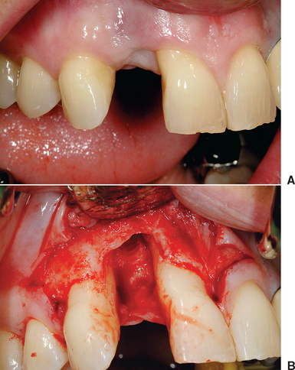
Figure 36-20 A, A bone defect is observed between two teeth. B, A bony wall is present on the palatal and apex. No bone is on the mesial, distal, or buccal. This two-wall bony defect will be difficult to cement because few keys are present.

Transitional Prostheses
The transitional prosthesis worn during the soft tissue healing and maturation of the bone is a critical component of predictable bone grafting. The transitional restoration affects the keys of soft tissue closure, the maintenance of space for the augmentation, and the immobilization of the graft during healing. In addition, the restoration often restores some esthetic and functional components for patients during the many months required for the maturation of the bone. It may also help contour the soft tissues and allow maturation before the final fabrication of the prosthesis. The value of transitional restorations should not be underestimated from either a patient management or a predictable outcome perspective.
Whenever possible, a fixed restoration that does not rely on soft tissue support in the area of the bone graft is preferred. There are several options to accomplish this goal. When natural teeth are in position around the graft site and require restoration, a transitional acrylic fixed partial denture may use the natural abutments and pontics span the site of the augmentation (Figure 36-21). Whenever the pontic span is greater than two teeth, consideration is given to metal reinforcement, as the risk of fracture exponentially increases. Other options include increasing the bulk of acrylic (twice the thickness decreases fracture risk by half) and eliminating occlusal forces over the pontics.
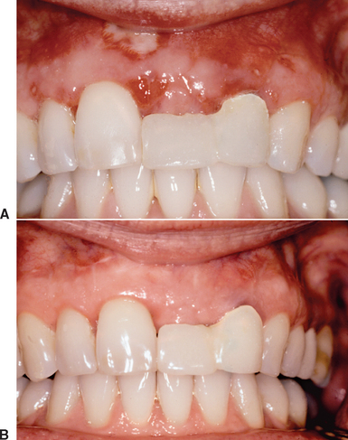
Figure 36-21 A, A provisional prosthesis with a pontic was used to restore the missing tooth over the grafted site to provide an undisturbed healing environment. B, A fixed transitional prosthesis is the best treatment option during graft maturation.
When natural teeth are present adjacent to the augmented sites but do not require restoration, a resin-bonded prosthesis may be fabricated. These are designed gingival to the occlusal contacts, so the teeth do not require preparation. However, this increases the risk of debonding, so a secondary removable device may be delivered and used as an emergency until the patient is able to return to the office for rebonding of the restoration. These resin-bonded prostheses should use acrylic denture teeth so that they may be modified (add or subtract) at the time of surgery and during the healing process.
When natural teeth are not present adjacent to the bone graft site, a fixed temporary may be fabricated on a small diameter and temporary implants placed in the lingual plate or in sites away from the bone graft. These implants are often inserted at the same time as the bone graft and immediately restored with an acrylic, fixed, transitional prosthesis. These restorations should be out of occlusion in partially edentulous patients and have no posterior cantilevers out of the esthetic zone in completely edentulous patients (Figure 36-22).
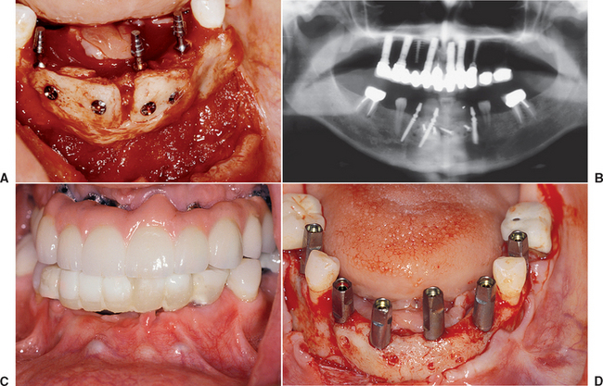
Figure 36-22 A, A block bone graft is placed in an anterior mandible. Small-diameter transitional implants are inserted into the lingual plate. B, A postoperative panoramic radiograph of the mandibular block bone graft and three transitional implants. C, A transitional prosthesis on the small-diameter implant is out of occlusion during the healing period. D, After bone graft maturity, the transitional implants are removed and the final implants are inserted.
The transitional implants should engage as much cortical bone as possible and therefore are usually longer than implants with a delayed loading protocol. At the reentry and final implant placement, the transitional implants are often removed. At this point, the final implants may be immediately loaded to support a modified transitional restoration, or a removable prosthesis may be fabricated. The risk of micromovement on the soft tissue over the graft site is less, as the graft has already matured 4 to 8 months before the implant placement. There is a higher risk of implant failure with transitional implants, which, as a consequence, may cause loss of graft volume. Therefore other transitional methods, when possible, are suggested.
A removable restoration may be fabricated over the bone graft but should be designed to not load the soft tissue over the graft site. When teeth are present, a cast metal framework with direct and indirect retainers and rest seats may be fabricated. Before the removable partial denture framework design, a stone cast of the patient’s mouth is augmented with clay or wax in the laboratory in the sites of the future bone graft. In addition, the framework does not have metal mesh over the bone graft site. Otherwise, the surgeon most often must remove the chrome cobalt mesh, as the laboratory often does not provide enough relief between the augmented site and the metal framework (Figure 36-23).
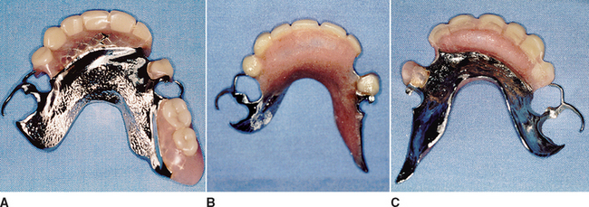
Figure 36-23 A, A removable partial denture with rest seats and clasps may be modified over a bone graft. B, Acrylic is added to the external side of the prosthesis to increase the thickness over the grafted site. C, The framework is then relieved to ensure a lack of pressure on the grafted site.

BONE GRAFT MATERIALS
In addition to the keys needed to develop a predictable bone augmentation site, there are materials necessary to augment the location. Bone graft materials and their mechanism of action are not all the same. The materials most often used in implant dentistry to aid in bone augmentation include: (1) collagen, (2) human DFDB, (3) human freeze-dried allograft (FDB), (4) xenograft bone, and (5) autogenous bone (Box 36-3).
Box 36-3 Bone Grafting Materials
• Collagen
• Autologous bone (osteogenesis)
• Allografts DFDB, FDB (osteoinduction)
• Xenografts (osteoconduction)

Collagen
Several types of collagen are found in the human body. Type I collagen is among the first products synthesized by the body when bone formation occurs.^{124,125} The irregular pattern of initial bone formation (woven bone) is a result of the rapid, unorganized response of the body to lay down collagen, which is then invaded and mineralized with HA along the direction of the collagen fibers by osteoblasts. The haphazard organization of collagen results in unorganized bone formation, called woven bone, which forms first and at a faster rate and is less strong. The most common source of collagen in implant dentistry is bovine collagen from the “Achilles” tendons in the leg. Another source of type I collagen is DFDB, which can provide the space necessary for blood vessel ingrowth into the graft and may contribute to the bone formation process. However, DFDB alone has not proven an effective graft material and should be combined with other categories of bone-grafting materials.
Collagen also is an integral part of the soft tissues with chemotactic and hemostatic properties. It can bond and activate platelets to form a platelet plug within the vessel. It may also act as a scaffold for migrating cells of the epithelium. In the application of bone regeneration, collagen may be used at the level of the soft tissue to accelerate healing over an extraction site or to promote coagulation of a bleeding surgical site.
Over the last decades, several collagen barrier membranes have been introduced for guided bone regeneration. Processed bovine type I collagen membranes (from tendons and dermis) have yielded favorable results to decrease the invasion rate of epithelial cells or fibroblasts into a graft site. Resorption rates of collagen barrier membranes are variable, with ranges from a few months to 1 year, and are often intended to be maintained for the whole bone regeneration cycle.

Autologous Bone and Osteogenesis
An important key for predictable bone augmentation is the presence of autogenous bone as a component of the graft. Autogenous bone is the only graft material that directly forms bone from transplanted trabecular bone cells. The autogenous graft also contributes to bone growth with several growth factors (e.g., BMPs) that are released into the environment during incorporation of the graft and form bone through induction. The autograft, which becomes nonviable bone, acts as an osteoconductive matrix of calcium phosphate for bone growth by creeping substitution (Figure 36-24). The space requirements of grafting may also be fulfilled by the autogenous bone because its physical volume maintains the contours of the desired augmentation. The growth factors also help the soft tissue healing on the outside and accelerate blood vessel growth into the graft site of the host bone on the inside of the graft.
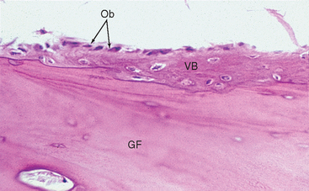
Figure 36-24 A bone biopsy of an iliac crest bone graft after 6 months of healing. Most of the autograft is devital. Bone is growing into the graft around the newly formed blood vessel. As the bone graft resorbs, it is replaced by new, vital bone (creeping substitution). Ob, Osteoblasts; VB, vital bone; GF, graft (autograft).

Osteogenesis
Osteogenesis refers to the growth of bone from viable cells transferred within the graft. Autogenous bone is the only graft material available with osteogenic properties. There are more osteoblasts in trabecular bone than cortical bone. New bone may be regenerated from endosteal osteoblasts and marrow stem cells transferred with the graft. This is not to say cortical bone is not an effective graft material. In fact, the author has observed that the cortical bone grafts from the mandibular ramus and symphysis and the cortical bone grafts from the iliac crest form more volume of bone than trabecular bone grafts from these regions. Apparently, cortical bone, although less rich in osteoblasts, has great osteoconductive properties and bone growth factors.
For the transplanted autogenous bone graft to produce osteoid, it must remain vital. Vitality of the graft may be improved in several ways. The recipient site is prepared first so that minimal time elapses between graft harvest and placement. It is then placed into an environment that provides for prompt angiogenesis to maintain its viability, rather than mixed with other synthetic graft materials, which impair blood vessels to reach the autogenous bone graft (Figure 36-25). As a result, the optimal place for the autologous graft is directly on the host bone after the cortical bone of the host site has been decorticated with a surgical bur (Figure 36-26).
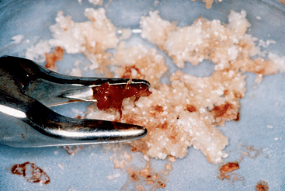
Figure 36-25 The harvested autograft should not be mixed with other alloplasts or allografts, but should be placed on bone for early vascularization to minimize autograft cell death.
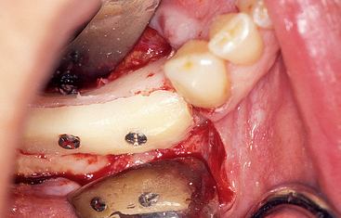
Figure 36-26 An autograft should be laid directly on top of the host bone. This releases growth factors, including those required for early vascularization, which is needed to maintain the vitality of the bone graft.
Once harvested, the autologous graft should be used immediately (which is preferable) or stored in sterile saline, lactated Ringer’s solution, or D₅W(5% dextrose in water), to maintain cell vitality. Distilled water is contraindicated as a storage media, as the hypotonicity results in cell lysis. Storing bone grafts in blood is also detrimental to cellular survival, as red blood cells release several cytotoxic products once the cells lyse.⁹⁸ Because the autogenous graft material may require an additional operative site, it is usually selected when conditions for growth of bone are less ideal or in combination with other allografts or alloplasts.
The mechanism of bone growth within autogenous bone grafts includes three phases. Some transplanted osteoblastic cells survive the first 3 or 4 days through nutrition from the surrounding vascular tissue. The osteoblasts and stem cells at the surface of the bone graft from either trabecular or cortical bone that survive the transplantation process are responsible for proliferation and formation of new osteoid product.¹²⁶ This osteogenic process, referred to as phase I bone,¹²⁷ is related to the number of cells transplanted and initially dictates the amount of new bone that will directly form beyond the original dimension. Most of the osteocytes within the mineralized cancellous bone die because they cannot directly access nutrients (Box 36-4).
Box 36-4 Autogenous Bone

Bone Blood Supply
Phase I: Osteogenesis—bone regeneration
Surviving cells 4 weeks (osteoid)
Phase II: Osteoinduction
BMP release 2 weeks to 6 months; peak at 6 weeks
Phase III: Osteoconduction
Inorganic matrix-space filler
Phase IV: Cortical plate, barrier membrane
BMP, Bone morphogenetic protein.
Blood vessels can grow into a graft site with almost the same speed as fibrous tissue, at approximately 1 mm per day. The graft success, therefore, depends on early vascularization.¹²⁸ In the hypoxic environment of the recipient bed and graft, macrophages secrete macrophage angiogenesis factor (MDAF) and macrophage-derived growth factors (MDGF). Platelet degranulation releases PDGF, which also initiates angiogenesis.¹²⁷ This process is directly proportional to the density of cells transplanted.¹²⁹ Therefore, to increase the transplanted cell volume when trabecular bone is harvested, the overall volume of the graft is packed into a syringe and compressed to provide as many bone cells per area as possible.¹³⁰
The fresh autogenous trabecular bone that provides the survival of the maximum number of transplanted bone and undifferentiated cells for large grafts is usually harvested from the ilium. However, only osteoblasts within 300 microns of the blood supply within the first 1 to 2 weeks will survive, whereas all others die before adequate nutrition can reach them by diffusion.¹²⁷ Because blood vessels may grow 1 mm per day, only the autologous graft less than 7 to 10 mm thick will survive the transplantation.
In the 3 to 7 days after bone grafting, stem cells and endosteal osteoblasts produce only a small amount of osteoid. Production increases as soon as oxygen and nutrients can be brought by the newly developed bloodstream. Therefore, initially, primary osteoid develops between the trabecular bone. New bone consolidation also occurs during this phase, which produces an unorganized woven bone.

Demineralized Freeze-Dried Bone and Osteoinduction
Osteoinduction involves new bone formation from osteoprogenitor cells derived from primitive mesenchymal cells under the influence of one or more inducing agents that emanate from the bone matrix.¹³¹⁻¹³³ When an osteoinductive material is placed subcutaneously in the absence of bone or within a muscle, it has been shown to induce bone formation in the ectopic site. Landmark work in this particular class of bone graft materials has been performed over the years by Urist et al. to identify the osteoinductive factors and their mode of action.^{104,134-136}
The first phase of the bone formation process (osteogenesis) diminishes within 4 weeks. As the transplanted bone cells die, osteoclasts from the host tissue precede the invading blood vessels and remodel the graft by resorption. Inductive proteins and growth factors are then released from the transplanted bone and initiate the phase-II osteoinductive process. Stem cells in the graft and BMPs mostly from cortical bone also contribute to osteoblast differentiation and new bone formation and result in phase II bone, which is less cellular, more mineralized, and organized. This phase begins after approximately 6 weeks and lasts as long as 6 months.
The most commonly used osteoinductive materials for bone augmentation in implant dentistry are bone autografts and allografts. A bone allograft is an osseous, transplanted tissue from the same species as the recipient but of different genotype. Therefore, when performing grafts on humans, cadaver bone must be used. However, when using allograft for animal studies on dogs, dog bone must be processed. The main advantage of allografts is that they eliminate the need for a donor site. In addition, their unlimited availability permits their use in large quantities if necessary. However, larger grafts most often require other material to make the bone augmentation predictable. Osteoinductive materials are more contributory to bone formation during the remodeling process.¹³⁴ The tissue is processed and then stored in various shapes and sizes in bone banks for future use.¹³⁷ There are primarily three types of bone allografts: frozen, freeze-dried, and demineralized freeze-dried.
Frozen bone is often harvested, frozen, and stored for use on the same patient at a later date. It may also be irradiated to decrease the immune reaction when used for a different recipient. Allograft frozen bone is rarely used in implant dentistry because of the risks of rejection and disease transmission. It has often been used in biomechanical analyses to determine the physical properties of bone found in the jaws.
The most common allografts used in implant dentistry are DFDB and FDB. The process to form FDB and demineralized DFDB is different and specific, although some variations among laboratories exist.¹³⁶ In both allografts, cortical and trabecular bone is harvested in a sterile fashion from a disease-free donor. The bone is then washed in distilled water and ground to a particle size of 500 μm to 5 mm. It is then immersed in 100% ethanol to remove fat, frozen in nitrogen, then freeze-dried and ground to smaller particles (250 to 1500 μm), which has been shown to promote osteogenesis.¹³⁶ The desiccating step allows for long-term storage and decreases antigenicity. This bone process results with FDB. Solvent-preserved products have been developed instead of freeze drying to reduce antigenicity and still assure a minimal risk of contamination.¹²⁸⁻¹⁴⁰ The inorganic and organic matrix is therefore maintained because the calcium and phosphate salts of HA remain.
The organic material in bone, which includes bone morphogenetic proteins, is found within the structure of the HA. However, osteoclasts are required to resorb the bone to release its bone growth factors. This delays the release over a longer period. Coupled with the fact that very little growth factors are present, this results in a graft material that is primarily an inorganic mineral source of HA, which serves as scaffold for bone formation. Therefore FDB acts primarily through an osteoconductive process, because inductive proteins are slowly released after resorption of the mineral and often found in only minute quantities (Table 36-1).
Table 36-1 Allografts
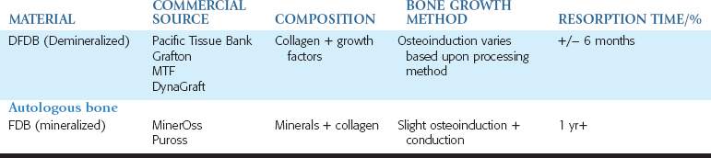
DFDB and FDB have a similar initial processing step, but DFDB is produced by an additional step, demineralizing the ground bone powder in 0.6-N hydrochloric or nitric acid for 6 to 16 hours. The BMP is not acid soluble, but the calcium and phosphate salts of HA are acid soluble and therefore are removed from the bone in the acid-reducing process. As a result, the demineralization of the freeze-dried bone more readily exposes the BMPs.^{141,142}
Completely demineralized grafts have been shown to stimulate more bone induction than partially demineralized material.¹⁴³ Because the mineral salts are removed from the bone, the nonsoluble BMPs are available in the local environment earlier than with freeze-dried bone, which requires their release by osteoclastic activity. As a result, more undifferentiated cells may transform earlier into osteoblasts.^{144,145}
Therefore FDB is primarily osteoconductive and DFDB is not osteoconductive (as it has no mineral) but is believed to be more osteoinductive.
After washing and dehydration of the DFDB after the acid bath, it is often either irradiated or sterilized in ethylene oxide (EO) to further decrease the antigenicity and to protect the host from disease transmission. The use of irradiation is controversial, and it is generally agreed that doses greater than 2.5 Mrad of irradiation are destructive to the BMPs and, therefore, to bone formation.¹⁴⁶ EO is also controversial, and it is recommended to limit it to a 5-hour EO sterilization process at 29° C to maintain osteoinductive properties.¹⁴⁷
Several tests are performed to evaluate the safety of the allograft and to ensure that the acid demineralization process destroys all pathogens.¹⁴⁸⁻¹⁵⁰ The probability that a particular graft of DFDB might contain human immunodeficiency virus has been calculated to be 1 in 2.8 billion,^{151,152} and to the author’s knowledge, no occurrence has been reported in the literature. Because some reports suggested that a dose of irradiation or EO sufficient to kill spores may render the BMP in the allograft unable to induce bone formation, it may be beneficial to use DFDB bone that is harvested from soft tissue donors with no history of disease transmission and no preparation history of radiation or EO.¹⁴⁸ Results of studies using DFDB for bone regeneration are conflicting. Several reports conclude that DFDB exhibits osteopromotive properties, whereas others question such benefits.^{34,35,153-158} In particular, some reports raise the question of variability of BMP concentration and activity in commercially available allografts, and therefore qualify them as less predictable.^{139,159} Product fabrication and formulation are critical in ensuring the quality and osteoinductive properties of the product.¹⁶⁰⁻¹⁶⁴ The osteoinductive properties of DFDB are variable from one cadaver source to another. As a general rule, the younger the cadaver, the more BMPs available in the bone.¹⁶⁵ The demineralized cortical bone mineral contains a higher concentration of BMPs than trabecular bone and is recommended. In addition, membranous cortical bone exhibits greater concentrations of BMP than endochondral cortical bone, so the skull represents a better source of inductive proteins than the rest of the skeleton.
Some studies that substantiate the osteoinductive capacity of DFDB have been performed with materials enriched with rhBMP-2. These studies may have as much as 500 to 1200 mg of BMP compared with 0.001 mg found in a 5-g vial of DFDB from a bone bank; therefore the results may not be reproducible in clinical practice.^{108,166,167} This explains some of the wide variability of the results discussed in the literature related to DFDB.
The particle size of DFDB may also affect its efficacy. Sizes smaller than 150 μm are less effective than those of 250 μm or larger. Fibers of cortical bone (e.g., Grafton) are more effective than particles. When a bone matrix fiber forms new bone, the osteoid material creeps along the length of the fiber. When a particle forms new bone, it appears localized to the particular spot (Figure 36-27). On a histologic slide, 1 DFDB particle out of 10 to 20 appears to form new bone, whereas more fibers appear to participate more often in the inductive process and act as a wick to promote bone formation along the entire length of the cortical fiber. More recently, putty consistency products have been introduced that facilitate delivery and use of the material intraorally. The fillers used to create the putty do not participate in the bone formation process and serve only to make the product more user friendly. The bone fibers in this preparation provide a scaffold for new bone growth and have been shown to be more inductive than particle forms of the DFDB.
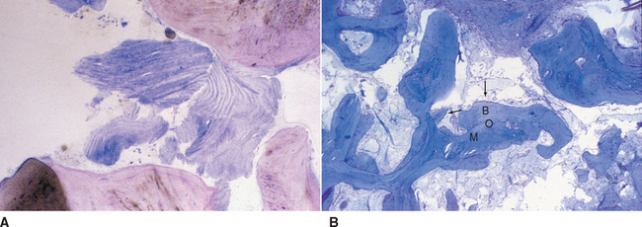
Figure 36-27 A, A particle of demineralized freeze-dried bone (DFDB) may be inductive and contribute to the bone graft. However, it has been observed by the author that very few particles participate in the inductive process, and marginal new bone formation next to a particle is observed. B, A cortical fiber of DFDB (Grafton) in a histologic section after a similar time frame elicits greater bone formation, more fibers participate in the inductive process, and greater new bone contact is observed along the length of the fiber. B, New bone formation; O, initial bone formed by induction; M, matrix of DFDB fiber (Grafton).

Calcium Phosphate Minerals and Osteoconduction
It is postulated that the inorganic matrix of HA, which forms a scaffold in the autogenous graft, contributes the osteoconductive effect of bone formation as new bone forms by creeping substitution. This may be considered a third phase of bone formation by autogenous bone⁴⁸ (see Box 36-4).
Osteoconduction, which characterizes bone growth by resorption or apposition from the surrounding bone, has been called creeping substitution. Therefore this process must occur in the presence of bone or differentiated mesenchymal cells. Osteoconductive materials do not grow bone when placed into subcutaneous tissues, muscles, or fibrous tissue. Instead, the material remains relatively unchanged or resorbs. Osteoconductive materials are biocompatible, and bone or soft tissue can grow adjacent to them by apposition without evidence of a toxic reaction. The most common osteoconductive bone grafting materials used in implant dentistry are allografts, alloplasts, and xenografts. Allografts such as FDB already have been addressed. Recently, allografts that maintain the inorganic portion of bone (versus the organic components, such as in DFDB) have gained acceptance as the osteoconductive portion of the graft. Alloplastic materials are exclusively synthetic, biocompatible products developed to cover a broad range of indications. They come in a great variety of textures, particle sizes, and shapes (Table 36-2). They may be separated into ceramics, polymers, and composites. The most frequently used are ceramics, which may be characterized as bioinert (e.g., aluminum oxide and titanium oxide) or bioactive (e.g., calcium phosphate). Bioinert ceramics exhibit direct bonding with the host bone (at the light microscopic level) and are mechanically held in contact to the bone. The healing of bone around a bioinert osteointegrated implant is an osteoconductive process, which follows typical phases of remodeling at the bone-implant interface.
Table 36-2 Alloplasts
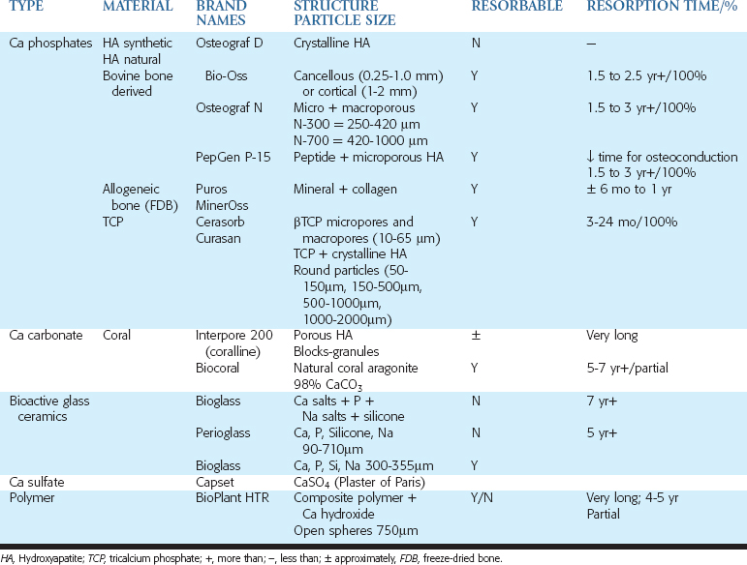
Bioactive ceramics are the largest family of alloplasts used for bone augmentation and include calcium phosphate products such as synthetic HA and bovine-derived anorganic bone matrix, tricalcium phosphates, and calcium carbonates. Calcium phosphate materials display a complete lack of toxicity. Their ability to act as a substrate for bone growth makes them a popular material for osteoconductive properties, but they are not osteogenic or osteoinductive.¹⁶⁸
Xenografts are fabricated from the inorganic portion of bone from animals other than humans and are also osteoconductive. Xenograft bone is reported as a good bone bank material, provided it is completely deproteinated and placed in a bed of bleeding trabecular bone or used with autologous red marrow.¹⁶⁹ It may also be used to augment soft tissue. Proponents of xenografts believe that the nonorganic bone of the animal most resembles the natural human bone mineral.
Osteoconductive materials for hard tissue maintenance or augmentation may be characterized as nonresorbable or resorbable, dense or porous, or crystalline or amorphous materials. Dense HA has become a popular bone substitute when living bone is not a requirement for the augmentation. This material has been described as nonresorbable when it is a highly dense crystalline structure.^{170,171} In the presence of bone, a direct bone-HA interface may be observed.¹⁷⁰ This finding is more common when dense HA is placed within the bone and fibrous tissue is not in direct contact during healing. Fibrous tissue proliferates at a rate of 0.5 to 1 mm daily, compared with bone that forms much slower (approximately 50 μm per day). Thus the soft tissue has the capacity to reach and encapsulate the HA when it is placed on top of cortical bone. The contacting layer of HA may develop a bony interface, but the majority of material is surrounded by fibrous tissue.¹⁷³ The purpose of this type of augmentation is to serve as a denture support region or tissue augmentation to improve soft tissue contours around implants or teeth. When the material is placed into a bone preparation, tooth socket, or other cavity, such as the maxillary sinus, or covered with a barrier membrane (which prevents fibrous tissue from reaching the HA), the tissue developing at the interface is more likely to be bone. However, the material does not resorb to allow creeping substitution and new bone to replace the HA.
Dense HA is inorganic and, as such, cannot grow or integrate to an implant surface. It is also three times harder than cortical bone and is more similar to dentine than bone. Therefore when placed into bone, its primary purpose is to obtund a space and maintain bone contour and volume. If an endosteal implant is planned in the bone-dense HA region, a diamond and high-speed hand piece may be required to prepare the HA. Therefore this material is not recommended for placement into sockets that may receive dental implants in the future. A more common use for dense HA is its placement on the facial or crestal aspect of a ridge around implants to improve the soft tissue contour, or as a ridge augmentation material for denture support.¹⁷⁴ Its use was more widespread a few years ago when fewer bone augmentation products were available.
Highly crystalline HA is more resistant to cellular breakdown than the amorphous form. The crystalline structures of available graft materials present differences based on the origin of the product. It is felt that small crystals, such as observed in normal bone, are desirable. The different treatment (chemical or heat) results in different crystal sizes. It is argued that heat treatment (in excess of 1000°C) results in crystal growth, which does not change the basic structure but may cause altered surface characteristics. In vivo implantation studies in animals suggest that the resorption rate is somewhat proportional to the tricalcium phosphate (TCP) content of the material.^{175,176} Therefore all HA may resorb, depending on the surrounding pH, porosity, particle size, volume, and crystallinity.
More porous or amorphous forms of calcium phosphate ceramics are osteoconductive materials, which are resorbable when placed into bone or soft tissue, and are replaced by a process similar to “creeping substitution” found in natural bone remodeling.^{177,178} As the field of oral implantology grows, this category of products has been greatly expanded to assist in preservation of the alveolar ridge anatomy after tooth loss and before or in conjunction with implant placement. These materials are usually made of HA, beta-tricalcium phosphate (βTCP), the inorganic portions of a xenograft bone, or various combinations. This category of bone graft produces also includes human cadaver bone that has been freeze dried, but not demineralized (FDB).
Resorption primarily occurs through two different mechanisms: solution and cell mediated. Solution-mediated resorption of a material is a consequence of the pH of the surrounding media. As the pH decreases, mineralized materials such as HA dissolve. It should be noted that HA resorbs at these low pH levels at a similar rapid rate whether calcium phosphate, porous HA, or formulations of dense HA.¹⁷² Solution-mediated resorption occurs too quickly to maintain a space and participate in bone formation. Therefore this category of resorption is to be avoided in most all augmentation sites.
In cell-mediated resorption, cells surrounding the grafted material resorb the material by phagocytosis and then intracellular degradation.^{179,180} Osteoclasts and osteoblasts also have been shown to participate in this activity. It is suggested that cell-mediated resorption leads to the activation of protein kinase C, endocytosis, and intracellular dissolution of calcium phosphate materials, which then increases the intracellular calcium concentration, which in turn activates a “calcium-dependent pathway” leading to a mitogenic response.¹⁸⁰
The resorption rate of calcium phosphates by cellular activity is affected by the particle size, volume of material porosity, and composition of the material. Larger particles require a longer time to resorb, if all other things are equal. For example, a 250-μm particle (a common size of bone substitutes) resorbs faster than a 750-μm particle. Resorption is also related to the volume of material implanted. Larger-size defects filled with HA take longer to be replaced by bone than smaller defects, with all other factors being equal.
The porosity of the material has a primary effect on the resorption time. Dense HA particles exhibit little to no porosity. A macroporous HA exhibits a larger, usually visible porous architecture with 15% holes or more by volume.¹⁸¹ This type of topography may be produced by a hydrothermal exchange reaction with CaCO₃, found in the natural particles of the coral reef. A microporous HA (usually obtained from the inorganic portion of bone of xenografts or freeze-dried cadaver bone) exhibits in excess of 30% holes by volume with cortical bone and up to 70% pores when trabecular bone is used, thus leaving a large intraparticle volume of grafted area available for the regeneration of bone. Microporous HA will resorb by cellular activity faster than macroporous HA, and dense HA is the slowest to resorb, if all other factors are similar.
The tissue where the graft material is inserted also affects the cellular resorption rate. The rib has a cellular turnover rate of 2% per year; long bone, a 10% cellular turnover rate; and bone in the jaws, a turnover rate of 40% or more per year. The resorption process will be fastest in the jaws and slowest for a rib. The dense, crystalline HA particles may last a lifetime when large in size or volume and under stable pH conditions and in a slow turnover rate system. Amorphous forms of HA may resorb in several months when in small volumes and size and in a fast turnover rate region. Microporous materials are intermediate in resorption times but may require more than 1 year when in larger volumes, such as sinus grafts.
A synthetic 15 residue peptide (P-15) related to a biologically active domain of type I collagen has been identified. Reports suggest that P-15-coated anorganic bovine bone mineral may act as a matrix for bone repair.¹⁸²⁻¹⁸⁴
Prolific literature supporting the use of one alloplast versus another is available in the field of dentistry.¹⁸⁵⁻¹⁹⁴ This may be confusing at times when selecting a specific product. An organized approach should consider the following elements:
• Does the product need to resorb and serve as a scaffold for new formation, or does it need to simply preserve the anatomy?
• If the product needs to resorb for bone growth, what time frame is appropriate for the type of procedure?
Short healing periods need a more readily resorbable product, which therefore should be more porous to facilitate cell-mediated resorption. However, if too easily removed by the recipient site, it may not maintain sufficient space to allow adequate bone formation. In contrast, a more crystalline, less porous product will maintain the space longer but will also take longer to disappear and form bone. Therefore, the choice of product should not necessarily always be from one family or another but is based on the application and the macromolecular and biochemical profile of the product.
Bioactive glass and bioinert ceramics can essentially be grouped with dense crystalline HA because their structure renders them practically unresorbable. Their use is limited to ridge maintenance in areas where no bone growth is needed (e.g., pontics, ridges under a denture).
Partially or slowly resorbable materials may be mixed with readily resorbable materials. In this way, the materials that resorb slowly maintain the space while the body invades the easily resorbed material. An example is in the sinus or membrane grafts with the layered approach of autograft in the host bone, DFDB (30%) and FDB (70%) in the middle layer, and a barrier membrane as a top layer. The material resorbs totally to allow the body to regenerate the whole grafted space, even though this may take years to accomplish.

Natural Barrier Membranes
A thick cortical plate on the graft may act similar to a barrier membrane in guided bone regeneration and prevent the infiltration of epithelium and connective tissue into the graft site. Misch has called this phase IV of bone grafting, which allows the cortical block to obtain large volumes of bone, even when the surface of the block has soft tissue covering the site. Autogenous bone is still the gold standard in grafting materials because it may form bone in all four mechanisms (osteogenesis, osteoinduction, osteoconduction, and barrier membrane) and is often readily available.

Summary
The 11 keys of bone grafting are the necessary ingredients to predictable bone augmentation. Because bone modeling is more difficult than remodeling, more keys are required. Bone graft materials help provide several of these keys but are not the entire picture. Instead, the materials and keys are blended for an optimum result. A layered approach to bone augmentation has been developed by Misch. The first layer is the host bone, which has an absence of infection and a surgical RAP before the placement of the bone graft. The defect size and topography is a factor for subsequent consideration. An autograft is placed on the host bone and is immobilized with tent or fixation screws. The autograft and RAP encourage host bone blood vessels to grow into the graft site. Many host growth factors are presented to the graft site as a consequence. The next layer is a mixture of DFDB (30%) and mineralized bone (70%), mixed with PRP. This provides induction, growth factors, and longer space maintenance. A collagen barrier membrane (or cortical bone block) is the next layer, covered with PRP, PPP, or both. Soft tissue closure without tension on the incision line is the next consideration.
A transitional prosthesis, off the soft tissue, is the next step in the process. The last consideration is the undisturbed healing time. When in doubt, “wait longer” is a most important consideration for a successful graft. As a consequence, as many keys and bone graft materials are incorporated into the process as possible, all of which increase the predictable nature of the bone augmentation process.
References
1 Carlsson GE, Thilander H, Hedegard B. Changes in contour of the maxillary alveolar process after extractions with or without insertion of an under immediate full denture. Acta Odontol Scand. 1967;25:21-43.
2 Pietrokovski J, Massler M. Alveolar ridge resorption following tooth extraction. J Prosthet Dent. 1967;17:21-27.
3 Pietrokovski J, Massler M. Ridge remodeling after tooth extraction in rats. J Dent Res. 1967;46:222-231.
4 Schropp L, Wenzel A, Kostopoulos L, et al. Bone healing and soft tissue contour changes following single-tooth extraction: a clinical and radiographic 12-month prospective study. Int J Perio Rest Dent. 2003;23:313-323.
5 Misch CE. Bone augmentation for implant placement: keys to bone grafting. In Misch CE, editor: Contemporary implant dentistry, ed 2, St Louis: Mosby, 1999.
6 Simion M, Baldoni M, Rossi P, et al. A comparative study of the effectiveness of e-PTFE membranes with and without early exposure during the healing period. Int J Periodontics Restorative Dent. 1994;14:166-180.
7 Machtei EE. The effect of membrane exposure on the outcome of regenerative procedures in humans: a meta-analysis. J Periodontol. 2001;72:512-516.
8 Becker W, Dahlin C, Becker BE, et al. The use of a e-PTFE barrier membranes for bone promotion around titanium implants placed into extraction sockets: a prospective multicenter study. Int J Oral Maxillofac Implants. 1994;9:31-40.
9 Simion M, Trisi P, Maglione M, et al. A preliminary report on a method for studying the permeability of expanded polytetrafluoroethylene membrane to bacteria in vitro: a scanning electron microscopic and histological study. J Periodontol. 1994;65:755-761.
10 Nowzari H, London R, Slots J. The importance of periodontal pathogens in guided periodontal tissue regeneration and guided bone regeneration. Compend Contin Educ Dent. 1995;16:1042-1046.
11 Pallasch TJ. The healing pattern of an experimentally induced defect in the rat femur studied with tetracycline labeling. Calcif Tissue Res. 1986;2:334-342.
12 Rupprecht S, Petrovic L, Burchhardt B, et al. Antibiotic-containing collagen for the treatment of bone defects. J Biomed Mater Res B Appl Biomater. 2007. [e-pub ahead of print].
13 Beardmore AA, Brooks DE, Wenke JC, et al. Effectiveness of local antibiotic delivery with an osteoinductive and osteoconductive bone-graft substitute. J Bone Joint Surg Am. 2005;87:107-112.
14 Misch CM, Misch CE. The repair of localized severe ridge defects for implant placement using mandibular bone grafts. Implant Dent. 1995;4:261-267.
15 Tolman DE. Reconstructive procedures with endosseous implants in grafted bone: a review of the literature. Int J Oral Maxillofac Implants. 1995;10:275-294.
16 Schwartz-Arad D, Levin L, Sigal L. Surgical success of intraoral autogenous block onlay bone grafting for alveolar ridge augmentation. Implant Dent. 2005;14:131-138.
17 Jovanovic SA, Spiekermann H, Richter EJ. Bone regeneration around titanium dental implants in dehisced defect sites: a clinical study. Int J Oral Maxillofac Implants. 1992;7:233-245.
18 Carpio L, Loza J, Lynch S, et al. Guided bone regeneration around endosseous implants with anorganic bovine bone mineral: a randomized controlled trial comparing bioabsorbable versus non-resorbable barriers. J Periodontol. 2000;71:1743-1749.
19 Haas R, Baron M, Dortbudak O, et al. Lethal photosensitization, autogenous bone, and e-PTFE membrane for the treatment or peri-implantitis: preliminary results. Int J Oral Maxillofac Implants. 2000;15:374-382.
20 Locci P, Calvitti M, Belcastro S, et al. Phenotype expression of gingival fibroblasts cultured on membranes used in guided tissue regeneration. J Periodontol. 1997;68:857-863.
21 Gapski R, Wang HL, Misch CE. Management of incision design in symphysis graft procedures: a review of the literature. J Oral Implantol. 2001;26:134-142.
22 Park SH, Wang HL. Clinical significance of incision location on guided bone regeneration: human study. J Periodontol. 2007;78:47-51.
23 Silverstein LH. Principles of suturing. Mahwah, NJ: Montage Media, 1999.
24 Kurtzman GM, Silverstein LH, Shatz PC, et al. Suturing for surgical success. Dent Today. 2005;24:96-102.
25 Ethicon sutures. In: Wound closure manual. Somerville, NJ: Johnson and Johnson; 1999.
26 Leknes KN, Roynstrand IT, Selvig KA. Human gingival tissue reactions to silk and expanded polytetrafluoroethylene sutures. J Periodontol. 2005;76:34-42.
27 Leknes KN, Selvig KA, Boe OE, et al. Tissue reactions to sutures in the presence and absence of antiinfective therapy. J Clin Periodontol. 2005;32:130-138.
28 Yaltirik M, Dedeoglu K, Bilgic B, et al. Comparison of four different suture materials in soft tissues of rats. Oral Dis. 2003;9:284-286.
29 Selvig KA, Biagiotti GR, Leknes KN, et al. Oral tissue reactions to suture materials. Int J Periodontics Restorative Dent. 1998;18:474-487.
30 Ivanoff CJ, Widmark G. Nonresorbable versus resorbable sutures in oral implant surgery: a prospective clinical study. Clin Implant Dent Relat Res. 2001;3:57-60.
31 Jones JK, Triplett RG. The relationship of cigarette smoking to impaired intraoral wound healing: a review of evidence and implications for patient care. J Oral Maxillofac Surg. 1992;50:237-239.
32 Ziran BH, Hendi P, Smith WR, et al. Osseous healing with a composite of allograft and demineralized bone matrix: adverse effects of smoking. Am J Orthop. 2007;36:207-209.
33 Trombelli L, Scabbia A. Healing responses of gingival recession defects following guided tissue regeneration procedures in smokers and non smokers. J Clin Periodontol. 1997;24:529-533.
34 Becker W, Becker BE, Caffesse R. A comparison of demineralized freeze-dried bone and autogenous bone to induce bone formation in human extraction sockets. J Periodontol. 1994;65:1128-1133.
35 Becker W, Lynch SE, Lekholm U, et al. A comparison of e-PTFE membranes alone or in combination with platelet-derived growth factors and insulin-like growth factor I or demineralized freeze-dried bone in promoting bone formation around immediate extraction socket implants. J Periodontol. 1992;63:929-940.
36 Dahlin C, Sennerby L, Lekholm U, et al. Generation of new bone around titanium implants using a membrane technique: an experimental study in rabbits. Int J Oral Maxillofac Implants. 1989;4:19-25.
37 Nemcovsky CE, Artzi Z, Moses O. Rotated palatal flap in immediate implant procedures. Clinical evaluation of 26 consecutive cases. Clin Oral Implants Res. 2000;11:83-90.
38 Chen ST, Darby IB, Adams GG, et al. A prospective clinical study of bone augmentation techniques at immediate implants. Clin Oral Implants Res. 2005;16:176-184.
39 Buser D, Dula K, Belser U, et al. Localized ridge augmentation using guided bone regeneration. 1. Surgical procedure in the maxilla. Int J Periodontics Restorative Dent. 1993;13:29-45.
40 Buser D, Dula K, Hirt HP, et al. Lateral ridge augmentation using autografts and barrier membranes: a clinical study with 40 partially edentulous patients. J Oral Maxillofac Surg. 1996;54:420-432. discussion, 432-433
41 Fugazzotto P. Ridge augmentation with titanium screws and guided tissue regeneration: technique and report of case. Int J Oral Maxillofac Implants. 1993;8:335-339.
42 Prousssaefs P, Lozada J. Use of titanium mesh for staged localized alveolar ridge augmentation: clinical and histologic-histomorphometric evaluation. J Oral Implantol. 2006;32:237-247.
43 Becker W, Becker BE, McGuire MK. Localized ridge augmentation using absorbable pins and e-PTFE barrier membranes: a new surgical technique: case reports. Int J Periodontics Restorative Dent. 1994;14:49-61.
44 Mellonig JT, Nevins M, Sanchez R. Evaluation of a bioabsorbable physical barrier for guided bone regeneration. Part II. Material and a bone replacement graft. Int J Periodontics Restorative Dent. 1998;18:129-137.
45 Wikesjo UM, Qahash M, Thomson RC, et al. Space-providing expanded polytetra fluoroethylene devices define alveolar augmentation at dental implants induced by recombinant human bone morphogenetic protein 2 in an absorbable collagen sponge carrier. Clin Implant Dent Relat Res. 2003;5:112-123.
46 Wang H-L, Carroll J. Utilizing absorbable collagen membranes for guided tissue regeneration, guided bone regeneration, and in the treatment of gingival recession. Compend Contin Educ Dent. 2000;21:399-414.
47 Stentz WC, Mealey BL, Gunsolley JC, et al. Effects of guided bone regeneration around commercially pure titanium and hydroxyapatite-coated dental implants II. Histologic analysis. J Periodontol. 1997;68:933-949.
48 Misch CE, Dietsh F. Bone grafting materials in implant dentistry. Implant Dent. 1993;2:158-167.
49 Wikesjo UM, Nilveus RE, Selvig KA. Significance of early healing events on periodontal repair: a review. J Periodontol. 1992;63:158-165.
50 Anusaksathien O, Giannobile WV. Growth factor delivery to re-engineer periodontal tissues. Curr Pharm Biotechnol. 2002;3:129-139.
51 Lin KY, Bartlett SP, Yaremchuk M, et al. The effect of rigid fixation on the survival of onlay bone grafts: an experimental study. Plast Reconstr Surg. 1990;86:449.
52 LaTrenta GS, McCarthy JG, Breitbart AS, et al. The role of rigid skeletal fixation in bone graft augmentation of the craniofacial skeleton. Plast Reconstr Surg. 1989;84:578.
53 Schenk RK, Buser D, Hardwick WR, et al. Healing pattern of bone regeneration in membrane-protected defects: a histologic study in the canine mandible. Int J Oral Maxillofac Implants. 1994;9:13-29.
54 Melcher AH, Dryer CJ. Protection of the blood clot in healing of circumscribed bone defects. J Bone Joint Surg. 1962;44B:424-429.
55 Melcher AH, Accurs GE. Osteogenic capacity of periosteal and osteoperiosteal flaps elevated from the parietal bone of the rat. Arch Oral Biol. 1971;16:573-580.
56 Ogiso B, Huges FJ, Melcher AH, et al. Fibroblasts inhibit mineralized bone nodule formation by rat bone marrow stromal cells in vitro. J Cell Physiol. 1991;146:442-450.
57 Frost H. The biology of fracture healing: an overview for clinicians. Part I. Clin Orthop. 1989;248:283-293.
58 Frost H. The biology of fracture of healing: an overview for clinicians. Part II. Clin Orthop. 1989;248:294-309.
59 Frost H. The regional acceleratory phenomenon: a review. Henry Ford Hosp Med J. 1983;31:3-9.
60 Shih MS, Norrdin RW. Regional acceleration of remodeling during healing of bone defects in beagles of various ages. Bone. 1985;6:377-379.
61 Martin RB. Osteonal remodeling in response to screw implantation in canine femora. J Orthop Res. 1987;5:445-454.
62 Yaffe A, Fine N, Alt I, et al. The effect of bisphosphonate on alveolar bone resorption following mucoperiosteal flap surgery in the mandible of rats. J Periodontol. 1995;66:999-1003.
63 Rompen BH, Biewer R, Vanheusden A, et al. The influence of cortical perforations and of space filling with peripheral blood on the kinetics of guided bone generation. A comparative histometric study in the rat. Clin Oral Implants Res. 1999;10:85-94.
64 Nishimura I, Shimizu Y, Ooya K. Effects of cortical bone perforation on experimental guided bone regeneration. Clin Oral Implants Res. 2004;15:293-300.
65 Giannobile WW, Ryan S, Shih MS, et al. Recombinant human osteogenic protein-1 (OP-1) stimulates periodontal wound healing in class III furcation defects. J Periodontol. 1998;69:129-137.
66 Fiorellini JP, Buser D, Riley E, et al. Effect on bone healing of bone morphogenetic protein placed in combination with endosseous implants: a pilot study in beagle dogs. Int J Periodontics Restorative Dent. 2001;21:41-47.
67 Bogoche E, Gschwend N, Rahn B, et al. Healing of cancellous bone osteotomy in rabbits. Part I. Regulation of bone volume and the regional acceleratory phenomenon in normal bone. J Orthop Res. 1993;11:285-291.
68 Shih MS, Norrdin RW. Effect of prostaglandin E1 on regional haversian remodeling in beagles with fractured ribs: a histomorphometric study. Bone. 1987;8:87-90.
69 Mueller M, Schilling T, Minne HW, et al. A systemic acceleratory phenomenon (SAP) accompanies the regional acceleratory phenomenon (RAP) during healing of a bone defect in the rat. J Bone Miner Res. 1991;6:401-410.
70 Winet H. The role of microvasculature in normal and perturbed bone healing as revealed by intravital microscopy. Bone. 1996;19:39S-57S.
71 Hammerle CH, Schmid J, Olah AJ, et al. A novel model system for the study of experimental guided bone formation in humans. Clin Oral Implants Res. 1996;7:38-47.
72 Buser D, Dula K, Belser UC, et al. Localized ridge augmentation using guided bone regeneration II. Surgical procedure in the mandible. Int J Periodontics Restorative Dent. 1995;5:10-29.
73 Lynch SE, Genco RJ, Marx RE. Tissue engineering applications in maxillofacial surgery and periodontics. Carol Stream, Ill: Quintessence, 1999.
74 Lee MB. Bone morphogenetic proteins: background and implications for oral reconstruction. A review. J Clin Periodontol. 1997;24:255-265.
75 Reddi A, Cunningham NS. Initiation and promotion of bone differentiation by bone morphogenetic proteins. J Bone Miner Res. 1993;8:S499-S502.
76 Shimokado K, Raines EW, Madtes DK, et al. A significant part of macrophage-derived growth factor consists of at least two forms of PDGF. Cell. 1985;43:277-286.
77 Rose LE, Rosenberg E. Bone grafts and growth and differentiation factors for regenerative therapy: a review. Pract Proced Aesthet Dent. 2001;13:725-734.
78 Grotendorst GR, Martin GR, Pencev D, et al. Stimulation in granulation tissue formation by platelet-derived growth factor in normal and diabetic rats. J Clin Invest. 1985;76:2323-2329.
79 Howes R, Bowness JM, Grotendorst GR, et al. Platelet derived growth factor enhances demineralized bone matrix induced cartilage and bone formation. Calcif Tissue Int. 1988;42:34-38.
80 Marx RE, Carlson BR, Eichstaedt RM, et al. Platelet-rich plasma: growth factor enhancement for bone grafts. Oral Surg Oral Med Oral Pathol Oral Radiol Endod. 1998;85:638-646.
81 Grotendorst GR, Pencev D, Misten GR, et al. Molecular mediators of tissue repair. In: Hunt TK, Heppenstall RB, Pines E, et al, editors. Soft and hard tissue repair. New York: Prager, 1984.
82 Martas H. Fibrin seal: the state of the art. J Oral Maxillofac Surg. 1985;43:605.
83 Bosch P, Lintner F, Arbes H, et al. Experimental investigations of the effect of the fibrin adhesive on the Kiel heterologous bone graft. Arch Orthop Trauma Surg. 1980;96:177.
84 Sporn MB, Roberts AB, Shull JB, et al. Polypeptide transforming growth factors isolated from bone sources and used in wound healing in vivo. Science. 1983;219:1329-1331.
85 Beck LS, Deguzman L, Lee WP, et al. Rapid publication. TGF-beta 1 induces bone closure of skull defects. J Bone Miner Res. 1991;6:1257-1265.
85a Gerard D, Carlson ER, Gotcher JE, et al. Effects of platelet-rich plasma on the healing of autologous bone grafted mandibular defects in dogs. J Oral Maxillofac Surg. 2006;64:443-451.
86 Lind M, Schumacker B, Soballe K, et al. Transforming growth factor-beta enhances fracture healing in rabbit tibiae. Acta Orthop Scand. 1993;64:553-556.
87 Joyce ME, Roberts AB, Sporn MB, et al. Transforming growth factor-beta and the initiation of chondrogenesis and osteogenesis in the rat femur. J Cell Biol. 1990;110:2195-2207.
88 Marcopoulou CE, Vavouraki HN, Dereka XE, et al. Proliferative effect of growth factors TGR-beta1, PDGR-BB and rhBMP-2 on human gingival fibroblasts and periodontal ligament cells. J Int Acad Periodontol. 2003;5:63-70.
89 Ruskin JD, Hardwick R, Buser D, et al. Alveolar ridge repair in a canine model using rhTGF-beta 1 with barrier membranes. Clin Oral Implants Res. 2000;11:107-115.
90 Howell TH, Fiorellini JP, Paquette DW, et al. A phase I/II clinical trial to evaluate a combination of recombinant human platelet-derived growth factor BB and recombinant human insulin-like growth factor-I in patients with periodontal disease. J Periodontol. 1997;68:1186-1193.
91 Lee SJ, Park YJ, Park SN, et al. Molded porous poly (L-lactide) membranes for guided bone regeneration with enhanced effects by controlled growth factor release. J Biomed Mater Res. 2001;55:295-303.
92 Stefani CM, Machado MA, Sallum EA, et al. Platelet-derived growth factor/insulin-like growth factor-I combination and bone regeneration around implants placed into extraction sockets: a histometric study in dogs. Implant Dent. 2000;9:126-131.
93 Graves DT, Kang YM, Kose K. Growth factors in periodontal regeneration. Compend Contin Educ Dent Suppl. 1994;18:S672-S677.
94 Jackson RA, Nurcombe V, Cool SM. Coordinated fibroblast growth factor and heparin sulfate regulation of osteogenesis. Gene. 2006;279:79-91.
95 Inui K, Maeda M, Sano A, et al. Local application of basic fibroblast growth factor minipellet induces the healing of segmental bony defects in rabbits. Calcif Tissue Int. 1998;63:490-495.
96 Fiedler J, Brill C, Blum WF, et al. IGF-I and IGF-II stimulate directed cell migration of bone marrow-derived human mesenchymal progenitor cells. Biochem Biophys Res Commun. 2006;45:1177-1183.
97 Marx RE. Platelet-rich plasma (PRP): what is PRP and what is not PRP? Implant Dent. 2001;10:225-228.
98 Gerard D, Carlson ER, Gotcher JE, et al. Effects of platelet-rich plasma on the healing of autologous bone grafted mandibular defects in dogs. J Oral Maxillofac Surg. 2006;64:443-451.
99 Marx RE, Snyder RM, Kline SN. Cellular survival of human marrow during placement of marrow cancellous bone grafts. J Oral Surg. 1979;37:712-718.
100 Garg AK, Gargenese D, Peace I. Using a platelet-rich plasma to develop an autologous membrane for growth factor delivery in dental implant therapy. Dent Implantol Update. 2000;11:41-44.
101 Marx RE. Platelet-rich plasma. A source of multiple autologous growth factors for bone grafts. In: Lynch SE, Genco RJ, Marx RE, editors. Tissue engineering application in maxillofacial surgery and periodontics. Chicago: Quintessence, 1999.
102 Tischler M. Platelet-rich plasma. The use of autologous growth factors to enhance bone and soft tissue grafts. N Y State Dent J. 2002;68:22-24.
103 Salata LA, Franke-Stemport V, Rasmusson I. Recent outcomes and perspectives of the application of bone morphogenetic proteins in implant dentistry. Clin Implant Dent Relat Res. 2002;4:27-32.
104 Urist MR, Strates BS. Bone morphogenetic protein. J Dent Res. 1971;50:1392-1406.
105 Urist MR. Mesenchymal cell reactions to inductive substrates for new bone formation. In: Dunphy JE, Van Winkle WJr, editors. Repair and regeneration. New York: McGraw-Hill, 1969.
106 Urist MR, DeLange RJ, Finerman GAM. Bone cell differentiation and growth factors. Science. 1983;220:680-686.
107 Lind M. Growth factors: possible new clinical tools. A review. Acta Orthop Scand. 1996;67:407-417.
108 Wang EA, Rosen V, D’Alessandro JS, et al. Recombinant human bone morphogenetic protein induces bone formation. Proc Natl Acad Sci USA. 1990;87:2220-2224.
109 Toriumi DM, Kotler HS, Luxenberg DP, et al. Mandibular reconstruction with a recombinant bone-inducing factor. Arch Otolaryngol Head Neck Surg. 1991;117:1101-1112.
110 Vohof JS, Haus MT, de Ruijter AE, et al. Bone formation in transforming growth factor beta-I-loaded titanium fiber mesh implants. Clin Oral Implants Res. 2002;13:94-102.
111 Okubo Y, Bessho K, Fujimura K, et al. Expression of bone morphogenetic protein in the course of osteoinduction by recombinant human bone morphogenetic protein-2. Clin Oral Implants Res. 2002;13:80-85.
112 Sigurdsson TJ, Lee MB, Kubota K, et al. Periodontal repair in dogs: recombinant human bone morphogenetic protein-2 significantly enhances periodontal regeneration. J Periodontol. 1995;66:131-138.
113 Nagao H, Tachikawa N, Miki T, et al. Effect of recombinant human bone morphogenetic protein-2 on bone formation in alveolar ridge defects in dogs. J Oral Maxillofac Surg. 2002;31:66-72.
114 Nevins M, Kirker-Head C, Nevins M, et al. Bone formation in the goat maxillary sinus induced by absorbable collagen sponge implants impregnated with recombinant human bone morphogenetic protein-2. Int J Period Rest Dent. 1996;16:8-19.
115 Boyne PJ, Marx RE, Nevins M, et al. A feasibility study evaluating rhBMP-2/absorbable collagen sponge for maxillary sinus augmentation. Int J Periodontics Restorative Dent. 1997;17:25.
116 Camelo M, Nevins M, Schenk R, et al. Periodontal regeneration in human Class II furcations using purified recombinant human platelet-derived growth fact-BB (rh PDGF-BB) with bone allograft. Int J Periodontics Restorative Dent. 2003;23:213-225.
117 Nevins M, Giannobile WV, McGuire MK, et al. Platelet derived growth factor (rhPDGF-BB) stimulates bone fill and rate of attachment level gain. Results of a large multicenter randomized controlled trial. J Periodontol. 2005;76:2205-2215.
118 Nevins M, Camelo M, Nevins ML, et al. Periodontal regeneration in humans using recombinant human platelet derived growth factor-BB (rhPDGF-BB) and allogenic bone. J Periodontol. 2003;74:1282-1292.
119 Fiorellini JP, Buser D, Riley E, et al. Effect on bone healing of bone morphogenetic protein placed in combination with endosseous implant: a pilot study in beagle dogs. Int J Periodontics Restorative Dent. 2001;21:41-47.
120 Sigurdsson TJ, Nguyen S, Wikesjo UM. Alveolar ridge augmentation with rh BMP-2 and bone-to-implant contact in induced bone. Int J Periodontics Restorative Dent. 2001;21:461-473.
121 Taba MJr, Jin Q, Sugai JV, et al. Current concepts in periodontal bioengineering. Orthod Craniofac Res. 2005;8:292-302.
122 Wei G, Jin Q, Giannobile WV, et al. The enhancement of osteogenesis by nano-fibrous scaffolds incorporating rh BMP-7 nanospheres. Biomaterials. 2007;28:2087-2096.
123 Marks T, Wingerter S, Franklin L, et al. Histological and radiographic comparison of allograft substitutes using a continuous delivery model in segmental defects. Biomed Sci Instrum. 2007;43:194-199.
124 Dequeker J, Merlevede W. Collagen content and collagen extractability pattern of adult human bone according to age, sex and degree of porosity. Biochem Biophys Acta. 1971;244:410-420.
125 Dickerson JWT. The effect of development on the composition of a long bone of the pig, rat, fowl. Biochem J. 1962;82:47.
126 Gray JC, Elves MW. Early osteogenesis in compact bone isografts: a quantitative study of contributions of the different graft cells. Calcif Tissue Int. 1979;29:225-237.
127 Marx RE, Schiff WM, Saunders TR. Reconstruction and rehabilitation of cancer patients. In Fonseca RJ, Davis WH, editors: Reconstructive preprosthetic oral and maxillofacial surgery, ed 2, Philadelphia: WB Saunders, 1995.
128 Holmstrand K. Biophysical investigations of bone transplants and bone implants: an experimental study. Acta Orthop Scand Suppl. 1957;26:1-92.
129 Friedenstein AJ, Piatetzky-Shapiro II, Petrakova KV. Osteogenesis in transplants of bone marrow cells. J Embryol Exp Morphol. 1966;16:381-386.
130 Marx RE, Wong ME. A technique for the compression and carriage of autogenous bone during grafting procedures. J Oral Maxillofac Surg. 1987;45:988.
131 Glowacki J, Mulliken JB. Demineralized bone implants. Clin Plast Surg. 1985;12:233-241.
132 Friedlander GE. Bone grafts: the basic science rationale for clinical applications. J Bone Joint Surg. 1987;69A:786-790.
133 Covey DC, Albright JA. Clinical induction of bone repair with demineralized bone matrix or a bone morphogenetic protein. Orthop Rev. 1989;18:857-863.
134 Takagi K, Urist MR. The role of bone marrow in bone morphogenetic protein-induced repair of massive diaphyseal defects. Clin Orthop. 1982;171:224-231.
135 Takagi K, Urist MR. The reaction of the dura to bone morphogenetic protein (BMP) in repair of skull defects. Ann Surg. 1982;196:100-109.
136 Mellonig JT, Levey R. The effect of different sizes of freeze dried bone allograft on bone growth. J Dent Res. 1984;63:222.
137 Buck BE, Malinin TL. Human bone and tissue allografts. Clin Orthop. 1994;303:8-17.
138 Gunther KP, Scharf HP, Pesch HJ, et al. Osteointegration of solvent-preserved bone transplants in an animal model. Osteologie. 1996;5:4-12.
139 Becker W, Urist M, Becker BE, et al. Clinical and histologic observations of sites implanted with intraoral autologous bone grafts or allografts. 15 human case reports. J Periodontol. 1996;67:1025-1033.
140 Dalkyz M, Ozcan A, Yapar M, et al. Evaluation of the effects of different biomaterials on bone defects. Implant Dent. 2000;9:226-235.
141 Acil Y, Springer IN, Broek V, et al. Effects of bone morphogenetic protein-7 stimulation on osteoblasts cultured on different biomaterials. J Cell Biochem. 2002;86:90-98.
142 Wikesjo UM, Sorensen RG, Kinoshita A, et al. RhBMP-2/alpha BSM induces significant vertical alveolar ridge augmentation and dental implant osseointegration. Clin Implant Dent Relat Res. 2002;4:174-182.
143 Narang R, Wells H, Laskin DM. Experimental osteogenesis with demineralized allogeneic bone matrix in extraskeletal sites. J Oral Maxillofac Surg. 1982;40:133.
144 Cunningham NS, Reddi AH. Biologic principles of bone induction: application to bone grafts. In: Habal MB, Reddi HA, editors. Bone grafts and bone substitutes. Philadelphia: Saunders, 1992.
145 Mulliken JB, Glowacki J. Induced osteogenesis for repair and construction in the craniofacial region. Plast Reconstr Surg. 1980;65:553.
146 Forsell JH. Irradiation of musculoskeletal tissues. In: Tomford WW, editor. Musculoskeletal tissue banking. New York: Raven Press, 1993.
147 Ijiri S, Yamamuro T, Nakamura T, et al. Effect of sterilization on bone morphogenetic protein. J Orthopaed Res. 1994;12:628-636.
148 Munting E, Wilmart JF, Wijne A, et al. Effect of sterilization on osteoinduction comparison of five methods in demineralized rat bone. Acta Orthop Scand. 1988;59:34-38.
149 Mellonig JT, Prewett AB, Moyer MP, et al. Allograft safety: viral inactivation with bone demineralization. Contemp Orthop. 1995;31:257-261.
150 Swenson CL, Arnoczky SP. Demineralization for inactivation of infectious retrovirus in systemically infected cortical bone. J Bone Joint Surg Am. 2003;85-A:323-331.
151 Russo R, Scarborough N: Inactivation of viruses in demineralized bone matrix. Presented at U.S. Food and Drug Administration workshop on tissue for transplantation and reproductive tissue, June 1995.
152 Buck BE, Malinin TI, Brown MD. Bone transplantation and human immunodeficiency virus: an estimate of risk of acquired immunodeficiency syndrome (AIDS). Clin Orthop. 1989;240:129-136.
153 Mellonig JT, Triplett RG. Guided tissue regeneration and endosseous dental implants. Int J Periodontics Restorative Dent. 1993;13:108-119.
154 Landsberg CJ, Grosskopf A, Weinzeb M. Clinical and biologic observation of demineralized freeze dried bone allografts in augmentation procedures around dental implants. Int J Oral Maxillofac Implants. 1994;9:586-592.
155 Becker W, Schenk ND, Higuchi K, et al. Variations in bone regeneration adjacent to implants augmented with barrier membranes alone or with demineralized freeze-dried bone or autologous grafts: a study in dogs. Int J Oral Maxillofac Implants. 1995;10:143-154.
156 Pinholt EM, Hanaes HR, Roervik M, et al. Alveolar ridge augmentation by osteoinductive materials in goats. Scand J Dent Res. 1992;100:361-365.
157 Shanaman RH. A retrospective study of 237 sites treated consecutively with guided tissue regeneration. Int J Periodontics Restorative Dent. 1994;14:293-301.
158 Shigeyama Y, D’Errico JA, Stone R, et al. Commercially-prepared allograft material has biological activity in vitro. J Periodontol. 1995;66:478-487.
159 Schwartz Z, Mellonig JT, Carnes DL, et al. Ability of commercial demineralized freeze-dried bone allograft to induce new bone formation. J Periodontol. 1996;67:918-926.
160 Feighan JE, Davy D, Prewett AB, et al. Induction of bone by a demineralized bone matrix gel: a study in a rat femoral defect model. J Orthop Res. 1995;13:88.
161 Chesmel KD, Branger J, Wertheim H, et al. Healing response to various forms of human demineralized bone matrix in athymic rat cranial defects. J Oral Maxillofac Surg. 1998;56:857-863.
162 Edwards JT, Diegmann MH, Scarborough NL. Osteoinduction of human demineralized bone: characterization in rat model. Clin Orthop Relat Res. 1998;357:219-228.
163 Callan DP, Salkeld SL, Scarborough N. Histologic analysis of implant sites after grafting with demineralized bone matrix putty and sheets. Implant Dent. 2000;9:36-44.
164 Takikawa S, Bauer TW, Kambic H, et al. Comparative evaluation of the osteoinductivity of two formulations of human demineralized bone matrix. J Biomed Mater Res Am. 2003;65:37-42.
165 Martin GJ, Boden SD, Titus L, et al. New formulations of demineralized bone matrix as a more effective bone graft alternative in experimental posterior lateral lumbar spine arthrodesis. Spine. 1999;24:637.
166 Sigurdsson TJ, Nygaard L, Tatakis DN, et al. Periodontal repair in dogs: evaluation of rh BMP-2 carriers. Int J Periodontics Restorative Dent. 1996;16:524-537.
167 Niederwanger M, Urist MR. Demineralized bone matrix supplied by bone banks for a carrier of recombinant human bone morphogenetic protein (rh BMP-2): a substitute for autogeneic bone grafts. J Oral Implantol. 1996;22:210-215.
168 Kent JN, Jarcho M. Ridge augmentation procedures with hydroxylapatite. In Fonseca JS, Davis WH, editors: Reconstructive preprosthetic oral and maxillofacial surgery, ed 2, Philadelphia: WB Saunders, 1995.
169 Salama R, Burwell RG, Dickson IR. Recombined grafts of bone and marrow. J Bone Joint Surg. 1973;55:402-417.
170 Jarcho M. Calcium phosphate ceramics as hard tissue prosthetics. Clin Orthop. 1981;157:259-278.
171 Rejda BV, Peelen JGJ, de Groot K. Tri-calcium phosphate as a bone substitute. J Bioeng. 1977;1:93-97.
172 LeGeros RZ. Calcium phosphate materials in restorative dentistry: a review. Adv Dent Res. 1988;2:164-180.
173 Chang C, Matukas VJ, Lemons JE. Histologic study of hydroxylapatite as an implant material for mandibular augmentation. J Oral Maxillofac Surg. 1983;41:729-737.
174 Mercier P, Bellavance F, Cholewa J, et al. Long-term stability of atrophic ridges reconstructed with hydroxylapatite: a prospective study. J Oral Maxillofac Surg. 1996;54:960-968.
175 Uchida A, Nade SML, McCarney ER, et al. The use of ceramics for bone replacement. J Bone Joint Surg. 1984;66B:269-275.
176 Klein CPAT, Drissen AA, deGroot K. Biodegradation behavior of various calcium phosphate material in bone tissue. J Biomed Mater Res. 1983;17:769-784.
177 Tofe AJ, Watson BA, Bowerman MA. Solution and cell-mediated resorption of grafting materials [abstract]. J Oral Implantol. 1991;17:345.
178 Cheung HS, Tofe AJ. Mechanism of cell growth on calcium phosphate particles: role of cell mediated dissolution of calcium phosphate matrix. STP Pharma Sciences. 1993;3:51-55.
179 Holtrap ME, Cox KA, Glowacki J. Cells of the mononuclear phagocytic system resorb implant’s bone matrix: a histologic and ultrastructural study. Calcif Tissue Int. 1982;34:488-494.
180 Kwong CH, Burns WB, Cheung HS. Solubilization of hydroxyapatite crystals by murine bone cells macrophages and fibroblasts. Biomaterials. 1989;10:579-584.
181 White E, Shors EC. Biomaterial aspects of Interpore 200 porous hydroxyapatite. Dent Clin North Am. 1986;30:49-67.
182 Smiler D, Soltan M, Lee JW. A histomorphogenic analysis of bone grafts augmented with adult stem cells. Implant Dent. 2007;16:42-53.
183 Scarano A, Degidi M, Iezzi G, et al. Maxillary sinus augmentation with different biomaterials: a comparative histologic and histomorphometric study in man. Implant Dent. 2006;15:197-207.
184 Thompson DM, Rohrer MD, Prasad HS. Comparison of bone grafting materials in human extraction sockets: clinical, histologic, and histomorphometric evaluations. Implant Dent. 2006;15:89-96.
185 Nevins ML, Camelo M, Lynch SE, et al. Evaluation of periodontal regeneration following grafting intrabony defects with bio-oss: a histologic report. Int J Periodontics Restorative Dent. 2003;23:9-17.
186 Tonetti MS, Cortellini P, Lang NO, et al. Clinical outcomes following treatment of human intrabony defects with GTR/bone replacement material or access flap alone. A multicenter randomized controlled clinical trial. J Clin Periodontol. 2004;31:770-776.
187 Scarano A, Iezzi G, Petrone G, et al. Cortical regeneration with a synthetic cell-binding peptide: a histologic and histomorphometric study. Implant Dent. 2003;12:318-324.
188 Lekovic V, Camargo P, Weinlander M, et al. Combination porous bone material, enamel matrix proteins, and a bioabsorbable membrane to repair intrabony peri-odontal defects in humans. J Periodontol. 2001;72:583.
189 Paolantonio M, Scarano A, DiPlacido G, et al. Periodontal healing in humans using anorganic bovine bone and bovine peritoneum-derived collagen membrane: a clinical and histologic case report. Int J Periodontics Restorative Dent. 2001;21:505-515.
190 Mellonig JT. Human histological evaluation of a bovine-derived bone xenograft in the treatment of periodontal osseous defects. J Periodontics Restorative Dent. 2000;20:19-29.
191 Artzi Z, Tal H, Dayan D. Porous bovine bone mineral in healing of human extraction sockets. Part 1: histomorphometric evaluations at 9 months. J Periodontol. 2000:1015-1023.
192 Proussaefs P, Lozada J, Kleinmann A, et al. The use of titanium mesh in conjunction with autogenous bone graft and inorganic bovine bone mineral (bio-oss) for localized alveolar ridge augmentation: a human study. Int J Periodontics Restorative Dent. 2003;23:185-195.
193 Maiorana C, Santoro F, Rabagliati M, et al. Evaluation of the use of iliac cancellous bone and anorganic bovine bone in the reconstruction of the atrophic maxilla with titanium mesh: a clinical and histologic investigation. Int J Oral Maxillofac Implants. 2001;16:427-432.
194 Kubler A, Neugebauer J, Oh JH, et al. Growth and proliferation of human osteoblasts on different bone graft substitutes: an in vitro study. Implant Dent. 2004;13:171-179.

