Chapter 16

Preimplant Prosthodontics

Overall Evaluation, Specific Criteria, and Pretreatment Prostheses
Carl E. Misch, Francine Misch-Dietsh
Implants serve as a foundation for the prosthetic support of missing teeth. However, in a partially edentulous patient, the existing teeth may often require restorations or other types of treatment. Hopeless teeth should be extracted and teeth with advanced periodontal or endodontic conditions treated before determining the final implant restoration and the implant position and number (Figure 16-1). Too often, a detailed treatment plan (complete with study models and computed tomography [CT] scans) is attempted before the extraction of hopeless teeth. After the extractions, more (or less) bone grafting and implant treatment is a usual consequence. As such, the time and effort to prepare the treatment plan are wasted. In addition, it causes confusion for the patient and often results in the delay of critical decisions for predictable treatment.
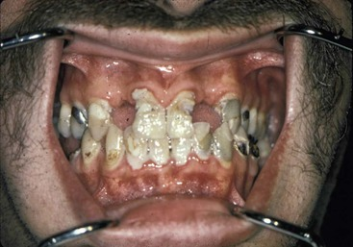
FIGURE 16-1 Before developing a definitive treatment plan, it is beneficial to extract hopeless teeth and treat teeth with advanced oral conditions of the hard and soft tissues.

Extraction of Teeth with a Poor Prognosis
Maintaining natural teeth in health, function, and esthetics is a primary goal of all dentists. In the past, the maintenance of natural teeth was paramount because tooth replacement techniques were costly and not as predictable as repairing natural teeth. However, today dental implants are very predictable when available bone volume and density are present in the edentulous site. As such, under some conditions, the advanced repair procedures of a natural tooth, such as retreatment of endodontic failures or furcation treatment, may have a lower success rate than an implant to replace the tooth. Therefore, on occasion, when the natural tooth is significantly compromised, the extraction and replacement with an implant is the treatment of choice. In addition, multiple advanced procedures on the same tooth may be more expensive (and less predictable) than extraction of the tooth and replacement with an implant.
A tooth may be considered for extraction because of prosthetic, endodontic, periodontal, or surgical considerations. On rare occasions, extraction is considered rather than orthodontics to restore the teeth in a more esthetic or functional position.

Prosthetic Considerations
Caries on a natural tooth is most often able to be removed and the tooth restored. However, on occasion, the tooth is unrestorable after the decay is removed. A prosthetic axiom is to have at least 1.5 to 2 mm of tooth structure for a crown with a cervical ferule effect. In addition, adequate retention and resistance from the tooth preparation should exist.^{1–2} As a result of the caries, additional treatment as endodontic therapy, post and core, and functional crown lengthening may be required (Figure 16-2). Thus, procedures to save the tooth are costly and on occasion less predictable than an implant. In addition, the end result may not be esthetically pleasing. For example, when a central incisor requires considerable functional crown lengthening, the gingival margin may be compromised and have a poor esthetic result.
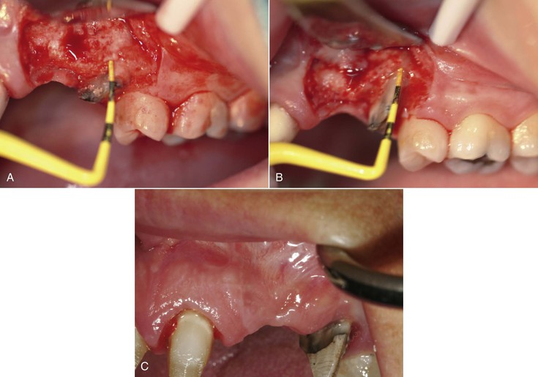
FIGURE 16-2 A, An endodontic-treated maxillary canine with inadequate exposed tooth structure to predictably restore. B, After functional crown lengthening, there is adequate tooth structure for a ferule effect from the crown to help prevent tooth fracture and improve crown retention and resistance. C, After soft tissue healing, a post and core improves retention and resistance for the canine crown.
A patient with a history of high decay rate, a high caries index, and recurrent caries under crowns requiring endodontics with a post and core before restoration and may be better served with an extraction and implant insertion (Figure 16-3). The repeated recurrent decay can be eliminated, at least for that tooth, with an implant. In addition, when caries extends within the root canal, the outer structural walls of the natural root may be too thin for a predictable post or restoration. As a result, extraction and implant insertion has a better prognosis.
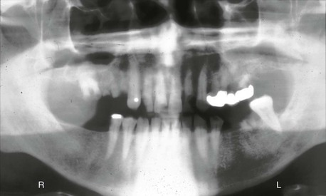
FIGURE 16-3 A panoramic radiograph of a patient with recurrent decay and many hopeless teeth.
When the dentate arch opposing an edentulous posterior region exfoliates or extrudes beyond the occlusal plane many millimeters, the tooth may require several procedures to restore the correct occlusal plane. Endodontics and functional crown lengthening beyond the furca of the roots may be necessary. After these procedures, the lateral wall thickness of the root may be minimal for the post and core. A structural failure is most likely under these conditions. An extraction and implant may be appropriate, especially in cases of moderate to severe parafunction. Another option for extruded or exfoliated teeth may be orthodontic intrusion, often with an implant as a transitional anchorage device (TAD). This is more often the treatment of choice when orthodontic therapy is required to improve the position of the rest of the teeth in both arches.

Endodontic Considerations
Endodontic conditions may cause the dentist to consider tooth extraction rather than traditional treatment. For example, when the root canal cannot be accessed because of abnormal root anatomy or previous restoration, an extraction and implant insertion may be considered rather than an apicoectomy (Figure 16-4). On occasion, the endodontic procedure in the posterior mandible requires an apicoectomy and has a moderate to high risk of paresthesia. An implant after extraction may be less invasive and have less risk of paresthesia.
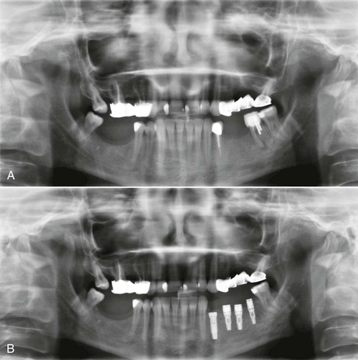
FIGURE 16-4 A, A panoramic radiograph of a patient with mandibular second molar with a lesion of endodontic origin and the canal access is compromised with a post (and perforation of the distal root and furca is present). B, A panoramic radiograph of the patient after extraction and implant insertion.
A tooth with a “split root” syndrome may have root canal therapy, with pain still present during function, and may be treated with extraction and implant insertion. If the endodontic procedure appears satisfactory but pain persists during function, retreatment of the tooth is often not predictable. Rather than waiting for an observable symptom, the subjective finding of pain during function may be enough cause to extract the tooth. An extraction and implant insertion is usually a definitive treatment that eliminates more predictably pain during function than endodontic retreatment of the tooth.
A meta-analysis of endodontic success concludes the success rate of endodontic therapy is 90% at 8 years. However, it must be noted that the rates of success for endodontics are different than the “success” rates reported with implants.^{3,4} Success rates reported with dental implants are most often survival rates.⁵ If the implant is in the mouth, it is considered a “success” regardless of the quality of health. However, success in many endodontic studies is often related to resolution of all peirapical pathology. Hence, when tooth survival after endodontic therapy is considered, endodontic treatment is similar to implant therapy. As such, traditional endodontics is the treatment of choice for most teeth that are able to be restored.
Whereas a vital tooth has endodontic success rates above 93%, a nonvital tooth has an 89% rate.^{6,7} A large periapical lesion (larger than 5 mm) compromises the success rate of traditional endodontics. A nonvital tooth with large periapical pathology has a success rate of 78%. As a result of a lower “success” rate, endodontic therapy should still be performed, but the tooth should be evaluated over several months before post, core, and crown treatment (Figure 16-5).
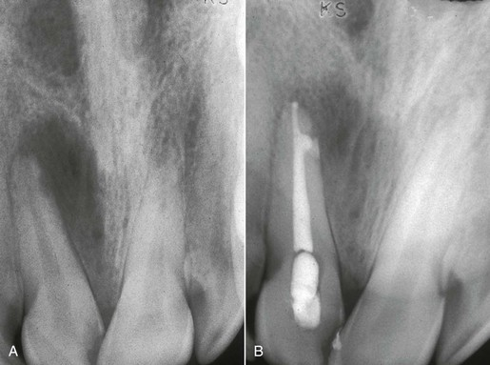
FIGURE 16-5 A, A periapical radiograph of a maxillary central incisor with a lesion of endodontic origin greater than 5 mm in diameter. A devital tooth with an endodontic lesion of more than 5 mm has less than an 88% treatment success rate. B, A postoperative periapical radiograph of the central incisor after endodontic therapy. The large endodontic lesion has started to resolve. As a result, the tooth may be restored with confidence. If not successful, extraction rather than retreatment is considered because the retreatment success rate is 65%.
If endodontic retreatment is necessary, consideration for extraction may be more justified. A retreatment of an endodontic tooth (that appears radiographically to be within normal limits) with a periapical lesion has a reported “success” rate of 65%. As a result, the additional retreatment cost may lead to consideration for extraction and implant replacement. Therefore, for devital teeth with more than 5-mm apical radiolucencies that do not resolve after initial endodontic treatment and periapical lesions remain or reappear with clinical consequences, an extraction should be considered. This may be even more justified when an apicoectomy is the treatment of choice to treat the failure.⁸

Periodontal Considerations
The existing teeth in a partially edentulous patient should be evaluated for periodontal disease. Advanced periodontal disease may be addressed with extraction of questionable abutments more frequently than in the past, provided the resulting edentulous area offers sufficient bone for predictable endosteal implant placement and a predictable prognosis⁹ (Figure 16-6).
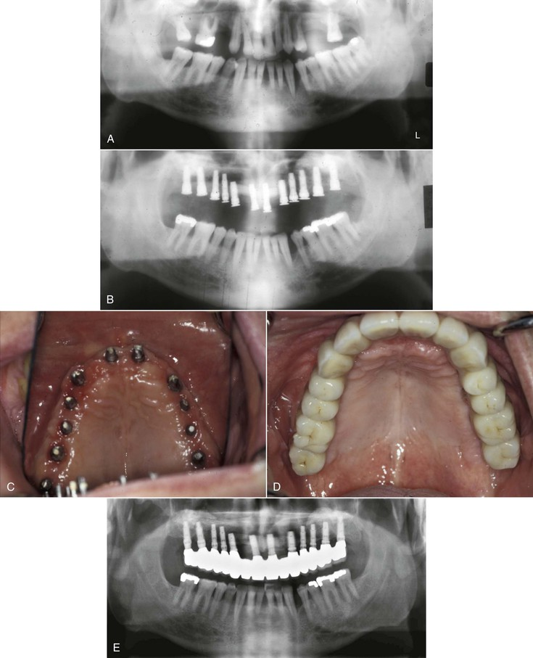
FIGURE 16-6 A, A panoramic radiograph of a patient with advanced periodontal disease in the maxillary arch and moderate disease in the mandibular arch. B, The maxillary teeth were extracted, and after initial healing, dental implants were inserted. C, An intraoral view of the implant abutments after initial healing. D, A full arch maxillary implant prosthesis from an intraoral view. E, A 10-year panoramic radiograph of the maxillary implants and prosthesis.
Herodontics are discouraged when the prognosis is poor or failure of treatment may result in inadequate bone for implant placement. This is especially noted when the existing available bone around the tooth roots is compromised in height, especially in the posterior mandible. Unsuccessful periodontal treatment and continual bone loss may render the remaining bone inadequate for placement of implants after extraction of the teeth. Bone grafting to improve available bone height in the posterior mandible is more unpredictable than any other region of the jaws. As a result, when 10 mm of bone is all that remains from the mandibular canal to the remaining bone around the periodontally involved teeth, consideration is given to the predictable aspects of periodontal therapy. When in doubt, the teeth should often be extracted (Figure 16-7).
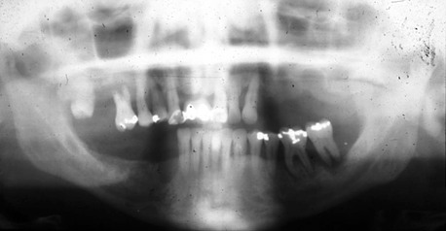
FIGURE 16-7 A panoramic radiograph of a patient with advanced periodontal disease in the maxilla and mandibular second molar. The mandibular second premolar and molar should also be considered for extraction because the remaining bone above the canal is still adequate for implants, and the periodontal prognosis is questionable.
The etiology of furcation involvements includes bacteria as well as plaque in the furca with extension of inflammation in the region with loss of interradicular bone. This leads to a progressive and site-specific loss of attachment in most individuals. A first molar furcation entrance cannot be accessed with traditional periodontal hand instruments almost 60% of the time.¹⁰ In addition, pulpal pathoses with accessory canals in the furca may cause a combination of endodontic and periodontal problems. Vertical root fracture after endodontic therapy may also occur with greater incidence. Hence, patients with moderate periodontal disease that includes the molars are at greater risk of the continuation of the disease.
Furcation treatment of molars may include root amputation. The lowest success rate for root resection was found on mandibular distal root resections (75%).^{11,12} Even when successful, the remaining root indicates endodontics, core and crown of the remaining root, and the prosthetic replacement of the distal root with an implant or fixed partial denture (FPD) (Figure 16-8). An extraction, socket graft, and implant is more predictable to treat this condition. An implant may also replace the whole tooth with a lower cost. As a consequence, mandibular molar root resection should be replaced by extraction and implant therapy.
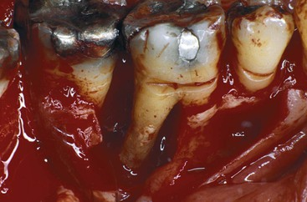
FIGURE 16-8 A mandibular first molar with a distal root resection generally has a success rate of 75%. Even when successful, the mesial root requires endodontic treatment, core, and crown, and the distal root needs replacement. Therefore, an implant or three-unit fixed partial denture is indicated. It is more cost effective to extract, implant, and fabricate one crown even when bone grafting is indicated.
A distal furca in a maxillary molar is the most common furca involvement because it is directly below the interproximal contact and has difficult access for hygiene.^{13,14} A maxillary molar that has lost bone to the furcation has lost almost 30% of the root surface area of support. However, when a distal buccal root is resected in the maxilla, often the crown may be restored to fill the mesiodistal space, and an additional procedure is not required. Hence, a distal–palatal furca treated with a root resection is often indicated in the maxilla rather than extraction and an implant.
When a maxillary molar has more than one furca condition or short roots, a root resection, or even a considerable functional crown lengthening may compromise the remaining support or result in another furcation involvement. The endodontics, post and core, and functional crown lengthening may not be as predictable as extraction and implant insertion. In addition, the cost of this conventional treatment may be twice the cost of an implant.
On occasion, successful periodontal therapy is accompanied with a poor esthetic result. It may be more prudent to extract the unesthetic teeth even though the periodontal therapy was “successful.” Under these conditions, implant prosthesis may restore the dentition with a more esthetic restoration (Figure 16-9).
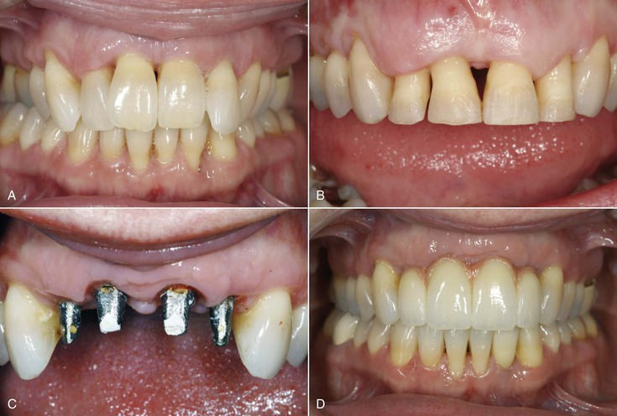
FIGURE 16-9 A, A preoperative view of a patient with moderate bone loss from periodontal disease. B, The periodontal surgery and orthodontics successfully treated the patient, but a poor esthetic result was obtained. C, The anterior four teeth were extracted, bone grafted, and implanted. D, The final implant prosthesis is more esthetic than the original condition.
Traditional methods to save a tooth have increased in cost over the years. The cost of questionable periodontal treatment may result in the patient's inability to afford the subsequent more predictable implant therapy. Multirooted endodontic therapy now approaches the cost of an implant surgery. When functional crown lengthening and endodontic posttreatment are also required, the fees are usually greater than those for extraction and implant insertion. Therefore, part of the equation of whether to extract or treat a tooth may also relate to the cost of the service provided. The natural molar tooth that requires endodontics, root amputation, post and core placement, and nevertheless a compromised root with a poor root surface area may be cost prohibitive for the service provided. In these cases, an implant in the site after tooth extraction is often less expensive and more predictable in the long term.
It should be noted that the recent trend to extract teeth with a good prognosis (with or without the need for endodontic or periodontal treatment) is discouraged.¹⁵ Implants are not yet 100% predictable, and implants should not be substituted for natural teeth presenting a good or even a fair prognosis.

0-, 5-, or 10-Year Rule
The dentist evaluates the natural teeth for their quality of health with widely used prosthetic, periodontal, and endodontic indexes. After this is accomplished, the dentist may obtain an estimate of longevity and decide whether to extract or to treat and maintain the tooth following a 0-, 5-, or 10-year rule.¹⁶ Box 16-1 summarizes the decision-making protocol involving a natural tooth. If the natural tooth has a favorable prognosis for more than 10 years, it is included in the treatment plan. The decision to use it or not as an abutment if it is adjacent to an edentulous space requires additional information, but few reasons support removal of the tooth to restore the partially edentulous patient.
Box 16-1
Extract or Maintain Natural Tooth: 0-, 5-, and 10-Year Rule¹²
PROGNOSIS | PROTOCOL
>10 years | Keep the tooth and restore as indicated.
5–10 years | Independent implant restoration. If the natural tooth must be included with implants in the restoration, make it a “living pontic” by adding implants on each side and splint together.
<5 years | Extract the tooth and graft the site or consider an implant.
If the natural tooth prognosis (after periodontal, endodontic, or restorative therapy when necessary) is in the 5- to 10-year range, the tooth should be maintained. If the tooth is adjacent to a missing tooth site, an independent implant-supported prosthesis is indicated. If the edentulous region does not provide sufficient implant support for an independent restoration, then placement of as many implants as possible around the tooth, with treatment alternatives that will permit removal of the tooth without sacrificing the restoration is indicated. For example, a coping may be placed on the tooth with a 5- to 10-year prognosis, and the tooth may act as “living pontic” in the final restoration, splinted to the adjacent implants on each side. Whether the tooth is missing or present does not modify the prosthesis. In this way, the prosthesis may be removed in the future, and the tooth may be extracted (if indicated). In this way, the prosthesis essentially is maintained without compromise.¹⁷
When teeth with copings are joined to implants, the copings on the teeth should be designed with a different path of insertion than the FPDs, and the coping should be cemented with permanent cement. The fixed implant prosthesis usually is cemented with a weaker (soft access) or temporary cement. Thus, the FPD path of removal differs from that of the natural tooth coping and, along with the weaker cement, allows the prosthesis to be removed while the coping remains permanently cemented on the tooth. The preparation of copings on natural teeth often requires additional removal of tooth structure to prevent overcontoured restorations and as a consequence may mandate endodontic therapy.¹⁹
When the estimate of survival of the natural tooth is in the 0- to 5-year survival (even after treatment), strong consideration is given to extraction of the tooth and implant replacement. As a consequence, the definitive treatment plan is delayed until after the extraction(s). For example, CT scans, mounted study casts, treatment prostheses, bone grafts (other than socket grafts), and so on are delayed until after the extraction sites initially heal because some intraoral conditions may be modified during this process. This treatment scenario may also often be faster and less costly over a 5- to 10-year period compared with maintaining a questionable tooth, especially when it is adjacent to an edentulous site.

Clinical Examples
If hygiene is poor in patients with a grade II or III furca involvement in molars, the tooth most often is considered in the 0- to 5-year category and is considered for extraction. This is especially considered when other teeth in the same quadrant are missing or hopeless or only 8 to 10 mm of bone remains between the crest of bone and the opposing landmark.^{12,13,18}
Molars with grade I furcation involvement often are placed in the 5- to 10-year prognosis category. However, it should be noted that maxillary molars are at higher risk of furca complications, and even grade I furcations are lost 33% of the time within 5 years without treatment.¹⁴ Mandibular molars have a 20% failure at this same reference time. Therefore, even when grade 1 furcas are diagnosed, aggressive treatment and good oral hygiene are necessary, especially if the tooth needs extensive restoration.
Patients with a potential structural failure after restoration (as a result of caries or trauma) and who require endodontics, functional crown lengthening, posts and cores are considered in the 0- to 5-year category. When the caries index is high, especially with poor hygiene, and multiple restorations have failed, extraction of those teeth may be indicated.
When the patient has an endodontic lesion of greater than 5 mm on a previously treated endodontic tooth (which appears within an acceptable technique), the tooth is considered for extraction. A tooth that has pain during function, despite radiographically successful endodontic therapy, may have a split root and is considered to be in the 0- to 5-year category.
The dentist should evaluate teeth especially next to an edentulous site. A natural tooth distant from the future implant restoration site is less likely to affect the implant reconstruction and alter the treatment sequences in this site. However, failure of a natural tooth adjacent to an implant site may cause failure of the adjacent implant and almost always (whether failure occurs or not) causes the restoration to be delayed and compromised. Therefore, if the practitioner is not sure whether the tooth is in the 0- to 5-year or 5- to 10-year category, the tooth adjacent to the future implant site more often should be considered to have the poorer prognosis.

Overall Evaluation
The evaluation of the remaining teeth should precede the definitive treatment plan to replace missing teeth. The existing conditions of the stomatognathic system outside the range of normal should be evaluated and treated when necessary. This treatment may be performed before or in conjunction with implant therapy. As such, preimplant prosthodontic considerations are a vital phase of the overall treatment.
The existing teeth and arch relationships do not need to be perfect before implant surgery. However, because implant dentistry always concerns the replacement of teeth, at least a diagnosis and treatment plan should occur before implant placement. The goal is to identify and restore the prosthetic parameters of the remaining teeth within normal limits. The correct tooth positions should be first determined, so even if the total treatment time is extended over several years, at least each segment will aim toward a consistent goal. Too often the restoring dentist assumes the patient wants the cheapest or fastest treatment related to each treatment or to remain within the dental insurance limits of reimbursement. As a consequence, the mouth is restored one or two teeth at a time, fitting the restoration into the patient's present occlusal condition, which usually worsens over time and never improves on its own. As a result, after the patient has been in the same practice for several decades, the overall dentition is in poorer condition than when the patient started. Although it is easier to restore an entire mouth to the correct occlusal relationships at one time, it is also possible to obtain a similar result one tooth at a time as long as each step proceeds along the predetermined course of the overall treatment.
The preimplant prosthodontic evaluation of the patient's overall condition closely resembles traditional dentistry. When a restoring dentist first evaluates the prosthetic needs of a patient, an orderly process is required regardless of the current state of the dentition. In other words, regardless of whether the patient has all of his or her teeth or is missing all of the teeth, after the dentist accepts the responsibility of long-term professional guidance and treatment as necessary, a consistent approach to care is beneficial.
There are five initial elements of the existing teeth that should be assessed in sequence and treated when indicated. These elements are the maxillary anterior tooth position, existing occlusal vertical dimension (OVD), mandibular incisor edge position, maxillary occlusal plane, and mandibular occlusal plane¹⁶ (Box 16-2). These elements are evaluated in a partially edentulous patient during the initial clinical examination and may also be assessed on mounted diagnostic casts (which may also serve for diagnostic wax-up procedures).
Box 16-2
Overall Evaluation
Sequence of Treatment

Maxillary anterior tooth position
Occlusal vertical dimension
Mandibular incisal edge
Maxillary posterior plane
Mandibular posterior plane

Maxillary Anterior Tooth Position
The position of the existing maxillary anterior teeth is first assessed. Most often these natural teeth are adequate in location and incisal edge position. However, if their position is undesirable for any reason, orthodontics or restoration may be indicated. At this point, the evaluation is not for the cosmetic aspects of tooth color or shape, but tooth position is scrutinized. If the maxillary incisor edge is modified in either the horizontal or vertical plane, all other four elements of the stomatognathic system may also need to be changed.
The labial position of the maxillary anterior teeth is first determined with the lip in repose. This is primarily evaluated by overall support of the maxillary lip and its relationship to the balance of the face, especially in relation to the nose and presence or absence of a philtrum in the midline.^{19–21} A perpendicular line from the Frankfort plane (plane passing through the lowest point in the floor of the left orbit and the highest point of each external auditory meatus of the skull) that touches the lower lip should most often find the maxillary lip 1 to 2 mm in front of this line and the chin 1 to 2 mm behind this line (at the correct OVD) (Figure 16-10).
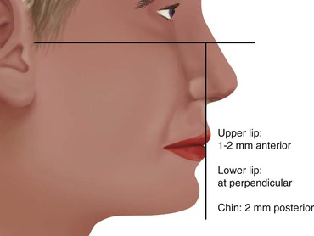
FIGURE 16-10 The labial position of the teeth is first evaluated relative to the support of the maxillary lip. A vertical line is drawn through the subnasal point and perpendicular to the Frankfort plane. The maxillary lip should be 1 to 2 mm anterior to this line, the lower lip even with the line, and the chin 2 mm behind the line.
When the teeth are positioned more labially, the vertical position of the lip is elevated. Likewise, a more palatal position of the maxillary anterior teeth results in a more inferior or extended position of the lip. If the labial or horizontal position of the lip is going to be altered, orthodontic therapy is the treatment of choice in a dentate premaxilla. On occasion, a prosthetic or surgical approach may be indicated with or without orthodontic treatment.
An alternative to increasing the length of the anterior teeth so more teeth are visible with the lip in repose may be to increase the thickness of the premaxillary alveolar ridge. This extra alveolar ridge thickness brings out the lip and raises the vermilion border. As a result, the teeth are not longer, but the border of the lip is higher. In addition, if the added width to the ridge is with autologous bone, replacing teeth with implants rather than pontics further helps to maintain the situation. The fuller maxillary lip may also look younger because vertical age lines may also be reduced.
In a completely edentulous patient, the labial flange of the patient's existing denture may be removed and the lip position evaluated before the completed treatment plan for a fixed restoration. When the lip needs the support of the labial flange for esthetics yet a fixed restoration is planned, onlay grafts with hydroxyapatite (HA), connective tissue, autograft, or allograft may be indicated to increase labial tissue thickness for proper lip support.
The next step in the evaluation process (when the labial position is acceptable) is the vertical position of the maxillary anterior teeth related to the lip in repose.²² The maxillary canine is the key for this position.²³ Misch has suggested the canine tip be located ± 1 mm with the lip in repose regardless of the age or sex of the patient (Figure 16-11). A horizontal line drawn from one canine tip to the other should be level to the horizon. The central incisors are 1 to 2 mm longer than the horizontal plane to the canines.
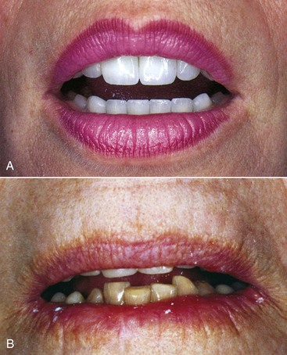
FIGURE 16-11 A, The vertical position of the maxillary anterior teeth is assessed. The ideal position is determined by the canine to lip in repose position: a horizontal line is drawn from canine tip to canine tip, and the central incisors are 1 to 2 mm longer. B, This position is consistent (within 1 mm) regardless of the age or sex of the patient.
The position of the maxillary central incisor, in relation to the maxillary lip and the age of the patient (a range of 8 mm) is much more variable than the position of the canine (a range of 3 mm).²³ The lip bow in the center of the upper lip rises several millimeters on some women and is barely obvious on others. The higher the lip bow, the more central incisor surface is seen on the patient regardless of age. Men rarely exhibit an exaggerated lip bow and therefore have a more consistent incisor edge to lip position. The canine position is closer to the corner of the lip and is not affected by the lip bow effect in the midline. As such, it is a more consistent position and usually corresponds to the length of the resting lip position from 30 to 60 years of age in both men and women.
No other region of the mouth should be restored until this position is corrected because it negatively influences the proper position of every other segment (e.g., OVD, mandibular anterior tooth position, and posterior planes of occlusion). If the patient is wearing a maxillary complete denture, the maxillary anterior tooth position is often incorrect. As a result of resorption of the premaxilla, the denture shifts apically and posteriorly following the bone loss pattern.
Arch relationships are often affected by resorption patterns in edentulous ridges. The anterior and posterior edentulous maxilla resorbs toward the palate after tooth loss.²⁴ The width of the alveolar ridge decreases 40% within a few years, primarily at the expense of the labial plate. Consequently, implants are often placed lingual to the original incisal tooth position. The final restoration is then overcontoured facially to restore the incisal two thirds in the ideal tooth position for esthetics. This results in a cantilevered force on the implant body. The maxilla is affected more often than the mandible because the incisal edge position in the esthetic zones cannot be modified and is dictated by esthetics, speech, lip position, and occlusion. Anterior cantilevered crowns from maxillary anterior implants often require additional implants splinted together and an increase in the anteroposterior (A-P) distance between the most distal to most anterior implant positions to compensate for the increased lateral loads and moment forces to the premaxillary implants, especially during mandibular excursions.
The maxillary anterior horizontal and vertical tooth positions are evaluated before any other segment of the arches, including the OVD. If the maxillary anterior teeth are significantly malpositioned, the clinician should obtain further diagnostic studies, such as a cephalometric radiograph, to determine the relationship of the maxilla to the cranial base. The patient may have unfavorable skeletal relationships (vertical maxillary excess or deficiency). If the position of the natural maxillary anterior teeth is undesirable for any reason, orthodontics, orthognathic surgery, or restoration may be indicated. After the position of the maxillary anterior teeth is acceptable, the next prosthetic step is either the evaluation of the OVD or maxillary occlusal plane.

Existing Occlusal Vertical Dimension
To determine the anterior position of the mandible and the crown height space (CHS) of the maxilla, mandible, or both, the overall issue of OVD must be addressed. The patient's existing OVD should be evaluated early in an implant prosthetic treatment plan because any modification will significantly modify the overall treatment. Not only will a change in OVD require at least one full arch to be reconstructed, but it will also affect the CHS and therefore the potential number, size, position, and angulation requirements of the implants.
The OVD is defined as the distance between two points (one in the maxilla and the other directly below in the mandible) when the occluding members are in contact.²⁵ This dimension requires clinical evaluation of the patient and cannot be evaluated solely on the diagnostic casts.
The determination of the OVD is not a precise process because a range of dimensions is possible without clinical symptoms.^{26,27} At one time, it was believed OVD was very specific and remained stable throughout a patient's life. However, this position is not necessarily stable when the teeth are present or after the teeth are lost. Long-term studies have shown that this is not a constant dimension and often decreases over time without clinical consequence in dentate, partially edentulous, and completely edentulous patients. A completely edentulous patient often wears the same denture for more than 10 years, during which time the OVD is reduced 10 mm or more without symptoms or even patient awareness.
The OVD may be altered without the symptoms of pain or dysfunction, especially when the condylar disc assembly is healthy. However, this is not to say that altering the OVD has no consequence. Rather, a change in OVD affects the esthetics of the chin to face position and the CHS. As such, it may affect the biomechanics of the support system of a prosthesis. Any change in the OVD will modify the horizontal dimensional relationship of the maxilla to the mandible. Therefore, a change in OVD will modify the anterior guidance, range of function, and facial esthetics.²⁸
The most important effect of OVD on tooth (implant) loading may be the effect on the biomechanics of anterior guidance. The more closed the OVD, the farther forward the mandible rotates and the more skeletal class III the chin appears (Figure 16-12). A bruxing patient who had a skeletal class I tooth position may develop an end-to-end incisal position along with a closed OVD (Figure 16-13). Because this type of patient has lost incisal guidance, the continued bruxism will more rapidly wear the anterior and posterior teeth. Hence, restoring OVD and incisal guidance is paramount to any oral reconstruction.
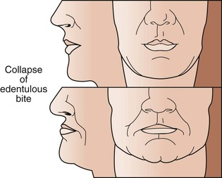
FIGURE 16-12 The closed (bottom) occlusal vertical dimension (OVD) rotates the chin farther forward than the original position (top).
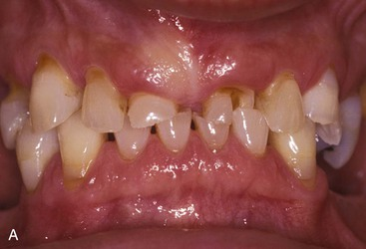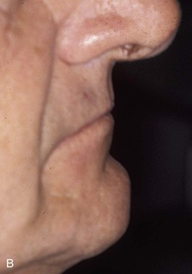
FIGURE 16-13 A, A bruxing patient may wear the anterior teeth and end up with an edge to edge occlusion and a closed occlusal vertical dimension (OVD). The more closed the occlusal vertical dimension, the farther forward the mandibular teeth occlude. B, This same patient has a closed OVD, and the chin is anterior to the lips.
In a skeletal class II, division 2 patient, the more closed the OVD, the steeper the anterior guidance and the greater the vertical overbite of the anterior teeth. When the OVD is opened, there may be no anterior contact in occlusion. Hence, orthodontics or repositioning the lower anterior teeth may be necessary to restore incisal guidance. Anterior guidance is necessary to maintain incisal guidance during mandibular excursions to decrease the risk of posterior interferences.
The conditions of an increased vertical overbite will increase the forces to the anterior teeth (or implants). Hence, the OVD should be increased in a skeletal class II division II patient. Increasing the OVD has the opposite effect on the incisal guidance. In general, for a dentate patient, it may be more precarious to close an OVD than to open it because the resulting anterior rotation of the mandible will position mandibular incisor teeth facially in a closer relationship to the maxillary teeth in centric occlusion.
In completely edentulous patients restored with fixed implant prosthodontics, a change in OVD in either direction affects biomechanics. Opening the OVD and decreasing the incisal guidance with a resulting bilaterally balanced occlusion may increase forces placed on posterior implants during mandibular excursion. Closing the OVD may increase the forces to anterior implants during any excursion. On occasion, a change in the OVD may also affect the sibilant sounds by altering the horizontal position of the mandible.
The OVD is almost never naturally too large and, unless some manufactured interference has been created, it is within clinical guidelines or collapsed. Therefore, the restoring dentist most often should determine whether the OVD needs to be increased. In other words, the existing OVD in a patient without symptoms of the temporomandibular joint (TMJ) is a position to start the evaluation, not one that necessarily must be maintained.
According to Kois and Phillips, three situations primarily mandate the modification of the OVD: (1) esthetics, (2) function, and (3) structural needs of the dentition.²⁸ Esthetics is related to OVD for incisal edge positions, facial balance, and position of the chin and the occlusal plane. Function is related to the canine positions, incisal guidance, and angle of load to teeth or implants. Structural requirements are related to dimensions of teeth for restoration while maintaining a biological width, or the CHS, which may modify biomechanical force.

Methods to Evaluate Occlusal Vertical Dimension
In traditional prosthodontics, a range of techniques has been described to establish the OVD. Whereas objective methods use facial dimension measurements, subjective methods rely on esthetics, resting arch position, and closest speaking space. There is no consensus on the ideal method to obtain the OVD. Therefore, this dimension is part art form and part science. And yet it is critical enough that a final treatment plan should not be rendered until a determination has been made relative to this dimension.
The subjective methods to determine OVD include the use of resting interocclusal distance and speech-based techniques using sibilant sounds.^{29,30} Niswonger proposed the use of the interocclusal distance (“freeway space”), which assumes that the patient relaxes the mandible into the same constant physiologic rest position.²⁷ The practitioner then subtracts 3 mm from the measurement to determine the OVD. Two observations conflict with this approach. First, the amount of freeway space is highly variable in the same patient, depending on factors such as head posture, emotional state, presence or absence of teeth, parafunction, and time of recording (greater in the morning). Second, interocclusal distance at rest varies 3 to 10 mm from one patient to another. As a result, the distance to subtract from the freeway space is unknown for a specific patient. Therefore, the physiologic rest position should not be the primary method to evaluate OVD. However, it should be evaluated after the OVD is established to ensure a freeway space exists when the mandible is at rest.
Silverman stated that approximately 1 mm should exist between the teeth when making an S sound.³¹ Pound further developed this concept for the establishment of centric and vertical jaw relationship records for complete dentures.^{32,33} Although this concept is acceptable, it does not correlate to the original OVD of the patient. Denture patients often wear the same prosthesis for more than 14 years and during this time lose 10 mm or more of their original OVD. Yet all of these patients are able to say “Mississippi” with their existing prosthesis. If speech were related to the original OVD, these patients would not be able to pronounce the S sound because their teeth would be more than 11 mm apart. But to say the letter “S” with the correct sound, the teeth must be approximately 1 mm apart. Therefore, the speaking space should not be used as the only method to establish OVD. After the OVD has been determined, the speaking space should be observed, and the teeth should not touch during sibilant sounds. On occasion, a short adjustment period of a few weeks may be required to establish this criterion. Therefore, on occasion, a transitional prosthesis should be used to evaluate this position in case it must be modified before the final restoration.
Kois and Phillips have noted that the subjective method of esthetics to establish an OVD is the most difficult to teach inexperienced dental students and therefore is least likely to be initially addressed when teaching the concepts of determining OVD.²⁸ However, experienced clinicians often value this method more than any other to assess OVD.
After the position of the maxillary incisor edge is determined, the OVD influences esthetics of the face in general. Facial dimensions are objective (because they are measured) and directly related to the ideal facial esthetics of an individual. They can be easily assessed regardless of the clinician's experience.^{34–42} This objective evaluation is usually the method of choice to initially evaluate the existing OVD or establish a different OVD during prosthetic reconstruction. In addition, it may be performed without the need of additional diagnostic tests.
Facial measurements can be traced back to antiquity, when sculptors and mathematicians followed the golden ratio for body and facial proportions as described by Plato and Pythagoras. The golden ratio relates to the length and widths of objects in nature as 1 to 0.618. It was observed that biologic features follow this ratio. Architectural proportions often follow the golden ratio because it is considered the most esthetically appealing to the human eye.^{35–37} Leonardo da Vinci later contributed several observations and drawings on facial proportions, which he called divine proportions.³⁹ He observed the distance between the chin and the bottom of the nose (i.e., OVD) was a similar dimension as (1) the hairline to the eyebrows, (2) the height of the ear, and (3) the eyebrows to the bottom of the nose—and each of these dimensions equaled one third of the face.
Many professionals, including plastic surgeons, oral surgeons, artists, orthodontists, and morticians, use facial measurements to determine OVD. Misch reviewed the literature and found that many different sources reveal many correlations of features that correspond to the OVD^{40,41}:
1. The horizontal distance between the pupils
2. The horizontal distance from the outer canthus of one eye to the inner canthus of the other eye
3. Twice the horizontal length of one eye
4. Twice the horizontal distance from the inner canthus of one eye to the inner canthus of the other eye
5. The horizontal distance from the outer canthus of the eye to the ear
6. The horizontal distance from one corner of the lip to the other following the curvature of the mouth (cheilion to cheilion)
7. The vertical distance from the external corner of the eye (outer canthus) to the corner of the mouth
8. The vertical height of the eyebrow to the ala of the nose
9. The vertical length of the nose at the midline (from the nasal spine [subnasion] to the glabella point)
10. The vertical distance from the hairline to the eyebrow line
11. The vertical height of the ear
12. The distance between the tip of the thumb and the tip of the index finger when the hand lays flat with the fingers next to each other (Figure 16-14).
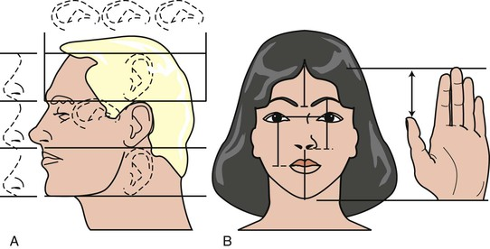
FIGURE 16-14 A, The occlusal vertical dimension (OVD) may initially be evaluated by objective measurements, comparing facial dimensions with the existing OVD. Leonardo da Vinci described divine proportions in the following way: “The distance between the chin and the nose and the hairline and the eyebrows are equal to the height of the ear and a third of the face. From the outer canthus of the eye to the ear, the distance is equal to the height of the ear and to one-third of the face height.” B, In addition, facial height (from chin to hairline) is equal to the height of the hand, and the nose to chin is the same length as the distance between the tip of the thumb and the tip of the index finger.
All of these measurements do not correspond exactly to each other, but they usually do not vary by more than a few millimeters (with the exception of the vertical height of the ear) when facial features appear in balance. An average of several of these measurements may be used to assess the existing OVD. In a clinical study by Misch, the OVD was often slightly larger than the facial measurements listed (more in men than women) but was rarely a smaller dimension.⁴¹ The subjective criteria of pleasing esthetics may then be considered after the facial dimensions are within balance to each other.
Esthetics are influenced by OVD because of the relationship to the maxillomandibular positions. The smaller the OVD, the more skeletal class III the jaw relationship becomes; the greater the OVD, the more skeletal class II the relationship becomes. The maxillary anterior tooth position is determined first and is most important for the esthetic criteria of the reconstruction. Alteration of the OVD for esthetics rarely includes the maxillary tooth position. For example, the OVD position may be influenced by the need to soften the chin for a patient with a large mental protuberance by increasing the OVD.
Radiographic methods to determine an objective OVD are also documented in the literature. Tracings on a cephalometric radiograph are suggested when gross jaw excess or deficiency is noted. Such conditions may stem from vertical maxillary excess; vertical maxillary deficiency; vertical mandibular excess (long chin); vertical mandibular deficiency (short chin); or apertognathia or skeletal class II, division 2 (deep bite) situations. Orthodontic treatment planning of a dentate patient often includes a lateral cephalogram and may be used to evaluate OVD (glabella–subnasale, subnasale–menton). The same measurements may be performed on an edentulous patient.^{43,44}
After the OVD satisfies the esthetic requirement of the prosthetic reconstruction, it may still be slightly refined. For example, the OVD may be modified to improve the direction of force on the anterior implants. In addition, on occasion, anterior mandibular implants are too facial to the incisal edge position, and increasing the OVD makes them much easier to restore. Therefore, because the OVD is not an exact measurement, the ability to alter this dimension within limits may often be beneficial.

Combination Syndrome
The evaluation of the pretreatment OVD is also very important for a patient wearing a complete maxillary denture opposing a partially edentulous mandible, especially in the case of edentulous posterior segments that are not compensated by a removable partial denture (Kennedy-Applegate class I). Under these conditions, a combination (Kelly) syndrome may be present and is especially noteworthy if the OVD is within normal limits.⁴⁵ The clinical symptoms include (1) maxillary incisors of the denture positioned up and rotated back from ideal, (2) lower natural anterior teeth overerupted and beyond the mandibular occlusal plane, (3) maxillary horizontal occlusal plane tilted apically in the anterior and occlusally in the posterior regions, (4) enlarged tuberosities encroaching on the mandibular interarch space, (5) maxillary palatal hyperplasia, and (6) highly mobile tissue in the premaxilla. In addition, because the mandibular posterior teeth have been missing for many years to develop these clinical conditions of this syndrome, there is a lack of posterior bone in the mandible to place endosteal implants (Figure 16-15).
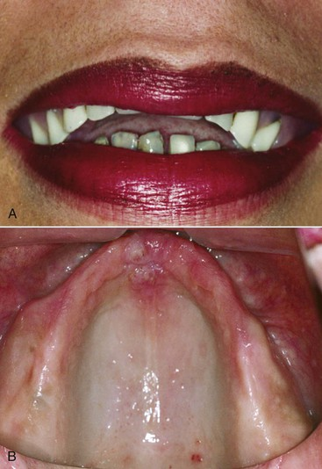
FIGURE 16-15 A, A combination syndrome describes the clinical conditions occurring when a maxillary denture opposes mandibular anterior teeth and no partial denture. The mandibular teeth overerupt as the maxillary denture seats up in the anterior and down in the posterior. B, The premaxillary bone is lost and the tuberosities enlarged.
The proper maxillary incisal edge position and OVD are especially critical for these patients because of the incidence of mandibular incisor extrusion beyond the maxillary occlusal plane. The extrusion is usually accompanied by the alveolar process. To position the maxillary incisors properly, the mandibular anterior teeth must be repositioned at the proper incisal plane. Orthodontic intrusion (often with implants that are TADs) or enamel plasty and endodontic therapy and crown lengthening procedures are necessary to precede the restorations on the lower arch to obtain a retentive and esthetic restoration. On occasion, the remaining roots of the mandibular anterior teeth are too short to consider for long-term prognosis after orthodontics or the crown lengthening is performed. Under these conditions, extraction of the mandibular anterior teeth, alveoloplasty, and implant placement may be indicated.
When the residual arch shape after extraction is ovoid to tapered, five anterior implants may be adequate to serve as support for a full-arch implant–supported restoration. Therefore, the implants replace the teeth extracted from overeruption, and they can also replace the posterior missing teeth. This is usually very helpful because long-term edentulous posterior segments are usually deficient in bone volume. Thus, this approach eliminates the need for posterior bone grafts to restore the lower arch with a fixed implant–supported restoration.

Mandibular Incisor Edge Position
After the maxillary incisal edge and the OVD are deemed clinically acceptable, the position of the lower anterior teeth is evaluated. When natural teeth are present or when a fixed prosthesis supported by natural teeth is planned in the anterior region, the mandibular teeth incisal edge should contact the lingual aspect of the maxillary anterior natural teeth at the desired OVD position.⁴⁶ In a full-arch maxillary and mandibular overdenture, implant prosthesis, or maxillary denture, no anterior contact in centric relation (CR) occlusion is designed.⁴⁷ A vertical overbite with natural maxillary anterior teeth is usually in the range of 5 mm. When an implant prosthesis is planned in both anterior jaw regions, a reduced 3- to 4-mm vertical overbite is beneficial (Figure 16-16).
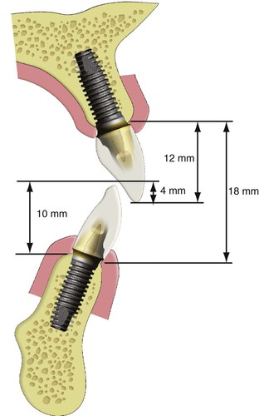
FIGURE 16-16 A full-arch maxilla and mandibular implant prosthesis or maxillary denture or overdenture does not have anterior centric contacts in centric occlusion. In addition, the vertical overbite is reduced to 3 to 4 mm. The crown height space in the anterior region is measured from the crest of the bony ridge to the incisal edge.
The incisal guidance is defined as the influence of contacting surfaces of the mandibular and maxillary anterior teeth on mandibular movements.²⁵ The incisal guide angle is formed by the intersection of the plane of occlusion and a line within the sagittal plane determined by the incisal edge of the maxillary and mandibular central incisors in maximal intercuspation (MI). It is responsible for the amount of posterior tooth separation during mandibular excursions; to do so, it should be steeper than the condylar disc assembly (Christensen's phenomenon). Therefore, any planned prosthesis and associated compensating curves should be developed within these confines. If not, the maxillomandibular arch position may be improper (i.e., in a skeletal class II, division I patient), and the posterior teeth may exhibit lateral contacts during mandibular excursions. Under these conditions, the masseter and temporalis muscles do not reduce their contraction force during these jaw movements (as they do when only anterior teeth occlude in excursions), and the strong muscles of mastication continue to contract and place an increased force on the entire stomatognathic system.
An anterior cantilever on implants in the edentulous mandibular arch may correct an Angle's skeletal class II, division I jaw relationship. The maxillary anterior teeth support the lower lip at rest in both Angle's skeletal class I and class II relationships. A traditional complete mandibular denture cannot extend beyond the anatomical support or neutral zone of the lips without decreasing stability of the prosthesis. However, with implants, the denture teeth may be set in a more ideal esthetic and functional position.¹⁶
The anterior cantilever in the class II mandible depends on adequate implant number and A-P distance between the splinted implants. To counteract the anterior cantilever effect, the treatment plan should provide increased implant support by increasing the surface area by number, size, design, or A-P implant position. In these cases, a RP-4 prosthesis, designed to prevent food impaction, may facilitate daily care compared with a FP-3 prosthesis.
The palatal resorption pattern of the maxilla, paired with the anterior rotation of the mandible from decreased OVD found in long-term, complete denture patients may mimic an Angle's skeletal class III relationship on a lateral cephalometric radiograph. However, in this condition, class III mandibular mechanics do not apply (primarily vertical chewers with little to no anterior excursions during mastication or parafunction). On the contrary, these patients exhibit a full range of mandibular excursions and can contribute significant lateral forces on the maxillary restoration, which is cantilevered off the implant base to obtain a skeletal class I esthetic restoration. Therefore, additional splinted implants are suggested in the maxilla with the widest A-P distance available. This usually requires sinus grafts and posterior implants in the first or second molar position splinted to the anterior implant support.
The incisal guidance is often evaluated on mounted diagnostic models. A steep incisal guidance helps in avoiding posterior interferences in protrusive or lateral movement. However, the steeper the incisal guide angle, the greater force applied to anterior teeth and crowns. This may present a significant problem for an anterior single tooth implant replacement. On occasion, this occurs because the natural tooth is lost as a result of severe parafunction on a tooth with a steep incisal guidance (usually from fracture after endodontic therapy).
On the other hand, if the existing incisal guidance is too shallow and posterior contracts exist in excursions, it may be necessary to plan recontouring or prosthetic restoration of posterior teeth that exhibit contact during excursions. For example, a mesially tipped mandibular third molar is often in this situation and may greatly compromise the implant placed in a maxillary second molar region.

Existing Occlusal Planes (Posterior Maxillary and Mandibular Planes of Occlusion)
After the maxillary anterior teeth position, OVD, and mandibular anterior teeth position are deemed acceptable, the horizontal occlusal planes are evaluated in the posterior regions of the mouth. The maxillary occlusal plane may also be determined immediately after the maxillary incisal edge position is correct. One side of the arch should be parallel to the other. When it is not, one ramus may be longer than the other or one side may have extruded (exfoliated) from the lack of opposing dentition.⁴⁶ Their position related to the curves of Wilson (mediolateral) and Spee (A-P) and to each other should allow harmonious occlusion with maximum occlusal interdigitation and canine or mutually protected occlusion in excursions.
In complete denture fabrication, the posterior occlusal plane is often established by a horizontal line drawn from the tip of the mandibular canine to a position half the height of the retromolar pad.²⁹ The posterior position of the plane (half up the retromolar pad) is often parallel to line from the ala of the nose to the bottom of the ear. In other words, it is well below Camper's plane.¹⁶Ideally, the maxillary posterior occlusal plane should be parallel to the Camper's plane (i.e., to the midtragus to ala position) (Figure 16-17).
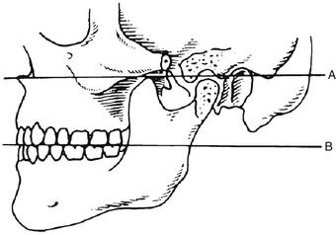
FIGURE 16-17 The ala–tragus line (Camper's plane) (line A) is parallel to the occlusal plane of the maxillary teeth (line B).
The maxillomandibular relationships are assessed in the vertical, horizontal, and lateral planes. An improper skeletal position may be modified by orthodontics, surgery, or prosthetics. It is far better to discuss these options with the patient before implant surgery because the implant placement may compromise the final prosthetic result if the arch positions are altered after implant insertion. Compromises of the final result should be discussed with patients when orthognathic surgery or orthodontic therapy is declined by patients with skeletal discrepancies.
The CHS in the edentulous site may be significantly reduced as a result of posterior extrusion or exfoliation. The implant drills and implant body insertion often require a posterior CHS of more than 8 mm from the ideal plane of occlusion, so the handpiece, drill, or implant may be inserted at the correct position and angulation.
The natural dentition of a partially edentulous ridge also must be carefully examined and often needs modification before surgical placement of the implants, especially in the posterior regions of the mouth. The remaining posterior teeth have often drifted or tipped into the edentulous site as a result of improper or missing opposing occlusal contacts.
Odontoplasty, endodontic therapy, functional crown lengthening, and crowns are indicated to remedy tipping or extrusions (exfoliation) of adjacent or opposing natural teeth. A pretreatment diagnostic wax-up is suggested to evaluate the needed changes before implant placement when these conditions exist. A proper curve of Spee and curve of Wilson are also indicated for proper esthetics and are reproduced in the compensating curves for complete denture fabrication (Figure 16-18).
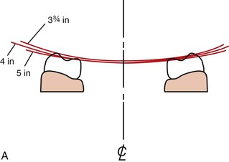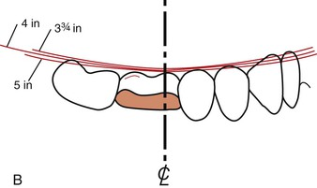
FIGURE 16-18 A, The curve of Spee is similar to the radius of a 4-inch sphere and is related to skull size. B, The curve of Wilson is evaluated before reconstruction in the region. The radius of the average curve also corresponds to the radius of a 4-inch sphere.
The occlusal plane correction seems like an obvious step in the patient dental evaluation. However, an evaluation of three-unit fixed prostheses in several large dental laboratories revealed most restoring dentists prepare crowns or three-unit fixed prostheses without correcting the opposing occlusal plane. Apparently, the existing occlusal plane is not routinely evaluated before the fabrication of the prosthesis, or the patient and doctor have decided to compromise the final result and restore the missing teeth to the preexisting poor position. Instead, the restoring dentist should highlight to the patient the extrusion or exfoliation of the surrounding teeth, which is often obvious on a panoramic radiograph or diagnostic casts, after it is noted. The need to restore the missing tooth sooner rather than later is apparent to the patient because the teeth are already shifting as a result of the arch collapse. If the patient cannot afford the complete treatment plan related to the missing teeth, the opposing arch with the poor occlusal plane should be treated first, not the arch with the missing tooth. In this way, opposing quadrants will ultimately be restored to a proper relationship. Of course, the missing tooth should be replaced before the occlusal plane is compromised again.
An occlusal plane analyzer may be used on diagnostic casts to evaluate pretreatment conditions and assist in intraoral occlusal plane correction. Occlusal analyzers may be fabricated in several sizes. The average size corresponds to a 4-inch sphere and provides a starting point for ideal curves of Wilson and Spee. Any discrepancy observed on the cast may be corrected in the mouth. Misch has designed a laboratory-assisted template with this intent.⁴⁸ In the laboratory, a vacuum or press fit of an acrylic shell is prepared over the cast. The occlusal plane analyzer is then used to evaluate and correct an improper occlusal plane. A handpiece is used to grind the acrylic shell and protruding occlusal cusps on the duplicate diagnostic cast. The clear acrylic shell is then taken intraorally and inserted over the teeth. Any cusp extending through the acrylic shell is recontoured to the level of the surrounding acrylic. As such, the occlusal plane is rapidly corrected to an ideal condition (Figure 16-19).
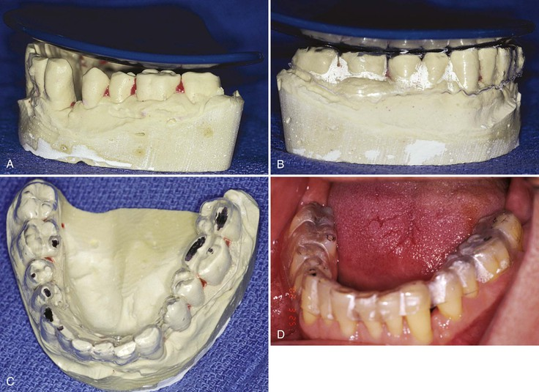
FIGURE 16-19 A, A Misch Occlusal Analyzer is fabricated in three sizes as follows: -inch, 4-inch, and 5-inch sphere. The occlusal plane of the patient is evaluated before the restoration of the opposing arch. B, A press-form (vacuum) shell is placed over a duplicate study cast of the patient. The template and teeth are adjusted so the casts follow the Misch Occlusal Analyzer more accurately. C, The areas on the cast are marked to indicate the areas to modify intraorally. The modified template is inserted in the mouth, and the dental regions above the template are recontoured. D, Intraorally, the correction is performed using the template.
The partially edentulous posterior ridge with facial resorption and outside the range of esthetics during smiling or speech may require implant insertion more medial in relation to the original central fossa of the natural dentition. Enameloplasty of the stamp cusps of the opposing teeth is often indicated to redirect occlusal forces over the long axis of the implant body and may be determined with the diagnostic casts and modified in the mouth before the opposing arch impression and bite registration at the final impression appointment.⁴⁷ Then, at the metal try-in or final prosthesis delivery, the final modifications of the opposing dentition may be made.
Transversal arch relationships include the existence of posterior crossbites, which occur frequently in implant dentistry, especially when they are out of the high lip line esthetic zone. Edentulous maxillary posterior arches resorb palatally and medially after tooth loss. Sinus grafts can restore available bone height, but the ridge still remains medial to the opposing mandibular tooth central fossa. This is especially pronounced when opposing a Misch-Judy division C–h or moderately atrophic mandible because the mandible widens after the residual alveolar ridge resorbs. For example, when mandibular implants are used in division C–h bone volume for implant support opposing a complete denture, the posterior teeth may be set in crossbite (especially when out of an esthetic zone) to decrease the moment forces developing on the maxillary posterior teeth, causing denture instability.

Specific Criteria
After the five elements of the existing teeth (restorations) have been evaluated and modified when necessary, several other conditions may modify and hinder the course of implant treatment if overlooked. These conditions should be considered before the final treatment plan is presented to the patient and include the following:
1. Active lip lines
2. Existing occlusion
3. CHS
4. TMJ status
5. Existing prostheses
6. Arch form (ovoid, tapering, square)
7. Soft tissue evaluation of edentulous sites
A large number of these items may be evaluated on the mounted diagnostic casts. Others require the direct observation of the patient. A checklist is helpful to methodically gather the data, which may directly influence the treatment plan.

Active Lip Lines

Teeth Number
Active lip positions are evaluated, not only the lip in repose. Maxillary high lip line during smiling, and mandibular low lip line during speech are observed in relation to the teeth and the surrounding soft tissue (the soft tissue drape). The lip line positions are especially noted when teeth within the “esthetic zone” are replaced or restored.
The number of teeth displayed in the horizontal dimension in a broad smile is first assessed and is variable⁴⁹ (Figure 16-20). Approximately 7% of patients only show the anterior six teeth in the maxilla or mandible when smiling or during speech. The first premolar is more often seen in the maxilla during smiling and represents 48.6% of the population and is the largest group of patients. The second premolar can be seen in 40.6% of the population. The first molar can be seen in 3% of the patients and is the smallest group (Figure 16-21). When the teeth are in the esthetic zone, the facial contours of the teeth should not be compromised. Bone augmentation may be necessary to insert the implants in a more ideal position, so facial ridge laps or cantilevers are not necessary.
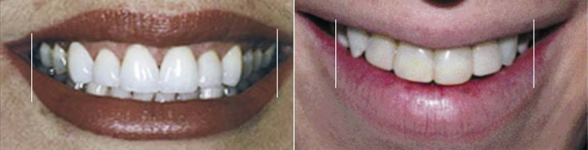
FIGURE 16-20 The horizontal depth of a smile is highly variable and should be evaluated relative to the teeth and the soft tissue drape before developing a treatment plan.
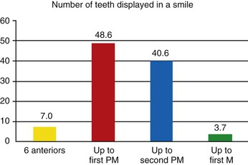
FIGURE 16-21 The number of teeth displayed in a smile most often includes the first and second premolar (PM) region.
The active lip positions in the vertical position are also highly variable but in general are related to the patient's age and sex. In general, older patients show less maxillary teeth during smiling but demonstrate more mandibular teeth during sibilant sounds.⁴⁹ Women show more maxillary teeth during smiling, and younger patients show more teeth than older patients. Men show more mandibular teeth during speech.⁵⁰ A man shows fewer teeth than a woman of the same age.

Maxillary High Lip Line
The vertical translation of the maxillary lip during smiling is variable. The maxillary high lip line is determined while the patient displays a natural, broad smile. There are three vertical categories of maxillary high lip lines: low, average (ideal), and high (“gummy”) (Figure 16-22). The low active lip line displays no soft tissue around the teeth (interdental papilla or gingiva above the teeth) during smiling (Figure 16-23). The active high lip line demonstrates all of the interdental papillae and any of the soft tissue above the cervices of the teeth. This is slightly different than the high lip position described in “esthetic dentistry,” which most often used a 2-mm cervical soft tissue guideline.⁴⁹ This modification is necessary with implant prostheses because the cervical soft tissue will need to be replaced or the teeth will often appear too long (Figure 16-24). The clinical characteristics of the average or ideal esthetic smile include crown exposure, any of the interdental papilla, and no gingival exposure over the cervicals of the teeth (maxillary lip at the free gingival margin of the centrals and canines during smiling) (Figure 16-25).
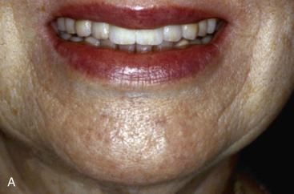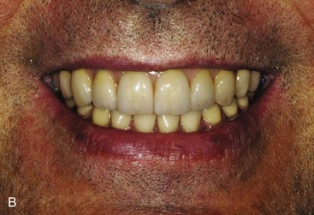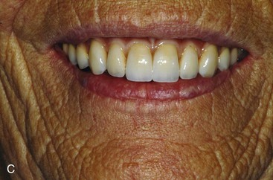
FIGURE 16-22 The vertical translation of the maxillary lip is variable and classified as low (A), average (B), and high (C).
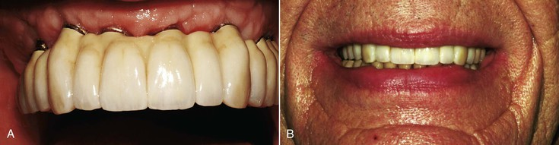
FIGURE 16-23 A, A full-arch maxillary FP-2 implant prosthesis. B, The low lip line during smiling does not show any of the soft tissue drape.
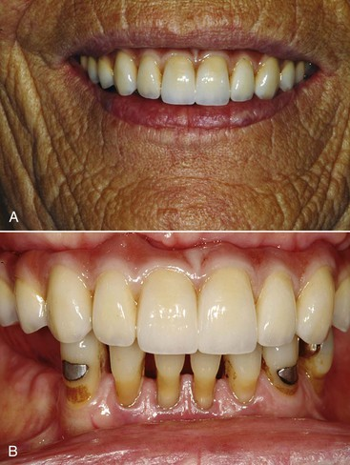
FIGURE 16-24 A, A high smile line exposes all of the clinical crown, the interdental papillae, and the full gingival margin above the teeth. B, This patient has a full-arch implant–supported FP-3 porcelain–metal prosthesis.
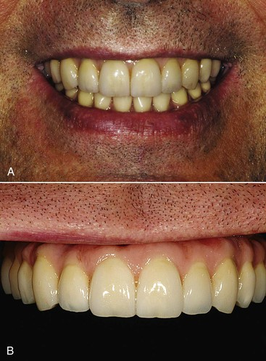
FIGURE 16-25 A, An ideal high smile line exposes the clinical crown and the interdental papillae. B, The patient in A has a full-arch implant–supported FP-3 pink and white porcelain–metal prosthesis (shown here in a retracted position).
Approximately 70% of the adult population has a high smile line within a few millimeters of the free gingival margin, and approximately 60% of the population shows interdental papillae but no cervical tissue⁴⁹ (Figure 16-26). In implant restorations, if any of the soft tissue (e.g., interdental papilla or cervical tissue) is displayed, the implant surgery, bone graft, or restoration must also replace soft tissue. The FP-1 prosthesis in implant dentistry attempts to reproduce a normal crown contour. However, with a high lip position during smiling, this goal must also make sure the soft tissue drape is ideal around the crown. As a consequence, the esthetic requirements are much more demanding and often mandate additional surgical steps to enhance the soft and hard tissues before the crown restoration. The selection of a FP-2 and a FP-3 fixed prosthesis is often based solely on the evaluation of the high lip line. A FP-2 prosthesis is easier to fabricate because it does not require gingiva-colored restorative materials in the prosthesis, but it can only be used when no soft tissue is exposed during smiling or speech.
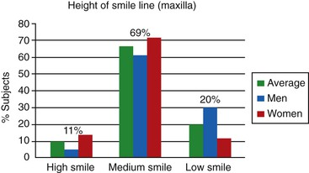
FIGURE 16-26 The height of the maxillary lip during smiling is variable and is usually more in women than men.
Approximately 30% of men and 12% of women older than the age of 35 years have a low lip line and do not show the interdental papilla when smiling (average of 20%)⁴⁹ (see Figure 16-26). This percentage increases to 40% behind the maxillary canine and 70% behind the first premolar. In these patients, the soft tissue drape does not require a primary focus and can often be compromised with a FP-2 restoration when the patient is notified before treatment. However, an average to high lip position during smiling contraindicates this restoration type because of poor cervical esthetics.
A gummy or high smile line occurs in 14% of the young female patients and 7% of young male patients and in fewer of older patients⁴⁸ (see Figure 16-26). The normal clinical crown height is 10 mm for the central incisor, 9 mm for the lateral incisor, and 10 mm for the canine. If the patient demonstrates a band of gingiva over the cervical areas of the teeth, the height of the clinical crowns are evaluated, relative to their width. The height/width ratio is 0.86 for the central incisor, 0.76 to 0.79 for the lateral incisor, and 0.77 to 0.81 for the canine.⁵¹ Esthetic crown lengthening is often a good option when the height of the central clinical crown is less than 10 mm (and the width is greater than 8 mm). Often the effect of crown lengthening is a dramatic improvement and may be accomplished at the same time as the implant surgery.
In patients with a high lip line during smiling who are missing all their anterior teeth, the prosthetic teeth can be made longer (up to 12 mm) instead of the average 10 mm height to reduce the gingival display and result in a more esthetic restoration. Therefore, the height of the maxillary anterior teeth is determined by first establishing the incisal edge of the canine by the lip in repose. Second, the high smile line determines the height of the tooth (from 9 to 12 mm).¹⁶ Third, the width of the anterior teeth is determined by the height–width ratios.
The cervical third of the maxillary premolars is also observed during a high smile line. It is not unusual to reveal the cervical third and gingiva of the interdental papilla of the premolar with a high lip line (Figure 16-27). These teeth should not appear too short (or long) and unnatural in height. Resorption may also cause the implants to be inserted more palatally in this area. The position of these crowns may then be too palatal and therefore affect the esthetic result. Bone and soft tissue grafts are the primary method to eliminate the need for ridge laps or the addition of pink porcelain at the gingiva. They are also indicated to reduce crown height.
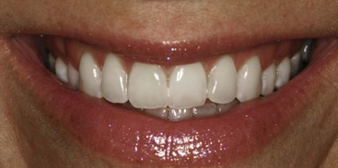
FIGURE 16-27 The high smile line is evaluated for all the exposed teeth in the maxilla. The anterior region may be ideal, yet the posterior region may have a “gummy” smile.
For a multiple tooth replacement in the posterior regions, when the high lip line exposes the interdental papilla region but not the cervical gingival region, the interimplant space may use pink restorative materials to replace the papillae. When the high lip line exposes the cervical areas, the interdental and cervical aspects of the region should be addressed with surgery (e.g., grafting) or prosthetics (e.g., FP-3 restorations).
A high lip position of the edentulous maxilla restored with a FP-3 prosthesis that displays the patient's soft tissue in the edentulous site is more difficult to restore than when the CHS is greater than usual but no soft tissues are shown in the edentulous site. When the patient's soft tissue is seen, the prosthetic gingival replacement must match the color and texture of the patient's tissue (Figure 16-28). When the patient's soft tissue is not visible, the restoration materials do not need to match the existing color, and it is easier to obtain an esthetic result.
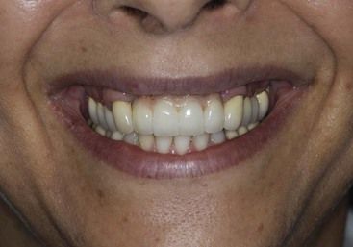
FIGURE 16-28 The high smile line of this patient shows the soft tissue drape around her natural teeth. The anterior FP-3 prosthesis is more noticeable because the pink porcelain is difficult to match to the soft tissues.
The pink porcelain restoration (FP-3) to replace the soft tissue may be esthetic but is rarely the treatment of choice for single tooth replacement. The lack or deficiency of an interdental papilla is difficult to blend into the existing soft tissue. On the other hand, in multiple missing adjacent anterior teeth, the pink porcelain is often the treatment of choice because the soft tissue drape is usually unable to be ideal, even with bone and tissue grafts.

Mandibular Low Lip Line
The mandibular low lip position during speech is often neglected, with disastrous esthetic results. The mandibular incisors are more visible in middle-aged and older patients during speaking than maxillary teeth, especially in men (Figure 16-29). In addition, lower central incisors are often visible in their incisal two thirds during exaggerated smiles.⁵⁰ Although the maxillary high lip line is evaluated during smiling, the mandibular low lip position should be assessed during speech. In pronunciation of the S sound, or sibilants, some patients may expose the entire anterior mandibular teeth and gingival contour.
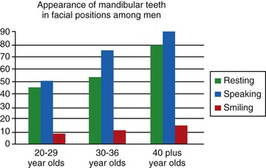
FIGURE 16-29 The mandibular anterior teeth often are displayed during speech, especially in older men.
Patients are often unaware of the preexisting lower lip position during speech and blame the final restoration for the display of the mandibular gingiva or complain that the teeth look too long. Therefore, it is recommended to make the patient aware of the active existing lip lines in both the maxilla and mandible before treatment and emphasize that these lip positions will be similar after treatment. A FP-3 mandibular restoration may be indicated to restore the patient with a low mandibular lip position. Rarely is the FP-3 restoration required distal to the mandibular canine position (Figure 16-30).
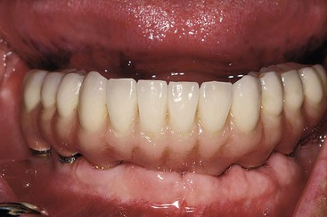
FIGURE 16-30 A FP-3 implant prosthesis for the mandibular arch.

Existing Occlusion
Maximal intercuspation is defined as the complete intercuspation of the opposing teeth independent of condylar position, sometimes described as the best fit of teeth regardless of the condylar position.²⁵ Centric occlusion is defined as the occlusion of opposing teeth when the mandible is in CR.²⁵ This may or may not coincide with the tooth position of MI. Its relationship to CR—a neuromuscular position independent of tooth contact with the condyles in an anterior, superior position—is noteworthy to the restoring dentist.⁴⁶ The potential need for occlusal adjustments to eliminate deflective tooth contacts as the mandible closes in CR and the evaluation of their potential noxious effects on the existing dentition and the planned restoration is important to evaluate.
Correction of the deflective contacts before treatment presents many advantages and may follow a variety of approaches depending on the severity of the incorrect tooth position: selective odontoplasty (a subtractive technique), restoration with a crown (with or without endodontic therapy), or extraction of the offending tooth. The existing occlusion is best evaluated with facebow-mounted diagnostic casts and open-mouth bite registration in CR.
Controversy exists as to the necessity to have MI harmonious with CR (CR occlusion). A vast majority of patients around the world do not have such a relationship, yet they do not exhibit clinical pathology or accelerated tooth loss. Therefore, it is difficult to state that these two positions must be similar. What is important is to evaluate the existing occlusion and the mandibular excursions to consciously decide whether the existing situation should be modified or be maintained. In other words, dentists should determine whether they are going to ignore or control the occlusion of the patient (Figure 16-31).
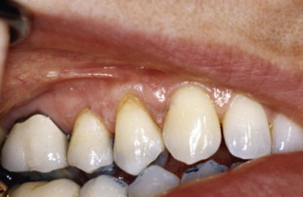
FIGURE 16-31 The existing occlusion is evaluated to decide whether the maximal intercuspation (MI) is similar to centric occlusion (the mandible is in centric relation). The mandibular excursions are also evaluated. The lack of canine contact and premature first premolar contact in the excursion and the uneven occlusal plane indicated correction of the occlusion before final reconstruction.
As a general rule, the more teeth replaced or restored, the more likely the patient is restored to CR occlusion. For example, if a completely edentulous mandible is to be restored with an implant-supported fixed prosthesis, the CR occlusion position provides consistency and reproducibility between the articulator and the intraoral condition, and slight changes in OVD to position anterior implant abutments in a more favorable restoration position may be studied and implemented on the articulator without the need to record the new occlusal vertical position on the patient.
On the other hand, when one anterior tooth is being replaced, the existing MI position is often satisfactory to restore the patient even though a posterior interference and anterior slide into full interdigitation may be present. The underlying question that helps determine the need for occlusal correction before restoration of the implant patient is the observation of negative symptoms related to the existing condition. This may include TMJ conditions, tooth sensitivity, mobility, wear, tooth fractures or abfraction, or porcelain fracture. The fewer and less significant the findings, the less likely an overall occlusal modification is required before restoration of the patient. However, to properly assess these conditions, the dentist must not ignore them before treatment.

Crown Height Space
The interarch distance is defined as the vertical distance between the maxillary and mandibular dentate or edentate arches under specific conditions (e.g., the mandible is at rest or in occlusion).²⁵ A dimension of only one arch does not have a defined term in prosthetics; therefore, the author proposed the term crown height space.^{52,53} The CHS for implant dentistry is measured from the crest of the bone to the plane of occlusion in the posterior region and the incisal edge of the arch in question in the anterior region (see Figure 16-16). The ideal CHS for a FP-1 fixed implant prosthesis should range between 8 and 12 mm. This space accounts for the “biological width,” abutment height for cement retention or prosthesis screw fixation, occlusal material strength, esthetics, and hygiene considerations around the abutment crowns (Figure 16-32). Removable prostheses often require more than 12 mm of CHS for denture teeth and acrylic resin base strength, attachments, bars, and oral hygiene considerations.
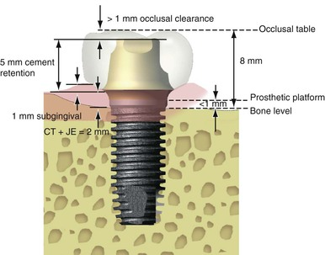
FIGURE 16-32 The crown height space is measured from the occlusal plane to the level of the bone. CT, Connective tissue attachment; JE, junctional epithelial attachment.

Biomechanic Consequences of Excessive Crown Height Space
Mechanical complication rates for implant prostheses are often the highest of all complications reported in the literature and are often caused by excessive stress applied to the implant–prosthetic system.⁵⁴ Implant body or component failure may occur from overload and result in prosthesis failure and bone loss around the failed implants.⁴⁷ Crestal bone loss may also be related to excessive forces and often occurs before implant body fracture. The biomechanics of CHS are related to lever mechanics. The issues of cantilevers and implants were demonstrated in the edentulous mandible where the length of the posterior cantilever directly related to complications or failure of the prosthesis.⁵⁵ Rather than being a posterior cantilever, the CHS is a vertical cantilever and therefore is also a force magnifier.
When the direction of a force is in the long axis of the implant, the stresses to the bone are not magnified in relation to the CHS (Figure 16-33). However, when the forces to the implant are on a cantilever or a lateral force is applied to the crown, the forces are magnified in direct relationship to the crown height. Bidez and Misch evaluated the effect of a cantilever on an implant and its relation to crown height.^{47,55} A horizontal cantilever may have three different directions of applied load (occlusal–gingival, buccolingual, and mesiodistal). These force directions result with six different rotational forces applied to the implant (moment forces). When the crown height is increased from 10 to 20 mm, two of six of these moments are increased 200%. As a consequence, when the available bone height is decreased, the CHS is increased, and the resultant forces on the shorter implants are increased.
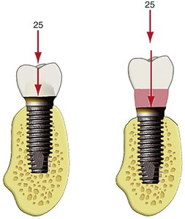
FIGURE 16-33 The crown height is not a multiplier of force when the load is in the long axis of the implant. However, any angled force or cantilever increases the force, and the crown height magnifies the effect.
An angled load to a crown also magnifies the force to the implant. A 12-degree force to the implant increases the force by 20%. This increase in force is further magnified by the crown height.⁴⁷ For example, a 12-degree angle with a 100-N force will result in a force of 315 N-mm on a crown height of 15 mm. Maxillary anterior teeth are usually at an angle of 12 degrees or more to the occlusal planes. Therefore, even implants placed in an ideal position in the premaxilla are usually loaded at an angle to the occlusal load. In addition, maxillary anterior crowns are often longer than any other teeth in the arch, and the effects of an increased crown height cause greater risk. The angled force to the implant may also occur during protrusive or lateral excursions because the incisal guide angle usually is greater than 20 degrees.⁴⁶ Anterior implant crowns will therefore be loaded at a considerable angle during excursions compared with the long axis of the implant. As a result, an increase in the force to maxillary anterior implants should be compensated for in the treatment plan.
Most forces applied to the osseointegrated implant body are concentrated in the crestal 7 to 9 mm bone regardless of implant design and for most bone densities. Therefore, unlike a natural tooth root, implant body height is not an effective method to counter the effect of crown height. Moderate bone loss before implant placement may result in a crown height–bone height ratio greater than 15 mm, with greater lateral forces applied to the crestal bone than in abundant bone (in which the crown height is less). A linear relationship exists between the applied load and internal stresses.⁵⁵ Therefore, the greater the load applied, the greater the tensile and compressive stresses transmitted at the bone interface and to the prosthetic components.
The greater the CHS, the greater number of implants usually required for the prosthesis, especially in the presence of other force factors. This is a complete paradigm shift to the concepts advocated originally with many implants in greater available bone and small crown heights and fewer implants with greater crown heights in atrophied bone⁵⁶ (Figure 16-34). Because an increase in the biomechanical forces is in direct relationship to the increase in CHS, the treatment plan of the implant restoration should consider stress-reducing options whenever the CHS is increased (Box 16-3).
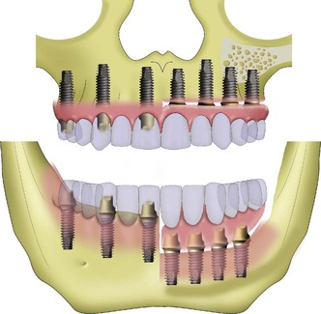
FIGURE 16-34 The greater the crown height space (CHS), the more implants are required to restore the patient (right side). The less the CHS (left side), the fewer the implants to restore the patient.
Box 16-3
Excessive Crown Height Space
Treatment Planning Options to Decrease Stress

• Shorten cantilever length.
• Minimize buccal and lingual offset loads.
• Increase the number of implants.
• Increase the diameters of implants.
• Design implants to maximize the surface area.
• Fabricate removable restorations (less retentive) and incorporate soft tissue support.
• Remove the removable restoration during sleeping hours to reduce the noxious effects of nocturnal parafunction.
• Splint implants together regardless of whether they support a fixed or removable prosthesis.

Excessive Crown Height Space
Crown height space is excessive when greater than 15 mm. Treatment of excessive CHS as a result of vertical resorption of bone before implant placement includes surgical methods to increase bone height or stress reduction methods to the support system and prosthesis. Several surgical techniques may be considered to increase bone height, including block onlay bone grafts, particulate bone grafts with titanium mesh or barrier membranes, interpositional bone grafts, and distraction osteogenesis.^{52,53}
Bone augmentation may be preferred to prosthetic replacement. Surgical augmentation of the residual ridge height will reduce the CHS, improve implant biomechanics, and often permit the placement of wider-body implants with the associated benefit of increased surface area. Although prosthetics is the most commonly used option to address excess CHS, it should be the last option used. Gingiva-colored prosthetic materials (pink porcelain or acrylic resin) on fixed restorations or changing the prosthetic design to a removable restoration should often be considered when restoring excessive CHS with the prosthesis.
In the maxilla, a vertical loss of bone results with a more palatal ridge position. As a result, implants are often inserted more palatally than the natural tooth position. A RP-4 removable restoration (removable but completely implant supported, retained, and stabilized) has several advantages under these clinical circumstances. The removable prosthesis does not require embrasures for hygiene and may be removed during sleep to decrease the effects of an increase in CHS on nocturnal parafunction. It may also improve the deficient lip facial support. The overdenture may have sufficient bulk of acrylic resin to permit denture tooth placement without infringement of the substructure and to decrease the risk of prosthesis fracture. The RP-4 restoration may also improve oral hygiene of the implant interface because it may be removed before daily hygiene procedures. However, it has identical requirements for the implant support system (e.g., implant position, number, and size) as a fixed prosthesis because it is rigid during function (hidden cantilever situation).
In the case of removable prostheses with mobility and soft tissue support (a RP-5 prosthesis), two prosthetic levers of height should be considered. The first is the height of the attachment system to the crest of the bone. The greater the height distance, the greater the forces applied to the bar, screws, and implants. The second CHS to consider is the distance from the attachment to the occlusal plane. This distance represents the increase in prosthetic forces applied to the attachment. Therefore, in a CHS of 15 mm, an O-ring may be 7 mm from the crest of bone, resulting in a lever action of 7 mm applied to the implants. The distance from the rotation point of the O-ring to the occlusal plane may be an additional 8 mm or more. Under these conditions, a greater lever action is applied from the prosthesis occlusal plane to the attachment system. This results in increased instability of the restoration under lateral forces.⁵³
Crown height space greater than 15 mm means a large amount of metal must be used in the substructure of a traditional fixed restoration to keep porcelain to its ideal 2-mm thickness (Figure 16-35). Control of surface porosities of metal substructures after casting becomes increasingly difficult because their different metal components cool at different rates.^{57,58} If not controlled properly, both of these factors increase the risk of porcelain fracture after loading.⁵⁹ Noble metals are often used to control alloy's heat expansion or corrosion in these large castings, and the cost of such implant restorations is dramatically increased. For excessive CHS, considerable weight of the prosthesis (approaching 3 oz of alloy) may affect maxillary trial placement appointments because the restoration does not remain in place during the try-in appointment without the use of adhesive. Proposed methods to produce hollow frames to alleviate these problems include using special custom trays to achieve a passive fit, which can double or triple the labor costs.⁵⁶ An alternative method to fabricate fixed prostheses in situations of CHS 15 mm or greater is the fixed complete denture or hybrid prosthesis, which has a smaller metal framework, denture teeth, and acrylic resin to join these elements together (Figure 16-36). This type of fixed prosthesis is often indicated for implant restorations with a large CHS.
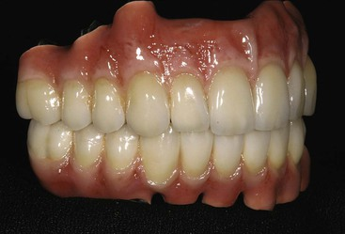
FIGURE 16-35 A large crown height space with a traditional porcelain–metal prosthesis requires a large amount of metal in the substructure with increased risk of complications such as porosities and fracture during cooling.
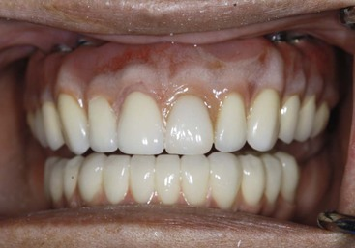
FIGURE 16-36 A hybrid prosthesis (maxillary arch) uses a cast metal substructure (smaller in size than porcelain to metal), acrylic, and denture teeth to restore the patient.
On occasion, undercontoured interproximal areas are designed by the laboratory in restorations of large CHS to assist oral hygiene and have been referred to as high-water restorations. This is an excellent method in the mandible; however, it results in food entrapment, affects air flow patterns, and may contribute to speech problems in the anterior maxilla.
Because crown height is a considerable force magnifier, the greater the crown height, the shorter the prosthetic cantilever should extend from the implant support system. In crown heights of more than 15 mm, no cantilever should be considered unless all other force factors are minimal and bone is of good quality (more often in the mandible opposing a maxillary denture in an elderly female). The occlusal contact intensity should be reduced on any offset load from the implant support system. Occlusal contacts in CR occlusion may even be eliminated on the most posterior aspect of a cantilever.⁴⁷ In this way, a parafunction load may be reduced because the most cantilevered portion of the prosthesis is only loaded during functional activity while eating food.

Reduced Crown Height Space
Issues related to CHS are accentuated by an excessive CHS that places more forces on the implant and prosthetic system, but reduced CHS makes the prosthetic components weaker. An ideal CHS is 8 to 12 mm. The 8-mm requirement for CHS consists of 2 mm of occlusal material space, 4-mm minimum abutment height for retention, and 2 mm above the bone for the biological width dimension (which does not include the sulcus, as a crown margin may be 1 mm subgingivally for retention or esthetics) (see Figure 16-32).
A reduced CHS has biomechanical issues related to a reduced strength of implant material or prosthetic components, an increased flexibility of the material, and a reduction of retention requirement of the restoration.⁵² The fatigue strength and flexure of a material is related to its radius to the power of 4.⁵⁵ In fixed restorations, the flexure of the reduced diameter material may cause porcelain fracture, screw loosening, or uncemented restorations. Therefore, in the situation of reduced CHS, material failures are more common (Box 16-4).
Box 16-4
Reduced Crown Height Space
1. Structural integrity problems of a restoration increase with a reduced CHS.
2. Surgical procedures during implant placement may increase a CHS.
3. Complications of an insufficient CHS may be increased by the surgical position of the implant (e.g., poor angulation, implant platform several millimeters above the bone).
4. Different implant systems have a different minimum CHS related to the height of the prosthetic components.
CHS, Crown height space.
Skeletal discrepancies (e.g., deep bite), reduced OVD from attrition or abrasion, minimal bone atrophy after tooth loss, and supraeruption of unopposed teeth may all result in less than ideal space for prosthetic replacement of the dentition. Traditional prosthetic and restorative procedures are indicated to restore the proper OVD and plane of occlusion. However, on occasion, even when the opposing arch and OVD is corrected, the CHS may still be less than ideal (<8 mm).
When the reduced OVD is in partially edentulous patients, the OVD may be restored by orthodontics, which is the preferred method. TAD may be necessary to extrude the teeth. This correction may also require a surgical orthognathic surgery, such as a LeFort I osteotomy and superior repositioning. However, use of prosthetics is a common approach and may involve an entire arch.
When the opposing teeth are in the correct OVD and centric occlusion position and the CHS is insufficient, additional space may be gained surgically with osteoplasty and soft tissue reduction of one arch, provided adequate bone height remains after the procedure for predictable implant placement and prosthetic support (Figure 16-37). If a removable implant-supported prosthesis is planned, an aggressive alveoloplasty should often be performed after tooth extraction to provide adequate prosthetic space.
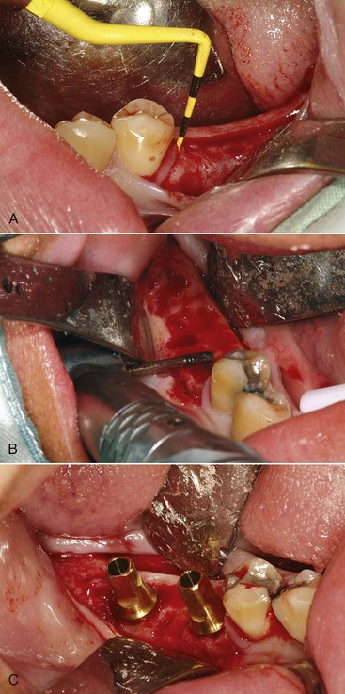
FIGURE 16-37 A, A reduced crown height space (CHS) results in short abutments, less cement retention, and increase of flexibility of the metal in the prosthesis. B, An osteoplasty increases the CHS before implant insertion. C, The implants may be positioned with an increase in CHS and fewer prosthetic complications.
Additional prosthetic space can also be obtained in many completely edentulous situations by soft tissue reduction, especially in the maxilla. Soft tissue reduction should be performed in conjunction with second-stage surgery if the implants heal in a submerged location. This allows the thicker tissue to protect the implants from uncontrolled loading by a soft tissue–supported prosthesis during healing. If the implants heal permucosally (one-stage surgery), the soft tissue reduction procedures should be done during implant placement. Soft tissue reduction procedures may include gingivectomy, removal of connective tissue, or apical repositioning of flaps. Efforts should be made to maintain adequate keratinized tissue around the implants. Soft tissue reduction also has the benefit of decreased probing depths around the implants. However, the definition of CHS is from the bone to the occlusal plane; therefore, although the prosthetic space is improved, the CHS remains similar when only soft tissue reduction is performed.
When the CHS is less than ideal, the following prosthetic parameters should be identified⁵³:
1. Available space
2. Abutment taper
3. Surface area of abutment
4. Cement type
5. Surface finish
6. Occlusal topography and material
7. Load on final restoration
8. Fit of restoration to abutment
9. Retention of prosthesis
10. Implant manufacturer
11. Implant platform to occlusal plane dimension
The consequences of insufficient CHS include a decrease in abutment height (which may lead to inadequate retention of the restoration), inadequate bulk of restorative material for strength or esthetics, and poor hygiene conditions compromising long-term maintenance. In addition, the final restoration flexes inversely to the cube of the thickness of material. A fixed prosthesis half as thick will flex eight times as much and will further result in loss of cement retention, loosening or fracture of fixation screws, or porcelain fracture.⁶⁰ Inadequate thickness of occlusal porcelain or acrylic or unsupported occlusal material caused by inadequate metal substructure design may also result in complications such as component fracture.
Minimum restorative requirements vary in function of the implant system. The minimum restoration space may be determined by limiting the occlusal material to 1 mm (metal occlusals) and reducing the abutment height to the top of the retaining screw. The smallest minimum restoration spaces correspond to 4.21 mm for 3I Osseotite, 4.35 mm for Replace Select (Nobel BioCare), 4.5 mm for BioHorizons, and 4.56 mm for Frialit 2 systems. The greatest restoration space requirements are found in Astra (6.6-mm), Lifecore (6.84-mm), and Straumann (7.0-mm) systems.⁶¹
When fabricating a cemented restoration, the restoration technique (indirect vs. direct) may be influenced by the CHS. Because additional abutment height for retention may be gained by a subgingival margin, the indirect technique (making an implant body level impression) may have an advantage over a direct intraoral impression. An implant body level impression and implant analog used to fabricate the prosthesis permits the subgingivally restoration to be placed more than 1 mm subgingival with greater accuracy because a subgingival margin and impression technique is more difficult when the margin extends more than 1 mm below the tissue. The indirect technique is also used for custom abutments, which can be designed with increased diameter to increase the overall surface area for retention. A custom abutment may also be fabricated to decrease the total occlusal convergence angle to increase retention for cemented prostheses. Therefore, the indirect laboratory analog technique represents benefit in a reduced CHS situation, especially when the soft tissue is several millimeters thick.
The retention and resistance difference between a 3-mm-high and a 5-mm-high implant abutment may be as great as 40% for a 4.5-mm-diameter abutment. Less than 3 mm of abutment height indicates a screw-retained crown, 3 to 4 mm requires a screw-retained or resin-cemented restoration, and greater than 4 mm of abutment height allows the operator's preference, although the ideal abutment height is 6 mm for ideal CHS and greater for larger CHS situations. Splinting implants together, regardless of whether they are screw retained or cement retained, can also increase retention.
Conditions such as cement hardness, surface condition of the abutment, and occlusal material (porcelain vs. metal) are also to be considered in limited CHS situations. The occlusal material is important to consider in reduced CHS for two primary reasons. When metal is used as the occluding surface, it is possible to provide greater retention for the prosthesis as a result of an increase in abutment height. The abutment height may be greater because the occlusal space required above the abutment is only 1 mm, but porcelain requires 2 mm of occlusal space and acrylic resin requires 3 mm or more. Another factor is the strength of the material. Metal occlusal surfaces provide the greatest resistance to fracture and should be considered when there is limited CHS. When a screw is used to retain the crown, the strength of occlusal porcelain is reduced by as much as 40% because an access hole penetrates the surface. Therefore, cemented restorations are a benefit unless the abutment is less than 4 mm high and the prosthesis screw is required to retain the restoration. Acrylic resin requires the most dimension for strength and is much more likely to fracture when the CHS is limited. This is one reason why acrylic resin overdentures require more CHS than a porcelain–metal fixed prosthesis.
Too little CHS can be further complicated when the surgeon places the implant above the bone. The surgeon may also magnify the prosthetic problem of limited CHS by placing the implant at an angle to the ideal position. Angled abutments lose surface area of retention from the abutment screw hole and further compromise the limited space conditions. In addition, a 30-degree taper on an abutment to correct parallelism loses more than 30% of the abutment surface area and dramatically decreases the retention for the abutment.
Overdentures also exhibit greater complications in situations of reduced CHS. Removable prostheses have space requirements for elements such as a connecting bar, type, and position of attachments and restorative material (metal vs. resin). According to English, the minimum CHS for individual attachments is 10 mm of CHS for Locator-type attachments and between 12 and 15 mm for a bar and O-rings.⁶² The ideal CHS for removable prostheses is greater than 14 mm, and the minimum height is 10.5 mm.⁵³ The lowest possible profile attachment should be used in situations of reduced CHS to fit within the contours of the restoration, provide greater bulk of acrylic resin to decrease fracture, and allow proper denture tooth position without the need to weaken the retention and strength of the resin base.⁶³
Overdenture bars may be screw retained or cement retained.⁶⁴ The most common method of retention for a fixed prosthesis is cement retention. The most common method of bar retention by almost the same percentage for overdentures is screw retention. Yet the advantages of cement retention for a fixed prosthesis also apply to an overdenture bar. Therefore, in minimum CHS situations, the screw-retained bar has a clear advantage, but in ideal to excessive CHS situations, the cemented bar should be considered. A combination of screw retention on some abutments and cement retention on others offers an advantage for many RP-4 prostheses.

Temporomandibular Joint
The TMJ may exhibit signs and symptoms of dysfunction. Symptoms include pain and muscular tenderness experienced by the patient. Noises or clicking in the joint during opening, deviation of the mandible during jaw opening, and limited jaw movements are signs of potential dysfunction observed during the patient examination. Patient complaints or signs gathered during the initial evaluation should be carefully evaluated before further reconstructive treatment.⁴⁶
Palpation of the temporalis, masseter, and internal and external pterygoid muscles is part of the TMJ examination. The muscles should not be tender during this process. Parafunction may contribute to TMJ disorders and is a direct source of muscle tenderness. Under these conditions, the muscles are usually hypertrophied as a result of the excess occlusal forces. The masseter and temporalis muscles are easily palpated. The lateral pterygoid muscle is often overused in this patient profile yet is difficult to palpate. The ipsilateral medial pterygoid muscles can be as diagnostic and are easier to evaluate in the hamular notch region. They act as the antagonist to the lateral pterygoid muscle in hyperfunction and, when tender, it is a good indicator of overuse of either muscle.⁴⁶
Deviation to one side during opening indicates muscle imbalance on the same side as the deviation and possible degenerative joint disease.⁴⁶ The patient should also be able to perform unrestricted mandibular excursions. Maximal opening is noted during this examination and is normally greater than 40 mm from the maxillary incisal edge to the mandibular incisal edge in an Angle's skeletal class I patient. If any horizontal overjet or vertical overbite exists, it is subtracted from the 40-mm minimum opening measurement.⁶⁵ The range of opening without regard to overlap or overbite ranges from 38 to 65 mm in men and 36 to 60 mm in women, from one incisal edge to the other.
The practitioner is encouraged to carefully evaluate the TMJ status. It is beyond the scope of this text to address the methods of treatment of TMJ dysfunction. However, many patients with soft tissue–borne prostheses and TMJ dysfunction benefit from the stability and exacting occlusal aspects that implant therapy provides. As such, these patients may benefit from implant support to improve their condition. However, a transitional prosthesis is often a benefit to evaluate the TMJ function and symptoms before the fabrication of the final restoration.

Existing Prostheses
When present, existing prostheses are evaluated for proper design and function. A removable partial soft tissue–supported restoration opposing the proposed implant-supported prosthesis is of particular interest. The occlusal forces vary widely as the underlying bone remodels. The patient may not even wear the opposing removable partial denture in the future, which will dramatically modify the occlusal conditions. Therefore, continued maintenance and follow-up evaluations are indicated, including relines and occlusal evaluation.
The patient should be asked whether esthetic desires are met with the current restorations. It is not unusual that the prosthesis is completely acceptable yet the patient wishes a different shade or contour for the teeth. If unacceptable to the patient, the reasons for dissatisfaction are noted. In addition, the existing restorations are evaluated throughout the mouth for clinical harmony. It is better to leave a poor esthetic restoration that is in occlusal harmony than to provide one that is esthetic but improper in position because the latter may influence all future restorations. Pontic regions of existing prostheses may often be improved with the addition of connective tissue grafts.
An acceptable preexisting maxillary removable prosthesis, which will be replaced with a fixed implant prosthesis, may be used as a template for implant reconstruction when fabricating an implant-supported fixed or removable implant prosthesis.⁶⁴ The thickness of the labial flange of the existing denture is evaluated and is often removed to evaluate the difference in lip position and support. If implants may be correctly inserted yet additional lip support is needed after the labial flange is eliminated, an HA, connective tissue, or acellular dermal onlay graft is usually indicated. This graft is not intended for implant support or placement but to enhance the support of the labial alveolar mucosa to improve maxillary lip support.

Arch Form
Two different arch forms are to be considered for implant prostheses.¹⁶ The first arch form is of the residual edentulous bone and determines the A-P distance for implant support. The second arch form is of the replacement teeth position. The edentulous arch form and the dentate arch form in the horizontal plane are described as ovoid, tapering, or square. In the edentulous arch form, the ovoid arch form is the most common followed by the square and then the tapered form. The square arch form may result from the residual formation of the basal skeletal bone. However, the presence of a square arch form is more common in maxillary implant patients as a result of labial bone resorption of the premaxilla region when anterior teeth are lost earlier than the canine. The tapering arch form is often found in skeletal class II patients as a result of parafunctional habits during growth and development. It is not uncommon to find different arch forms in the upper and the lower arches.
The dentate and edentulous arch form are not necessarily related, and the worst situation in the maxilla corresponds to a square residual arch form that supports a tapered dental restoration. The prosthesis cantilever off the anterior available bone is greatest in this combination (Figure 16-38).
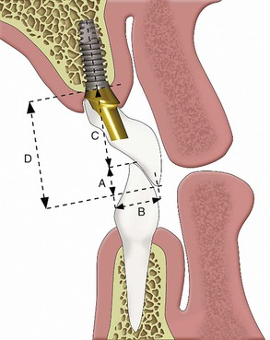
FIGURE 16-38 The dental arch form may be different than the arch form of the residual arch. A tapered dentate arch form on a square residual bone form is the worst combination because the anterior teeth are cantilevered from the implant abutments.
The most ideal biomechanical arch form depends on the restorative situation. The tapering residual ridge arch form is favorable for anterior implants supporting posterior cantilevers. The square dental arch form is preferred when canine and posterior implants are used to support anterior teeth in either arch. The ovoid arch form has qualities of both tapered and square arches.
The arch form is a critical element when anterior implants are splinted together and support a posterior cantilever restoration. For these conditions, a square arch form provides a poorer prognosis than a tapered arch form. The A-P distance or A-P spread is the distance from the center of the most anterior implant to a line joining the distal aspect of the two most distal implants.⁶⁶ It provides an indication as to the amount of cantilever that can be reasonably planned. When five anterior implants in the mandible are used for prosthesis support, the cantilevered posterior section of the restoration should not exceed two times the A-P spread when all patient force and stress factors are low and bone density is favorable. The actual length of the cantilever depends not only on implant position but also on other stress factors, including parafunction, crown height, implant width, and number.
The predominant factors to determine the cantilever length are related to stress, not only the A-P distance.^{16,67} For example, the distance between two implants supporting a cantilever (C) forms a class I lever. For implants 10 mm apart and a 10-mm posterior cantilever, the following forces are applied: a 25-lb force on cantilever C results in a 25-lb force on the most anterior implant from the cantilever (A) and 50 lb for the nearest implant to the cantilever (B), which acts as a fulcrum. An interimplant distance of 5 mm with the same 10-mm cantilever and a 25-lb force applied on C results in a 50-lb force on A and a 75-lb force on B. The diminution in the distance between implants significantly increases the forces to both implants. But in the first example, if a patient with parafunction bites with a 250-lb force on C, the force on implant A is 250 lb, and the force on implant B is 500 lb. In other words, parafunction is much more meaningful in terms of force than the interimplant distance (A-P distance) when designing a cantilever.¹⁶ Therefore, A-P distance is only one stress factor to evaluate for cantilever length. Parafunction, crown height, masticatory dynamics, arch position, opposing arch, direction of force, bone density, implant number, implant width, implant design, and A-P distance are all factors to be considered. When the force factors are low and the area factors (implant number, width, and design) are high, the cantilever length may be as much as two times the A-P distance in good-quality bone.
As mentioned previously, anterior endosteal implants often may not be inserted in their ideal location in the maxilla as a result of labial plate resorption and inadequate bone width at the implant site. This not only requires implant placement more palatally compared with the original natural teeth, but it may also negate the lateral and central positions and require the use of the canine regions in more advanced atrophic arches. The resulting restoration is a fixed, anteriorly cantilevered prosthesis to restore the original arch form. Under these conditions, greater stresses are placed on the dentate tapered arch forms compared with dentate square arch forms, all other factors being identical.⁶⁷
The maxillary anterior cantilever to replace teeth in a dentate-tapered arch form requires the support of additional implants of greater width and number to counteract the increase in lateral load and moment force. For example, not only are the canine implants necessary, but two more additional anterior implants are also suggested even if bone grafting is required before their placement. In addition, additional posterior implants in the first to second molar region splinted to the most anterior implants are highly suggested. Therefore, if a maxillary tapered arch form requires this treatment approach, at least eight implants (four on each side) and an increased A-P distance from molar implants splinted to incisor implants is suggested. In addition, second molar implants should be splinted to the anterior implants to increase the A-P distance.⁶⁷ In the maxilla, the recommended anterior cantilever dimension is less than for the posterior cantilever in the mandible because of poor bone density and forces directed outside the arch during excursions.

Soft Tissue Support
The evaluation of the soft tissue support is primarily concerned with the treatment planning of RP-5 prostheses (overdentures which gain dual support from implants and edentulous ridges). RP-5 restorations should have implant retention and some stability from the anterior region. The posterior soft tissue regions provide the region for soft tissue support. The following factors should be evaluated: ridge shape, size, parallelism, and palate shape.
Large jaws with little resorption provide a better support base than smaller-sized ridges with greater atrophy in either the maxilla or mandible. The size of the soft tissue support cannot be solely evaluated on a radiograph because it is highly dependent on the position of the muscle attachments. High muscle attachments on abundant to moderate bone (division A or B) may be improved by vestibuloplasty procedures in conjunction with implant surgery.
Prosthesis support depends on the shape of the residual ridge and, in the maxilla, the palatal vault. A square ridge form yields optimal resistance and stability. A relatively flat one represents a compromised factor for retention and stability, although support is still adequate. Tapering ridges in the maxilla with the palatal vault usually equate with poor stability.⁵⁶
Ridge parallelism to the opposing arch is also evaluated. The edentulous ridge parallel to the occlusal plane is most favorable for soft tissue support. If the ridges are divergent, the stability of the denture will be greatly affected.
The lateral throat form in a maxillary denture or RP-5 restoration is evaluated. A soft palate slope is favorable when it has a long, gradual slope from the junction of the hard and soft palate, which allows a greater extension of the posterior palatal seal and enhances retention.⁶⁸ On the other hand, a soft palate that drops abruptly may lead to soreness, loss of valve seal, and gagging.⁶⁹
Soft tissue support elements are of great diagnostic value in the evaluation of the maxillary fully edentulous patient who may consider an implant-supported overdenture. A greater number of unfavorable anatomical structures may direct the treatment plan toward a RP-4 prosthesis with greater implant support and no soft tissue support to address all the anatomic needs of the patient.^{70,71}
It should be emphasized to the patient that a partial or total soft tissue–borne prosthesis will not stabilize bone loss. As a result, all soft tissue–borne devices should be considered transitional dentures. They all require repeated relines, rebasing, and refabrication to replace the missing bone. A totally implant-supported restoration (fixed or removable) does not require soft tissue support and may be considered a definitive restoration.
Many soft tissue–supported restorations are fabricated because the patient cannot afford a totally implant-supported restoration, especially in a completely edentulous patient. However, the doctor often forgets that if a patient cannot afford the ideal treatment today, it does not mean the patient cannot afford any further treatment later. For example, if a patient needs four first molars replaced but cannot afford all restorations at this time, the doctor most often can still replace one of the molars. Then a few years later, the next tooth may be replaced. Eventually, the four molar sites are treated and the arch form and occlusion restored. In similar fashion, a patient who can afford only two implants to retain a mandibular denture could possibly afford further treatment later. Therefore, a lifetime strategy for health should be established, which may include the addition of more implants in the future to reduce and eventually halt the continued bone loss and consequences on esthetics and function.

Treatment Prostheses

Fixed Restorations
Pretreatment prostheses in restorative dentistry are often indicated to obtain a diagnosis, improve soft tissue health before fabricating soft tissue–borne restorations, reestablish or evaluate the OVD, evaluate esthetic considerations, or treat TMJ dysfunction (Figure 16-39). Restoration of implant patients may also require treatment prostheses for similar reasons. In addition, the pretreatment prosthesis may be used to select a prosthetic option, to progressively load bone to improve its strength, and as a transitional restoration to protect a healing bone graft or implant. Immediate restoration after insertion of an implant system often uses a transitional prosthesis out of occlusion in a partial edentulous situation. In a completely edentulous patient, the transitional immediate load restoration has no cantilevers in nonesthetic areas. Treatment prostheses may also help evaluate the psychologic attitude of a patient before irreversible implant procedures are begun (Box 16-5).
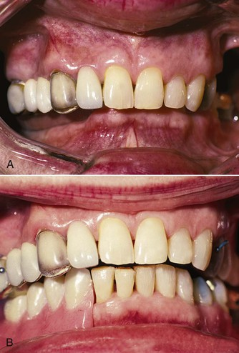
FIGURE 16-39 A, The patient has a collapsed occlusal vertical dimension (OVD) and a poor occlusal plane. When the final result is not clear to the restoring dentist, a treatment prosthesis is often a benefit to assess and reestablish prosthetic parameters. B, An acrylic removable partial denture in place is used as a treatment prosthesis to reestablish the proper OVD, jaw position, plane of occlusion, temporomandibular joint status, speech, and potential prosthetic result.
Box 16-5
Implant Treatment Prostheses
1. Help with diagnosis
a. Crown lengthening
b. Occlusal plane
c. Hopeless teeth
2. Evaluate the psychologic profile of the patient.
a. Denture before implant surgery
3. Improve soft tissues before final impression for implant overdentures.
4. Postoperative to implant surgery
5. Evaluate occlusal vertical dimension.
6. Evaluate temporomandibular joint dysfunction.
7. Improve implant position related to final tooth position.
8. Evaluate esthetics before surgery.
9. Evaluate hygienic contours of fixed restorations.
10. Determine whether removable restoration is required for maxillary lip support (RP vs. FP).
11. Protect bone graft or implants during healing.
12. Patient's financial and compliance management.
13. Progressive bone loading
14. Phonetics and esthetics for full-arch implant–fixed prostheses on complete edentulous patients
RP, Removable prosthesis; FP, fixed prosthesis.
Diagnosis in medicine is the first step to establishing a treatment for a disease or disorder. Likewise, to establish a treatment plan for a partially or completely edentulous patient, a proper diagnosis should be established. A treatment prosthesis may be required to help in this process. For example, questionable teeth may require initial restoration to assess their prognosis related to whether or not the extraction of the tooth and implant replacement therapy is required.
A treatment prosthesis may correct the existing occlusal plane; identify extruded teeth; and indicate whether endodontic therapy, crown lengthening, or extraction is required to complete the final treatment plan. Remember, after prosthetic crown lengthening is performed, at least 4 mm of tooth structure should be supracrestal (2 mm for connective tissue and junctional epithelial attachment and 2 mm to create a ferrule effect with the crown to reduce the risk of root fracture). As a consequence, the crown–root ratio is increased, and the mobility of the tooth should be evaluated after treatment. Excessive mobility may require additional implants, splinting teeth, or even extraction and additional implant insertion.
A partially edentulous patient with three or more adjacent teeth missing often wears a fixed-treatment prosthesis, which also acts as an interim prosthesis. Metal-reinforced transitional prostheses may be used when three to five pontics are present. These fixed, transitional treatment restorations may be used during bone grafts or healing of implants to decrease forces on the soft tissues that transmit forces the graft or healing implants.

Progressive Load
A pretreatment prosthesis to improve the quality of bone is most always used in D3 or D4 bone-supporting implants before the fabrication of the final restoration. Interim (provisional) acrylic restorations that gradually load bone for progressive loading may be considered pretreatment prostheses. A decrease in crestal bone loss and decrease in implant failure, especially in soft bone types, are particular advantages with progressively loaded treatment prostheses. Pretreatment prostheses also assist in the determination of the final form and function of the final prosthesis, especially for completely edentulous patients, for whom the “pretreatment” prosthesis may be the first full-arch–fixed restoration they have worn after several years of wearing a complete denture.

Financial Barriers
An additional benefit of pretreatment prostheses is that patient financial management may be facilitated and compliance issues resolved before more irreversible phases of treatment are rendered. However, it is beneficial to clearly establish the cost and emphasize the need to progress forward with treatment in an orderly fashion. Very few pretreatment or transitional restorations may be worn for years without risk of fracture, uncementation, or compromises in the bone graft or implants.

Removable Prostheses
Treatment prostheses may be used to improve the soft tissues used for support, stability, or retention before RP-5 overdentures or complete denture restorative procedures. The first evidence of residual ridge destruction by an ill-fitting denture is often deformed and traumatized overlying soft tissue.⁶⁹ The soft tissue bed may exhibit different degrees of redundant hyperplasia, epulis, hypertrophy, or abrasions.⁷⁰ A tissue conditioning treatment is usually indicated to restore soft tissue health before making the final impression for the soft tissue bone prosthesis.⁷¹ Additional treatment such as surgical removal of excessive hypermobile tissues is often warranted before soft tissue conditioning. The soft tissue conditioner may need to be replaced every 2 to 3 days (although 10 to 14 days is usually sufficient) to return the soft tissue to normal condition. The existing denture can often be used as the treatment prosthesis. Modification for tissue conditioning or to wear over healing implants is usual.
It should be noted that soft tissue conditioners are different from soft liners used in soft tissue support areas of removable prostheses. Tissue conditioners change dimensions during the first 18 to 24 hours. As such, as the tissues return to a more normal condition, the material changes dimension to allow and encourage these changes. However, the modifiers required for this reaction leach out of the material, halt the process within a day, and result in a stiff material. Soft liners, on the other hand, stay soft longer than tissue conditioners, especially when coated with a sealer. However, the material does not change dimension during the first day and therefore will not accommodate a changing tissue condition.
Most often, tissue conditioners are used to improve abused tissues before a final soft tissue impression for a removable prosthesis. In addition, these materials are used after implant surgery in regions under a removable prosthesis while the implant–bone interface heals. The tissue conditioner may respond to the swelling and tissue changes immediately after soft tissue reflection. In addition, it is relieved over the implant site. At the suture removal appointment, the tissue conditioner is removed and replaced with a sealed soft liner. This material stays soft during extended periods and is less likely to load the implant through the soft tissue.

Occlusal Vertical Dimension
Long-term edentulous patients who have been wearing the same denture may require a treatment prosthesis to restore the OVD and ridge relationship before implant treatment.⁷² The OVD may gradually collapse, especially in a completely edentulous patient, as a result of continued bone loss and prosthesis occlusal wear. TMJ and myofacial dysfunction may be the further consequence of this condition. A treatment prosthesis to reestablish the proper OVD or assess a symptomatic joint helps determine the patient's specific needs regarding the dysfunction.
As the OVD decreases, the mandibular jaw rotates forward and closes in a more prognathic pseudo skeletal class III relationship. To place the implants in the correct angulation, the OVD should be reestablished before implant surgery so the correct position of the teeth relative to the arch is established.
A pretreatment prosthesis for a completely edentulous patient before the delivery of a fixed- or removable-implant prosthesis is most often a complete denture. It is fabricated with acrylic teeth to facilitate recontouring and the addition of cold-cured acrylic for repairs or to change the OVD or lip support.
In the case of immediate implant loading for a completely edentulous patient, a treatment prosthesis is delivered at or soon after the implant surgery. The design of the prosthetic superstructure concomitant with the implant substructure is necessary for immediate loading in implant overdentures. Therefore, a treatment prosthesis is indicated to establish the proper OVD and tooth position before the placement of the implants and fabrication of the superstructure bar.
As the OVD increases in the skeletal class III patient, the maxillomandibular relationship evolves toward a class I relationship. This influences the position or angulation of the implant. In addition, the location of an overdenture bar may be equally influenced by variations of the OVD. The treatment prosthesis may be used to establish the prosthetic position of the teeth.

Esthetic Assessment
On occasion, a patient's desire for esthetic improvement may be very demanding or unrealistic. In a completely edentulous patient, a treatment denture may be used to evaluate if the esthetic concerns can be satisfied before implant surgery. Tooth shape, surface quality, size and position, tooth color, lip and soft tissue contour, tooth position, gingival color, soft tissue contour, and papilla support may all be evaluated.⁷³ If the patient cannot be satisfied with the pretreatment prosthesis, it is far better to realize this before implant placement. Although demanding patients may not be satisfied with the pretreatment prosthesis, they can decide to lower expectations and continue with treatment or be referred to another dentist. If the latter is chosen, it is prudent to contact the next practitioner and inform him or her that another pretreatment prosthesis is indicated before implant placement.
A high lip line in the maxilla or low lip line position in the mandible may influence the need for a specific gingival contour and color in the restoration, yet the maintenance needs of the restoration may compromise the final esthetic result. A fixed restoration must be designed to allow access for proper hygiene procedures around the teeth and implants. A pretreatment prosthesis may help determine whether an implant-supported removable prosthesis rather than a fixed restoration is required to satisfy the patient's esthetic goals and desires for the restoration yet may be removed to allow proper daily maintenance.
The maxillary vermillion border of this lip is usually altered by the loss of the maxillary anterior teeth. After bone is also lost, the natural support of the entire lip is often deficient and depends on the labial flange of the prosthesis. A FPD may require an anterior cantilever away from the soft tissue in a horizontal and vertical dimension to provide this support. A pretreatment prosthesis can provide the information required to determine whether a fixed prosthesis will compromise esthetics, support, or hygiene in this region above the teeth.

Psychologic Attitude
The finalized treatment plan and patient's physical and mental evaluation should be assessed before implant surgery. If the restoring dentist is not sure the planned final prosthesis is compatible with the desires of the patient or the patient's attitude and demand do not seem reasonable, further evaluation is required. A pretreatment prosthesis provides additional appointments and time for these evaluations.^{73,74}

Summary
Preimplant prosthodontics for partially edentulous patients includes overall evaluation of five intraoral segments: (1) the maxillary incisal edge, (2) the OVD, (3) the mandibular incisor edge, (4) the maxillary occlusal plane, and (5) the mandibular occlusal plane. In addition, 10 specific criteria affect a treatment plan: (1) lip lines, (2) maxillomandibular relationships, (3) existing occlusion, (4) CHS, (5) TMJ status, (6) extraction of hopeless or guarded-prognosis teeth, (7) existing prosthesis, (8) arch form, and (9) soft tissue evaluation. Pretreatment prostheses are also used in an implant prosthetic evaluation process (Box 16-6).
Box 16-6
Treatment Sequence for Implant-Supported Reconstructions
The proposed treatment for implant-supported reconstructions performed by the implant team can be as follows:
Initial Appointments
Medical and dental history
Dental evaluation and x-ray examinations
Diagnostic casts
Preliminary discussion of treatment alternatives
Decision to proceed with treatment
Initial treatment plan, case presentation, and alternatives
Clinical and laboratory procedures before additional diagnostic records
Extra-office diagnostic orders (e.g., setup, computed tomography scans, tests for medical evaluation, consultation, and team members)
Diagnostic wax-up of final results on duplicate diagnostic casts
Final treatment plan and alternatives
Medical laboratory tests evaluated
Prescriptions and postoperative instructions
Consent forms and request for treatment forms
Pictures of existing condition
Phase I Dentistry
Presurgical restorative appointment—initial caries removal, extractions, temporary teeth
Periodontal treatment, endodontic therapy, orthodontics
Occlusal vertical dimension
Occlusal plane correction, treatment prosthesis, recontour existing teeth, enameloplasty
Transitional prosthesis (removable or fixed) or diagnostic try-in; tissue conditioning
Impression for surgical guide template (if oral condition altered from initial diagnostic cast)
Preimplant Reconstructive Surgery Osseous (Grafting), Soft Tissue
Implant surgery
Stage I: Implant Placement
Healing phase
Stage II: Secondary Permucosal Extension, Initial Loading
Prosthodontics: progressive bone loading
Initial abutment preparation and impression
Final abutment preparation and impression
Metal try-in or waxed teeth try-in
Initial delivery—occlusal
Final delivery—occlusal adjustment
Night guard
Maintenance
First year: every 3 to 4 months
Radiographs at 6 months, then annually for 3 years, then as required
Home care education
Fluoride on teeth
Chlorhexidine on implants
The prosthodontic evaluation of an implant candidate borrows several conventional criteria from the evaluation of natural abutments. In addition, many of these situations require a unique approach for implant prosthodontics and may influence the implant treatment plan. The goal of the implant surgeon is to achieve predictable, rigid fixation of endosteal implants. The restoring dentist's responsibility is to maintain the implant–bone interface in an environment that satisfies all the traditional prosthodontic criteria.

References
1. Crispin BJ, Watson JF. Margin placement of esthetic veneer crowns. Part 1: Anterior tooth visibility. J Prosthet Dent. 1981;45:278–282.
2. Laney WR, Gibilisco JA. Diagnosis and treatment in prosthodontics. Lea & Febiger: Philadelphia; 1983.
3. Farzaneh M, Abitbol S, Friedman S. Treatment outcome in endodontics: the Toronto study. Phases I and II: orthograde retreatment. J Endod. 2004;30:627–633.
4. Farzaneh M, Abitbol S, Lawrence HP, et al. Treatment outcome in endodontics—the Toronto study. Phase II: initial treatment. J Endod. 2004;30:302–309.
5. Adell R, Lekholm U, Rockler B, et al. A 15 year study of osseointegrated implants in the treatment of edentulous jaw. Int J Oral Surg. 1981;6:387.
6. Sjogren U, Hagglund B, Sundquist G, et al. Factors affecting the long-term results of endodontic treatment. J Endod. 1990;16:498–504.
7. Peak JD. The success of endodontic treatment in general dental practice: a retrospective clinical and radiographic study. Prim Dent Care. 1994;1:9–13.
8. Rapp EL, Brown CE Jr, Newton CW. An analysis of success and failure of apicoectomies. J Endod. 1991;17:508–512.
9. Klokkevold PR, Newman MG. Current status of dental implants: a periodontal perspective. Int J Oral Maxillofac Implants. 2000;15:56–65.
10. Bower RC. Furcation morphology relative to periodontal treatment: furcation entrance architecture. J Periodontol. 1979;50:23–27.
11. Fugazzotto PA. A comparison of the success of root resected molars and molar position implants in function in a private practice: results of up to 15-plus years. J Periodontol. 2001;72:1113–1123.
12. Hamp S-E, Ravald N, Teiwik A, et al. Modes of furcation treatment in a long-term prospective study. J Parodontol. 1992;11:11–23.
13. Muller H-P, Eger T, Lange DE. Management of furcation-involved teeth: a retrospective analysis. J Clin Periodontol. 1995;22:911–917.
14. Wang HL, Burgett FG, Shyr Y, et al. The influence of molar furcation involvement and mobility on future clinical periodontal attachment loss. J Periodontol. 1994;65:25–29.
15. Balshi T: Newsletter, 2009.
16. Misch CE. Pre-implant prosthetics. Misch CE. Contemporary implant dentistry. ed 2. Elsevier Mosby: St Louis; 2005:157–179.
17. Misch CE. The evaluation of natural teeth adjacent to implant sites. Misch CE. Contemporary implant dentistry. ed 2. Elsevier Mosby: St Louis; 2005:151–162.
18. Reider CE. Copings on tooth and implant abutments for superstructure prostheses. Int J Periodontics Restorative Dent. 1990;10:437–454.
19. Rufenacht CR. Fundamentals of esthetics. Quintessence: Chicago; 1990.
20. Lynn BD. The significance of anatomic landmarks in complete denture service. J Prosthet Dent. 1964;14:456.
21. Harper RN. The incisive papilla: the basis of a technique to reproduce the positions of key teeth in prosthodontics. J Dent Res. 1948;27:661.
22. Vig RG, Brundo GC. The kinetics of anterior tooth display. J Prosthet Dent. 1978;39:502–504.
23. Misch CE. Guidelines for maxillary incisal edge position. A pilot study: the key is the canine. J Prosthodont. 2008;17(2):130–134.
24. Pietrokovski J, Masseler M. Alveolar ridge resorption following tooth extraction. J Prosthet Dent. 1967;17:21–27.
25. The glossary of prosthodontic terms. J Prosthet Dent. 1999;81:39–110.
26. Shannon TEJ. Physiologic vertical dimension and centric relation. J Prosthet Dent. 1956;6:741–747.
27. Niswonger ME. The rest position of the mandible and centric relation. J Am Dent Assoc. 1934;21:1572–1582.
28. Kois JC, Phillips KM. Occlusal vertical dimension: alteration concerns. Compend Contin Educ Dent. 1997;18:1169–1180.
29. Sherry JJ. Complete denture prosthodontics. McGraw-Hill: New York; 1968.
30. Robinson SC. Physiological placement of artificial anterior teeth. Can Dent J. 1969;35:260–266.
31. Silverman MM. Accurate measurement of vertical dimension by phonetics and the speaking centric space, part I. Dent Dig. 1951;57:265.
32. Pound E. Let /S/ be your guide. J Prosthet Dent. 1977;38:482–489.
33. Pound E. Utilizing speech to simplify a personalized denture service. J Prosthet Dent. 1970;24:586–600.
34. McGee GF. Use of facial measurements in determining vertical dimension. J Am Dent Assoc. 1947;35:342–350.
35. Danikas D, Panagopoulos G. The golden ratio and proportions of beauty. Plast Reconstr Surg. 2004;114:1009.
36. Amoric M. The golden number: applications to cranio-facial evaluation. Funct Orthod. 1995;12:18.
37. Haralabakis NB, Lagoudakis M, Spanodakis E. A study of esthetic harmony and balance of the facial soft tissue [in Greek (modern)]. Orthod Epitheorese. 1989;1:175.
38. Ricketts RM. The biologic significance of the divine proportion and Fibonacci series. Am J Orthod. 1982;1:357–370.
39. da Vinci L. The anatomy of man. [Drawings from the collection of Her Majesty Queen Elizabeth II, Windsor, United Kingdom, ca] 1488.
40. Misch CE. Vertical occlusal dimension by facial measurement. Continuum: Misch Implant Institute Newsletter, summer. 1997.
41. Misch CE. Objective vs. subjective methods for determining vertical dimensions of occlusion. Quintessence Int. 2000;31:280–281.
42. Mach MR. Facially generated occlusal vertical dimension. Compendium. 1997;18:1183–1194.
43. Brzoza D, Barrera N, Contasti G, et al. Predicting vertical dimension with cephalograms, for edentulous patients. Gerodontology. 2005;22:98–103.
44. Ciftci Y, Kocadereli I, Canay S, et al. Cephalometric evaluation of maxillomandibular relationships in patients wearing complete dentures: a pilot study. Angle Orthod. 2005;75:821–825.
45. Kelly E. Changes caused by a mandibular removable partial denture opposing a maxillary complete denture. J Prosthet Dent. 1978;27:140–150.
46. Dawson PE. Evaluation, diagnosis and treatment of occlusal problems. ed 2. Mosby: St Louis; 1989.
47. Misch CE, Bidez MW. Implant protected occlusion: a biomechanical rationale. Compend Contin Educ Dent. 1994;15:1330–1343.
48. Misch CE: Dental Tooth System Patent #5,501,598, March 26, 1996.
49. Tjan AHL, Miller GD, Josephine GP. Some esthetic factors in a smile. J Prosthet Dent. 1984;51:24–28.
50. Cade RE. The role of the mandibular anterior teeth in complete denture esthetics. J Prosthet Dent. 1979;42:368–370.
51. Kokich VG, Spear FM, Kokich VO. Maximizing anterior esthetics: an interdisciplinary approach: esthetics and orthodontics. McNamara JA. Craniofacial growth series. Center for Human Growth and Development, University of Michigan: Ann Arbor, MI; 2001.
52. Misch CE, Goodacre CJ, Finley JM, et al. Consensus Conference Panel Report: crown-height space guidelines for implant dentistry—part 1. Implant Dent. 2005;14:312–318.
53. Misch CE, Goodacre CJ, Finley JM, et al. Consensus Conference Panel Report: crown-height space guidelines for implant dentistry—part 2. Implant Dent. 2006;15:113–121.
54. Goodacre CJ, Bernal G, Rungcharassaeng K, et al. Clinical complications with implants and implant prostheses. J Prosthet Dent. 2003;90:121–132.
55. Bidez MW, Misch CE. Force transfer in implant dentistry: basic concepts and principles. J Oral Implantol. 1992;18:264–274.
56. Zarb GA, Bolender CL, Hickey JC, et al. Diagnosis and treatment planning for the patient with no teeth remaining. Zarb GA, Bolender CL. Boucher's prosthodontic treatment for edentulous patients. ed 10. Mosby: St Louis; 1990.
57. Bidger DV, Nicholls JI. Distortion of ceramometal fixed partial dentures during the firing cycle. J Prosthet Dent. 1981;45:507–514.
58. Bryant RA, Nicholls JI. Measurement of distortion in fixed partial dentures resulting from degassing. J Prosthet Dent. 1979;42:515–520.
59. Bertolotti RL, Moffa JP. Creep rate of porcelain-bonding alloys as a function of temperature. J Dent Res. 1980;59:2061–2065.
60. Smyd E. Mechanics of dental structures. Guide to teaching dental engineering at undergraduate level. J Prosthet Dent. 1952;2:668–692.
61. Finley JM: Personal communication, 2005.
62. English CE. The mandibular overdenture supported by implants in the anterior symphysis: a prescription for implant placement and bar prosthesis design. Dental Implantol Update. 1993;4:9–14.
63. English CE. Prosthodontic prescriptions for mandibular implant overdentures—part 1. Dental Implantol Update. 1996;7:25–28.
64. Misch CE. Treatment options for mandibular implant overdentures. Misch CE. Contemporary implant dentistry. ed 2. Elsevier Mosby: St Louis; 2005:175–192.
65. Tanaka TT. Recognition of the pain formula for head, neck and TMJ disorders. The general physical examination. Calif Dent Assoc J. 1984;12:43–49.
66. English CE. The critical A-P spread. Implant Soc. 1990;1:2–3.
67. Misch CE. Premaxillary implant considerations, treatment planning and surgery. Misch CE. Contemporary implant dentistry. Mosby: St Louis; 1999:509–520.
68. House MM. The relationship of oral examination to dental diagnosis. J Prosthet Dent. 1958;8:208–219.
69. Lytle RB. Soft tissue displacement beneath removable partial and complete dentures. J Prosthet Dent. 1962;12:34–43.
70. Lambson GO. Papillary hyperplasia of the palate. J Prosthet Dent. 1966;16:636–645.
71. Lytle RB. The management of abused oral tissue in complete denture construction. J Prosthet Dent. 1957;7:27–42.
72. Turbyfill WF. The successful mandibular denture implant. Part two. Dent Econ. 1996;86(1):104–106.
73. Pound E. Preparatory dentures: a protective philosophy. J Prosthet Dent. 1965;15:5–18.

