20 Posterior Single-Tooth Replacement

Chapter 20

Posterior Single-Tooth Replacement

Treatment Options and Indications
Carl E. Misch
Seventy percent of the dentate population in the United States is missing at least one tooth. The average number of missing teeth above the poverty level in a U.S. survey from 1999 to 2004 was 2.96 teeth and below the poverty level was 4.15 teeth. Hence, income is not a major factor for the average tooth loss in the adult population (Figure 20-1). Single-tooth replacement will most likely comprise a larger percentage of prosthetic dentistry in the future, compared with past generations. In 1960, the average American older than age 55 years had just seven original teeth. Today the average 65-year-old adult has 18 original teeth, and baby boomers (those born between 1946 and 1964) can expect to have at least 24 original teeth when they reach 65 years of age (Figure 20-2).
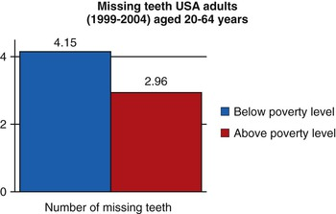
FIGURE 20-1 The average number of missing teeth in a 20- to 64-year-old population is similar, regardless of income.
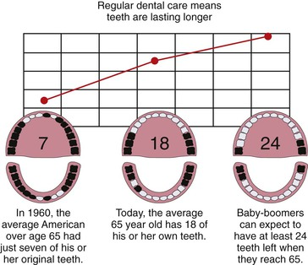
FIGURE 20-2 The number of missing teeth in people older than the age of 65 years old has been decreasing since 1960.
The first adult teeth lost today are usually between the ages of 35 and 54 years. Almost 30% of the 50- to 59-year–old adults examined in a U.S. national survey exhibited either single or multiple posterior edentulous spaces bordered by natural teeth.¹ This segment of the population has the most disposable income and is the least dependent on insurance companies to pay for dental care. Treatment to replace single teeth in the posterior regions represents nearly 7% of the annual dental care reimbursement from insurance companies and totals more than $3.2 billion each year.^{2,3} Because most companies often reimburse less than 50% for tooth replacement, the total costs of single-tooth replacement may approach $7 billion in the United States each year.

Posterior Missing Tooth
The first molars are the first permanent teeth to erupt in the mouth and often play a pivotal role in the maintenance of the arch form and proper occlusal schemes. These teeth are often the first to decay, and adult patients often have had one or more crowns fabricated to restore the integrity of the teeth and replace previous large restorations. Longevity reports of crowns have yielded very disparate results, with the mean life span at failure reported to be 10.3 years. The primary cause of failure of the crown is endodontic therapy, porcelain or tooth fracture (or both), or uncemented restoration. Teeth are at risk for extraction as a result of these complications, and coupled with decay, these complications are a leading cause of single posterior tooth loss in adults^{1–9} (Figure 20-3).
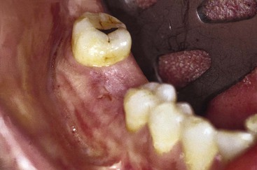
FIGURE 20-3 A mandibular first molar is often the first tooth lost in a permanent dentition.

Posterior Single-Tooth Replacement Options
Evidence-based medicine is the conscientious, explicit, and judicious use of the best evidence in making decisions about the care of individual patients.¹⁰ Over the years, researchers have observed that external clinical evidence would both invalidate previously accepted treatment and allow replacement with new modalities that are more efficacious and safe.¹⁰ An evidence-based approach may be applied to the replacement of a posterior single tooth.
Five alternative treatment options exist for the replacement of a posterior single missing tooth (Box 20-1). The interocclusal space must be assessed carefully regardless of the treatment selected. Patients with insufficient vertical space may be contraindicated for any prosthesis without the prior correction of the occlusal plane and maxillomandibular relationships.
Box 20-1
Alternative Options
Single-Tooth Replacement

1. Removable partial denture (RPD)
2. Resin-bonded fixed prosthesis
3. No restoration (space maintained)
4. Fixed partial denture (FPD)
5. Implant prosthesis

Removable Prosthesis
One option to replace a single missing posterior tooth is a removable partial denture (RPD) (Figure 20-4). A common axiom in restorative dentistry is to use a fixed prosthesis whenever possible.⁸ RPDs are usually indicated to replace spans of three or more posterior teeth or a missing canine and two or more adjacent teeth. Rarely does a patient consent to a RPD as an acceptable definitive substitute for one posterior single tooth.
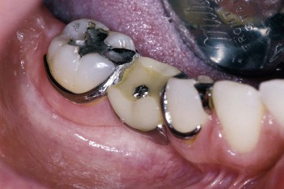
FIGURE 20-4 A removable partial denture to replace a missing posterior tooth is rarely a definitive appliance.
The advantages of the removable restoration for multiple tooth loss include ease of daily care of the adjacent teeth, the ability to have a soft tissue replacement around the missing tooth in esthetic zones with gross defects, maxillary lip support in gross defects, minimal preparation of the abutment teeth, and reduced cost (Box 20-2). However, no reported advantages exist for a RPD replacing one posterior tooth.
Box 20-2
Advantages of Removable Partial Dentures
1. Hygiene
2. Soft tissue replacement in esthetic areas
3. Maxillary lip support in gross defects
4. Minimum tooth preparation
5. Reduced cost
Removable prostheses do not maintain bone. The maxillary posterior teeth are often in the esthetic zone (especially the maxillary premolars), and bone loss may compromise the esthetic result. Function is not improved with a removable prosthesis replacing one or two teeth. Therefore, esthetics and the fear of other teeth shifting in the arch are the two primary reasons for the patient to consent to wearing the restoration. Because of its bulk and usually the need for cross-arch stabilization, a RPD promotes more food debris and plaque accumulation on the adjacent teeth than any other treatment option (Box 20-3). Few clinical reports are available to assess the longevity survival rate, complications, or survival of adjacent teeth for a single-tooth RPD in the posterior regions of the mouth. From an evidence-based approach, this procedure is not indicated.
Box 20-3
Disadvantages of Single-Tooth Removable Partial Dentures
1. Bulk—often requires cross-arch stabilization
2. Food debris, plaque
3. Movement
a. Speech affected
b. Function decreased
4. No clinical studies
5. Bone loss in edentulous site
6. Highest loss of abutment teeth (up to 44% within 10 years)
The plaque accumulation with the RPD increases the risk of decay and periodontal complications. Recently, Shugars et al.³ and Aquilino et al.¹¹ have reported on survival rates of teeth adjacent to treated and untreated posterior-bounded edentulous spaces. When RPDs supported by adjacent teeth on each side were used to replace teeth, the survival rate of the posterior teeth adjacent to the edentulous space were poorer than with any other treatment option, with ranges from 17% to 44% abutment tooth loss at 4.2 to 13.5 years.^{3,11–14} Patients electing not to wear the RPD had greater survival of the adjacent teeth than those wearing the removable prosthesis.
In conclusion, an evidence-based evaluation for a posterior single-tooth replacement with a RPD as a definitive restoration is not indicated and may even accelerate the loss of the adjacent teeth. These devices are most often used as a transitional prosthesis in the esthetic zone.

Resin-Bonded Fixed Partial Denture
A second option to restore a single missing tooth bordered by posterior natural teeth is a resin-bonded fixed partial prosthesis. The primary advantages of this restoration are the minimal preparation of the adjacent teeth and reduced cost compared with a fixed partial denture (FPD) (Box 20-4).
Box 20-4
Advantages of Resin-Bonded Fixed Partial Dentures
1. Minimal preparation of teeth
2. Good for young patients (no need to crown, no risk of encroachment on pulp)
3. An alternative when skeletal growth is not complete
Failure rates reported in the literature are greatly disparate, but the majority of reports indicate a failure rate of at least 30% within 10 years and as high as 54% within 11 months.^{6,15–17} It also appears that earlier perforated designs exhibited lower survival rates (Box 20-5).
Box 20-5
Disadvantages of Posterior Resin-Bonded Fixed Partial Dentures
1. High debond rates (50% within 3 years)
a. Inconvenience to patient and doctor
2. Risk of decay on abutment teeth when partially debonded
The majority of resin-bonded FPD failure initially occur from cement failure (which often results in caries when partially retained), with different regions of the mouth exhibiting various retention rates. The highest survival rates occur in the maxillary anterior followed by mandibular anterior, maxillary posterior, and mandibular posterior teeth, respectively.¹⁸ Therefore, posterior tooth replacement is not as successful compared with an anterior resin-bonded restoration.
Debonding most often occurs during function, and because eating is often a social experience, this may cause the patient embarrassment and insecurity. The prosthesis may also become partially debonded and result in decay under the retainer. The selection of this option is usually driven by economics and the desire to maintain as much tooth structure as possible on the abutment teeth. This option is usually more accepted by the patient than the RPD, but it should be considered as a transitional restoration because of its high debonding rate and associated decay.

Maintenance of the Posterior Space
A third treatment option for a missing posterior tooth is to not replace the tooth but instead to maintain the missing space. A common doctrine has been to replace a missing tooth to prevent complications such as tipping, extrusion, increased plaque retention, caries, periodontal disease, and collapse of the integrity of the arch^{8,14} (Figure 20-5). It is speculated that these conditions cause the loss of additional teeth and have been cited as the second most common cause of missing teeth after the age of 30 years. Clinical studies evaluating the consequences of adjacent tooth loss indicate the loss of one or two teeth adjacent to a long-term edentulous space may range from 25% to less than 8% at 8 to 12 years.^{3,13,14} For example, Aquilino et al.¹¹ reported an 18% 10-year tooth loss rate of adjacent teeth to a posterior missing tooth.
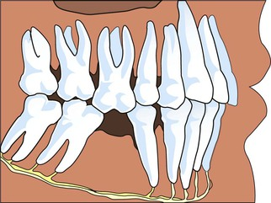
FIGURE 20-5 As many as 82 reasons have been presented in the literature for replacing a first molar after extraction. The most common reasons are tipping of adjacent teeth, extrusion of opposing teeth, and eventual loss of additional teeth.
An indication for not replacing a single missing posterior tooth is a small intratooth space. When the space between the teeth is less than 6 mm, the adjacent teeth are often prevented from migration or extrusion from the existing occlusion. The existing occlusion often has each of the adjacent teeth with occlusal contact with two opposing teeth and as such prevents the tipping of adjacent teeth and the extrusion of the opposing teeth. This condition is most often observed with a missing mandibular second premolar when a third molar is present or after orthodontics when the first premolar was extracted. When the reduced amount of intratooth space should be closed, orthodontics or overcontoured crown(s) on adjacent teeth may correct the condition.
The location of a missing posterior tooth may influence the prosthodontic treatment plan. In general, when third molars are missing, the author suggests not replacing a second mandibular molar¹⁹ (Figure 20-6). The mandibular second molar is not in the esthetic zone of the patient. Ninety percent of the masticatory efficiency is generated anterior to the mesial half of the mandibular first molar, so function is rarely a primary reason to replace the second molar. A 10% greater occlusal force is measured on the second molar compared with the first. As a result, biomechanical stress–related complications are more of a risk, including abutment screw loosening. This tooth is more likely to exhibit working or nonworking interfaces during mandibular excursions. As a result of the increased forces and occlusal interferences, a greater incidence of porcelain fracture occurs. The crown height space (CHS) decreases as it proceeds posteriorly and represents a limited access for implant placement along with abutment screw and abutment insertion, especially when opposing natural dentition. A reduced CHS results in the abutment height being reduced, so the retention of the crown may be compromised. Cheek biting is more common in this region because of the proximity of the buccinator muscle (Box 20-6).
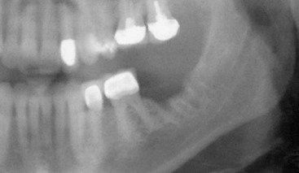
FIGURE 20-6 When a mandibular second molar is missing, there are few consequences when the tooth is not replaced, and there are advantages.
Box 20-6
Disadvantages of Replacing a Mandibular Second Molar
1. Not in esthetic zone
2. Extruded maxillary second molar not esthetic or occlusal consequence
3. Less than 5% of total chewing efficiency
4. A 10% higher bite force (increased bone loss risk, porcelain fracture risk, and abutment screw–loosening risk)
5. More often exhibits occlusal interferences during excursions
6. Higher and less predictable location of mandibular canal in that site
7. Less dense bone
8. Submandibular fossa depth greater
9. Angulation of bone to occlusal plane greater
10. Limited to unfavorable crown height space for cement retention (increased risk of uncementation)
11. Limited access for occlusal screw placement
12. Limited access for correct implant body placement
13. Crossbite position—implant placed more buccal than maxillary tooth
14. Hygiene access more difficult
15. Cheek biting more common
16. More incision line opening after surgery
17. Greater mandibular flexure during parafunction
18. Greater cost to patient
19. When mandibular third molar (when present) moves forward, intratooth space limited
The course of the mandibular canal anterior to the mid first molar corresponds to the level of the mental foramen. However, in the region of the second molar, its course becomes highly variable with less available bone height and an elevated risk of paresthesia and neurovascular bundle damage during implant surgery and insertion. The bone quality in the second mandibular molar region is often inferior to other regions of the mandible, with an increased risk of bone loss or implant failure as a consequence.²⁰ The submandibular fossa topography is deeper in the second molar regions compared with the premolar or first molar sites and mandates greater implant body angulation, with associated increased stresses at the crestal region of the implant, thereby increasing the risk of bone loss and abutment screw loosening. In addition, the facial artery is located in the submandibular fossa before it crosses the mandibular notch and crosses over the face. Perforation of the lingual plate in the region of the second molar may violate the facial artery and cause life-threatening bleeding. The mandible exhibits increased flexure and torsion in this area during opening or heavy biting on one side, and masticatory dynamics are less favorable. As a result, the implant may not integrate in a patient with moderate to severe bruxism or clenching. Finally, the cost of an implant or fixed prosthesis to replace the second molar often does not warrant the benefits achieved. As a consequence, the mandibular second molar is often not replaced when the third molar and second molar are the only posterior mandibular teeth missing.
The primary disadvantage of electing not to replace a mandibular second molar tooth is the potential extrusion and loss of the maxillary second molar or a loss of proper interproximal contact with the adjacent tooth with increased risk of caries, periodontal disease, or both. The extrusion of the maxillary second molar is usually not an esthetic or occlusal concern. When the mandible moves into an excursion, the maxillary second molar is behind the mandibular first molar and does not alter the mandibular pathway of movement even if the maxillary second molar extrudes. If extrusion of the maxillary second molar is a concern for the patient or doctor, then a crown on the mandibular first molar may include an occlusal contact with the mesial marginal ridge of the maxillary second molar, or the maxillary second molar may be bonded to the maxillary first molar.
On the other hand, a missing maxillary second molar opposing a mandibular second molar with extrusion may result in occlusal concern when the mandible moves into an excursion. The extrusion of a mandibular second molar results in an occlusal interference when the mandible moves into protrusive or lateral excursion. Hence, as a general rule, maxillary second molars are usually replaced with an implant when opposing a natural tooth (Figure 20-7).
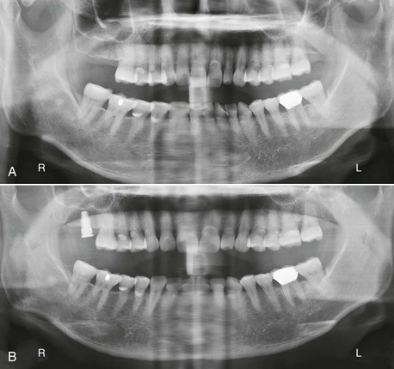
FIGURE 20-7 A, When a maxillary second molar is lost, there are more consequences when the tooth is not replaced. B, As a result, the opposing plane of occlusion is corrected, and an implant is used to replace the maxillary second molar.
The mandibular second molar is usually replaced when the third molar is in function and will remain present (Figure 20-8). In addition, some patients desire an intact dentition and wish to have the tooth replaced, whether or not they have a third molar (Figure 20-9). If the bone is abundant and no paresthesia or surgical risk is apparent, then the second molar may be replaced. However, this is usually the exception rather than the rule of treatment and usually replaces only a premolar-sized tooth.
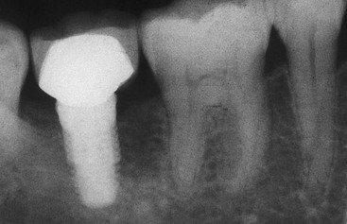
FIGURE 20-8 The second mandibular molar is usually replaced when the third molar is present and will remain in function.
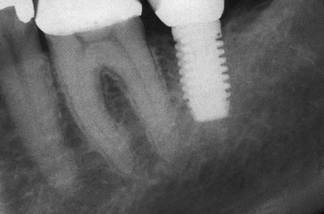
FIGURE 20-9 Some patients desire a second molar replacement despite the lack of need. When existing conditions are favorable, little disadvantage exists to placing an implant in this region. Most often a bicuspid-sized tooth and one implant are used in this region for the restoration.
The other indication to replace a mandibular second molar is when the force factors are extreme (e.g., severe parafunction) and the patient is also missing both molars. In these cases, two or three implants may be indicated to replace the missing teeth (Figure 20-10).
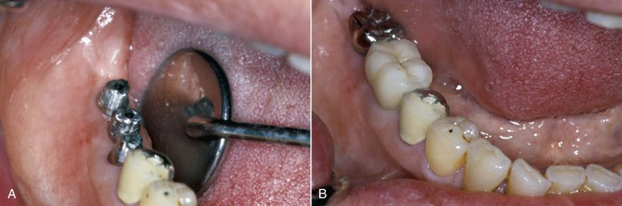
FIGURE 20-10 A, The mandibular second molar is often replaced when the first molar is also missing. B, Greater force factors than usual may indicate three implants to replace the two molars.

Fixed Partial Denture
The treatment most commonly used for the replacement of a posterior single tooth is the three-unit fixed restoration (Figure 20-11). In 1990, more than 4 million FPDs were placed in the United States.²¹ This type of restoration can be fabricated within 1 to 2 weeks and satisfies the criteria of normal contour, comfort, function, esthetics, speech, and health. Because of these benefits, the FPD has been the treatment of choice for the past 6 decades.^{22,23} Few bone and soft tissue considerations exist in the missing tooth site. Every dentist is familiar with the procedure, and it is widely accepted by the profession, patients, and dental insurance companies (Box 20-7).
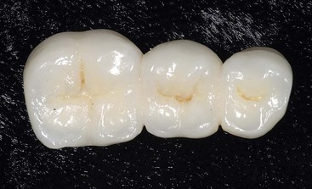
FIGURE 20-11 A three-unit fixed partial denture is the most common method taught in dental schools to replace a posterior missing tooth.
Box 20-7
Advantages of Fixed Partial Dentures
1. Most common treatment (doctor friendly)
2. Reduced time (two appointments, 1 to 2 weeks apart)
3. Restores function, esthetics, and intraarch health
4. Few bone and soft tissue considerations
5. Proven long-term survival
6. Reduced cost—dental insurance covers procedure (reduced patient cost)
7. Less than 6-mm mesiodistal space
8. Potential abutments have clinical mobility; will benefit from being splinted
9. Increases patient compliance and reduces fear
10. Few consequences if failure
A three-unit FPD presents survival limitations to the restoration and to the abutment teeth.⁷ In an evaluation of 42 reports since 1970, Creugers et al.²³ calculated a 74% survival rate for FPDs for 15 years. Walton et al.²⁴ and Schwartz et al.²⁵ reported mean life spans (50%) of 9.6 and 10.3 years, respectively. Scurria et al.²⁶ performed a meta-analysis of several reports at 10 to 15 years and found 30% to 50% failure within these time frames. However, reports are very inconsistent with as little as 3% loss over 23 years to 20% loss over 3 years.^{4,5,23–26}
Caries and endodontic failure of the abutment teeth are the most common causes of prosthesis failure.^{22,24,26} Caries occurs more than 20% of the time and endodontic complications to the abutments of a FPD 15% of the time. Caries on the abutment crown primarily occurs on the margin next to the pontic (Figure 20-12). Fewer than 10% of patients floss on a regular basis, and those using a floss threader are even fewer.²⁷ As a result, the pontic acts as a large overhang next to the crown and a reservoir for plaque. The long-term periodontal health of the abutment teeth may also be at greater risk as a result of the plaque increase, including bone loss.
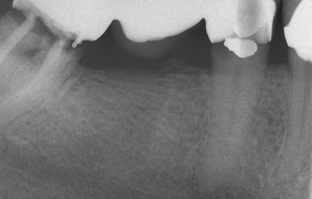
FIGURE 20-12 The most common reason for fixed partial denture failure is caries on an abutment tooth resulting from increased plaque retention next to the pontic. Caries, endodontic failure, fracture, and uncemented restorations often lead to abutment tooth loss.
When a vital tooth is prepared for a crown, a 3% to 6% risk of irreversible pulpal injury and subsequent need for endodontic treatment exists.²⁸ Not only does tooth preparation present a risk for endodontics on each of the vital abutment teeth, but the crown margin next to the pontic is also more at risk of decay and the need for endodontics as a result. Up to 15% of abutment teeth for a fixed restoration require endodontic therapy compared with 3% to 6% of nonabutment teeth with crown preparations²⁹ (Box 20-8).
Box 20-8
Disadvantages of Fixed Partial Dentures
1. Mean life span often 10 to 15 years
2. Caries and endodontic failure of abutment teeth most common complication
3. Increased plaque retention of pontic increases caries and periodontal disease risk
4. Damage to healthy teeth
5. Failure of prosthesis related to loss of abutment teeth (8% to 18% within 10 years)
6. Fracture complications (porcelain, tooth)
7. Esthetics complications (crowns less esthetic than natural teeth)
8. Uncemented restoration
Unfavorable outcomes of FPD failure include not only the need to replace the failed prosthesis but also the loss of an abutment tooth and the need for additional pontics and abutment teeth in the replacement bridge. Root canal therapy is not guaranteed, and a meta-analysis reports a 90% success at the 8-year mark. Because 15% of FPD abutment teeth require endodontics, many abutment teeth may be lost. In addition, an endodontic posterior tooth abutment is at a greater risk of fracture. Reports indicate that abutment teeth for a FPD fail from endodontic complications (e.g., fracture) four times more often than those with vital pulps^{27,30,31} (Figure 20-13). The fracture of the tooth may result in failure of the prosthesis and abutment tooth.
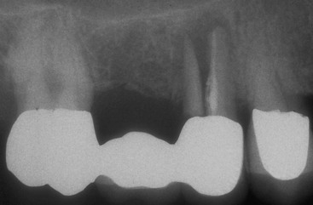
FIGURE 20-13 Fracture of an abutment occurs four times more often when the tooth has endodontic therapy.
The abutment teeth of a FPD may be lost from caries, endodontic complications, or root fracture at rates up to 30% for 8 to 14 years.^{3,13,14} Recent reports indicate 8% to 18% of the abutment teeth holding a FPD are lost within 10 years (Figure 20-14). This is most disturbing because 80% of abutments have no previous decay or are minimally restored before the fabrication of the FPD.^{6,32}
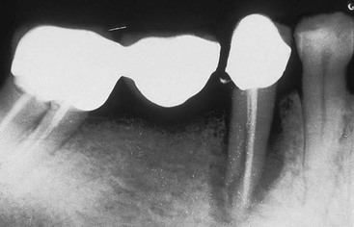
FIGURE 20-14 Several consequences of fixed partial denture complications result in abutment tooth or teeth loss.
Contraindications for a posterior fixed partial prosthesis primarily are related to the abutment teeth. When the abutment teeth have bone loss or short roots, the additional support required for the missing tooth with a FPD may place them at risk. A FP-3 prosthesis is more difficult to fabricate when the teeth and pontic areas have inadequate hard and soft tissue in the esthetic zone. A partial denture may be more esthetic under these conditions. On occasion, the patient does not want the natural teeth to be prepared for crowns because they are adequate in contour, health, and esthetics. The FPD cannot be fabricated without their preparation. In addition, young patients with abutment teeth that have not erupted into final position may be contraindicated for a FPD, especially when the large pulp horns in the clinical crowns are still present (Box 20-9).
Box 20-9
Contraindications for Fixed Partial Dentures
1. Poor abutment teeth support
2. Inadequate hard or soft tissue (or both) in esthetic regions (pontic contour)
3. Patient will not allow preparation of adjacent teeth (patient desire)
4. Young patients with large pulp horns in clinical crowns
Indications for a FPD include time, patient fear of surgery, adjacent tooth mobility, and unfavorable missing tooth size. A final prosthesis may be delivered within 2 weeks with a traditional FPD. An implant option most often requires several months. Rarely, is this the determining factor but on rare occasion may be significant. The patient may have a psychologic fear of implant surgery. This most often can be handled with conscious sedation. But if general anesthesia is required, a FPD may be more prudent.
When the teeth adjacent to a missing space have class II mobility and all other periodontal indexes are normal, a FPD may be the treatment of choice. A posterior space requirement for an implant option is most often greater than 6.5 mm in width and 9 mm in height. If a mandibular canal or maxillary sinus may not be modified by augmentation or the mesiodistal space is too narrow, a FPD is often the treatment of choice (see Box 20-7).

Single-Tooth Implants
The fifth treatment option to replace a posterior single missing tooth is a single-tooth implant (Figure 20-15). For years patients were advised to set their desires aside and accept the limitations of a FPD. The primary reasons for suggesting the FPD were its clinical ease and reduced treatment time. However, a RPD is faster, easier, and less expensive. If this concept of faster, easier, and cheaper was expanded, then extractions would replace endodontics, and dentures could even replace orthodontics (the teeth are straight and white). The primary reason to suggest or perform a treatment should not only be related to treatment time, cost, or difficulty to perform the procedure but also should reflect the best possible long-term solution for each individual.
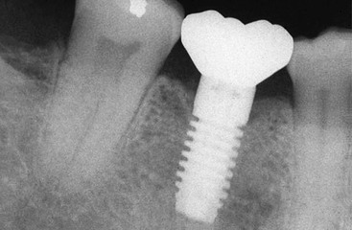
FIGURE 20-15 A single-tooth implant is usually the best treatment option to replace a posterior missing tooth.
Before 1990, few long-term studies focusing on single-tooth implant replacement with osseointegrated implants in any region of the mouth had been published. Early reports indicated that single-tooth implant results were less predictable than they have become in the past 10 years. For example, in 1990, Jemt et al.³³ reported a 9% implant failure within 3 years of prosthesis completion on 23 implants (21 in the maxilla, two in the mandible). In 1992, Andersson et al.³⁴ published a preliminary report of a prospective study of 37 implants restored with single-tooth crowns in 34 patients. A 3-year follow-up included this “developmental group” and an additional 23 patients with 28 crowns. The cumulative success rate recorded was 93.7%, with 89% of the developmental group in function 3 to 4 years.²⁴
From 1993 to the present time, single-tooth implants have become the most predictable method of tooth replacement. Almost all 5- and 10-year reports demonstrate a higher survival rate than for any other method of tooth replacement. For example, in 1993, Schmitt and Zarb³⁵ reported no failures for 40 implants placed in 32 patients (28 in the maxilla, 12 in the mandible, with 27 in the anterior region and 13 in the posterior). After a period of up to 6.6 years, all implants were in function. In 1994, Ekfeldt et al.³⁶ reported a 4- to 7-year retrospective study of 77 patients who received 93 implants. Two implants were lost, both within the first year of function. In 1995, Haas et al.³⁷ reported on 76 single-tooth implants observed for 6 years with a 2.6% implant loss. Simon³⁸ observed 70 molar implants over a period ranging from 6 months to 10 years, with a 97.1% success rate. Levin et al.³⁹ reported in 2006 on single-molar replacement with implants over a 10-year period with a 93.6% success rate.
A multicenter prospective clinical study by general dentists was initiated in 1996.⁴⁰ Thirty-eight implants were placed in the posterior regions of the jaws: 15 in the maxilla and 23 in the mandible. The implant survival rate was 100% at the 5-year follow-up. The mean bone loss from implant insertion to uncovering was 0.4 mm from the original crest of the ridge, the additional mean bone loss over the first 1 year of loading averaged less than 0.3 mm, and no bone loss over the following year was observed. No incidence of abutment screw loosening or fracture of any components was observed in this study. In 2000, Misch et al. reported on 30 single-tooth implants in the posterior maxilla, with a 100% survival rate over a 5-year period. In 2006, Misch et al. followed 1377 single-tooth implants in a multicenter study for 10 years and found a 98.9% survival rate for single-tooth implants.^{40,41} A 10-year report by Priest indicated that the posterior single-tooth implant was more than 97% successful.⁶
Perhaps of more significance, the Misch et al. and Priest reports evaluated the teeth next to the implant crowns more than 10 years.^{6,32} In both reports, no adjacent teeth were lost from endodontic failure or caries. Only one tooth required endodontic therapy after implant insertion, and fewer than 10% of the teeth required a restoration. These reports clearly identify that the adjacent teeth are least at risk when the missing tooth is replaced with an implant.
Although posterior single-tooth replacement is a relatively new treatment alternative, more articles have been published on this treatment option than for any other alternative. If early reports are excluded, then survival rates reported range from a low of 94.6% to a high of 100% for up to 10 years. A review of the literature by Goodacre et al.⁴² from 1981 to 2003 found single-tooth replacement with an implant had the highest implant prosthesis survival rate and averaged 97% survival. The most common complications reported have been abutment screw loosening or porcelain fracture, which do not cause the implant or adjacent teeth to fail.
Cost comparison studies conclude that the implant restoration demonstrates a more favorable cost-effectiveness ratio.^{6,42,43} Even when the adjacent teeth are not lost, the conventional FPD often needs to be replaced every 10 to 20 years because of decay, endodontic complications, porcelain fracture, or unretained restoration (which then decays and may need endodontics). Implants do not decay or need endodontics. Hence, the restorations have an extended lifetime. Unlike a FPD or resin-bonded restoration, an implant may replace a posterior tooth without a distal abutment. Hence, a second molar in the maxilla may be replaced and prevent the extrusion of the mandibular second molar.
Despite some limitations and obvious clinical challenges, the posterior single-tooth implant represents a highly desirable and justified treatment option. When the adjacent teeth next to the implant are not prepared for crowns, many advantages are incurred. These advantages include the decreased risk of caries and endodontic treatment on the abutment teeth, the improved ability to clean the proximal surfaces of the adjacent teeth (which decreases the risk of decay and periodontal disease), a decreased risk of cold or root contact sensitivity with a brush or scaler on the abutment teeth, improved esthetics (the unrestored adjacent teeth look more natural than a crown), psychological advantages (especially with congenitally missing teeth or the loss of a tooth after endodontics and crown restoration), and the decreased risk of abutment tooth loss from endodontic failure or caries (Box 20-10). These advantages are so significant to the health and periodontal condition of the adjacent teeth and maintenance of the arch form that the single-tooth implant has become the treatment of choice in most situations.
Box 20-10
Advantages of Single-Tooth Implants
1. Adjacent teeth do not require splinted restorations
a. Less risk of caries
b. Less risk of endodontics
c. Less risk of porcelain fracture
d. Less risk of uncemented restoration
e. Less fracture of tooth
2. Psychological need of patient addressed: patient does not desire two adjacent teeth (often virgin) prepared and splinted to restore missing tooth
3. Improved hygiene conditions
a. Less decay risk
b. Floss versus floss threader
c. Less pontic “plaque trap overhang”
4. Decreased cold or contact sensitivity
a. Prepared teeth more temperature sensitive
b. Cementum of tooth removed by tooth preparation; toothbrush or scaler sensitive
5. Improved esthetics: natural tooth versus crown esthetics
6. Maintains bone in site: 30% decreasing bone width within 3 years after extraction
7. Decreases adjacent tooth loss: 30% versus 0.05% risk at 10 years
In conclusion, the single-tooth implant exhibits the highest survival rates of the five treatment options presented for single-tooth replacement. In addition, the adjacent teeth have the highest survival rate and the lowest complication rate, which is a considerable advantage (Figure 20-16). On the other hand, the longevity of the implant crown has not been adequately determined because these reports do not extend as long as those of other treatment options and often do not report on prosthetic complications. However, 10-year data clearly indicate an implant and its associated crown have greater survival than a FPD, and the adjacent teeth are less at risk.
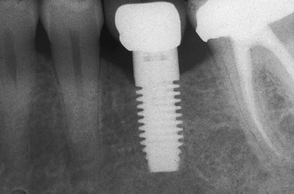
FIGURE 20-16 Because a single-tooth implant has the highest success rate of all the treatment options to replace a single tooth, it is the treatment of choice, especially when the adjacent tooth has endodontics or when the adjacent teeth need crowns (Note: A tooth with a crown has a 3% incidence of endodontic treatment vs. a 15% risk for a tooth serving as an abutment of a fixed prosthesis.)

Contraindications and Limitations of Posterior Single-Tooth Implants
Local contraindications that are unique to posterior single tooth implants and favor a FPD include inadequate bone volume, inadequate intratooth space, observable mobility of the adjacent teeth, the time required for treatment, and psychologic fear of surgery. Grafting may modify inadequate bone volume, either in height or width. Bone grafting for additional height when the adjacent teeth have lost bone is not as predictable as implant insertion and healing regardless of the technique used. Therefore, a FPD may still be the treatment of choice in some clinical conditions.
The consequences of early failure may be greater for a single-tooth implant compared with a three-unit fixed prosthesis. Although surgical success is very high, the implant failure almost always results in bone loss. As a result, if the patient elects to repeat the procedure, then bone grafting may be required. This most often is at the expense of the doctor because most patients believe early implant failure, at least in part, is the doctor’s responsibility. Bone grafting is not as predictable as implant surgery; therefore, if a graft is required (especially in height), then the procedure may not be successful. However, contrary to failure of a fixed prosthesis, implant failure usually does not compromise the adjacent teeth and does not increase the risk of their loss.
The most common conditions that render posterior implant surgery contraindicated in height is found in the mandible. On occasion, the posterior roots of the teeth are short, and the mandibular canal runs higher than usual in the body of the mandible. The ideal available bone height for an implant is 12 mm or greater. An implant that is 9 mm long is usually the shortest length, which ideally should have 11 mm of bone height to have a 2-mm safety zone above the mandibular canal. When less than 10 mm of bone is present in height, the dentist may elect to not place an implant.
The posterior maxilla more often has less than 10 mm of bone in height because the sinus rapidly expands after tooth loss. Sinus grafting is very predictable. However, increased training, increased cost, and a healthy sinus are the requirements to gain additional bone height. Some sinuses have chronic sinusitis, and it is difficult to resolve the pathology for sinus grafting. In these patients, a FPD may be the treatment of choice.
The mesiodistal posterior space should be at least 6.5 mm or larger. Smaller posterior intratooth spaces should be restored with a FPD or two adjacent crowns that are overcontoured (or allow the space to be maintained). Flossing is easier between two adjacent, unsplinted, overcontoured crowns than for a fixed prosthesis, and the cost is reduced. If the space is out of the esthetic zone, then the clinician may consider not replacing the tooth if the adjacent teeth are not at risk of tipping or extrusion because of the occlusal relationship of the opposing teeth.
When the adjacent teeth have observable primary mobility but all other periodontal indices are within normal limits, a three-unit fixed restoration is superior to the other treatment options. When the adjacent teeth have moderate to severe mobility, the occlusal adjustment of an implant crown may be difficult to perform because it is the only rigid component in a span of three to five teeth.
Posterior healthy teeth move vertically 28 microns and exhibit lateral movement of less than 75 microns during primary tooth movement. A heavy bite force occlusal adjustment allows the teeth to move within their physiologic range before the implant crown contacts in occlusion. However, when the surrounding teeth are excessively mobile, an equilibration of force is not possible because the implant crown will come into contact before the conclusion of the adjacent natural tooth primary movement. As a result, the implant bears the load of all the mobile teeth and therefore may be contraindicated when surrounded by teeth with advanced clinical mobility.
On occasion, patients may have a psychologic fear of surgery and require a general anesthetic when these procedures are necessary. If bone grafting or several surgeries are required before implant surgery, it may be necessary to opt for a FPD.
On rare occasions, the length of time needed to replace the missing tooth constitutes the primary deterrent of the treatment. A FPD can be fabricated in less than 1 week and allows for the placement of a fixed transitional prosthesis. An implant may require several months before the final restoration is delivered.
To summarize, the primary indications for the selection of a three-unit FPD correspond to the limitations of single-implant tooth replacements: (1) limited time frame, (2) lack of available bone height with poor prognosis or impossibility to augment, (3) inadequate intratooth space, (4) advanced clinical mobility of adjacent teeth, and (5) psychologic fear of surgery. Under most other clinical conditions, a single-tooth implant is the treatment of choice.

Specific Single-Tooth Implant Indications

Anodontia
The absence of one or more teeth is known as anodontia and may be complete (very rare) or partial (also called hypodontia). It is many times more common than supernumerary teeth.⁴⁴ The primary cause of partial anodontia (third molars excluded) is familial heredity, and the incidence ranges from 1.5% to as high as 10% in the U.S. population.⁴⁵ Congenital absence appears to occur less often in Asians and black Americans (2.5%) than in whites (5.15%). The highest average has been reported in Scandinavian countries (10.1% in Norway and 17.5% in Finnish Skolt-Lapps). In addition, a number of syndromes exist in the literature that include multiple missing teeth, of which ectodermal dysplasia is the most common.
A high correlation is found between primary tooth absence and a permanent missing tooth; however, a missing tooth occurs more frequently in the permanent dentition. Caprioglio et al.⁴⁶ evaluated the records of almost 10,000 patients between the ages of 5 to 15 years of age. Of all the missing single teeth, the mandibular second premolar was most often missing (38.6%), followed by the maxillary lateral incisor (29.3%), the maxillary second premolar (16.5%), and the mandibular central incisor (4.0%). The remaining teeth were absent at a rate of only 0.5% to 1.8%, with the maxillary first molar being the least affected. The missing mandibular second premolar primarily occurred in male patients, and the missing maxillary lateral incisor primarily occurred in female patients (Figure 20-17).
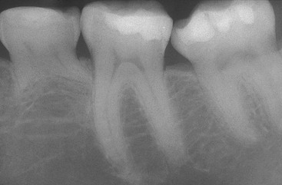
FIGURE 20-17 A periapical radiograph of a deciduous second molar and no permanent second premolar in a male patient.
The most common multiple teeth lost (other than third molars) are the maxillary lateral incisors followed by the mandibular second premolars and maxillary second premolars. Congenitally missing teeth are therefore a common scenario in a general practice. Fortunately, fewer than 1% of those missing teeth are missing more than two teeth, and fewer than 0.5% of this group are missing more than five permanent teeth. In the majority of children with more than five teeth missing, it is related to ectodermal dysplasia.
An emotional aspect exists to the replacement of a congenitally missing tooth. Because the cause is often genetic, the parent with the genetic defect often feels a psychological healing when the implant returns his or her son or daughter to “normal.” An implant appears to be less traumatic because the adjacent healthy teeth do not require preparation. These conditions make the parent eager for an implant regardless of the time or cost of the procedure. However, if the bone graft, implant, or both should fail, then emotional consequences result. It is especially dangerous to put an adjacent tooth at risk under these conditions. If a young patient loses an adjacent tooth because of improper implant insertion or a consequence of a bone graft, then the patient–doctor relationship is stretched to the limit. As such, the clinician should use highly predictable procedures with care, ensuring that adequate space and bone are present before implant placement.
The dentist should first determine whether space-opening (maintenance) procedures or space closure (orthodontics) is the treatment of choice for the missing tooth. The treatment options are usually different for a mandibular second premolar compared with a maxillary lateral incisor.
A congenital missing mandibular second premolar most often has a deciduous second molar. When the patient is 5 to 6 years old, the deciduous second molar may be extracted. The permanent first molar may then erupt in a more mesial position. When the first deciduous molar is lost naturally (around the age of 9 to 11 years), the first permanent premolar and first molar may be orthodontically positioned adjacent to each other. This approach eliminates the need for a second premolar replacement. Because the second premolar space is eliminated with orthodontics, no bone graft, implant surgery, or crown (or combination of these treatments) is required to replace the tooth. Very few disadvantages exist to the use of orthodontics to eliminate this posterior missing tooth space.
A common scenario is to maintain the deciduous second molar for as long as possible. Often, the tooth finally breaks down and needs to be extracted by age 35 to 40 years. When the deciduous second molar is maintained, it may become ankylotic approximately 10% of the time. As a result, the opposing maxillary second premolar extrudes and the adjacent teeth often tip over the deciduous tooth (Figure 20-18). In addition, because the deciduous molar is 1.9 mm larger than a premolar, the mesiodistal space is larger than the usual premolar space after the deciduous molar is lost at a later date in the adult patient’s life. An implant is usually the treatment of choice to replace the second premolar. However, the deciduous tooth does not have a buccolingual width of bone that is adequate for a larger-diameter implant. The crown for this larger tooth dimension is supported by a regular-size implant, which increases forces on the abutment screw and increases the risk of screw-loosening complications. However, this is most often the treatment of choice in adult patients rather than preparing the adjacent teeth for a traditional FPD (Figure 20-19). An alternative in an adult implant patient is to augment the site for width and place a larger-diameter implant (5 mm). This improves the emergence profile and decreases the risk of abutment screw loosening.
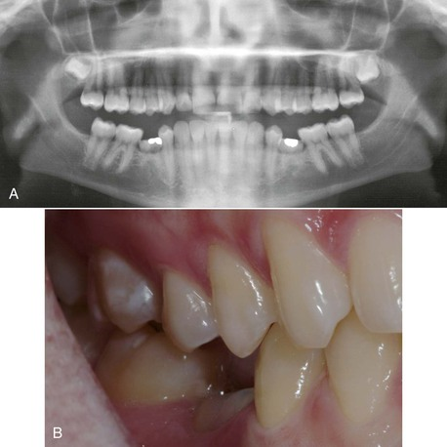
FIGURE 20-18 A, A panoramic radiograph of a patient missing bilateral mandibular second premolars and the deciduous molars are ankylosed. B, The opposing premolars have extruded and the adjacent teeth have tipped over the deciduous molar.
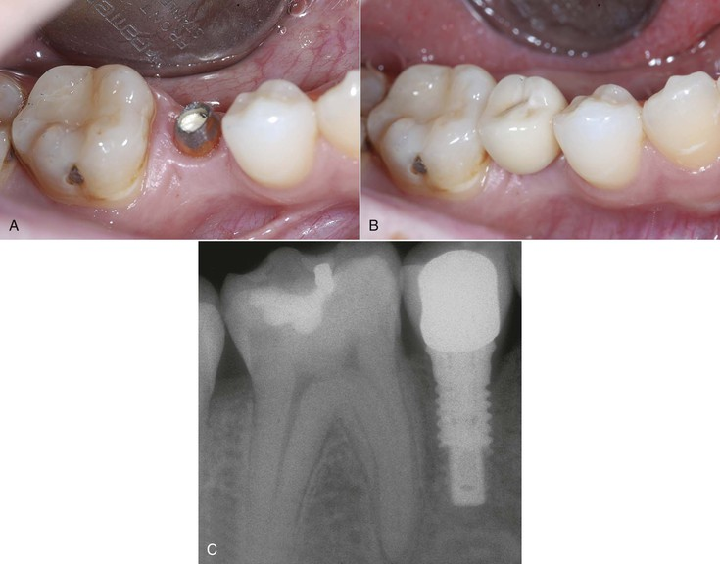
FIGURE 20-19 A, A single-tooth implant is usually the treatment of choice when a deciduous molar is lost in an adult patient. B, The bone volume is often less in width, and the mesiodistal space is greater for the replacement tooth. C, A 4-mm-diameter implant is often used to replace the second premolar.
Another option in an adult patient missing a permanent premolar is orthodontic closure of the space. However, care is taken so the anterior component of teeth do not shift distally and open the centric occlusal bite relationship. To prevent this occurrence, an orthodontic implant (transitional anchorage device) may be inserted distal to the canine root and used as anchorage to pull the molars forward to close the space (Figure 20-20). This approach may also negate the need to extract a third molar in that quadrant when performed on the adolescent patient.
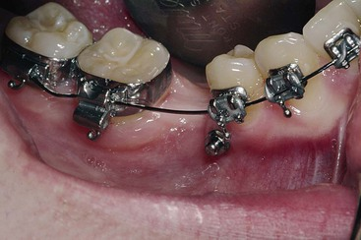
FIGURE 20-20 A transitional anchorage device may be positioned anterior to the deciduous molar space and help move the molars forward to close the missing tooth space.

Age Limitations
An ankylosis condition of primary teeth occurs in between 8% to 14% of children and primarily affects the deciduous molars. The tooth does not continue to erupt and appears below the occlusal plane of the adjacent teeth. It appears the root of this tooth has a direct bone–root contact, which prevents an eruption pattern. The same condition exists with an implant in a developing child. The direct bone–implant contact prevents the implant body to shift in conjunction with growth and development. Instead, it captures the bone in three-dimensional space and prevents the implant site from adapting to the changing environment.
A study with implants in developing pigs found the surrounding teeth continued to follow jaw development, and the adjacent teeth were facial and occlusal to mandibular implants and occlusal in the maxillary arch.⁴⁷ Tooth bud growth adjacent to the implants were also displaced in their path of eruption. Several clinical reports have found a similar situation in young implanted patients. Therefore, clinical reports and animal studies confirm implants do not accommodate growth and development of the jaws and instead remain in a similar position as initially inserted.
The growth of the jaws may be described in three different planes: transverse (width), anteroposterior (length), and vertical.⁴⁸ The order of completion of growth in both jaws is completed in width first followed by length and finally vertical growth. The width growth is completed in the anterior region before the adolescent growth spurt. Both the maxillary and mandibular posterior regions continue to expand until the second and third molars have fully erupted. The posterior maxilla has more growth in width than the anterior maxilla⁴⁸ (Figure 20-21).
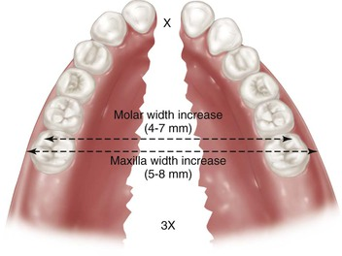
FIGURE 20-21 The posterior maxilla increases in width during growth and development more than the anterior maxilla.
Because teeth erupt sooner and develop faster in girls than in boys, the width growth usually finishes in girls and young women between 9 to 15 years. Boys have a greater width gain than girls and continue to grow after the growth spurt for a longer period (11–17 years); in comparison, a young woman may be 3 mm wider in the molar areas. As a consequence, an implant inserted in the posterior maxilla prematurely may result in the implant crown in crossbite after growth and development is complete, especially in young men (Figure 20-22). In the maxilla, the maxillary sinus expands as the permanent teeth erupt. Hence, the implant may also have the sinus drape over the end of the implant. It is not clear whether the bone–implant interface is affected by this action. The width growth in the mandible premolar site may be 2 to 3 mm. Hence, an implant crown in the mandible placed before growth and development is complete may appear more lingual.
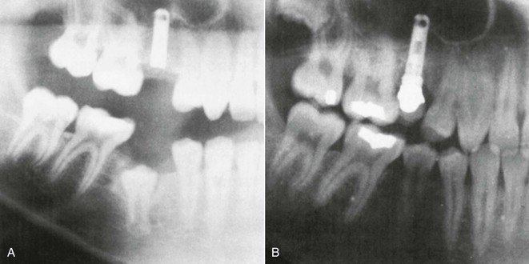
FIGURE 20-22 A, An implant placed in a maxillary second premolar site before the finish of growth and development. B, After maturity, the implant is in crossbite, the maxillary sinus has draped over the end of the implant, and the implant is in inferior occlusion. (From Oosterle LJ: Implant considerations in the growing child. In Higuchi KW, editor: Orthodontic applications of osseointegrated implants, Chicago, 2000, Quintessence.)
Growth in the anteroposterior direction continues after the width is completed. In young women, the growth is usually completed by 16 years of age, which is several years after menses begins. In young men, the anteroposterior growth may continue until the early 20s or more than 4 years after sexual maturation.
The vertical growth of the jaws is the last direction to be completed. The vertical growth for young women approximates 17 to 18 years and later for young men. This direction is the dimension most often noted when an implant is inserted before the completion of growth and development. As a result of this three-dimensional growth in the maxilla, from 9 to 25 years, the molars may erupt more than 8 mm downward, 3 mm laterally, and 3 mm mesially, with 1.5-mm changes per year during the growth spurt.
In the mandible, the anteroposterior direction is coupled with the vertical growth because it grows upward and backward. The body, ramus, and condyle growth makes the appearance that the lower jaw is being displaced down and forward. However, there is little actual change in the anterior region of the jaws.
An implant inserted in a premolar position before the completion of growth and development may have the permanent adjacent teeth erupt above the implant crown and change the interproximal contacts (Figure 20-23). The mandibular molar position may even erupt over the implant crown, with the rotational growth of the mandible.
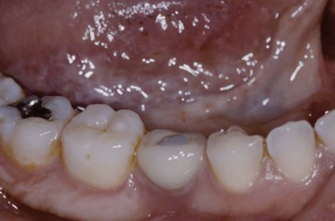
FIGURE 20-23 A second premolar implant placed before growth and development was complete may appear inferior in occlusion, more lingual, and have open interproximal contacts on the distal.
An implant inserted in a missing posterior premolar site may prevent the bone loss in width. However, if growth and development is not completed, the adjacent teeth may be more at risk from the misaligned position, the bone on the implant is more apical than the adjacent root position, the occlusal plane of the opposing arch may extrude or exfoliate, and a soft tissue pocket may develop around the implant.
Over the past decade, Misch et al.⁴⁹ have created four guidelines for implants placed in younger patients. The first guideline is the chronological age of the patient. The chronological age of vertical growth cessation for girls approximates 17 to 18 years and 18 to 19 years for boys (and is later than the anterior regions of the mouth). It is logical to wait until skeletal and dental growth have been completed. Therefore, as a general rule, implant insertion in the posterior regions is delayed for female patients until at least 17 years and male patients until 18 years of age.⁴⁸ However, this guideline is too variable to be used alone. Ideally, age is related to the patient’s biological age more than the chronological age.
Other biological factors indicative of completed growth should be assessed before implant insertion. The second criterion for implant insertion relative to children is endocrine changes. The pubertal growth spurt is related to these hormone changes. Female patients should be able to menstruate, and male patients should have body hair, voice changes, and most often need to shave (if his father shaves daily). These criteria are most always met by 17 to 18 years but must at least be included because it is called a “pubertal growth spurt.”⁵⁰
The height of the child is also very relevant for implant insertion and is the third criterion. The prospective implant patient should have greater height than their same-sex parent. The size of the patient is more important than the age of the patient when the minimum age is being considered for implant placement.
The fourth criterion for implant insertion is that the patient has not grown in height over the past 6-month period. Thilander et al. have noted that if no statural growth has occurred in the past 6 months, then growth and development of the jaws are at least near completion.^{51,52} This criterion is easier to observe than cephalograms or hand–wrist radiographs with a 2-year evaluation period.
Authors have suggested lateral cephalograms of 2 consecutive years of no changes.⁴⁴Although it is difficult to superimpose radiographs taken over several years, this criterion is the best indication that the pubertal growth spurt is finished and the majority of facial growth is finished. However, if any changes have taken place in the past year, another year is necessary with this technique to evaluate if growth has matured enough for implant insertion.

Transitional Restorations
The absence of a transitional posterior tooth replacement is the most frequent situation during bone augmentation and implant healing in a nonesthetic region, such as the mandibular posterior aspect of the mouth. Although the occlusion and adjacent teeth may change during the 4-month healing period, rarely is this a reason for a transitional restoration in nonesthetic regions (Figure 20-24).
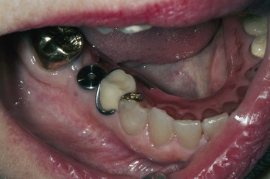
FIGURE 20-24 Rarely do the adjacent teeth shift during the 4-month healing period of an implant. However, the space should be monitored, and if changes begin to occur, a space maintainer may be indicated.
Few indications exist for a removable prosthesis as a definitive treatment when replacing a single posterior tooth. However, it is often used as a transitional restoration in esthetic regions during implant healing. The practitioner should be aware a soft tissue–borne removable transitional restoration (flipper) may load the soft tissue over a bone graft and compromise the end result. Although rare, the RPD may also cause bone loss or perhaps even implant failure from the early loading around the implant during stage I healing. The RPD transitional may also depress the interdental papillae of the adjacent teeth, resulting in an esthetic compromise. As a result, a RPD with rest seats and clasps, a tooth-supported Essix appliance, or a resin-bonded fixed restoration may be fabricated when replacing teeth in the esthetic zone to provide an improved functional transitional prosthesis and protect the region. The resin-bonded restoration is most often the primary option when bone grafting is necessary before or in conjunction with implant placement because of the bone graft’s extreme vulnerability to movement and the extended healing time required.
Both a tooth-supported removable and a resin-bonded fixed prosthesis may be fabricated for the transitional restoration. The removable restoration (i.e., Essix appliance) is worn immediately after surgery to protect the suture line during the initial healing.⁵³ After the sutures are removed, the resin-bonded restoration (without tooth preparation) may be delivered. Because both resin-bonded and removable restorations are fabricated, the patient can insert the removable restoration if the bonded restoration becomes uncemented. This eliminates the esthetic embarrassment until rebonding can be performed. However, this approach increases the overall cost of treatment. The posterior resin-bonded prosthesis may not be indicated in the case of short clinical crowns or unfavorable occlusal relationships.
A second option for a transitional posterior single-tooth replacement is an acrylic cantilevered or a three-unit temporary restoration. This is performed when the adjacent tooth or teeth require a crown. The adjacent tooth or teeth crown is prepared and serves as transitional abutments for the acrylic temporary prosthesis. After the implant is integrated, the crowns and implant crown may be fabricated at the same time as independent units.

Implant Body Selection
The implant body for a posterior single-tooth implant should include specific features to reduce complications. The implant body should be made of titanium alloy to reduce the risk of long-term fracture because it is four times more resistant to fracture than grade 1 titanium and twice as strong as grade 3 titanium. A threaded implant provides greater functional surface area than a cylinder, and a tapered implant provides less surface area than a parallel walled implant body. When implant bodies are internal hex designs, the dimension of the implant in the posterior regions should be at least 4 mm or more in diameter to increase the outer body wall thickness and reduce the risk of long-term body fracture.
The most common problem associated with a single-tooth implant is abutment screw loosening.⁴² Crest module and abutment connection designs that decrease forces to the abutment screw are therefore indicated. The implant must have an antirotational feature (i.e., external or internal hex). The greater the height or depth of the antirotational feature, the less force transmitted to the abutment screw. Accuracy of component fit and abutment screw design, as well as the number of threads on the abutment screw, are other critical features.^{54–56}
The ideal diameter of a single tooth implant depends on the mesiodistal dimension of the missing tooth and the buccolingual dimension of the implant site. An angular defect may develop around the abutment–body connection measuring 1.0 to 1.4 mm in width. As a result, when the implant is placed closer than this dimension to an adjacent tooth, the vertical, angular defect dimension may be converted to a horizontal defect and cause bone loss on the adjacent tooth. The horizontal bone loss around the implant will cause an increase in probing depths or an increased risk of soft tissue shrinkage. These may affect the bacterial flora or cervical esthetics of the soft tissue drape. When the implant has facial bone thickness less than 1.0 mm of cortical bone or 1.5 mm of trabecular bone, an increased risk of bone loss and implant failures may occur.⁵⁷ As a consequence, the ideal implant diameter is 1.5 mm or more from each adjacent tooth and 1.0 mm or more from each of the lateral plates of the ridge. Therefore, the ideal implant diameter in the intratooth posterior region should be at least 3 mm less than the mesiodistal dimension of the missing tooth (from cementoenamel junction [CEJ] to CEJ) and at least 2 mm narrower than the buccolingual dimension of bone. As general rule, the molar implant should be larger in diameter than a premolar implant (Figure 20-25).
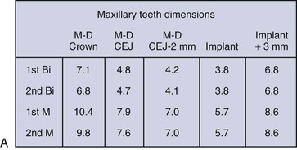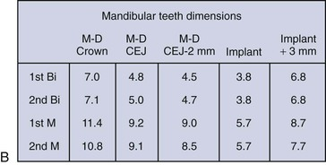
FIGURE 20-25 A, The average mesiodistal (M-D) size of the maxillary posterior teeth ranges from 6.8 mm to 10.4 mm. B, The average M-D size of the mandibular posterior teeth ranges from 7.0 mm to 11.4 mm, with the molars slightly larger than those in the maxilla. CEJ, Cementoenamel junction.

Premolar Implant Replacement
The most ideal posterior tooth to replace with an implant is the first premolar in either arch (Figure 20-26). When used as an abutment for a three-unit FPD, the canine is at an increased risk of material fracture or uncementation (because of the lateral forces applied) and is often more difficult to restore to its original appearance than are other anterior or posterior teeth. The vertical available bone is usually greater in the first premolar locations than in any other posterior tooth positions. In the maxilla, it is almost always anterior or below the maxillary sinus, and the mandibular first premolar is almost always anterior to the mental foramen and associated mandibular neurovascular complex. The bone trajectory for implant insertion is more favorable in the mandibular first premolar than for any other tooth in the arch.
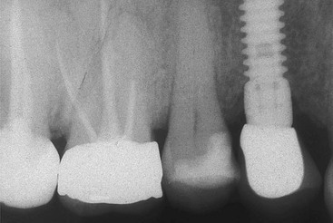
FIGURE 20-26 An implant in the first premolar region is usually anterior to the maxillary sinus or the mental foramen.
The maxillary premolars are often in the esthetic zone of patients with a high smile line. The need for bone grafting before maxillary first premolar implant placement is very common because the extraction process of the thin buccal root often causes facial bone loss during or after the extraction. Implant placement without bone grafting may result with a recessed emergence profile, which in the past was corrected with a facial ridge lap to the crown. However, the crown with a ridge lap contour does not allow proper hygiene or probing of the facial sulcular region of the crown and should be used as a last resort.
To ensure a proper esthetic result and to avoid the need for a crown with a ridge lap, the implant body is often positioned similar to an anterior implant, under the buccal cusp tip (one third buccal, two thirds lingual) rather than midcrest (which is under the central fossa). The slight buccal implant placement improves the cervical emergence profile of the maxillary premolar crown (Figure 20-27).
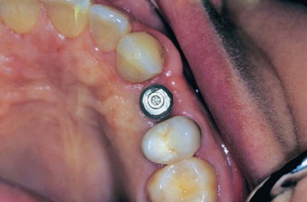
FIGURE 20-27 The maxillary first premolar implant is usually placed more facial than the mandibular first premolar implant because the cervical region is often in the esthetic zone during smiling.
The natural premolar tooth is 7 mm wide in the mandible and 6.5 to 7 mm in the maxilla. The premolar root is usually 4.2 mm in diameter on average at a distance of 2 mm below the CEJ, which is the ideal position of the bone. As a consequence, the most common implant diameter is about 4 mm at the crest module. This also provides approximately 1.5 mm of bone on the proximal surfaces adjacent to the natural teeth when the mesiodistal space is 7 mm or greater. However, when the mesiodistal dimension is only 6.5 mm, a 3.5-mm implant is suggested.
The maxillary canine root is often angled 11 degrees distally and presents a distal curve 32% of the time, which may extend over the shorter root of the maxillary first premolar. With posterior implant insertion, the implant body is often longer than the natural tooth root. The surgeon may inadvertently place the implant parallel to the second premolar and, consequently, into the natural canine root. This may not only result in endodontic therapy of the canine but also may cause root fracture and loss of the tooth. Therefore, in the maxillary first premolar region, care must be taken to evaluate the canine angulation and vertical height limitation. The first premolar implant may need to be placed parallel to the canine root, and a shorter implant than is considered ideal may be required (Figure 20-28). A tapered implant body at the apical third may also be of benefit to avoid encroachment upon the apical region of the canine.
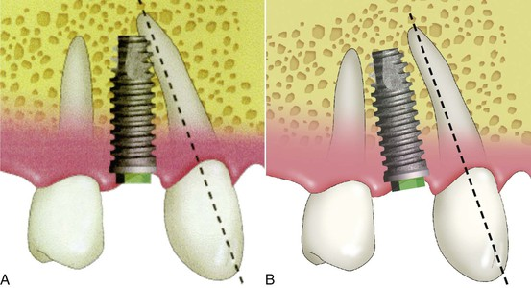
FIGURE 20-28 A, The canine root is often angled to the distal 11 degrees and has an apical distal curve 32% of the time. As a consequence, the first premolar implant may contact the canine root. B, The first premolar implant may need to be angled so it is parallel to the canine rather than the second premolar.
The second premolar root apices may be located over the mandibular neurovascular canal (or foramen) or maxillary sinus. The foramen is often 2 mm or more above the neurovascular canal. Hence, the second premolar available bone height may be less than the first molar region. This also results in a reduced height of bone compared with the anterior region of the jaws. As a result, a shorter implant than ideal is a common consequence in the second premolar site.

First Molar Implant Replacement
The first molar is one of the teeth most frequently lost in a posterior segment. The natural molars receive twice the load of the premolars and have 200% more root surface area; therefore, it is logical that the implant support in a molar region should be greater than in the premolar position. Its mesiodistal dimension usually ranges from 8 to 12 mm, depending on the original tooth size and the amount of mesial drift of the second molar before implant placement. It should be noted that the ideal size of the implant should be measured by the intratooth distance from the adjacent CEJ of each tooth, not the interproximal distance at the marginal ridges. A tipped adjacent tooth should be recontoured to a more ideal condition, so food impaction does not occur under the interproximal contacts in the enlarged triangular interdental papilla space, which is formed after the implant crown is inserted.
When one 4-mm-diameter implant is placed to support a crown with a mesiodistal dimension of 12 mm, this may create a 4- to 5-mm cantilever on the marginal ridges of the implant crown (Figure 20-29). The magnified occlusal forces (especially important in parafunction) may cause bone loss (which may complicate home care), increase abutment screw loosening, and increase abutment or implant failure because of overload.^{58,59} Sullivan⁵⁹ reported a 14% implant fracture rate for single molars fabricated on 4.0-mm implants composed of grade 1 titanium and concluded that this is not a viable treatment (Figure 20-30) Rangert et al.⁶⁰ reported that overload-induced bone resorption appeared to precede implant fracture in a significant number of 4.0-mm-diameter single-molar implant restorations.⁶⁰ Therefore, a larger-diameter implant should be inserted to enhance the mechanical properties of the implant system through increased surface area, stronger resistance to component fracture, increased abutment screw stability, and enhanced emergence profile for the crown^{61–64} (Figure 20-31).
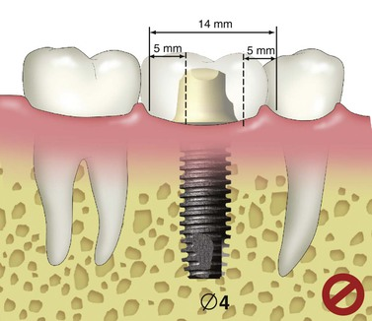
FIGURE 20-29 When a 4-mm-diameter implant replaces a molar, a mesial and distal cantilever is created on the crown.
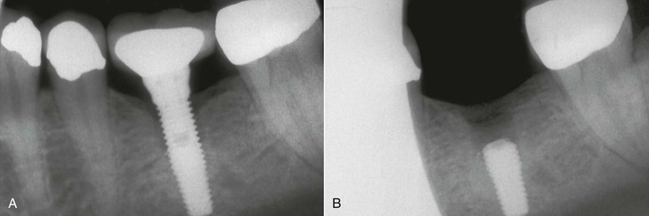
FIGURE 20-30 A, A 4-mm-diameter implant was used to replace a first molar. The mesial and distal cantilevers on the crown increased the biomechanical force. B, The implant body lost bone and then fractured.
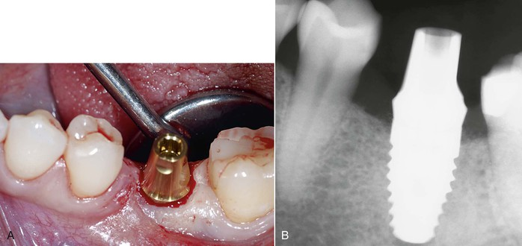
FIGURE 20-31 A, When a first molar is missing, a wider-diameter implant is usually indicated. B, The wider-diameter implant has less cantilevered forces on the crown and several biomechanical advantages.
When the mesiodistal dimension of the missing tooth is 8 to 12 mm with a buccolingual width greater than 7 mm, a 5- to 6-mm-diameter implant body is suggested (Figure 20-32). Langer et al. also recommended the use of wide-diameter implants in bone of poor quality or for the immediate replacement of failed implants.⁶¹ The larger diameter implant does not require as long an implant body to result in similar loading surface area, which is also a benefit because of the reduced posterior available vertical bone height because of anatomical limitations and landmarks present, such as the maxillary sinus or mandibular canal^{65,61,66} (Figure 20-33).
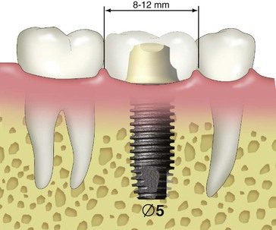
FIGURE 20-32 When the mesiodistal space in the posterior regions is 8 to 12 mm, a 5- to 6-mm-diameter implant is suggested.
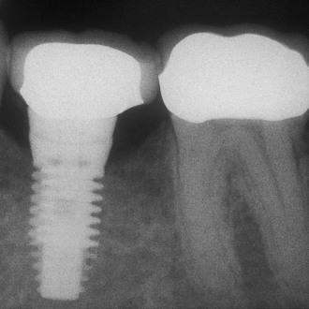
FIGURE 20-33 A 6-mm-diameter implant has more surface area than a 4-mm-diameter implant and may be used when the vertical bone height is limited by the mandibular canal.
When the mesiodistal dimension of the missing tooth site is 14 to 20 mm, two 4- to 5-mm diameter implants should be considered to restore the region (Figure 20-34). When two implants replace the molar region, the mesiodistal offset loads to the prosthesis can be eliminated because each implant may be placed 1.5 mm from the adjacent tooth. The total surface area of support is greater for the two implants compared with the surface area provided by one larger-diameter implant (two 4-mm-diameter implants >one 5- or 6-mm-diameter implant). In addition, the two regular-size implants provide more stress reduction than just one larger-diameter implant, which in turn reduces the incidence of abutment screw loosening.
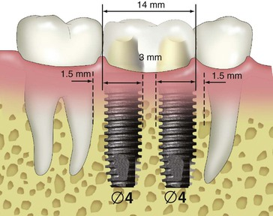
FIGURE 20-34 When the mesiodistal space is 14 to 20 mm, two implants should be used to support the crowns.
In 1996, Bahat et al. reported on the results of various implant numbers and size selection.⁶⁵ The overall failure rate was 1.2%, with the two 5-mm implants having 100% success. In the same year, Balshi et al. compared the use of one implant and two implants to replace a single molar.^{67,68} The 3-year cumulative success rate was 99%. Prosthesis mobility and screw loosening were the most common complications for the one-implant group (48%); this complication rate was reduced to 8% in the two-implant group. In vitro studies compared screw loosening of one wide-diameter versus two standard-diameter implants and concluded that the one wide-diameter implant had greater screw loosening.⁶⁹ In a finite element analysis of three different implant-supported molar crown designs, Geramy and Morgano showed a 50% decrease in mesiodistal and buccolingual stress between a 5-mm and standard-diameter implants.⁷⁰ The double-implant design had the least stress of all. Therefore, whenever possible, two implants should be used to replace a larger single-molar space to reduce cantilever loads and abutment screw loosening (Figure 20-35).
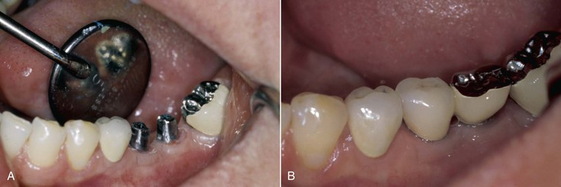
FIGURE 20-35 A, When the mesiodistal space is 14 to 20 mm, two implants should be used to support the missing teeth. B, The two implant crowns are often shaped as two premolar-size crowns.
When the posterior space is 14 to 20 mm, the largest implant diameter for the two implants may be calculated by subtracting 6 mm (1.5 mm from each tooth for soft tissue and surgical risk and 3 mm between the implants) from the intratooth distance and dividing by 2 to determine the size of each implant (16 mm – 6 mm = 10 mm ÷ 2 = 5 mm implants). Remember, when two adjacent molars are missing, it is advantageous to place each implant 1.5 to 2 mm from the adjacent teeth (or under the mesial of the first molar and distal of the second molar crown) and splint the implants together rather than placing the implant in the center of each tooth. This eliminates the cantilever to the mesial and distal from the implants (Figure 20-36).
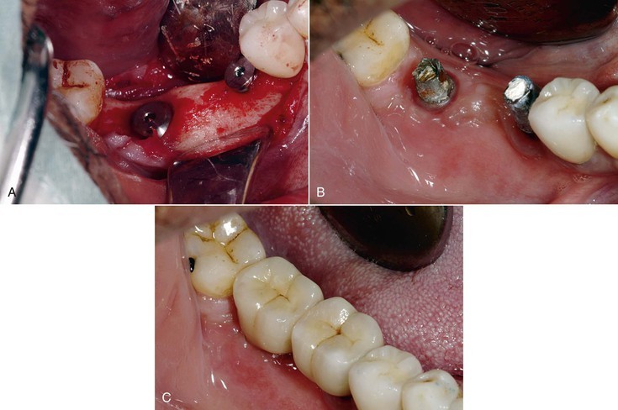
FIGURE 20-36 A, When the mesiodistal space is 14 to 20 mm, the two implants are positioned near the adjacent teeth rather than the center of the missing tooth. B, The two implants are always splinted together. C, The two crowns do not have mesial or distal cantilevers on the prosthesis.
The desired diameter of the implant is the crest module dimension (not the implant body), which is often 0.2 to 0.35 mm greater than the implant body dimension (i.e., BioHorizons, Nobel Biocare, 3i, Lifecore) (Figure 20-37). Ideally, the two implants should be 3 mm apart because crestal bone loss around each implant may occur. The width of the crestal defect is usually less than 1.5 mm. Therefore, the two adjacent implants 3 mm or more apart will not convert an angular defect next to an implant to be a horizontal defect that may increase sulcus depths and cause a loss of papilla height.⁷¹ Although this region is often out of the esthetic zone, the loss of papilla height increases food impaction.
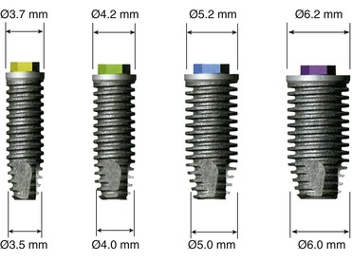
FIGURE 20-37 The crest module of an implant is often wider than the implant body dimension. (BioHorizons Dental Implants, External Hex, Birmingham, AL.)
When the mesiodistal space is 12 to 14 mm from adjacent CEJs, the treatment plan of choice is less obvious. A 5-mm-diameter implant may result in cantilevers up to 5 mm on each marginal ridge of the crown. However, two implants present a greater surgical, prosthetic, and hygiene risk. Unfortunately, the 12- to 14-mm space is not unusual. The primary goal is to obtain at least 14 mm of space instead of 12 to 14 mm (Figure 20-38). Additional space may be gained in several ways.
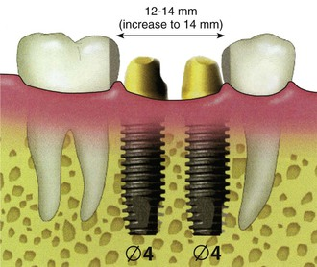
FIGURE 20-38 When the space between natural teeth is 12 to 14 mm, the choice of implant size and number is less obvious.
Orthodontics may be the treatment of choice to upright a tilted second molar or increase the intratooth space. One anterior implant may be placed and an orthodontic spring incorporated in the transitional crown; the spring pushes and uprights the distal tooth and moves it more distal. After orthodontic movement, the second implant may be inserted with less risk and improved hygiene between each implant. Another option is to use orthodontics to reduce the space and place only one implant and crown.
The implants may not be centered in the crestal width of bone. Instead, one implant is placed buccal and the other on a diagonal toward the lingual (Figure 20-39). The diagonal dimension increases the mesiodistal space by 0.5 to 1.0 mm. When implants are placed in such a way, consideration is given to oral hygiene and occlusion. In the mandible, the most anterior implant is placed to the lingual aspect of the midcrest, and the more distal implant is placed to the facial aspect to facilitate access of a floss threader from the vestibule into the intraimplant space. The occlusal contacts are also slightly modified on the buccal aspect of the mesial implant to occlude over the central fossa (Figure 20-40). In the maxilla, the anterior implant is placed to the buccal aspect and the distal implant to the palatal region to improve the esthetics of the more visible half of the tooth. The distal occlusal contact is placed over the lingual cusp, and the mesial occlusal contact is located in the central fossa position. The cervical esthetics of the maxillary molar is compromised on the distal half of the tooth to the benefit of greater intratooth distance and easier access for home care. This maxillary implant placement requires the intraimplant furcation to be approached from the palate rather than the buccal approach as in the mandible (Table 20-1).
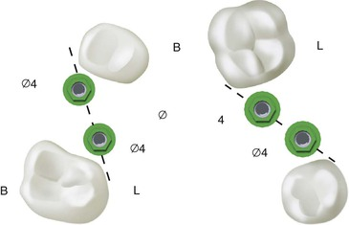
FIGURE 20-39 On the left (in the maxilla), the mesial implant is positioned more facial and the distal implant more palatal. On the right (mandible), the mesial implant is placed more lingual and the distal implant more buccal.
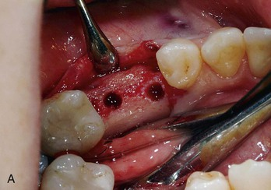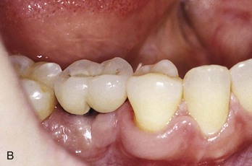
FIGURE 20-40 A, The mandibular molar mesiodistal space was 13 mm. The anterior implant is positioned more lingual and the distal implant more buccal (a mirror shot). B, The molar crown has a cervical region similar to two premolars to improve oral hygiene.
TABLE 20-1
Single-Molar Replacement Options
Mesiodistal | Implant Diameter
7–8 mm | 4 mm
8–12 mm | 5–6 mm
12–14 mm | Gain additional space; then place two 4-mm implants
14–20 mm | Two implants, one under mesial marginal ridge and one under distal marginal ridge and splint together

Summary
A missing single tooth is a common scenario in restorative dentistry. The options for single-tooth replacement usually are a FPD or a single-tooth implant. Rarely are FPDs the primary treatment option in the posterior regions of the mouth. Abutment teeth caries and endodontic procedures place these teeth at increased risk of loss. On occasion, the posterior tooth may not be replaced (e.g., a mandibular second molar or a small space in which the surrounding teeth are interdigitated to prevent extrusion or tipping).
The primary method to replace a single tooth should be a single-tooth implant of adequate size, design, and material. When the intratooth space is adequate and bone is present or can be created, the implant restoration is the treatment of choice. The single-tooth implant in the posterior regions of the mouth is the treatment of choice in the vast majority of patients.

References
1. Meskin LH, Brown LS. Prevalence and patterns of tooth loss in U.S. employed adult senior populations. J Dent Educ. 1988;52:686–691.
2. Hayden JW. Dental health services research utilizing comprehensive clinical data bases and information technology. J Dent Educ. 1997;61:47–55.
3. Shugars DA, Bader JD, White BA, et al. Survival rates of teeth adjacent to treated and untreated posterior bounded edentulous spaces. J Am Dent Assoc. 1998;129:1085–1095.
4. Palmquist S, Swartz B. Artificial crowns and fixed partial dentures 18 to 23 years after placement. Int J Prosthodont. 1993;6:279–285.
5. Holm C, Tidehag P, Tillberg A, et al. Longevity and quality of FPDs: a retrospective study of restorations 30, 20 and 10 years after insertion. Int J Prosthodont. 2003;6:283–289.
6. Priest GF. Failure rates of restorations for single tooth replacements. Int J Prosthodont. 1996;9:38–45.
7. Goodacre CJ, Bernal G, Rungcharassaeng K, et al. Clinical complications in fixed prosthodontics. J Prosthet Dent. 2003;90:31–41.
8. Shillingburg HT, Hobo S, Whitsett LD, et al. Fundamentals of fixed prosthodontics. ed 3. Quintessence: Chicago; 1997.
9. Cheung GSP, Dimmer A, Mellor R, et al. A clinical evaluation of conventional bridgework. J Oral Rehabil. 1990;17:131–136.
10. Chalmers I. The Cochrane Collaboration: preparing, maintaining, and disseminating systematic reviews of the effects of health care. Ann N Y Acad Sci. 1993;703:156–165.
11. Aquilino SA, Shugars DA, Bader JD, et al. Ten year survival rates of teeth adjacent to treated and untreated posterior bounded edentulous spaces. J Prosthet Dent. 2001;85:455–460.
12. Carlsson GE, Hedegard B, Kiovumina KK. Studies in partial denture prosthesis. IV. A 4 year longitudinal investigation of dentogingivally supported partial dentures. Acta Odontol Scand. 1965;23:443–472.
13. Bell B, Rose CL, Damon A. The Normative Aging Study: an interdisciplinary and longitudinal study of health and aging. Int J Aging Hum Dev. 1972;3:5–17.
14. Kapur KK, Glass RI, Leftus ER, et al. The Veterans Affairs longitudinal study of oral health and disease. Int J Aging Hum Dev. 1972;3:125–137.
15. Hansson O. Clinical results with resin bonded prostheses and an adhesive cement. Quintessence Int. 1994;25:125–132.
16. Barrack G, Bretz WA. A long term prospective study of the etched-cast restoration. Int J Prosthodont. 1993;6:428–434.
17. Thompson VP, deRij KW. Clinical evaluation and lifetime predictions for resin-bonded prostheses. Anusavice K. Quality evaluation of dental restoration: criteria for placement and replacement. Quintessence: Chicago; 1989.
18. Wood M, Kern M, Thomson VP, et al. Ten year clinical and microscopic evaluation of resin bonded restorations. Quintessence Int. 1996;27:803–807.
19. Misch CE. Single tooth implants—difficult, yet overused. Dent Today. 1992;11:46.
20. Fugazzotto PA. A comparison of the success of root resected molars and molar position implants in function in a private practice: results of up to 15-plus years. J Periodontol. 2001;72:113–123.
21. American Dental Association Survey Center. Changes in dental services rendered 1959–1990. ADA 1990 survey of dental services rendered. American Dental Association: Chicago; 1994.
22. Johnston JE, Phillips RN, Dykema RW. Modern practice in crown and bridge prosthodontics. WB Saunders: Philadelphia; 1971.
23. Creugers NH, Kayser HF, Van’t Hof MA. A meta-analysis of durability data on conventional fixed bridges. Community Dent Oral Epidemiol. 1994;22:448–452.
24. Walton JN, Gardner FM, Agar JR. A survey of crown and fixed partial denture failures, length of service and reasons for replacement. J Prosthet Dent. 1986;56:416–421.
25. Schwartz NL, Whitsett LD, Berry TG. Unserviceable crowns and fixed partial dentures, life span and causes for loss of serviceability. J Am Dent Assoc. 1970;81:1395–1401.
26. Scurria MS, Bader JD, Shugars DA. Meta-analysis of fixed partial denture survival: prostheses and abutments. J Prosthet Dent. 1998;79:459–464.
27. Payne BJ, Locker D. Oral self-care behaviours in older dentate adults. Community Dent Oral Epidemiol. 1992;20:376–380.
28. Jackson CR, Skidmore AE, Rice RT. Pulpal evaluation of teeth restored with fixed prostheses. J Prosthet Dent. 1992;67:323–325.
29. Bergenholtg G, Nyman S. Endodontic complications following periodontal and prosthetic treatment of patients with advanced periodontal disease. J Peridontol. 1984;55:63–68.
30. Reuter JE, Brose MO. Failures in full crown retained dental bridges. Br Dent J. 1984;157:61–63.
31. Randow K, Glantz PO, Zoger B. Technical failures and some related clinical complications in extensive fixed prosthodontics: an epidemiological study of long-term clinical quality. Acta Odontol Scand. 1986;44:241–255.
32. Misch CE, Misch-Dietsh F, Silc J, et al. Posterior implant single tooth replacement and status of abutment teeth: multicenter 10 year retrospective report. J Periodontol. 2008;79(12):2378–2382.
33. Jemt T, Lekholm U, Grondahl K. Three year follow up study of early single implant restoration ad modum Brånemark. Int J Periodontics Restorative Dent. 1990;10:340–349.
34. Andersson B, Odman P, Lidvall AM, et al. Single tooth restoration supported by osseointegrated implants: results and experience from a prospective study after 2 to 3 years. Int J Oral Maxillofac Implants. 1995;10:702–711.
35. Schmitt A, Zarb GA. The longitudinal clinical effectiveness of osseointegrated dental implants for single tooth replacement. Int J Prosthodont. 1993;6:187–202.
36. Ekfeldt A, Carlsson GE, Borjesson G. Clinical evaluation of single tooth restorations supported by osseointegrated implants: a retrospective study. Int J Oral Maxillofac Implants. 1994;9:179–183.
37. Haas R, Mensdorff Pouilly N, Mailath G, et al. Brånemark single tooth implants: a preliminary report of 76 implants. J Prosthet Dent. 1995;73:274–279.
38. Simon RL. Single implant-supported molar and premolar crowns: a ten-year retrospective clinical report. J Prosthet Dent. 2003;90:517–521.
39. Levin L, Laviv A, Schwartz-Arad D. Long-term success of implants replacing a single molar. J Periodontol. 2006;77:1528–1532.
40. Kline R, Hoar JE, Beck JH, et al. A prospective multicenter clinical investigation of a bone quality based dental system. Implant Dent. 2002;11:224–234.
41. Misch CE, Steigenga J, Barboza E, et al. Short dental implants in posterior partial edentulism: a multicenter retrospective 6-year case series study. J Periodontol. 2006;77:1340–1347.
42. Goodacre CJ, Bernal G, Rungcharassaeng K, et al. Clinical complications with implants and implant prostheses. J Prosthet Dent. 2003;90:121–132.
43. Bragger U, Krenander P, Lang NP. Economic aspects of single tooth replacement. Clin Oral Implants Res. 2005;16:335–341.
44. Graber TM. Anomalies in number of teeth. Graber TM. Orthodontics: principles and practice. ed 2. WB Saunders: Philadelphia; 1966.
45. Maklin M, Dummett CO Jr, Weinberg R. A study of oligodontia in a sample of New Orleans children. J Dent Child. 1979;46:478–482.
46. Caprioglio D, Vernole B, Aru G, et al. Le agenesie dentali. Masson: Milan, Italy; 1988.
47. Odman J, Grondahl K, Lekholm U, et al. The effect of osseointegrated implants on the dento-alveolar development: a clinical and radiographic study in growing pigs. Eur J Orthod. 1991;3:279–286.
48. Oosterle LJ. Implant considerations in the growing child. Higuchi KW. Orthodontic applications of osseointegrated implants. Quintessence: Chicago; 2000.
49. Creugers NH, Kreuler PA, Snoek RJ, et al. A systematic review of single tooth restorations supported by implants. J Dent. 2000;28:209–217.
50. Op Heij DG, Opdebeeck H, Steenberghe DV, et al. Age as compromising factor for implant insertion. Periodontol 2000. 2003;33:172–184.
51. Thilander B, Odman J, Grondahl K, et al. Osseointegrated implants in adolescents: an alternative in replacing missing teeth? Eur J Orthod. 1994;16:84–95.
52. Thilander B, Odman J, Jemt T. Single implants in the upper incisor region and their relationship to the adjacent teeth: an 8-year follow-up study. Clin Oral Implants Res. 1999;10:346–355.
53. Sheridan J, Ledoux W, McMinn R. Essix technology for the fabrication of temporary anterior bridges. J Clin Orthod. 1994;18:482–486.
54. Boggan RS, Strong TT, Misch CE, et al. Influence of hex geometry and prosthetic tooth width on static and fatigue strength of dental implants. J Prosthet Dent. 1999;82:436–440.
55. Binon PP. Evaluation of three slip fit hexagonal implants. Implant Dent. 1996;5:235–248.
56. Binon PP. The effect of implant/abutment hexagonal misfit on screw joint stability. Int J Prosthodont. 1996;9:149–160.
57. Spray JR, Black CG, Morris HF, et al. The influence of bone thickness on facial marginal bone response: stage 1 placement through stage 2 uncovering. Ann Periodontol. 2000;5:119–128.
58. Malevez C, Hermans M, Daelemans P. Marginal bone levels at Brånemark system implants used for single tooth restoration. The influence of implant design and anatomical region. Clin Oral Implants Res. 1996;7:162–169.
59. Sullivan DY. Wide implants for wide teeth. Dent Econ. 1994;84:82–83.
60. Rangert B, Krogh PH, Langer B, et al. Bending overload and fixture fracture: a retrospective clinical analysis. Int J Oral Maxillofac Implants. 1995;10:326–334.
61. Langer B, Langer L, Herrman I, et al. The wide fixture: a solution of special bone situations and a rescue for the compromised implant. Int J Oral Maxillofac Implants. 1993;8:400–408.
62. Davarpanah M, Martinez H, Kibir M, et al. Wide-diameter implants: new concepts. Int J Periodontics Restorative Dent. 2001;21:149–159.
63. Sato Y, Shindoi N, Hosokawa R. A biomechanical effect of wide implant placement and offset placement of three implants in the posterior partially edentulous region. J Oral Rehabil. 2000;27:15–21.
64. Ivanoff C-J, Grondahl K, Sennerby L, et al. Influence of variations in implant diameters: a 3- to 5-year retro-spective clinical report. Int J Oral Maxillofac Implants. 1999;14:173–180.
65. Bahat O, Handelsman M. Use of wide implants and double implants in the posterior jaw, a clinical report. Int J Oral Maxillofac Implants. 1996;11:379–386.
66. Renouard F, Arnoux JP, Sarment D. Five mm diameter implants without a smooth surface collar. Report on 98 consecutive placements. Int J Oral Maxillofac Implants. 1999;14:101–107.
67. Balshi TJ, Hernandez RE, Pryzlak MC, et al. A comparative study of one implant versus two replacing a single molar. Int J Oral Maxillofac Implants. 1996;11:372–378.
68. Balshi TJ, Wolfinger GJ. Two-implant-supported single molar replacement: interdental space requirements and comparison to alternative options. Int J Periodontics Restorative Dent. 1997;17:426–435.
69. Bakaeen LG, Winkler S, Neff PA. The effect of implant diameter, restoration design, and occlusal table variations on screw loosening of posterior single-tooth implant restorations. J Oral Implantol. 2001;27:63–72.
70. Geramy A, Morgano SM. Finite element analysis of three designs of an implant-supported molar crown. J Prosthet Dent. 2004;92:434–440.
71. Tarnow DR, Cho SC, Wallace SS. The effect of inter-implant distance on the height of inter-implant bone crest. J Periodontol. 2000;71:546–549.
Premium Wordpress Themes by UFO Themes
WordPress theme by UFO themes

