Natural Teeth Adjacent to an Implant Site

Joining Implants to Teeth
Carl E. Misch
A common prosthetic axiom is to provide a partially edentulous patient with a fixed prosthesis whenever possible. Implant dentistry may often provide the additional abutments necessary to fulfill this goal regardless of the number of teeth missing. The ability to add abutments in specific locations, rather than being limited to a particular remaining natural abutment that may not always be in optimum health, enables the dentist to expand this prosthetic axiom to most partially edentulous patients.
The dentist most often uses implants as independent support for the restoration. On rare occasion, the implant may be splinted to the natural teeth in the same prosthesis. In either situation, the treatment plan is strongly influenced by the dental evaluation of the remaining natural abutments adjacent to the edentulous site.
Natural teeth may require additional therapy before the final prosthesis can be completed. It is best to communicate with the patient regarding all required treatment involved in the rehabilitation process before the surgical placement of the implants. Otherwise, treatment outcome, sequences, and cost may conflict with the originally projected result and lead to dissatisfaction, the need to modify the original treatment plan, or a poorer prognosis.
Whether considered for abutment support or not, teeth adjacent to a partially edentulous site are evaluated thoroughly and from a different perspective than the rest of the dentition.^{1,2} In the previous chapter, the conditions that warrant extraction of the tooth are presented. In this chapter, the tooth adjacent to the edentulous site is planned to be maintained. However, on occasion, the adjacent tooth exhibits bone loss next to the edentulous site and presents a less than optimal quality of health. As a consequence, the available bone characteristics immediately adjacent to the tooth are highly influenced by its presence. Often this is a determining factor in the choice between an independent implant prosthesis, a traditional fixed partial denture (FPD), or a removable restoration. When multiple teeth are missing, the treatment becomes even more complex with additional restorative options, such as whether implants and natural teeth may serve as abutments in the same prosthesis.
The dental criteria of the adjacent tooth to an edentulous space addressed in this chapter are (1) abutment options, (2) adjacent bone and soft tissue anatomy, (3) cantilevers, (4) implants connected to teeth, (4a) mobility (of teeth and implants, (4b) splinting natural abutments, (4c) natural and implant pier abutments, and (5) transitional abutments (Box 17-1).
Box 17-1
Teeth Adjacent to Implant Site
1. Abutment options
2. Adjacent bone and soft tissue anatomy
3. Cantilevers
4. Implants connected to teeth
a. Mobility (of teeth and implants)
b. Splinting natural abutments
c. Natural and implant pier abutments
5. Transitional abutments

Abutment Options
Several options are available for the adequate restoration of an edentulous segment. Before the 1990s, when implants were used in a partially edentulous patient, a three- or four-unit FPD was fabricated with an implant used as one terminal abutment along with a natural tooth separated by one or two pontics^{3,4}(Figure 17-1). When the osseointegrated implant concept for completely edentulous fixed prostheses was introduced in the mid 1980s, the concept was modified for partially edentulous arches to make an implant prosthesis as an independent unit. The primary reason for this approach was to limit the cantilever effect of a “mobile” tooth joined to a “rigid” implant^{5,6} (Figure 17-2). However, the primary advantage of two separate prosthetic units is more related to reduced biologic complications of the tooth rather than biomechanical implications on the implant.
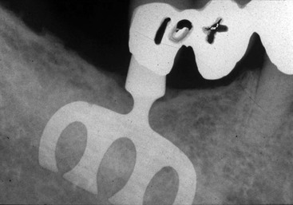
FIGURE 17-1 Before the 1990s, implants were often inserted into the jaws of partially edentulous patients and splinted to a natural tooth in the same fixed prosthesis.
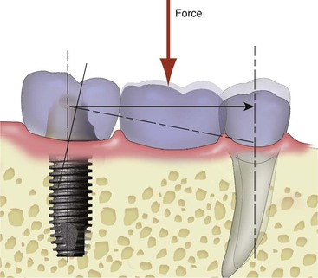
FIGURE 17-2 Splinting a rigid implant to a natural tooth has caused concerns relative to the biomechanical differential in movement between the implant and tooth. Because the tooth moves more than the implant, the implant may receive a moment force created by the “cantilever” of the prosthesis.
Under ideal conditions, placing implant abutments in sufficient number to fabricate a completely separate implant-supported prosthesis has several biologic advantages. The most common cause of failure of tooth-supported fixed prostheses is caries of the abutment teeth.⁷ Unrestored natural teeth do not decay as often as restored teeth, and implant abutments do not decay. In addition, the pontic between splinted abutments (whether natural teeth or a tooth and an implant) acts as a plaque trap. As a result, whereas a crown on a natural tooth has a decay rate of 1% at 10 to 15 years, an abutment for a FPD has a caries rate of more than 20% (Figure 17-3). The second most common cause of fixed prosthesis failure is endodontic failure or complications of a natural tooth abutment. Implant abutments do not need endodontic therapy. Unrestored natural teeth are less likely to require endodontics. Therefore, the natural tooth should not be splinted to an implant under ideal conditions. The 10-year survival rates indicate a greater than 25% improved survival rate for implant prosthesis compared with FPDs supported by natural teeth (or natural teeth splinted to implants) because the natural tooth is more prone to biologic complications.^{8,9}
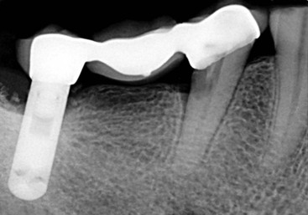
FIGURE 17-3 When an implant is splinted to a natural tooth, separated by a pontic, the pontic acts as a plaque trap and increases the risk of decay on the natural tooth.
Compared with unrestored natural teeth, natural teeth abutments are more difficult to clean; collect and retain more plaque; are often more temperature or contact sensitive; and are more subject to future prosthetic, periodontal, or endodontic treatment. Caries, endodontic problems, or both may cause not only a loss of the fixed prosthesis but also almost as often lead to the failure and extraction of at least one of the natural tooth abutments. As a result, an independent implant restoration is the treatment of choice for almost every multiple-tooth edentulous site in a partially edentulous patient. In addition to the biologic advantage of independent implant prostheses, there is also a biomechanical advantage. Natural teeth respond to occlusal forces differently than implants. Whereas a light force produces most of the recorded movement of a tooth, the amplitude of implant movement is related directly to the force applied.^{6–8,10–11} In arches with implant and natural abutments, it is easier to adjust the occlusion when these entities are two independent units.
When planning an independent implant prosthesis, instead of using a natural tooth as one of the terminal abutments, the dentist usually requires the addition of at least one more implant. An increase in implant abutment number enhances the implant–bone interface and therefore reduces the stress to the support system and improves the ability of the fixed restoration to withstand additional forces when necessary. In addition, because of the additional retentive units, uncemented or unretained restorations occur with less frequency. Unretained restorations are the third most common complication reported in fixed prosthodontics.^{7,8}
Abutment screw loosening is a complication reported for implant prostheses, especially during the first year.^{9,11,12} The increase in implant number also decreases the amount of forces on the abutment screws and thus reduces the risk of abutment screw loosening. As a result, many reasons justify the use of a sufficient number of implants for an independent prosthesis. So many advantages exist for an independent implant-supported fixed prosthesis with multiple units that such a treatment is always the first choice when possible (Figure 17-4).
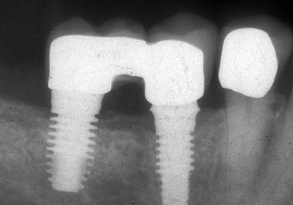
FIGURE 17-4 An independent implant prosthesis is the treatment of choice even when the adjacent tooth requires a crown.
Unfortunately, completely implant-supported fixed prostheses in partially edentulous patients are not always feasible and on occasion carry a higher surgical risk. Thus, the natural tooth occasionally may be considered a potential abutment. However, the dentist should consider splinting of implants and natural teeth within the same prosthesis only when the surface area of the implant support does not permit replacement of the total number of missing teeth and additional implant placement is not indicated.

Adjacent Bone Anatomy
When one or more missing teeth are between existing teeth, the bone position on the adjacent roots is thoroughly evaluated, especially when the missing tooth is in the esthetic zone. Ideally, the bone on each adjacent anterior tooth next to the edentulous site should be 2.0 mm or less from the interproximal cementoenamel junction (CEJ) (which is 3 mm above the facial CEJ). When this anatomy is present, the interdental papilla adjacent to the edentulous site will be ideal because it is supported by the interproximal bone on the tooth.
The edentulous bony structure adjacent to a natural tooth varies in height, width, length, and angulation and is a reflection of the history of the former tooth, its extraction, and the period of time the site has been edentulous. If the ridge topography is not ideal for endosteal implant placement in the site immediately adjacent to the natural abutment, the dentist should consider a bone graft or a pontic. An osteoplasty needed to obtain adequate bone width in the area adjacent to a natural tooth often compromises the adjacent natural root support; increases the crown height of the final implant restoration; and affects the esthetic outcome, especially in the interdental papilla region (Figure 17-5). Therefore, osteoplasty to gain additional width is usually not indicated adjacent to a natural tooth.
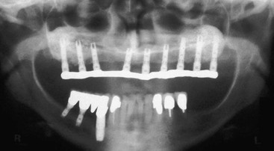
FIGURE 17-5 The implant in the mandibular right first premolar site is positioned more than 6 mm below the canine cementoenamel junction. Although bone is present on the distal of the canine, the soft tissue slope around the implant creates a soft tissue pocket greater than 5 mm and increases the risk of periimplant complications.
If an ideal prosthodontic abutment position is adjacent to a natural tooth and inadequate bone width is available, augmentation of the edentulous site before implant insertion may improve the bone anatomy without compromising the natural abutment. In case of inadequate bone width volume adjacent to a tooth with adequate bone on the root next to the site, the dentist considers treatment options to graft the site in width to permit division A or B implant placement.
Inadequate bone height adjacent to a tooth offers a poorer prognosis for augmentation than in other situations. In general, to grow bone in height is more difficult than to grow it in width. In addition, when the inadequate bone height of the edentulous site includes the region adjacent to a natural root (and results in horizontal bone loss on the tooth root), the ability to grow additional bone height becomes even more unpredictable and is usually unsuccessful.
Bone height augmentation is not predictable on a natural tooth root with a horizontal defect. If the natural tooth root has lost bone adjacent to the site, the bone augmentation in height usually will not occur above the existing position of bone on the root. There are four alternatives for inadequate bone height adjacent to a natural tooth. The first option is orthodontic extrusion of the tooth before the bone graft. When one of the teeth has a poor adjacent bone anatomy, orthodontic extrusion to elevate the interproximal bone of the tooth is considered. The orthodontic movement will increase bone height next to the tooth and improve the bone graft prognosis. After this is accomplished, a bone graft in the implant site is more predictable (Figure 17-6). However, the tooth or teeth usually require endodontics and restoration after the orthodontic extrusion process.
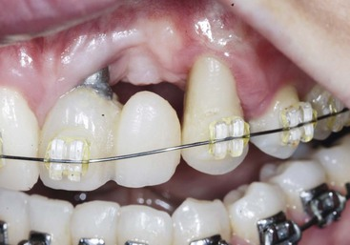
FIGURE 17-6 Orthodontic extrusion of a tooth adjacent to an implant site may advance the interproximal bone more coronally and modify the soft tissue drape.
A second option is extraction of the adjacent tooth and augmentation of the adjacent edentulous site and the extraction socket. This is more often indicated when only one toothadjacent to the implant site is compromised and the orthodontic extrusion is not indicated on this tooth because the amount of root in the bone is inadequate. In such cases, after the orthodontic extrusion, endodontics, and restoration, the end result is still a compromised tooth as a consequence (Figure 17-7).
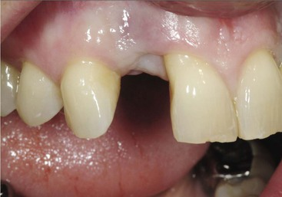
FIGURE 17-7 When one tooth adjacent to the edentulous site is compromised (the central incisor), an option is to extract the tooth (when orthodontic extrusion is not indicated) and graft two adjacent sites before implant insertion.
The third treatment option is the fabrication of the three-unit FPD. This is often the most predictable and less expensive treatment option. In a study by Tarnow et al., if the interproximal bone to interproximal contact region of the crown is more than 5 mm, the interdental papilla will often be depressed.¹³ However, when this distance is 6 mm, 40% of the papilla regions will appear within normal limits, and when 7 mm, 25% of the adjacent papilla will appear normal. When the interproximal bone between the two teeth adjacent to an edentulous site is not ideal on both of the adjacent teeth but the interdental papilla is within ideal limits, consideration is given to leaving the soft tissue as it is and fabricating a three-unit FPD (Figure 17-8). If an implant is attempted and the interproximal bone is not ideal, the soft tissue often shrinks after the surgery, and the soft tissue drape is compromised around the implant and, as important, exposes the root of the adjacent teeth.
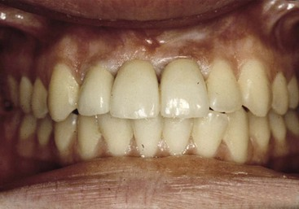
FIGURE 17-8 The edentulous site has bone height loss and the bone is lost on the roots of the adjacent teeth to an edentulous site, but the soft tissue drape is adequate. A three-unit fixed partial denture is often the treatment of choice to replace the missing tooth. In this case, the maxillary right central incisor is a pontic, supported by the adjacent teeth.
The fourth option is to place a pontic next to the natural tooth (Figure 17-9). An implant apically positioned more than 3 to 4 mm below the CEJ and interproximal bone level of the adjacent natural tooth root presents potential soft tissue contour problems (Figure 17-10). When the most distal natural tooth has inadequate bone height on the root, the soft tissue between the tooth and adjacent implant creates a more shallow slope, unlike the steep drop of the level of the bony crest between the elements. Under these conditions, a soft tissue pocket greater than 6 mm may result around the implant crown adjacent to the natural tooth (see Figure 17-5). Therefore, when a bone graft for height around a multitooth edentulous site is required to place an implant adequately adjacent to a natural root, the dentist should consider a pontic to replace the missing element next to the natural tooth. The pontic may be supported by a cantilever from implants or teeth or using dual support from teeth and implants.
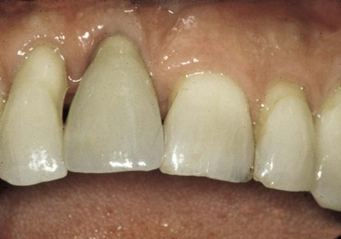
FIGURE 17-9 When an implant is surgically placed when the adjacent tooth does not have adequate height of bone on the adjacent root surface, the tissue often shrinks and compromises the soft tissue drape.
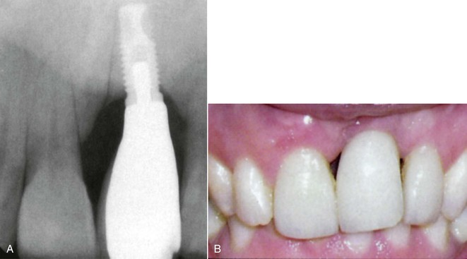
FIGURE 17-10 A, The implant is positioned several millimeters below the adjacent cementoenamel junctions of the adjacent teeth. B, The soft tissue drape had receded and compromised the cervical and interproximal esthetics.
In summary, if the bone is inadequate in height on the tooth root and implant site, the following should be done: (1) orthodontic extrusion and graft, (2) extract and graft two sites, (3) fabricate a three-unit FPD, or (4a) cantilever a pontic from two or more natural teeth or two or more division A implants or (4b) fabricate a fixed prosthesis with one pontic connecting an implant with one or two adjacent teeth, depending on the adjacent tooth status.

Cantilevers in Partial Edentulism
Cantilevers in fixed prostheses result in moment loads or torque on the abutments.¹⁴ They are used more frequently for implant-supported prostheses than natural teeth abutments.^{15,16} Several widely diverging guidelines have been recommended for the use of cantilevers in partially edentulous patients, ranging from almost no extension at all to the cantilever of several teeth.^{16,17} The cantilevered prosthesis is often problematic. The most common complication for a cantilevered restoration from natural teeth is uncementation of the abutment farthest from the cantilever.^{8,18} When a pontic is cantilevered, the abutment next to the pontics is a fulcrum, and an occlusal force on the pontic places a tensile and shear force on the more distal abutment (Figure 17-11). Cement is almost 20 times weaker in tension compared with compression forces. For example, the compressive strength of zinc phosphate cement is 12,000 psi, but its tensile strength before fracture is only 500 psi. As a result, the most common complication is an unretained crown on the more distal abutment; then the fulcrum abutment becomes mobile and loses bone, fractures, or both.
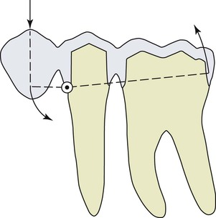
FIGURE 17-11 The most complications for a cantilevered pontic from two natural teeth is an unretained prosthesis. A compressive force on the pontic transfers a shear and tensile force to the distal abutment.
It is interesting to note that cantilevers with natural teeth abutments are rarely used in conventional prosthetics. The failure rate of a traditional three-unit FPD at 5 years is often less than 5%. However, the 5-year failure rate of cantilevered three-unit FPD is 25%, and 60% have complications.^{8,19} The failure is usually related to an uncemented abutment (farthest abutment from the cantilever), and the failure is biomechanical in nature. The traditional three-unit FPD fails more often from biologic conditions (e.g., decay, endodontics), which takes longer to occur. Implants are more rigid than teeth. As a consequence, the force to the cement seal is greater with implant abutments than teeth! The adjacent implant to the pontic acts even more as a fulcrum. In other words, it is worse to cantilever on implants than natural teeth (Figure 17-12).
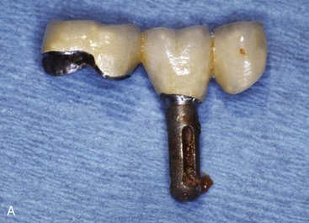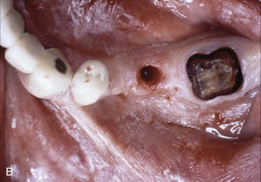
FIGURE 17-12 A, A failed implant and three-unit fixed partial denture. The implant served as an abutment next to the pontic. B, The cement seal broke and resulted in the prosthesis entirely supported by the implant, which failed. There is also decay on the natural tooth.
The force on the cantilever may be compared with a class I lever. The distance between the most anterior and most distal abutments is divided by the length of the cantilever to determine the mechanical advantage to the farthest abutment from the cantilever. Takayama has suggested that the cantilever should not extend beyond the distance between the implants to keep the mechanical advantage less than one times this distance.²⁰ The most common distance between two implant centers is 7 to 8 mm so that the outer dimensions of the implants may be 3 mm apart and the crowns on the implants are similar in size to a premolar. Thus, the size of the cantilever (when considered) should not be greater than a premolar of similar size when two implants support the three-unit prosthesis.
The most important factor in determining the safe length of the cantilever is the amount of force the patient places on the cantilever. For example, a cantilever may have a mechanical advantage (force multiplier) of two times. Hence, if a 25-lb load is applied to the pontic, a 50-lb force (tensile) is applied to the distal abutment, and 75 lb is applied to the fulcrum (class I lever mechanics). Hence the force is magnified two to three times. However, if the load on the pontic is 100 lb, it is magnified to 200-lb force on the distal abutment and a 300-lb force on the fulcrum or four times more than the first example. In other words, the amount of the force applied to the cantilever is even more important than the length of the cantilever or the distance between the implants.
Cantilevers on implants are more problematic than on teeth for several reasons. The magnification of forces are to the entire implant system. The cement or screw that retains the prosthesis may fail (Figure 17-13). The implant may fracture (Figure 17-14). The implant may become mobile and lost. These complications are often more significant than a cantilevered restoration supported by natural teeth.
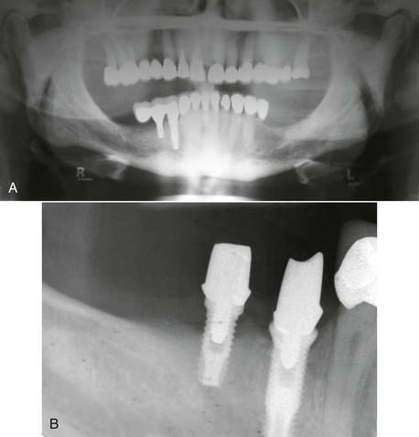
FIGURE 17-13 A, A distal cantilevered three-unit FPD from two implant abutments. B, The prosthesis became uncemented from the most distal abutment from the pontic, and bone loss occurred on the fulcrum abutment.
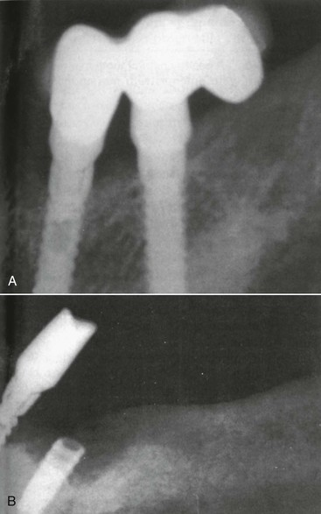
FIGURE 17-14 A, A three-unit fixed partial denture cantilevered to the distal. B, The prosthesis became unretained from the abutment most distal from the cantilever, and the fulcrum implant fractured.
Ideally, if a cantilever is necessary, it should extend mesially, rather than distally, to reduce the amount of occlusal force on the lever.⁶ (Figure 17-15). A cantilever of a lateral incisor from two or more adjacent implants is the least at risk because the canine tooth (implant) can protect lateral forces on the cantilever and the anterior region has less bite forces and the lateral incisor is the smallest tooth in the arch.
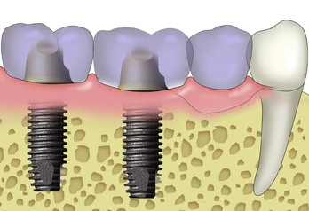
FIGURE 17-15 If a cantilever is required, it is beneficial to cantilever to the anterior to reduce the bite force.
The crown height also influences the amount of the force on the cantilever to the cement and bone interface. The force is magnified by the crown height when any lateral force or cantilever is present¹⁴ (Figure 17-16). An angled force on a cantilever is more detrimental than a force in the long axis of the abutments. As such, the cantilever magnifies any other force factor presented and therefore should be used with caution. When cantilevers are used in the final restoration, the occlusion on the cantilevered pontics should be reduced, with no contact on the cantilevered pontic during mandibular excursions.
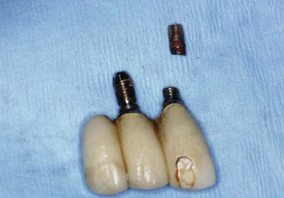
FIGURE 17-16 A crown height increase further magnified the force on a cantilevered restoration. The two implants fractured within a few years as a result of the cantilever and increase in crown height.
Cantilevers on two implants should not be used when force factors are moderate to severe or when other force factors are present. Instead, additional implants or grafting and implants positioned without cantilevers typically reduce complications. When the cantilever forces are too great, the dentist should consider joining the implants to adjacent teeth to eliminate the cantilever effect (Figure 17-17). There is often less biomechanical risk of joining an implant to a tooth than using a cantilever to replace the missing tooth or teeth.
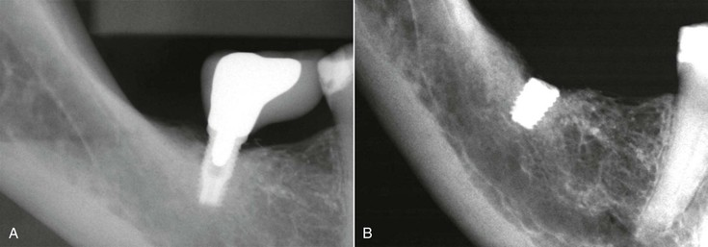
FIGURE 17-17 A, A posterior implant with a cantilevered crown to the mesial. B, The implant fractured within a few years. It is often more predictable to join an implant to a natural tooth than to cantilever from one implant.

Implants Connected to Teeth
As previously mentioned, before 1988, many practitioners connected an implant to one or two natural teeth.^{3,4} These implants were designed to have either a fibrous tissue or a direct bone interface.^{21,22} When the root form osseointegration concept of Brånemark for full-arch edentulous fixed prostheses became more dominate in the mid 1980s, these implants came to be used in partially edentulous arches. It was hypothesized at the time that joining a rigid implant to a natural tooth would cause biomechanical complications on the implant, implant prosthesis, or both.^{5,6} Since that time, several reports have indicated that a rigid implant may be joined to a natural tooth in the same prosthesis.^{16,23,24} In fact, implant-cantilevered prostheses in partial edentulous patients have more reported complications than when implants are joined to teeth.
There are more partially edentulous patients missing posterior teeth than anterior teeth. As a result, the most common scenario for which a root form implant may be joined to a natural tooth is in the posterior regions. Of these cases, the most common scenario is as a terminal abutment in a patient missing the molars. For example, if a patient is missing the first and second molars in a quadrant (with no third molar present), the segment requires at least two implants of proper size and design to independently restore these two teeth. If adequate bone exists in the second molar and distal half of the first molar but inadequate bone exists in the mesial half of the first molar, a premolar-size pontic is required. The pontic may be cantilevered from the anterior natural teeth or the posterior implants. Either of these options may result in complications because of tensile forces on the cement seal of the abutment farthest from the pontic.
An alternative may be to join the implant(s) to a natural tooth if all other factors are favorable. This treatment option is more likely in the presence of a division C–h ridge in the pontic region when inadequate bone height adjacent to the natural tooth decreases the prognosis of a vertical bone graft. This option is also available when a posterior implant is positioned too distal to restore with a single crown. It is almost always better to splint the implant to the adjacent tooth rather than fabricating a cantilevered crown from one implant. Another scenario in favor of this treatment plan is when the posterior implants are of a narrower diameter than usual. When two division B root forms are used in the posterior mandible to replace molars, there should be no cantilever to magnify the force on the implants. Posterior pontics should not be cantilevered from even two splinted division B root form implants because they will have a greater biomechanical risk. An additional root form implant or a natural tooth is usually required as an abutment for the fixed prosthesis. When an additional implant insertion is not an option, the posterior implants may be joined by a rigid connector (i.e., a solder joint) to a natural tooth or teeth within the prosthesis, provided all dental factors are favorable.
The connection of natural teeth and osseointegrated implants within a single rigid prosthesis has generated concern and publications, with studies and guidelines for both extremes (Figure 17-18).^{5,6,24,25} In other words, some articles report problems, but others state that no problem exists. To be more specific to a particular situation, more information is required to design a successful treatment plan. Two prosthetic designs are available for the connection of implants and teeth within the same prosthesis: a conventional FPD or a FPD with a nonrigid connector. To address this issue, the mobility of the natural abutment should be assessed.
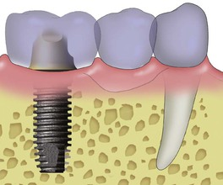
FIGURE 17-18 Joining an implant to a natural tooth, separated by a pontic, may be an acceptable treatment option.

Mobility: Vertical Movement

Implant and Tooth
The mobility of potential natural abutments greatly influences the decision to join implants and teeth more than any other factor. In the implant-tooth rigid fixed prosthesis, five components may contribute movement to the system: the implant, the bone, the tooth, the prosthesis, and implant and prosthetic components.
The tooth exhibits normal physiologic movements in vertical, horizontal, and rotational directions. The amount of movement of a natural tooth is related to its surface area and root design. Therefore, the number and length of the roots; their diameter, shape, and positions; and the health of the periodontal ligament primarily influence tooth mobility.²⁶ A healthy tooth exhibits no clinical mobility in a vertical direction. Actual initial vertical tooth movement is about 28 microns and is the same for anterior and posterior teeth.¹⁵ The immediate rebound of the tooth is about 7 microns and requires almost 4 hours for full recovery, so additional forces applied within 4 hours depress the tooth less than the original force.²⁷ The vertical movement of a rigid implant has been measured as 2 to 5 microns under a 10-lb force and is mostly attributable to the viscoelastic properties of the underlying bone²⁸ (Figure 17-19). The implant movement is not as rapid as the tooth movement because the tooth movement is a consequence of the periodontal ligament, not the surrounding bone elasticity.
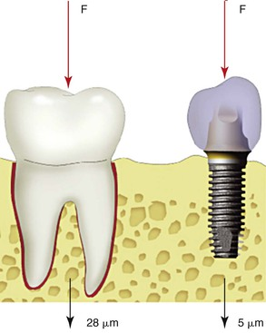
FIGURE 17-19 Whereas a vertical force (F) on a tooth results with 28-micron movement, an implant moves only 2 to 5 microns.

Prosthesis Movement
The fixed prosthesis that connects a tooth and implant also illustrates movement. Under a 25-lb vertical force, a prosthesis with a 2-mm connector fabricated in noble metal results in a 12-micron movement for one pontic and 97-micron movement for a two-pontic span.^{29,30} (Figure 17-20). Therefore, the FPD movement helps compensate for some difference in vertical mobility of a healthy tooth and implant.
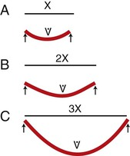
FIGURE 17-20 Bridge flexure is related to the cube of the span between abutments. Whereas a one-pontic prosthesis may flex 12 microns, a two-pontic prosthesis flexes up to 97 microns.

Implant and Prosthetic Components
Rangert et al. reported an in vitro study of a fixed prosthesis supported by one implant and one natural tooth and showed that the abutment or gold cylinder screw joint of the system also acts as a flexible element.³¹ The inherent flexibility matched the vertical mobility of the natural tooth. Therefore, the minimal movement of the tooth and the fact that implant, prosthesis, and abutment components have some mobility indicate that the risk is small in the vertical direction with the biomechanical difference of an implant and a tooth in the same prosthesis when one or two pontics separate these units.

Horizontal Movement

Tooth Mobility
Horizontal tooth mobility is greater than vertical movement. A very light force (500 g) moves the tooth horizontally 56 to 108 microns (Figure 17-21). The initial horizontal mobility of a healthy, nonmobile posterior tooth is less than that of an anterior tooth and ranges from 56 to 75 microns, which is two to nine times the vertical movement of the tooth.¹⁰ Initial horizontal mobility is even greater in anterior teeth and ranges from 90 to 108 microns in healthy teeth.²⁷
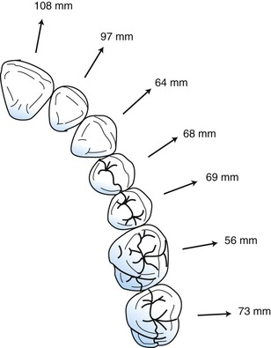
FIGURE 17-21 A healthy natural tooth may move laterally from 56 to 108 microns, with anterior teeth moving more than posterior teeth.
Muhlemann found that tooth movement may be divided into initial mobility and secondary movement.¹⁰ The initial mobility is observed with a light force, occurs immediately, and is a consequence of the periodontal ligament. If an additional force is applied to the tooth, a secondary movement is observed, which is related directly to the amount of force. The secondary tooth movement is related to the viscoelasticity of the bone and measures up to 40 microns under considerably greater force (Figure 17-22). The secondary tooth movement is similar to implant movement.
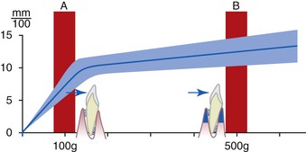
FIGURE 17-22 Teeth have a primary tooth movement related to a periodontal ligament. This accounts for the 28-micron apical and 56- to 108-micron lateral movement. They also have a delayed secondary mobility related to the viscoelastic nature of bone.

Implant Mobility
The implant–bone interface also exhibits lateral movement. Sekine et al. evaluated the movement of endosteal implants with rigid fixation and found a range of 12 to 66 microns of movement in the labiolingual direction.²⁸ Komiyama measured 40 to 115 microns of implant movement in the mesiodistal direction under a force of 2000 g (≈4.5 psi) and a labiolingual range of 11 to 66 mm³² (Figure 17-23). The greater implant movement in the mesiodistal dimension corresponds to the lack of cortical bone around the implants in this direction compared with the thicker lateral cortical plates present in the labiolingual dimension. Therefore, the mobility of implants varies in direct proportion to the load applied and the bone density and reflects the elastic deformation of bone tissue.
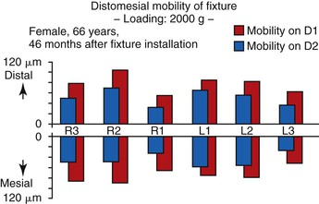
FIGURE 17-23 Implant movement is more mesiodistal than faciolingual, reaching values between 40 and 115 microns.³²
Although the implant has a range of mobility, the mobility is related to the viscoelastic component of bone, not the physiologic aspect of a periodontal membrane. As such, when the implant and tooth are loaded in the same prosthesis, the tooth immediately moves (primary tooth movement), and then the tooth and implant move together. In other words, secondary tooth movement is similar to implant movement because they both depend on the viscoelasticity of the bone. In a study by Sekine et al., when a tooth was gradually loaded over a 2-second period, the tooth immediately moved 36 microns and then gradually moved an additional 6 microns.²⁸ The implant gradually loaded had movement directly related to the amount of load and eventually moved as much as 22 microns. Hence, the secondary tooth movement was similar to the implant movement (Figure 17-24).
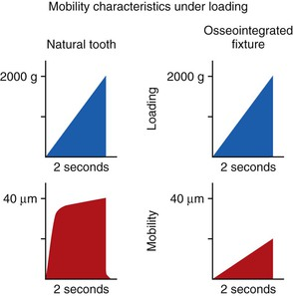
FIGURE 17-24 Sekine compared tooth movement with a gradual load over 2 seconds (left) with implant movement.²⁸ The secondary tooth movement was similar to implant movement.
An interesting note in implant mobility is that no significant difference was related to implant length. This finding further confirms that implant length is not the primary factor for implant support even in the presence of lateral loads. Bone density affects this condition more than implant length. These mobility characteristics are consistent with the findings of Fenton et al., who applied a 500-g load for 4 seconds to maxillary anterior teeth and osseointegrated implants.³³ The implants were displaced a mean 10 microns with a rapid elastic return (less than 1 msec), but the teeth showed a mean displacement of 57 microns with a prolonged viscoelastic return.
Therefore, when all factors are considered, an implant moves vertically and horizontally, the abutments and prosthesis flex, and the tooth has apical and lateral movements. However, the major difference in movement between implants and teeth is more related to the direction of movement (the horizontal dimension is more compared to much less difference in the vertical dimension).

Guidelines for Joining Implants to Teeth
To decrease biomechanical conditions, which increase the risk of complications, a requisite to join an implant to a natural tooth is that no lateral force should be designed on a unilateral prosthesis. Lateral forces increase the amount of tooth movement and decrease the amount of implant movement (faciolingual vs. mesiodistal). Horizontal forces placed on an implant also magnify the amount of stress at the crestal bone region.³⁴
A vertical movement or force placed on a posterior implant joined to a healthy posterior tooth causes mesial tension on the implant. The implant can move vertically 3 to 5 microns and mesially 40 to 115 microns, and a noble metal–fixed prosthesis with one pontic allows mesiodistal movement of 6 microns (Figure 17-25). Therefore, a natural tooth with no clinical mobility could be connected rigidly to an osseointegrated implant with no lateral forces because the implant, bone, and prosthesis compensate for the slight tooth movement. Finite element, photoelastic, and clinical documentation confirm that implants can be connected rigidly to stable teeth.³⁵⁻³⁸ However, the occlusion should be modified to allow the initial occlusal contacts on the natural tooth so that the implant does not bear the major portion of the initial load.³⁴
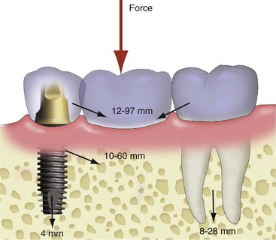
FIGURE 17-25 A three- or four-unit precious metal prosthesis with an implant and a posterior tooth rigidly splinted has some inherent movement. The implant moves apically 0 to 5 mm, and the tooth moves apically 8 to 28 mm but can rotate up to 75 mm toward the implant because of a moment force. The metal in the prosthesis can flex from 12 to 97 mm, depending on the length of the span and the width of the connecting joints. The abutment-to-implant component movement may be up to 60 microns because of abutment prosthetic screw flexure. As a result, a vertical load on the prosthesis creates little biomechanical risk when joined to a nonmobile tooth.
The lateral mobility of healthy anterior incisor teeth often is recorded as (+) with a range of movement from 90 to 108 micron. Therefore, visual clinical evaluation by the human eye can detect movement greater than 90 microns. When the horizontal mobility of a natural tooth (anterior or posterior) can be observed, mobility is greater than 90 microns and too great to be compensated by the implant, bone, and prosthesis movement. When the vertical posterior tooth movement, vertical implant movement, mesiodistal implant movement, and prosthesis movement are compared with the same conditions of a “mobile” tooth with lateral loads, the biomechanical risk factors are not the same. Therefore, one of the primary conditions for joining an implant to natural teeth is the lack of observable clinical movement of the natural abutment during functional movement. Hence, nonmobile posterior teeth with no lateral forces on the prosthesis may join rigid implants. However, implants rarely should be connected to an individual anterior tooth because (1) anterior teeth exhibit more than 10-fold greater clinical mobility than the implant, and (2) the lateral forces applied to the restoration during mandibular excursions are transmitted to the natural tooth and implant abutments (Figure 17-26).
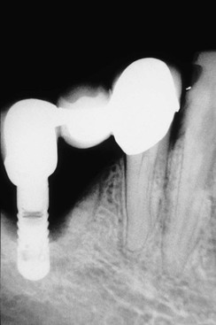
FIGURE 17-26 An implant joined to an anterior tooth or lateral forces applied to a natural tooth is at greater risk of biomechanical overload. The lateral force on the tooth causes greater movement than a vertical force. Anterior teeth receive more lateral loads than posterior teeth. The lateral loads are transferred to the implant. Lateral loads on the implant increase the amount of crestal bone stresses.
Implants should not be joined to mobile teeth with rigid attachments, which basically adds a cantilever on the implant (the tooth acting as a living pontic). If the natural teeth are too mobile in relation to the implant in the same prosthesis, several complications may occur and be detrimental to the tooth and implant. If the prosthesis is cemented, movement may break the cement–implant abutment seal. Cement does not adhere as well to titanium as to dentin. In addition, the mobile tooth will move (which decreases the impact force) rather than break the cement seal on the tooth. However, the rigid implant will have greater stresses applied to the cement (or screw) retained crown. After the prosthesis is loose from the implant, greater stress is applied to the natural mobile tooth. The tooth may increase in mobility as a result or fracture as a consequence (especially when endodontic procedures were performed).
A mobile attachment between the implant and natural tooth is usually not a benefit. A mobile attachment moves more than an implant or a tooth. Therefore, it is not an “attachment.” The pontic is cantilevered from the implant with little to no support from the tooth. It is usually better to have a rigid connector between implants and teeth than a mobile attachment.
When the natural abutment exhibits clinical horizontal movement or conditions promote horizontal forces against the abutment tooth, two options can be selected for the final prosthesis. The first, and the option of choice, is to place additional implants and to avoid the inclusion of natural abutments in the final prosthesis. This may include the extraction of the mobile tooth and replacement with an implant. The other option is to improve stress distribution by splinting additional natural abutments until no clinical mobility of the splinted units is observed.

Guidelines for Splinting Dental Units
Splinting natural teeth does not decrease the mobility of a tooth significantly after the prosthesis is removed; however, the overall prosthesis movement is decreased, especially when the splinted units form an arch. If posterior contacts cannot be eliminated in lateral excursions as a result of skeletal relationships or when opposing a removable prosthesis, splinting a mobile tooth often is safer to reduce the risk of long-term complications. In addition, splinting natural abutments also decreases the amount of load to each abutment (when a 150-psi load is distributed to all splinted abutments, the resultant force on each abutment is decreased)³⁹ (Figure 17-27).
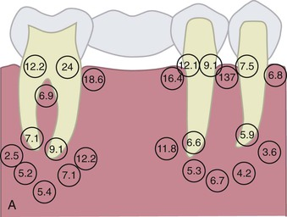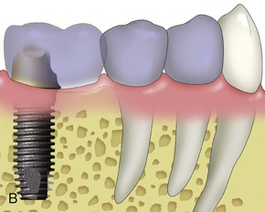
FIGURE 17-27 A, Splinting natural teeth together decreases their mobility and reduces the amount of stress transferred to the support system. (From Y. Ismail, Pittsburgh, PA). B, When the terminal natural tooth is slightly mobile, splinting an adjacent tooth is indicated.
The number of teeth to splint together is the number required to eliminate prosthesis movement. The initial dental evaluation may include acid etching and bonding potential mobile natural abutments to each other to determine how many teeth must be joined to reduce the abutment–prosthesis clinical mobility to zero. The dentist should also apply the following prosthetic guidelines when splinting teeth together:
1. The last tooth connected in the splint should not be mobile. In other words, to decrease mobility, at least the last tooth in the splint (and sometimes more) should be rigid.
2. The terminal abutments in the splint should not have poor retention form of the crown.
3. Adjacent teeth splinted together should be parallel enough to have the same path of insertion for the prosthesis.
4. Adjacent teeth should not be crowded or overlapped and should have enough room for splinted crowns to have adequate interproximal hygiene.
A classic axiom for splinting teeth in prosthodontics reads, “It is unadvisable to employ the last tooth as a splinted abutment if it lacks a degree of firmness comparable to its healthy neighbor, because the strain on the firm abutment could be destructive.”¹⁸ Implant prostheses may use additional secondary natural abutments to decrease the movement of the prosthesis so that rigid fixation of the implant will not be compromised. However, if the last abutment is mobile, it does not serve the intended purpose. Therefore, a general guideline is not to end a fixed prosthesis on the weakest splinted abutment. The weak tooth does not offer additional support and further burdens the healthier abutments. In addition, if cement failure occurs or the restoration needs retrieval, the partially retained prosthesis is more difficult to retrieve from the mobile abutment, resulting in more frequent coronal fracture and other complications.
The natural teeth exhibit some faciolingual movement, which varies from 56 to 108 microns in health. The discussion here is to reduce tooth movement when it is visible so that the mobile teeth may be connected to the implants. Although the teeth move in a faciolingual direction, different regions of the arch have different directions of movement relative to each other. In other words, the faciolingual direction of the anterior teeth corresponds to the mesiodistal direction of the posterior teeth; therefore, if these dental units are splinted to each other, the splint may become nonmobile (Figure 17-28).
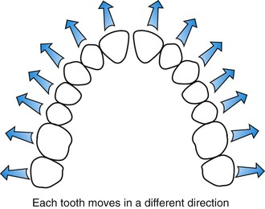
FIGURE 17-28 Because the teeth are positioned around an arch, their faciolingual movement is not in the same plane.
A dental arch may be described as a five-sided structure.¹ The posterior teeth on one side move in a similar direction to each other, the canine moves in a different direction, the anterior teeth move in a third direction, the contralateral canine moves in yet a different direction in comparison, and the other posterior component of the arch moves in a similar direction as the first. The more dental sections are connected, the more rigid the structure. As a general rule, three or more sections rigidly connected create an overall nonmobile dental structure. Even mild to moderate individual mobile dental units may become a nonmobile single unit.
The approach of joining implants to mobile teeth in several different arch positions is usually limited to conditions when the multiple sections of the dental arch already require restoration. Rarely would one consider crowning eight or more teeth solely to splint to the implant component. Instead, the use of a natural tooth pier abutment may be indicated.
The last tooth in a splinted prosthesis should not have poor retentive form. When a force is applied to the terminal region of a multiple-splinted restoration, the pier abutments may act as a fulcrum. As a consequence, tensile and shear forces may be applied to the cement seal. Because the cements are 20 times weaker in shear compared with compressive forces, the cement seal may break. As a consequence, the natural abutment often decays and may be lost. Hence, the most distal tooth in a splinted restoration should have adequate height and retentive form.
The adjacent teeth should be able to have the path of insertion as all the dental units in the prosthesis (Figure 17-29). It may be necessary to perform endodontics or even extract an offending tooth to accomplish the goal of splinting across an arch.
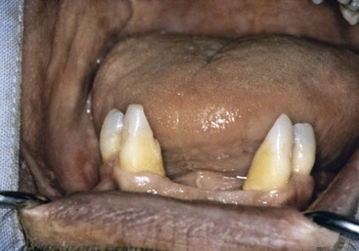
FIGURE 17-29 The teeth splinted together should be parallel enough to the implants, so they all have the same path of insertion for the prosthesis.
The adjacent teeth that are splinted together should not be overlapped or crowded (Figure 17-30). It may be necessary to have orthodontics or selective extractions to prepare the teeth for a similar path of insertion as the implant prosthesis. When the adjacent teeth are splinted, enough interproximal tooth tissues must be removed to permit adjacent metal crowns, connectors, and porcelain to be applied and maintain interproximal hygiene (Figure 17-31).
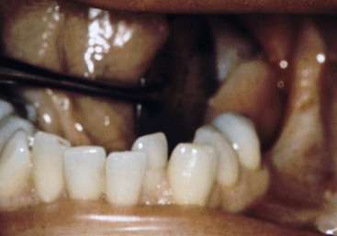
FIGURE 17-30 Potential teeth that will be splinted together should not have rotations or overlapping.
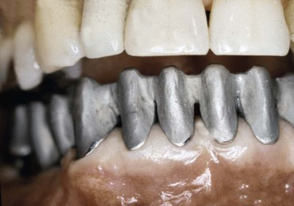
FIGURE 17-31 Enough space between the roots of teeth should exist so when splinted together, interproximal hygiene is possible.
In conclusion, the natural abutment connected to a rigidly fixated implant should not exhibit clinical mobility or poor retentive form. These same two criteria should be considered for the natural tooth used as a secondary abutment when splinting teeth in a FPD.

Nonrigid Connectors
Although nonrigid connectors have been advocated in the literature,^{18,40} a nonrigid connector in a unilateral prosthesis rarely is indicated for implant-fixed prostheses and may be detrimental. Nonrigid connection does not improve the stress distribution between the different abutments^{36,38} and has been reported to have caused migration of the natural teeth.⁴¹⁻⁴³ If the nonrigid connector exhibits any clinically observed mobility, it moves more than the implant. As such, the implant-supported part of the restoration is cantilevered to the attachment. In addition, the nonrigid (or mobile) attachment adds cost, creates overcontoured abutments, impairs daily hygiene, and does not decrease the clinical tooth movement.
Reports of intrusion of the natural tooth connected to an implant usually include the use of temporary cement to lute a coping to the natural abutment, leaving the final restoration uncemented on the coping, or the use of a nonrigid connector⁴¹ (Figure 17-32). When implants are joined to teeth that act as a terminal abutment, a definitive cement should be used for the natural tooth. The tooth cannot intrude unless it becomes unretained from the abutment (or has a nonrigid connector between the units).
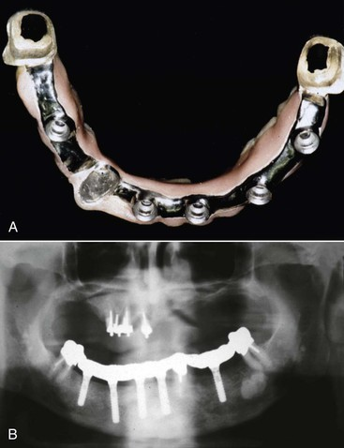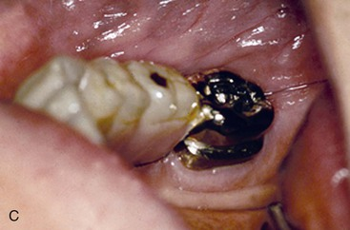
FIGURE 17-32 A, An implant prosthesis fabricated to join implants and teeth in the same prosthesis. Copings were designed for the teeth. B, A panoramic radiograph of the implants and prosthesis in place. C, The teeth intruded from the prosthesis. The cement seal must separate in order for the tooth to intrude (or a nonrigid connection exists between the units).
A possible explanation for tooth intrusion may be that the tooth is pushed vertically 28 microns but wants to rebound only 8 microns. The fixed prosthesis rebounds immediately and pulls on the tooth. The cement seal eventually breaks, causing a space to develop, which is first occupied by air. The prosthesis then acts as an orthodontic appliance and continually pushes the tooth in a vertical direction. Eventually, the space is occupied by saliva, and hydraulics continue the downward force during mastication. The tooth eventually submerges or intrudes from the prosthesis.

Implant Pier (Intermediary) Abutments
A pier abutment is one between two other abutments, sometimes referred to as an intermediate abutment. The intermediate abutment may be an implant or a natural tooth, and each type plays a different role in the overall treatment. When an implant serves as a pier abutment between two natural teeth, the difference in movement between implant and tooth may increase the complication rate compared with one intermediate tooth joined to two terminal implants (Figure 17-33). The pier implant abutment exhibits less movement than the natural teeth terminal abutments and acts as the fulcrum of a class I lever. As a consequence, a compressive force on one end of the prosthesis is converted to a tensile or shear force on the other terminal abutment.¹⁸ The cement tensile strength is often 20 or more times less than the compressive strength. Therefore, when the implant acts as a fulcrum, an uncemented abutment (usually the least mobile tooth or least retentive crown) is a common consequence, with decay being the next most common occurrence.
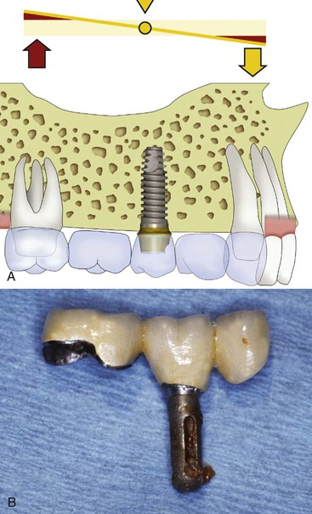
FIGURE 17-33 A pier implant abutment between two natural teeth may cause a cement seal to break on the teeth, especially if one is more mobile than the other.
This problem is magnified by a longer lever arm such as a pontic between the implant and tooth, when the natural tooth or teeth have clinical mobility, the force is lateral on the prosthesis, or the forces are greater than usual. A pier implant abutment may cause complications even when joined to nonmobile teeth as terminal abutments.
Uncemented restorations are a common complication in FPDs even when all aspects of treatment are within acceptable limits. Any condition that may increase this problem, such as the one presently addressed, should be carefully avoided. When bone grafting is not an option and additional implants cannot be inserted, a mobile attachment can be used to help restore the implant pier abutment (Figure 17-34). A nonrigid attachment connects the implant and the least nonmobile tooth to prevent the implant pier abutment from acting as a fulcrum.
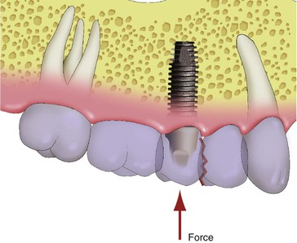
FIGURE 17-34 When grafting and additional implants are not an option, a mobile attachment may be used to prevent the pier implant from acting as a fulcrum.
The nonrigid attachment is used between the implant and the more mobile tooth. In conventional fixed prostheses, the “male” portion of a nonrigid attachment usually is located on the mesial aspect of the posterior pontic, and the “female” portion is in the distal aspect of the natural pier abutment tooth. This prevents mesial drift from unseating the attachment.⁴⁰ However, an implant does not undergo mesial drifting, and the nonrigid connector location is more variable in location.

Natural Tooth Pier Abutments
When a natural tooth rather than an implant serves as a pier abutment between two or more implants, the situation is completely different from the previous scenario. When the two or more implants may support the load of the prosthesis alone, the natural tooth becomes a “living pontic” (Figure 17-35). In other words, the tooth is not needed to support the prosthesis, and the rigid terminal abutments constitute the entire support system for the prosthesis. In absence of the tooth, the dental unit would be a pontic without compromise. Because the tooth has greater mobility than the terminal implants and does little to contribute to the support of the prosthetic load, it is referred to as a pontic with a root, or a “living pontic.” No more than one adjacent site should be a pontic, so a three-“pontic” span does not exist. Therefore, this scenario is best when no additional pontics are between the implants and the tooth. For a natural pier abutment between two implants, a stress breaker is not indicated.
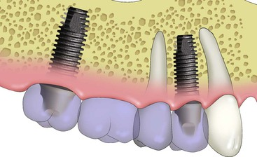
FIGURE 17-35 When a natural tooth serves as a pier abutment between two or more implants, the tooth may act as a “living pontic.” No stress breaker is needed in this situation.
On occasion, multiple implants in a full-arch prosthesis are splinted together to cantilever one or two pontics, yet a healthy, natural tooth is positioned between the implants. The tooth essentially is ignored in the development of the treatment plan, other than the dentist having to fabricate a crown rather than a pontic in the splinted prosthesis (Figure 17-36). One advantage of keeping the natural tooth, even though it does not contribute to the support of the prosthesis, is the proprioceptive aspect of the periodontal complex.³⁴ Implant prostheses have higher bite forces during mastication than natural tooth restorations because of the decrease in occlusal awareness. A living pontic may decrease the interaction of the forces found during function.
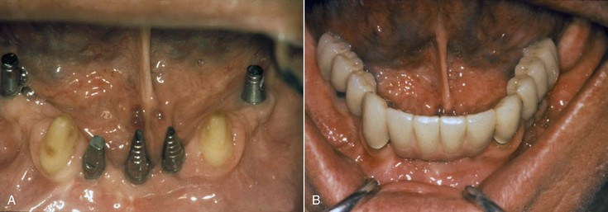
FIGURE 17-36 A, The mandibular restoration has five implants and two natural teeth splinted together, so a cantilever may be used to replace the posterior teeth. The five implants support the load of the restoration. The natural teeth pier abutments act as living pontics. B, An intraoral view of the fixed prosthesis. The natural teeth may give some proprioception to the restoration, especially when in the canine position. The support of the restoration is primarily from the implants, which surround the teeth and are splinted together.

Transitional Natural Abutments
On occasion, because of the lengthy aspect of implant treatment, especially when bone regeneration procedures are indicated before implant placement, initially maintaining strategic teeth (even with a poor prognosis) as interim restoration abutments may be desirable. These teeth are often terminal abutments that support a fixed temporary restoration, protect edentulous implant or graft areas from mastication trauma, and avoid the use of a removable soft tissue–borne partial interim prosthesis. These teeth are extracted after initial implant healing, and often these teeth are in an ideal implant site for the final restoration. When this occurs, the implant then is placed in the extraction site as a second surgical phase. This approach is beneficial to provide the patient with a fixed transitional prosthesis and to avoid soft tissue–supported restorations on bone augmentation sites but may extend the overall treatment by 6 months.
The transitional abutment scenario is most common in a full-arch rehabilitation patient who has a full-arch fixed transitional restoration on periodontally involved teeth. The prognosis of these abutments may be poor, mandating their extraction (less than 5-year survival category). However, if all the compromised teeth are extracted, the patient must wear a full immediate denture as a temporary prosthesis while grafting and implant insertion phases are performed. The psychologic and physiologic changes associated with a denture, even if a temporary solution, may have dramatic consequences for the patient. These patients may benefit greatly from a stepped approach in which a few poor, short-term, asymptomatic dental elements are maintained while all others are extracted for the sole purpose of providing the patient with a fixed temporary restoration⁴⁴ (Figure 17-37).
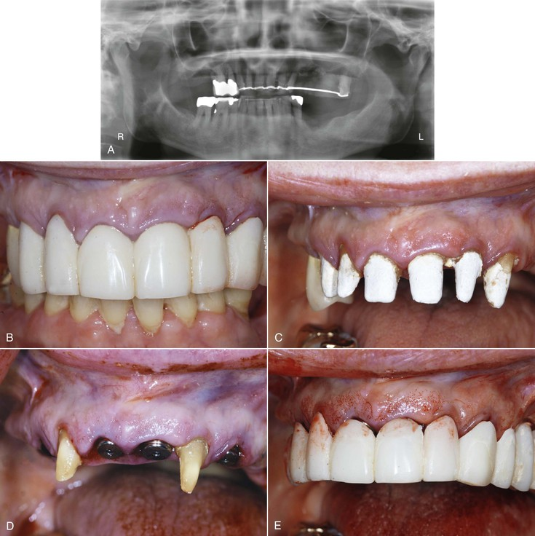
FIGURE 17-37 A, A panoramic radiograph of hopeless maxillary teeth. B, The teeth were splinted together with a transitional acrylic restoration to replace the missing teeth. C, The prosthesis was removed. D, Implants were inserted in strategic extraction sites, and three teeth remained to support the transitional prosthesis during initial integration of the implants. E, The transitional prosthesis was relined and recemented on the three transitional teeth.
The careful selection of the transitional abutments must not hinder the implant treatment. However, an extended treatment time with additional implant placement surgery may be required. For example, four compromised teeth dispersed throughout the arch may be kept for a fixed transitional restoration. Meanwhile, other sites are extracted, grafted, and implanted. When these implants are healed and ready to be restored, the “temporary” natural abutments may be extracted and additional implants placed. The healed implants now may support the transitional prosthesis. The new implants, on occasion when the bone density and biomechanical factors permit, may be immediately restored with a modified transitional restoration.
The advantage of the transitional abutment procedures is that a fixed prosthesis maintains the patient throughout treatment, protecting the implant surgical site during the submerged healing phase. Disadvantages include additional cost, increased time, risk of implant site contamination if any problem or flare-up of natural abutments occurs, and increased risk for the initial implants because the foundation is not completely sufficient for support until the additional implants are healed. The dentist should weigh the advantages and risks of such a treatment carefully before proposing it to a patient.
A fixed interim prosthesis in an edentulous arch also may be supported by three to six additional implants placed in function immediately at insertion to permit the fabrication of a temporary fixed prosthesis while all other implants are submerged.⁴⁵ The dentist evaluates these additional implants at the time of final prosthesis fabrication and may or may not include them in the final restoration, depending on their status at that time. Transitional mini-implants also have been developed to that effect.
Caution is needed in using additional implants of normal or minimized dimensions because the volume of bone used for their placement may be of strategic value during treatment and risks being destroyed by fibrous tissue formation or bone resorption when immediately loaded, which may affect a final prognosis. Such treatment options are indicated only on a case-by-case basis.

References
1. Misch CE. Pre-implant prosthetics. Misch CE. Contemporary implant dentistry. ed 2. Mosby: St Louis; 2008:157–179.
2. Misch CE. The evaluation of natural teeth adjacent to implant sites. Misch CE. Contemporary implant dentistry. ed 2. Mosby: St Louis; 2008:151–162.
3. Cranin AN. The anchor oral endosteal implant. J Biomed Mater Res. 1973;235(Suppl 4).
4. Kapur KK. Veterans Administration co-operative dental implant study—Comparison between fixed partial dentures supported by Blade-vant implants and partial dentures. J Prosthet Dent. 1987;59:499–512.
5. Ericsson I, Lekholm U, Brånemark PI, et al. A clinical evaluation of fixed bridge restoration supported by the combination of teeth and osseointegrated titanium implants. J Clin Periodontol. 1986;13:307–312.
6. English CE. Biomechanical concerns with fixed partial dentures involving implants. Implant Dent. 1993;2:221–242.
7. Holm C, Tidehaq P, Tillberg A, et al. Longevity and quality of FPDs: a retrospective study of restorations 30, 20, and 10 years after insertion. Int J Prosthodont. 2003;16:283–289.
8. Tan K, Pjetursson BE, Lang NP, et al. A systematic review of the survival and complication rates of fixed partial dentures (FPDs) after an observation period of at least 5 years. III. Conventional FPDs. Clin Oral Implants Res. 2004;15:654–666.
9. Pjetursson BE, Tan K, Lang NP, et al. A systematic reviewof the survival and complication rates of fixed partial dentures (FPDs) after an observation period of at least 5 years. I. Implant-supported FPDs. Clin Oral Implants Res. 2004;15:625–642.
10. Muhlemann HR. Tooth mobility: a review of clinical aspects and research findings. J Periodontol. 1967;38:686–708.
11. Klinge B. Implants in relation to natural teeth. J Clin Periodontol. 1991;18:482–487.
12. Dixon DI, Breeding LC, Sadler JB, et al. Comparison of screw loosening, rotation, and deflection among three implant designs. J Prosthet Dent. 1995;74:270–278.
13. Tarnow DP, Magnera W, Fletcher P. The affect of the distance from the contact point to the crest of bone on the presence or absence of the interproximal papilla. J Periodontol. 1992;63:995–996.
14. Bidez MW, Misch CE. Force transfer in implant dentistry. Basic concepts and principles. J Oral Implant. 1992;18(3):264–274.
15. Adell R, Lekholm U, Rockler B, et al. A 15-year study of osseointegrated implant in the treatment of the edentulous jaw. Int J Oral Surg. 1981;6:387.
16. Schackleton JL, Carr L, Slabbert JC, et al. Survival of fixed implant supported prostheses related to cantilever lengths. J Prosthet Dent. 1994;71:23–26.
17. McAlarney ME, Stavropoulos DN. Determination of cantilever length–anterior-posterior spread ratio assuming failure criteria to be the compromise of the prosthesis retaining screw-prosthesis joint. Int J Oral Maxillofac Implants. 1996;11:331–339.
18. Shillinburg HT, Hobo S, Whitsett LD, et al. Fundamentals of fixed prosthodontics. ed 3. Quintessence: Chicago; 1997.
19. Goodacre CJ, Bernal G, Rungcharassaeng K, et al. Clinical complications in fixed prosthodontics. J Prosthet Dent. 2003;90:31–41.
20. Takayama H. Biomechanical considerations on osseointegrated implants. Hobo S, Ichida E, Garcia CT. Osseointegration and occlusal rehabilitation. Quintessence: Chicago; 1989.
21. Linkow L. Mandibular implants: a dynamic approach to oral implantology. Glarus Publishing: New Haven, CT; 1978.
22. Misch CE. Osseointegration and the submerged blade-vent implant. J Houston District Dent Assoc. 1988;Jan:12–16.
23. Astrand P, Borg K, Gunne J, et al. Combination of natural teeth and osseointegrated implants as prosthesis abutments: a 2 year longitudinal study. Int J Oral Maxillofac Implants. 1991;6:305–312.
24. Cavicchia F, Bravi F. Free standing vs tooth connected implant supported fixed partial restoration: a comparative retrospective clinical study of the prosthetic results. Int J Oral Maxillofac Implants. 1996;9:711–718.
25. Lundgren D, Falk H, Laurell L. Prerequisites for a stiff connection between osseointegrated implants and natural teeth. J Dent Res. 1988;67:247.
26. Picton DCA. On the part played by the socket in tooth support. Arch Oral Biol. 1965;10:945–955.
27. Parfitt GS. Measurement of the physiologic mobility of individual teeth in an axial direction. J Dent Res. 1960;39:608–612.
28. Sekine H, Komiyama Y, Hotta H, et al. Mobility characteristics and tactile sensitivity of osseointegrated fixture-supporting systems. van Steenberghe D. Tissue integration in oral maxillofacial reconstruction. Elsevier: Amsterdam; 1986.
29. Phillips RW: Personal communication, 1990.
30. Bidez MW, Lemons JE, Isenberg BF. Displacements of precious and nonprecious dental bridges utilizing endosseous implants as distal abutments. J Biomed Mater Res. 1986;20:785–797.
31. Rangert B, Gunne J, Sullivan DY. Mechanical aspects of a Brånemark implant connected to a natural tooth: an in vitro study. Int J Oral Maxillofac Implants. 1991;6:177–186.
32. Komiyama Y. Clinical and research experience with osseointegrated implants in Japan. Albrektsson T, Zarb G. The Brånemark osseointegrated implant. Quintessence: Chicago; 1989.
33. Fenton AH, Jamshaid A, David D. Osseointegrated fixture mobility. J Dent Res. 1987;66:114.
34. Misch CE, Bidez MW. Implant protected occlusion, a biomechanical rationale. Compendium. 1994;15:1330–1342.
35. McGlumphy EA, Campagni WV, Peterson LJ. A comparison of the stress transfer characteristics of dental implants with a rigid or a resilient internal element. J Prosthet Dent. 1989;62:589–592.
36. Ismail YH, Misch CM, Pipko DJ, et al. Stress analysis of a natural tooth connected to an osseointegrated implant in a fixed prosthesis. J Dent Res. 1991;70:460.
37. Dimilano GP, Corrente G. Photoelastic evaluation of attachments in tooth connected implant restorations in relation to residual periodontal support. Riv Ital Osteointegrazione. 1992;2(Suppl 1):35.
38. Misch CM, Ismail YH. Finite element analysis of tooth to implant fixed partial denture designs. J Prosthodont. 1993;2:83–92.
39. Wylie R, Caputo AA. Force distribution to periodontally involved teeth by fixed splints [abstract]. J Dent Res. 1982;61:1030.
40. Shillingburg HT, Fisher DW. Nonrigid connectors for fixed partial dentures. J Am Dent Assoc. 1973;87:1195–1199.
41. Cho GC, Chee WL. Apparent intrusion of natural teeth under an implant supported prosthesis: a clinical report. J Prosthet Dent. 1992;68:3–5.
42. Rieder CE, Parel SM. A survey of natural tooth abutment intrusion in implant connected fixed partial dentures. Int J Periodontics Restorative Dent. 1993;13:335–347.
43. Pesun IJ. Intrusion of teeth in the combination implant-to-natural-tooth fixed partial denture: a review of the theories. J Prosthodont. 1997;6:268–277.
44. Gottehrer NR, Singer G. Full team approach for provisional stabilization of edentulous implant patients. Dent Today. 1996;15:56–59.
45. Schnitman PA, Wohrle PS, Rubenstein JE. Immediate fixed prostheses supported by two-stage threaded implants: methodology and results. Oral Implantol. 1990;16:96–105.

