CHAPTER 12 MEMBRANE BARRIERS FOR GUIDED TISSUE REGENERATION
Jack T. Krauser, Barry Kyle Bartee, Arun K. Garg
Dental Implants: The Art and Science book; 2e.
In the field of periodontics, the term guided tissue regeneration (GTR) describes an advanced surgical technique used to achieve restitution of the supporting tissues of teeth (i.e., bone, cementum, and periodontal ligament) that have been lost as a consequence of inflammatory disease or trauma.^{1,2} The technique involves thorough debridement of the bone defect and root surface and then, by means of a cell occlusive membrane, achieving selective cell repopulation of the defect. The protection afforded by the membrane allows the development of slower developing and more complex tissues derived from osteoprogenitor cells and the periodontal ligament, tissues that otherwise may be replaced with gingival epithelium or connective tissue.
In the field of implant dentistry, a related concept known as guided bone regeneration refers to the regeneration of bone that may have been lost due to periodontal disease, trauma, or postextraction atrophy, either prior to or concomitant with dental implant placement. Several treatment modalities have been used in an attempt to reach this goal involving the use of a variety of membrane materials with or without the placement of bone grafts or bone substitutes (Figure 12-1).^{1,3}
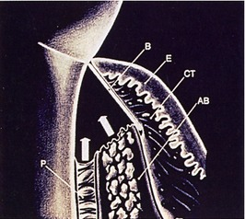
Figure 12-1. The concept of guided tissue regeneration is demonstrated. Key elements are a physical material (B) blocking the soft gingival tissue epithelium (E) and connective tissue (CT) from the desired space, allowing formation of alveolar bone (AB), cementum, and periodontal ligament (P). Arrows depict pathways of desired regeneration of tissues.
The concept of guided tissue regeneration in periodontics was proposed by Melcher, who described the biological behavior of different tissues (e.g., gingival epithelium, connective tissue, periodontal ligament, alveolar bone) during wound healing.^{4,5} According to this concept, cells that have the capability to form bone, cementum, and periodontal ligament must occupy the defect at the appropriate time and in the proper sequence to result in regeneration of the tissues as opposed to simple repair of the defect. Because the desired progenitor cells reside in the periodontal ligament or alveolar bone, the placement of a physical barrier between the gingival flap and the defect before flap repositioning and suturing was proposed to prevent gingival epithelium and connective tissue (undesirable and faster growing cells) from occupying the space under the barrier.^{6,7}
Although the early studies were concerned with the treatment of periodontal defects, membrane techniques were quickly adapted to facilitate prevention of ridge resorption after extraction, augmentation of alveolar ridge defects, improved bone healing around dental implants, and treatment of failing implants.^{8,9} According to Mellonig and Triplett, membranes may also be used to provide wound coverage, acting as a duplicate surgical flap to provide added stability and protection to the blood clot.¹⁰ In addition, membranes may also provide protection and isolation of the blood clot, creating a space under the surgical flap that will act as the scaffold for ingrowth of cells and blood vessels from the base of the bone defect.¹¹
Studies have shown that a series of complex, interrelated factors influence the predictability of regenerative procedures.^{12,13} In addition to the creation and maintenance of a blood clot–filled space, which provides mechanical stability and isolates the regenerative space from undesirable tissues, membranes may function as a physical barrier to contamination, preventing inflammation as a result of bacterial invasion into the resolving wound complex, and as a means of concentrating growth factors derived from adjacent bone marrow.

Materials Used for Membrane Barrier Techniques
Various membrane materials have been introduced over the years, along with expanded clinical applications and a general increase in use of membrane-based techniques.⁸ It has been shown that the biological and physical characteristics of the biomaterials used to manufacture membranes can significantly influence barrier function as well as host tissue response.¹³ Biocompatibility, space-making ability, ability to achieve tissue integration or attachment, and clinical manageability are criteria that must be considered in the design of materials used for regenerative procedures.¹⁴ These materials also should be safe, efficient, cost effective, and easy to use. In addition, they must remain intact as a physical barrier with the ability to exclude unwanted cells until regeneration is complete, yet not interfere with the development of newly formed tissue.^{15,16}
In numerous studies to date, the clinical and histological evidence associated with guided bone regeneration has been favorable. The available evidence suggests that successful regeneration can be achieved with a variety of membrane materials, each of which has particular benefits and limitations, and none of which has been found ideal for every clinical situation.^{13,17,18} Knowledge of the advantages and disadvantages inherent with each material for the application in which it is being used is important for ensuring success.¹³
Microporous cellulose filters (Millipore filter, Millipore Corp., Bedford, MA) and expanded polytetrafluoroethylene (ePTFE) (Gore-Tex Regenerative Material, W. L. Gore and Associates, Inc., Flagstaff, AZ) were used in the initial preclinical and clinical investigations of guided tissue regeneration. These materials were not originally manufactured for medical use, but were chosen as barrier materials because they were shown to be biocompatible, and their porosity was such that it allowed the passage of biological fluids across the barrier while excluding certain cell types.⁵

Cellulose Filters
Nyman et al. conducted the initial studies of the use of cellulose filters in primates with the intended goal of excluding connective tissue and gingival epithelium, allowing cells derived from the periodontal ligament to repopulate surgically created periodontal defects.¹⁹ In these early studies, the periodontal ligament, cementum, and alveolar bone on the facial aspect of the cuspid teeth was removed, and cellulose filters were placed over the resulting defects. After healing, histological examination of the healed defects demonstrated regeneration of the alveolar bone and new attachment of new cementum with inserting periodontal ligament fibers.
Nyman et al. were the first to use the regenerative approach on human teeth.¹⁹ On a mandibular incisor with advanced periodontal disease, debridement, scaling, and root planing were performed after elevation of full-thickness flaps. A cellulose filter was placed, covering the defect and the adjacent alveolar bone. Three months after the initial surgery, histological examination of the treated defect demonstrated regeneration of new cementum with inserting collagen fibers. Although the initial investigation did demonstrate efficacy of cellulose filters for GTR, disadvantages included premature exfoliation of the membrane and, when used with techniques requiring primary closure, the need for a second surgical procedure for their removal.

Expanded Polytetrafluoroethylene Membranes
To date, the vast majority of clinical studies involve the use of ePTFE membranes. Due to the early successes and the sheer number of studies and case reports in the literature, ePTFE has been considered the gold standard with which other types of membranes are compared.^{5,16} Structurally, ePTFE is a microporous matrix consisting of a repeating pattern of nodes and fibrils. By varying the distance between nodes, the material can be made to vary widely in porosity. As a biomaterial with a long history of successful use in vascular surgery, ePTFE is recognized for its inertness and tissue compatibility.²⁰ The size of the porous microstructure may be tailored to allow the ingrowth and attachment of connective tissue for stabilization of the healing wound complex¹³ (Figure 12-2).
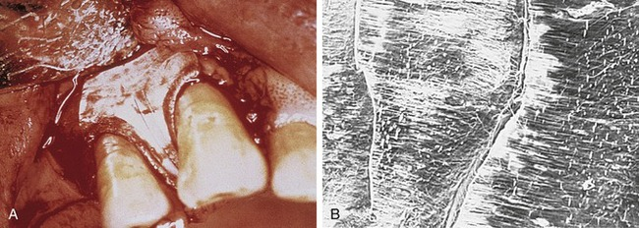
Figure 12-2. A, Well-adapted Gore-Tex expanded PTFE interproximal material is used to treat a compromised periodontal defect. B, Scanning electron microscopic view demonstrates Gore-Tex expanded PTFE membrane (mag ×200) at interface between its stiff and outer portions.
Historically, ePTFE membranes were constructed using both a closed and open microstructure. The open microstructure (collar) portion was designed to facilitate membrane by allowing ingrowth of connective tissue. Theoretically, this ingrowth of connective tissue would have the effect of inhibiting or reducing the chance for epithelial migration between the flap and membrane surface, a phenomenon called contact inhibition. The second part (inner occlusive portion) of the membrane consisted of an occlusive portion that prevented gingival cells from the flap from interfering with the healing process at the defect site.^{2,5} For periodontal applications, there were two configurations of ePTFE membranes, transgingival and submerged, that could be used in different situations. The transgingival design was used to treat defects associated with structures that extend through the gingiva, such as periodontally diseased teeth. The submerged design was intended to be used in situations in which there was no communication with the oral environment, such as alveolar ridge defects.²⁰
Later, titanium-reinforced ePTFE membranes were introduced, consisting of a thin framework of titanium metal between two pieces of laminated PTFE membrane. Because ePTFE is typically soft and flexible, the titanium reinforcement was designed to increase the space-making capability of the device, creating a tent-like effect over the bone defect. This was found to be advantageous when defect morphology did not inherently lead to the creation of adequate three-dimensional space under the membrane, such as would be found in a typical three-walled periodontal defect. Titanium-reinforced membranes also were available in transgingival and submerged configurations (Figures 12-3 and 12-4).²⁰
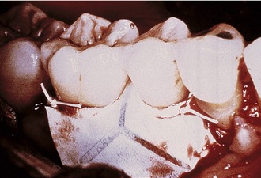
Figure 12-3. Gore-Tex titanium-reinforced expanded PTFE material adapts well in interproximal space. Reinforced titanium adds to shape and space-making capacity.
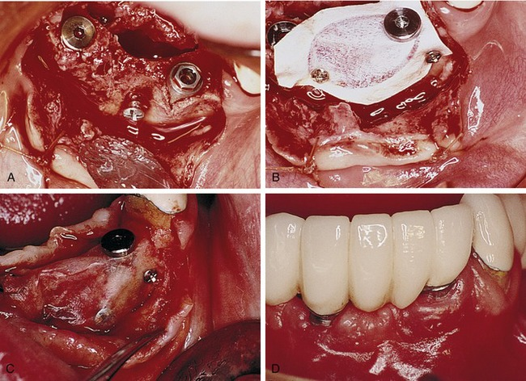
Figure 12-4. A, Traumatically avulsed incisor teeth replaced with implants in positions of teeth #23 and 26. A horizontally placed screw helps prop up membrane and create a tent pole–like effect. B, Well-secured Gore-Tex augmentation material is demonstrated with fixation screws and implant cover screw. Membrane is well trimmed and away from papilla of tooth #22, allowing for total undisturbed closure. (It is not recommended to secure membrane with implant cover screw.) C, Reentry is performed to retrieve membrane. Excellent adaptation of membrane to ridge is observed. D, Final prosthetic design is demonstrated. Maintenance of papilla mesial of tooth #22 is observed, which was preserved because of nonexposure of the membrane.
Several studies have shown that titanium-reinforced ePTFE membranes have substantial biological potential for regeneration of alveolar bone and periodontal structures. The space created is more predictable and resistant to collapse from overlying mucosal tissue than that created with nonreinforced membranes.^{21,22}
Bartee evaluated and reported on the use of a nonexpanded, high-density PTFE membrane as a guided tissue regeneration barrier.¹⁷ Initial reports on this material indicated that the membrane appeared to be well tolerated by the soft tissue, with no inflammation or clinical signs of infection, even when exposed in the oral cavity. The membrane also was shown to provide an effective barrier, allowing bone deposition in the osseous defects. However, the author concluded that more clinical studies are needed to evaluate the effect of this type of membrane. The purported advantage of the high-density PTFE membrane was that it could be left exposed in the oral cavity without the risk of compromising the bone regeneration process, in contrast to the requirement for primary closure with ePTFE (Figures 12-5 and 12-6). This ability to withstand exposure was due to the reduced pore size of dense PTFE, which was designed specifically to prevent the bacterial ingrowth into the dense PTFE membrane structure.
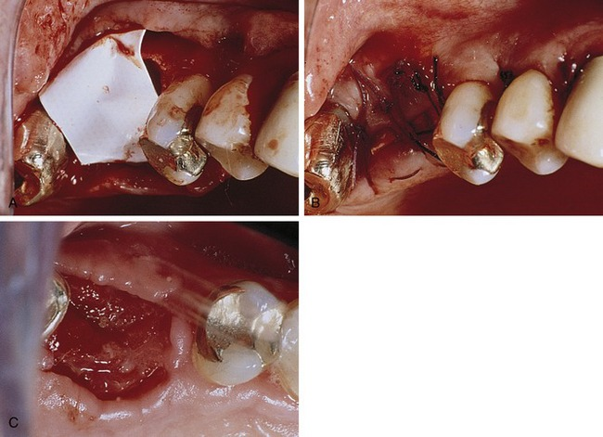
Figure 12-5. A, Extracted tooth #3 after socket debridement. A well-trimmed high-density PTFE membrane barrier (Cytoplast GBR200 Osteogenics, Biomedical, Inc., Lubbock, TX) was placed. B, Excellent closure with deliberate lack of primary closure enhances the buccolingual dimensions of keratinized tissue. C, Site at 3 weeks shows excellent buccolingual dimensions and newly regenerated tissue.
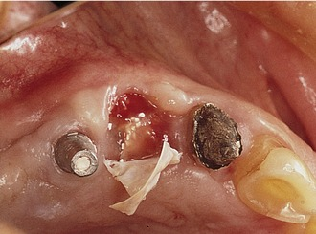
Figure 12-6. An immediate implant placement using Cytoplast high-density PTFE material depicts the relative ease of barrier removal. Excellent tissue mass completely covers top of implant.
The main disadvantage associated with the use of nonresorbable membranes in general and ePTFE membranes in particular, was that a second surgical procedure was required for removal. There is a major difference, however, in the removal procedure between the two materials. With ePTFE, due to the open microstructure and vigorous tissue ingrowth, surgical removal was often difficult and tedious, increasing the cost and surgical morbidity.⁵ In contrast, due to much reduced pore size and reduction of tissue ingrowth, removal of high-density PTFE membrane was greatly simplified, and could be accomplished nonsurgically if exposed, and using minimally invasive surgery if primary closure was used over the membrane.
On the positive side, with nonresorbable membranes the clinician remains in control over the length of time that the membrane is in place. It has been suggested that healing times may vary among different types or sizes of defects, especially bony defects of the alveolar ridge.^{13,22} The principal advantage of nonresorbable membranes, of both ePTFE and high-density PTFE, is that the membrane retains its functional characteristics long enough for adequate healing to occur, and then it can be eliminated immediately at the discretion of the surgeon. After removal, there is no possibility of breakdown products interfering with the maturation of the regenerated tissues as can occur with bioresorbable materials.¹⁶
In some situations nonresorbable membranes provide a more predictable performance, with less risk for long-term complications and simplified clinical management.¹³ Specifically, the use of high-density PTFE membrane may be advantageous in situations in which soft tissue management problems are anticipated and when reliable primary cannot be achieved and maintained. Further, because the removal process is simplified and nontraumatic, it can be accomplished without interfering with the regenerated tissues.¹⁶

Bioresorbable Guided Tissue Regeneration Membranes
Following the initial experience with ePTFE membranes for GTR, bioresorbable membranes of polylactide/polyglycolide (PLA/PGA) and collagen were introduced in an effort to reduce the need for additional procedures required for membrane removal.¹⁸ However, a disadvantage of bioresorbable materials was quickly realized: premature exposure or flap dehiscence resulting in postoperative tissue management problems. Such exposure in the early healing phase can lead to bacterial growth and premature degradation of the exposed device with loss of barrier function, reducing the success of the regenerative process. Another issue common to the bioresorbable membranes was their inherent mechanical stiffness. Clinicians experienced difficulty in maintaining space under the barriers and preventing membrane collapse into certain types of defects.²³
A secondary issue with bioresorbable materials relates to the local biological effects of the resorptive process. To be successful as a guided tissue regeneration barrier, bioresorbable barriers must have similar mechanical characteristics as nonresorbable ones, and the degradation process should not interfere with the regenerative outcome.^{5,13} The bulk properties of the device and the ratio of PLA to PGA affects the resorption rate and to some extent the local tissue response. PLA/PGA materials degrade via hydrolysis, ultimately breaking down into carbon dioxide and water. High concentrations of these materials’ degradation products (i.e., glycolide) have been shown to stimulate an inflammatory response via complement activation.²⁴⁻²⁶

Collagen Membranes
Collagen has been successfully used in various forms (e.g., sheets, gels, tubes, powders, sponges) as an implantable biomaterial for many years.²⁷ As a naturally occurring biomaterial, collagen has a number of characteristics that make it suitable as a barrier material, including high tensile strength and favorable effects on coagulation, cell attraction, attachment, and migration. From a manufacturing standpoint, collagen has additional advantages in that the degradation rate and mechanical properties can be controlled through cross-linking.^{18,28}
Processed bovine type 1 collagen membranes have been evaluated for membrane barrier procedures in animals and humans with positive results.¹⁸ These materials are sourced from a collagen-rich tissue such as Achilles tendon or dermis, hydrolyzed into a gel, freeze-dried, and then compressed into a flat sheet of collagen. Various cross-linking methods are employed, including the use of chemicals such as glutaraldehyde and formaldehyde. Multicenter studies have shown equivalence to nonresorbable membranes in the treatment of periodontal defects (Figure 12-7).¹⁸
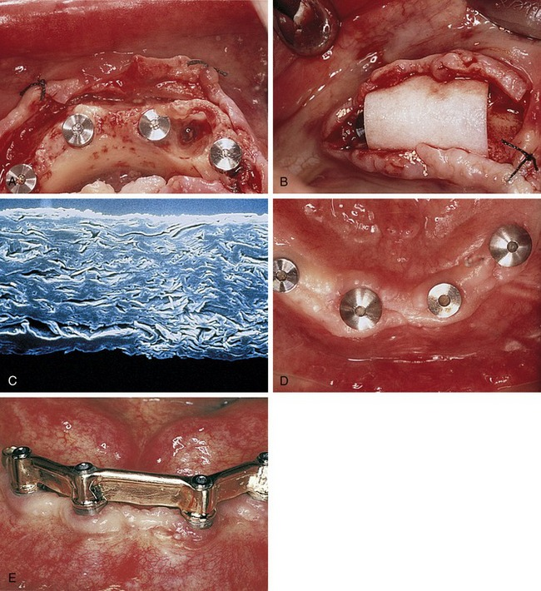
Figure 12-7. A, A case demonstrates immediate extractions and implant placement showing large residual socket defect. B, Well-trimmed BioMend (Zimmer Dental Inc., Carlsbad, CA) type I bovine collagen material placed over region. C, Scanning electron microscopic view of BioMend in cross-section shows structure and microporous nature. D, The case is ready for final prosthesis. E, Excellent contours and tissue integrity are demonstrated.
Pitaru et al. evaluated the degradation kinetics and potential problems associated with premature degradation of collagen membranes.^{29,30} The authors concluded that rapid degradation (30 days) caused by enzymes found in plaque and healing wounds could result in poor regenerative results. Because of these findings, researchers improved the quality of collagen membranes by using bilayered barriers to compensate for the premature degradation of the external barrier and by adding heparain sulfate and fibronectin to the internal barrier. Fibronectin acted as a chemotactic factor for fibroblasts, binding the heparain sulfate to the collagen membrane. The inner barrier was designed to act as a second barrier for the migrating epithelium and to serve as a delivery system for fibronectin and heparain sulfate. The results of this study showed that the enriched collagen barrier had improved properties to retard apical migration of epithelium compared with nonenriched membranes.³¹
A multicenter study evaluated the use of bovine tendon type I collagen membranes for membrane barrier procedures in human Class II furcation defects compared the efficacy of bioabsorbable collagen membranes with that of surgical debridement or ePTFE membranes. The results of the study showed that collagen membranes were clinically effective and safe for use in periodontal regenerative procedures. The gain in attachment using collagen membranes was equal to or greater than that obtained with the use of surgical debridement or ePTFE membranes.¹⁸
A study by Blumenthal and Steinberg showed successful treatment of one-, two-, and three-wall defects using a collagen membrane combined with antigen-extracted allogeneic bone and collagen gel.³² In this study, a 1- to 2-mm film of collagen gel was placed in the base of the defect, the allogeneic bone was packed into the defect, and a collagen membrane was placed over the defect.
The advantages of using collagen membranes include minimal postoperative complications, minimal antigenicity, rapid healing, and low incidence of dehiscence, tissue perforation, tissue sloughing, or postoperative infection.³³ It appears that collagen is a useful and beneficial membrane material for regenerative therapy because these membranes meet the basic criteria for such devices: space maintenance, tissue integration, cell occlusivity, biocompatibility, and clinical manageability.³³

Polylactic Acid
A bioresorbable matrix barrier composed of a blend of polylactic acid that was softened with citric acid to improve handling and flexibility was the first resorbable barrier to be approved by the Food and Drug Administration (FDA) as a barrier membrane, but is no longer on the market. This device was a multilayered matrix designed to promote ingrowth of gingival connective tissue and prevent apical downgrowth of gingival epithelium.⁵ The layer in contact with the bone or tooth (the inner layer) featured small circular perforations and several space holders to ensure enough room for the formation of new attachment, whereas the layer in contact with the gingival tissue (the outer layer) featured larger rectangular perforations to allow rapid ingrowth of gingival tissue into the interspace between the two layers, preventing or minimizing epithelial downgrowth.^{8,34,35} The resorption profile of the material was reportedly designed to ensure barrier function for a minimum of 6 weeks, after which it was slowly hydrolyzed and metabolized. Complete resorption occurred at approximately 12 months (Figure 12-8).^{35,36}
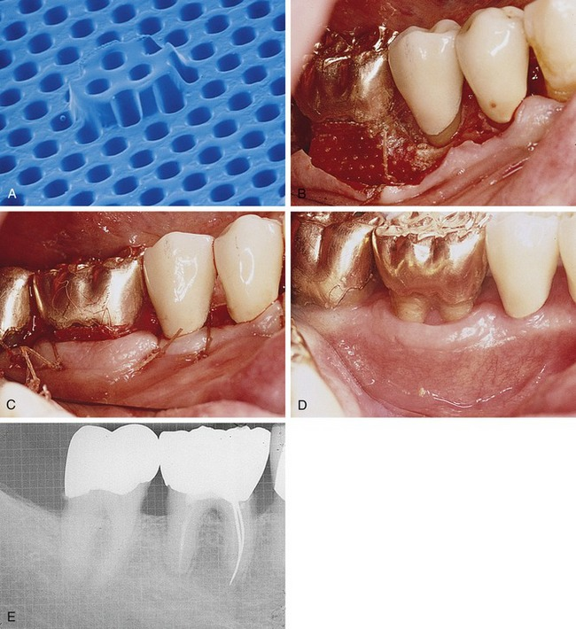
Figure 12-8. A, High-power view demonstrates Guidor (Sunstar Americas, Inc., Chicago, IL) polylactic acid material’s inner portion. Macroporosity and cleat maintains space. B, A case demonstrates a mandibular buccal furcation with a well-adapted Guidor membrane. C, Sutures in place are demonstrated. Minimal amount of coronal membrane is exposed. Six-week postoperative clinical view (D) and radiographic view (E) are demonstrated. Regenerated tissue is observed in furcation region.
Several studies have demonstrated the efficacy of polylactic acid membranes in the formation of new attachment and bone in the treatment of interproximal defects and gingival recession in primates, and in infrabony defects and Class II furcation defects in humans.³⁶⁻³⁹ The results obtained in these studies showed that the use of this matrix barrier around teeth resulted in reduced probing depths, a gain in clinical attachment, and a very low incidence of gingival pathological disease, gingival recession, and device exposure.³⁶
However, Magnusson et al. failed to demonstrate any advantage in the use of polylactic acid membranes in the treatment of circumferential periodontal defects in dogs, contradicting the results of their previous study using the same membranes in dogs.^{11,40} The reason for the difference in the results may be related to the type of defect: surgically created dehiscence defects on the buccal aspects of maxillary and mandibular premolars versus surgically created circumferential (one-wall vertical and horizontal) defects on maxillary premolars.^{11,40} A later study by Warrer et al. also failed to show adequate regeneration with the use of polylactic acid membranes (with a nonspecific design) in circumferential periodontal lesions in primates.⁴¹ The membrane failed to produce new attachment, and gingival recession and device exposure were common. In addition, an epithelial layer was found in these membranes. These results suggest that the membrane had exfoliated rather than reabsorbed into the tissue. However, the authors concluded that the material should not be considered inapplicable for use in membrane barrier techniques, stating that further modification and transformation were required to create a membrane that possesses all of the properties necessary to obtain better results. Subsequently, the manufacturer removed the membrane from the U.S. market.
Another clinical study in primates compared polylactic acid membranes with polylactic acid mesh barriers. The results demonstrated the superiority of the membranes in the production of new attachment and in biocompatibility compared with the mesh barriers, which showed downgrowth of the epithelium along or around the mesh, gingival recession, device exposure, and pronounced soft tissue inflammation.⁴² Another clinical study compared the effectiveness of bioresorbable polylactic acid membranes with ePTFE membranes in the treatment of Class II furcation defects in humans. This study showed that although there was a significant gain of clinical attachment with the use of both barriers, there was a significantly greater gain in clinical horizontal attachment and less gingival recession with the use of bioresorbable membranes. Postoperative complications such as swelling and pain occurred more frequently after the use of ePTFE barriers, usually during the first month of healing.⁴³
Roccuzzo et al. compared the reliability of resorbable polylactic acid barriers and nonresorbable ePTFE membranes for root coverage and clinical attachment gain in the treatment of human recession defects and reported no differences for any of the clinical variables assessed.³⁴ However, the advantages of the bioresorbable barrier included less discomfort, stress, and expense because of the single-step procedure. Gottlow et al. showed significantly more new attachment formation and less gingival inflammation and device exposure with the use of polylactic acid membranes when compared with ePTFE membranes.⁴⁴

Polyglycolic Acid and Polylactic Acid
Bioresorbable membranes made of polyglycolic acid and polylactic acid have been tested in experimental animals and proven to be safe, with a minimal inflammatory response and promotion of periodontal regeneration.¹⁶ These membranes consist of an occlusive film with a bonded, randomly oriented fiber matrix located on each surface. The film bonds the fibers and separates the soft tissue from the defect. The random arrangement of the fibers and the openness of the fibrous matrix encourage the ingrowth of connective tissue and inhibit apical migration of the epithelium. The fiber matrix is the primary structural component that provides adequate strength for space-making during the initial phases of healing (two to four weeks for periodontal defects) (Figure 12-9).¹³
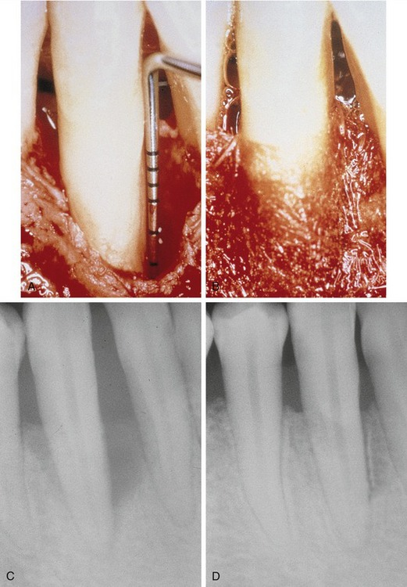
Figure 12-9. A, A deep and wide two- to three-wall periodontal defect after debridement and root preparation. B, Well-adapted Resolut (W.L. Gore and Associates, Inc.) polylactic-polyglycolic material in position shows excellent adaptive property over defect. C, Preoperative radiograph demonstrates a large osseous defect. D, A 6-month postoperative radiograph demonstrates an excellent osseous defect fill. Two- to three-wall periodontal defects that can support an absorbable or resorbable membrane will work well in these defects.
A clinical multicenter study was conducted by Becker et al. to evaluate the capacity of the combination of polyglycolic acid and polylactic acid membranes to promote clinical periodontal regeneration of Class II furcation defects and two- and three-wall infrabony defects.¹⁶ After 1 year, the results showed that the defects had healed with favorable changes in the measured clinical parameters (i.e., decrease in probing depths and horizontal probing for the furcations and a gain in attachment levels).
Vuddhakanok et al. studied the use of a biodegradable barrier made of polylactide : polyglycolide (50 : 50 DL-PLGA copolymer) in patients with severe horizontal bone loss and active periodontal disease.⁴⁵ Historically, this combination has been used for sutures and implant material and in a drug delivery system. Inflammatory tissue response after the implantation of copolymers was found to be minimal, and no adverse host tissue responses were observed. The results of this study showed that the barrier did not enhance connective tissue attachment or prevent epithelial migration. After placement, the material was clinically evident at 10 days to 2 weeks but not after 17 days, indicative of a very rapid resorption rate and inadequate barrier function for guided tissue regeneration.⁴⁵
A study by Simion et al. compared the use of resorbable membranes made of polyglycolic acid and polylactic acid with ePTFE membranes for membrane barrier procedures. This study showed a significantly greater amount of bone regeneration with the use of ePTFE membranes compared with the resorbable membranes.⁴⁶ According to the authors, this difference may be because of several factors: (1) the fixation screws may have acted as tent poles to prevent ePTFE membrane collapse, increasing the space for bone regeneration; (2) the stiffness of the resorbable material was not sufficient to maintain adequate space between the defect and the membrane; and (3) as the membrane resorbed, the space-making capability of the barrier decreased.

Synthetic Liquid Polymer (Atrisorb)
A polymer of lactic acid, poly(DL-lactide) (PLA), dissolved in N-methyl-2-pyrrolidone (NMP) as a plasticizer, has been studied as a resorbable barrier material. The material begins as a solution that sets to a firm consistency on contact with water or other aqueous solution.^{47,48} When outside the oral cavity, the membrane is a partially set solution, which allows it to be trimmed to the dimensions of the defect before intraoral placement. The barrier is then adapted to the defect and sets in a firm consistency in situ. Because of its semirigid property in the extraoral environment, this barrier has the advantage of being rigid enough for placement but flexible enough to be adapted to the defect. The barrier adheres directly to dental structures; therefore, sutures are not required.^{47,48} Chemically, the material is a polymer component that is resorbed through the process of hydrolysis. The rate of resorption is controlled and the membrane is present during the critical period of healing, preventing epithelial migration and isolating the periodontal defect compartment.⁴⁸ Alternatively, it can be used by placing graft material in the defect to ensure a tent-like position of the membrane, applying the liquid polymer directly to the surgical site, and then allowing contact with surrounding fluids, which initiates the set-up of the polymer to the firm consistency (Figure 12-10).
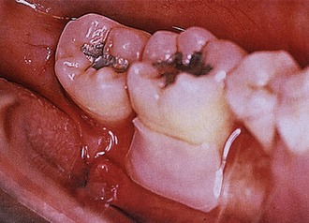
Figure 12-10. A well-adapted, well-trimmed customized Atrisorb membrane with minimally adhesive property of the membrane.
Several authors have studied the efficacy of this barrier. Early investigations by Poison et al. in dogs demonstrated that the material is safe, nontoxic, resorbable, and efficiently produces regeneration.⁴⁹ In addition, the animal model system allowed histological analysis 9 to 12 months after baseline surgery, which showed that formation of new cementum, periodontal ligament, and alveolar bone occurred after the placement of this membrane. Studies in humans also showed the efficacy of this material to produce periodontal regeneration in Class II furcation defects.⁴⁸ The results obtained in this study were confirmed in a later multicenter study by the same researchers.⁴⁷

Polyglactin
Another bioresorbable barrier that has been developed as a membrane barrier is a woven mesh barrier made of polyglactin 910, a copolymer of polyglycolic acid and polylactic acid in a 90 : 10 ratio with a resorption rate of 30 to 90 days (Figure 12-11). Several studies have questioned the use of polyglactin for GTR procedures, reporting that the mesh provides an insufficient barrier because of fragmentation of the material. The integrity of the mesh is lost after 14 days, and the cervical sealing between the mesh and the adjacent tooth may not be perfect, allowing for the growth of connective tissue and epithelium between the root surface and the barrier.^{35,50}
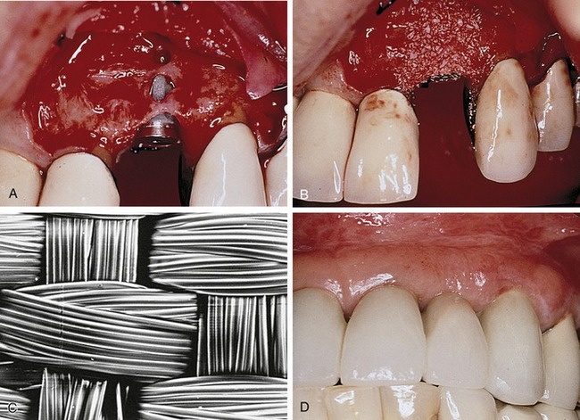
Figure 12-11. A, A single implant in tooth no. 10 position, depicting multiple buccal fenestration defects. B, The buccal contour is established with a mixture of autogenous bone chips and mineralized, freeze-dried bone allograft. C, A scanning electron microscopic view of Vicryl mesh (Ethicon, Inc., Somerville, NJ), a polylactic-polyglycolic material with exquisite woven pattern. D, The final case demonstrates excellent tissue response and contour.
A clinical and histological study in primates that compared the design of the mesh barrier with a matrix barrier concluded that the healing process differed considerably, both clinically and histologically. Histologically, complete integration with the surrounding tissue was found with the majority of matrix barriers, preventing epithelial downgrowth and pocket formation around the barrier. However, advanced epithelial downgrowth was found on the mesh barriers. Based on these findings, the author did not recommend the use of mesh barriers for membrane barrier procedures.³⁵ These results were similar to those of previous studies in which epithelial downgrowth, gingival recession, device exposure, and pronounced soft tissue inflammation were observed with the use of mesh barriers.⁴²

Calcium Sulfate
Medical-grade calcium sulfate, commonly known as plaster of Paris, has been used after immediate implant placement as part of a bone graft placed around the implants. Barriers composed of medical-grade calcium sulfate can be placed over bone grafts for clot stabilization and to exclude undesirable tissue (gingival connective tissue and epithelium). This material’s advantages include providing a source of calcium in the early mineralization process and aiding particle retention.⁵¹
A study by Maze et al. compared the bone regeneration capability of demineralized freeze-dried bone allograft (DFDBA) in the treatment of mandibular Class II furcation defects. The study compared the capability of DFDBA covered with an ePTFE membrane with DFDBA covered with calcium sulfate.⁵² They concluded that the results obtained with both barriers were comparable in selected defects. Anson and others showed successful results using medical-grade calcium sulfate and DFDBA for regeneration of periodontal defects.²³
Calcium sulfate has been shown to facilitate complete closure in situations where primary wound closure over the barrier membrane is not possible. An in vitro experiment comparing the ability of human gingival fibroblasts to migrate along a chemotactic gradient over three different forms of membrane barrier materials (e.g., ePTFE, polylactic acid, calcium sulfate) showed that the mean migration distance, as well as cell attachment and spreading, was significantly greater with the calcium sulfate barriers. Based on the results of this study, the authors concluded that calcium sulfate as a membrane appeared to offer greater potential than other membranes for healing by secondary intention in surgical sites where primary closure cannot be obtained.⁸
This material is available in sterile kits that contain exact amounts of medical-grade calcium sulfate powder and a prefilled syringe of liquid. When mixed together, these substances create a moldable plaster that can conform to the desired shape, even in the presence of blood. Sutures are not required because this mixture is adhesive. Calcium sulfate dissolves in approximately 30 days without an inflammatory reaction, and it does not attract bacteria or support infection (Figure 12-12).⁵¹
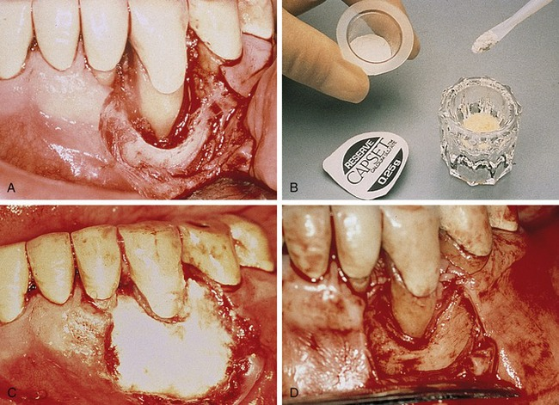
Figure 12-12. A, Tooth #27 with wide two-wall moat defect, depicting excellent root preparation and debridement of the defect. B, Mixing cups for calcium sulfate CAPSET (LifeCore Biomedical, Chaska, MN) material are demonstrated. C, Complete fill of defect and excellent hemostatic properties of calcium sulfate material are demonstrated. D, Six-month reentry shows an almost total fill of the defect, which can now be treated with a definitive osteoplasty.
The rationale for using medical-grade calcium sulfate for GTR procedures includes the following:
1. Complete resorption within 3 to 4 weeks
2. Biocompatibility (causes no increase in inflammation)
3. Adaptability (does not need to be cut before placement)
4. Porosity (allows fluid exchange, but excludes the passage of epithelium and connective tissue)
5. Minimal postoperative discomfort
6. Clot protection during the early stages of healing
7. Soft tissue growth over exposed calcium sulfate
8. Lack of infection with material exposure
9. Less effect on cellular morphology ^{23,53,54}

Acellular Dermal Allografts
A relatively new type of bioresorbable grafting material is acellular human dermis. The harvested material is chemically treated to achieve de-epithelialization and decellularization, leaving an acellular connective tissue collagen matrix.⁵⁵ Dermal allografts have been successfully used for the treatment of third-degree burns and are being used as a membrane barrier for treatment of mucogingival defects, for enhancement of keratinzed gingiva, and as a biological bandage after osseous resection.⁵⁶
In a study by Shulman, the material appeared to become completely and permanently incorporated into the surrounding tissue after 6 weeks when used as a membrane barrier.⁵⁷ With the use of dermal allografts, clinically normal healing and no inflammatory infiltrate have been observed, indicating that this material is compatible with human oral tissue (Figure 12-13).⁵⁸
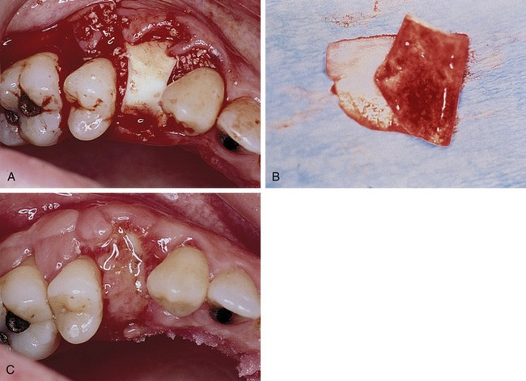
Figure 12-13. A, Horizontal fractured tooth #12 after traumatic removal, socket debridement, and filling with Bio-Oss (Osteohealth, Shirley, NY). A well-trimmed acellular dermal graft (Alloderm [Life Cell Corp., Branchburg, NJ]) is placed over the Osteograf-N (Dentsply Friadent, Mannheim, Germany). Excellent placement of the material is under the buccal and palatal tissues. B, Example of Alloderm material folded on itself shows red and white sides. Red side is placed toward the bone. C, Ten-day postoperative suture removal appointment depicts excellent plumping of ridge in buccolingual dimensions. This site will be ideal for single-tooth implant 4 months later.
The materials used for membrane barriers must have certain properties such as freedom from memory, ease of placement and adaptability, biocompatibility, and the ability to be covered by soft tissue and remain covered. If the material is bioresorbable, the bioresorbability must be predictable and the material must remain intact as a barrier for 6 weeks in most cases and longer for more challenging defects.¹⁵ Acellular dermal allografts have these desirable properties.
Acellular dermal allografts have several advantages over autografts because they do not contain cellular material, which eliminates the possibility of rejection because of the presence of major histocompatibility complex Class I and II antigens and yet does not require a second surgical site for harvesting of donor tissue.⁵⁷

Oxidized Cellulose Mesh
Galgut conducted a study to evaluate the use of oxidized cellulose mesh as a biodegradable membrane for GTR in furcation and infrabony defects.⁵⁹ Early studies showed that this material resorbs without deleterious effects on the healing process and has antibacterial properties.⁶⁰ The oxidized material is a resorbable hemostatic dressing that converts to a gelatinous mass and incorporates the blood clot to form a membrane. Most of the mesh resorbed at 1 week postoperatively. The defects in this case demonstrated normal healing, with crevicular depths of 2 mm in most sites and no evidence of bleeding with gentle probing. However, the author concluded that one case report is not sufficient to make conclusions regarding the efficacy and advantages of oxidized cellular mesh for the purposes of a membrane barrier.⁵⁹

Microbiology Associated With Barrier Membranes
Failure of membrane barrier procedures may be caused by infectious bacteria and related complications.⁶¹ Many of the bacterial cells that have been found on membranes have been linked to a gain in probing attachment.⁶² The successful regenerative results obtained in animal studies using membranes may be partly explained by the experimental procedure, which involved coronal repositioning of the flaps or complete submersion of the teeth. However, in clinical use, according to the literature, the barrier may become partially exposed during the early stages of healing approximately 30% of the time, leading to contamination by oral microorganisms. Therefore the materials used may be a pathway for infection, jeopardizing the regenerative process.⁶¹ In addition, a study presented by Yumet and Poison documented accelerated epithelial invagination into periodontal incisional wounds at plaque-infected sites.⁶³
Clinical and microbiological studies of early (1 week) exposure of titanium-reinforced ePTFE membranes in primates determined that the sequelae of membrane exposure included redness, edema, and tissue slough. Bacteroides fragilis, Streptococcus pneumoniae, Prevotella intermedia, and Staphylococcus intermedius microorganisms were found at all sites with prematurely exposed membranes. The results of this study emphasized the importance of studying microbiota because of their potential implications in the regeneration process.⁶⁴
Note that this study did not evaluate the effects of exposure of high-density PTFE membranes, however. The deleterious effects of exposure and subsequent bacterial colonization of ePTFE is due to the ability of bacteria to migrate into and invade the interstices of the expanded PTFE. This migration and internal colonization by bacteria is impossible with high-density PTFE due to the much smaller pore size.
Porphyromonas gingivalis is a common microorganism found in patients with periodontal disease, especially the rapidly progressive type of disease. In addition, the combination of P. gingivalis and Streptococcus mutans has been found to have the strongest adherence affinity to the membranes used for periodontal regeneration.⁶⁵
An in vitro study by Ricci et al. evaluated the ability of P. gingivalis to colonize and adhere to six different membranes (resorbable and nonresorbable).⁶⁶ The results showed that P. gingivalis cells passed through all six membranes analyzed at 48 hours. Polylactic acid and polyglycolic acid barriers and lactide copolymer membranes showed the lowest adherence of the microorganism, whereas Vicryl fibers were heavily colonized by cell aggregates. In another study, Wang et al. reported that the collagenase activity of P. gingivalis degraded the collagen membrane completely within 4 to 5 days.⁶⁵ Ricci et al. pointed out that essential factors such as the host defense mechanisms and bacterial competition were completely excluded from the study because an in vitro study cannot represent the complex system of the oral cavity (Figure 12-14).⁶⁶
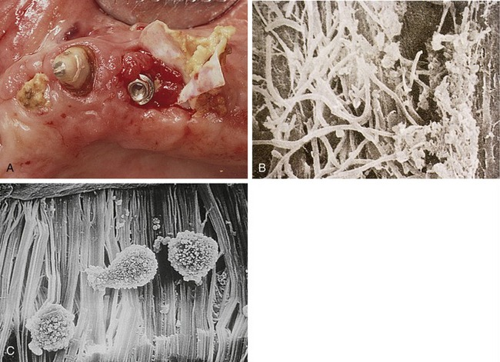
Figure 12-14. A, Premature exposure of Gore-Tex augmentation material depicts accumulation of bacteria on membrane. The robust regenerated tissue below the membrane is also observed. This membrane was removed and analyzed. B, Scanning electron microscopic view of exposed Gore-Tex augmentation material depicts significant bacterial colonies, including motile rods, filamentous forms, and other associated pathogenic flora. C, Scanning electron microscopic view of an in vitro study shows colonization potential of Gore-Tex material.

Membrane Selection
Considering all the different factors associated with the variety of membranes available, clinicians must choose which type of barrier is appropriate for each patient and each defect.¹⁶ There are clinical situations in which the use of nonresorbable barriers is less desirable, such as repair of sinus membrane tears. On the other hand, in situations in which membrane exposure is possible or primary closure is not predictably achievable, such as when covering a recent extraction site, resorbable membranes may be less desirable.¹⁷ The clinician must have a fundamental understanding of the different biomaterials available and use them selectively, based on the therapeutic goals and the clinical conditions associated with a particular case.

Guided Tissue Regeneration Membranes in the Prevention of Postextraction Bone Loss
For many years it has been widely appreciated that there is a progressive and irreversible loss of alveolar bone and soft tissue after tooth extraction.⁶⁷⁻⁷¹ Techniques for preservation of the alveolar ridge have been introduced over the past 30 years, most of which involve the use of particulate grafting materials with and without the use of guided tissue regeneration membranes.^{17,72-84} The efficacy of socket grafting in terms of preserving bone and soft tissue volume has been well documented in several clinical studies using standardized measurement techniques.^{73,75-78,80,81} However, the routine grafting of extraction sites, whether in conjunction with the placement of dental implants or for the preservation of the alveolar ridge, remains controversial.⁸⁶⁻⁸⁸ Consensus on the ideal graft material, the ideal membrane type, and the best method with which to accomplish the procedure remains elusive. This section describes the clinical impact of postextraction bone loss, evaluates the available techniques and evidence on preventing bone loss, and then develops an evidence-based rationale for the application of guided bone regeneration principles to enhance extraction site healing and ridge preservation.
The socket repair process following tooth extraction progresses quickly and usually without complications. Bone formation originates in the apical and lateral aspects of the socket, progressing toward the center and the coronal aspect of the socket. Within 6 weeks the apical two thirds of the socket is filled with new, mineralized bone.^{67,68} In the coronal one third of the socket repair tends to occur by direct migration of cells derived from the gingival soft tissues, preventing bone formation in this critical zone. Over the next several days and weeks resorption of the alveolar crest and cortical plate—now coronal to the bone level in the socket—tends to occur, resulting in net vertical loss in ridge height. A concomitant loss in width occurs due to resorption of the thin buccal plate as a result of surgical microtrauma and a reduction in blood supply. In the anterior maxilla, this pattern of repair and subsequent physiologic modeling of the alveolus may result in a loss of as much as 40% in height and 60% in alveolar width during the first 6 months,⁷⁷ with the majority of the horizontal width loss occurring at the expense of the buccal plate.⁶⁹
The consequences of postextraction bone loss have been described in several studies using measurements taken at the time of extraction, at the time of implant placement, and at the time of second-stage implant surgery. Covani et al. evaluating bone healing in extraction sites with immediately placed implants, concluded that the gap between the implant and the buccal wall would spontaneously fill with bone with no graft material or membrane if it was less than 2 mm in width. However, they reported a mean net reduction in ridge width of 3.7 mm, or 56% of the buccal-lingual width.⁸⁷ In a related study, the same group compared healing in immediately placed implants compared to delayed placement. The mean ridge width at the time of extraction was 10 mm, whereas the mean ridge width found in the delayed group (as measured 6 to 8 weeks postextraction) was 8.86 mm. At the time of second-stage surgery, the mean ridge width in the immediately placed group was 8.1 mm and in the delayed group was 5.8 mm, indicating a net loss of 1.9 mm and 4.2 mm respectively. They concluded that ridge resorption began immediately after tooth extraction and continued, nonuniformly, even after delayed implant placement.⁸⁸
Further evidence of clinically significant postextraction bone loss has been documented by Schropp et al. In a 12-month prospective study of single-tooth extraction sites, they reported a mean reduction in alveolar width of 6.1 mm with two thirds occurring in the first 3 months.⁸⁹ Botticelli et al. reporting on the healing of extraction sites with immediately placed implants, reported a reduction in buccal ridge width of 56% and a reduction in lingual ridge with of 30% in 4 months.⁹⁰
Closure type can have a profound effect on the outcome of ridge preservation procedures, particularly with regard to premature graft exposure and prevention of graft particle loss. Various techniques for closure, with or without the use of guided bone regeneration membranes, have been reported over the years and there is evidence that the use of membranes does result in improved results.
Nemcovsky et al.⁷³ performed a ridge preservation study using dense hydroxyapatite granules placed into fresh extraction sites. The granules were covered with a split-thickness connective tissue flap harvested from the palate and advanced to cover the graft material and socket. The missing teeth were replaced with a fixed prosthesis. Ridge dimensions were observed and recorded over 12 to 24 months using the base of the pontics as a fixed reference point. A mean horizontal tissue loss of 0.6 mm was observed and a mean vertical loss of 1.4 mm was reported, indicating the potential efficacy of the procedure as long as primary closure was maintained to prevent particle loss. Their results, which overall were positive, were complicated by particle exfoliation that occurred in 14 of 23 cases (61%) due to loss of the soft tissue flap covering the socket.
In a more recent study, Nevins et al. evaluated the effect of augmenting sockets at the time of extraction with anorganic bovine bone compared with untreated controls.⁸³ A split-thickness facial flap was developed on the facial aspect to help preserve the buccal plate. Following placement of the graft material, primary closure was achieved over the sockets. CT scans were taken immediately postoperatively and from 60 to 90 days postoperatively. Using the nasal floor as a fixed point of reference, they compared the preoperative and postoperative change in ridge height at a standardized ridge width of 6.0 mm, considered sufficient for placement of standard diameter dental implants. There was significantly less bone resorption seen in the sites grafted with anorganic bovine bone, with a mean loss of 2.42 mm in height compared to 5.24 mm in controls, representing a net loss of nearly 30% in ridge height. Total loss of the buccal plate was seen on CT as early as 6 weeks post-extraction. No membrane was used in this study; rather a split-thickness flap and primary closure was used to contain the graft material.
Clinical studies have shown that the principles of membrane-guided bone regeneration can be applied to extraction sites, resulting in more complete bony healing and a reduction in early bone loss. In a clinical study designed to evaluate the effect of GTR membranes on healing extraction sites, Lekovic et al., reported significantly less bone resorption in sockets covered with membranes, even without placement of graft materials into the socket.⁷⁵ In this controlled, prospective pilot study, two teeth were extracted on the same patient in the same dental arch. Immediately following extraction, one socket was covered with an ePTFE membrane and primary closure while the other was treated with flap advancement and primary closure. The sites were evaluated 6 months later using measurements taken from study models as well as direct bone measurements made during reentry surgery. The experimental sites averaged 0.5 mm in vertical bone loss compared to 1.2 mm in controls as determined by direct bone measurement. In the horizontal dimension, experimental sockets averaged 1.8 mm in bone loss compared to 4.4 mm in controls. Measurements were made to evaluate internal bone fill. The experimental sockets averaged a reduction in depth of 4.9 mm versus 3 mm in controls, indicating more vigorous osseous regeneration under the membrane. The authors concluded that the larger dimensional changes observed in the control group were statistically significant and that the technique offered a predictable method of ridge preservation. However, a relatively high (30%) incidence of premature exposure of the ePTFE membranes occurred in this study. In these sites, even in the absence of infection, clinical bone measurements were similar to controls. With regard to future use of the procedure, the authors suggest the development of membranes with specific properties designed for use in extraction sites.
In a second clinical study Lekovic et al. evaluated the effect of resorbable membranes (polylactide-co-gylcolide) on healing extraction sites.⁷⁷ In this blinded, prospective, randomized, controlled clinical trial, two teeth were extracted in the same dental arch. The sockets were treated with either a resorbable membrane and primary closure or primary closure alone. Titanium pins were placed at the time of extraction to serve as fixed reference points and measurements were taken immediately post extraction. Six months after the initial surgery, reentry surgical procedures were performed. Internal socket fill and external horizontal and external vertical bone measurements were all repeated and compared to the immediate postextraction values. Experimental sites averaged 0.38 mm of vertical bone loss compared to 1.5 mm in controls. In the horizontal dimension, experimental sites averaged 1.31 mm of bone loss compared to 4.56 in controls. With regard to internal bone fill, the experimental sites averaged a reduction in depth of 5.81 mm versus 3.94 in controls. The authors noted that the mean postoperative ridge width of 6.06 mm for experimental sites compared to 2.94 mm for controls was especially significant with regard to future implant placement. The authors suggest that the reduction in bone loss is likely a result of the ability of the membrane to stabilize the blood clot as well as prevent migration of epithelial and gingival connective tissue cells into the defect area.
As an alternative to using a guided tissue regeneration membrane, a technique for augmenting extraction sites using calcium sulfate as a barrier has been proposed. Camargo et al., performed a prospective clinical trial using bioactive glass particles placed into extraction sites and covered with a layer of calcium sulfate.⁷⁹ No attempt was made to achieve primary closure. Titanium pins were placed to serve as fixed reference points and surgical reentry was done at 6 months. Clinical measurements indicated less, although not statistically significant, resorption of alveolar bone height, indicating 0.38 ± 3.18 mm for experimental sites compared to 1 ± 2.25 mm for controls. In the horizontal plane, experimental sites averaged a similar degree of resorption compared with controls, averaging 3.48 ± 2.68 mm compared to 3.06 ± 2.41 mm for controls. There was a statistical improvement in internal socket fill with an average decrease in defect depth of 6.43 mm versus 4 mm in controls. The authors conclude by stating that the combination of bioactive glass and calcium sulfate is of “some benefit” in preserving alveolar ridge dimensions after tooth extraction. This study is interesting because it lends itself to comparison with previous studies by the same authors. Noteworthy is the amount of bone loss in the horizontal dimension in this study where a membrane was not used compared to previous studies with membranes.
In a clinical study of extraction sites grafted with mineralized bone allograft and covered with collagen membranes, Iasella et al. compared grafted and nongrafted sites at 4 and 6 months.⁸¹ Dimensional changes after extraction, implant success rates, bone quality as determined by histologic examination, and gingival thickness were measured. Clinical measurements were taken at the time of extraction and then at implant placement. In the experimental sites, an increase in vertical height, as opposed to bone loss, was achieved. The average vertical gain was 1.3 ± 2 mm versus an average loss of 0.9 ± 1.6 mm in controls. In the horizontal dimension, the experimental sites had an average loss of 1.2 mm compared to 2.7 mm in control sites. Histological analysis of bone cores revealed a slightly higher bone density in experimental sites compared with controls (65% versus 54%), although this included vital and nonvital allograft bone in the grafted sites. The authors concluded that the most predictable maintenance of ridge width, height, and position was achieved when a ridge preservation procedure was employed. The presence of residual, nonvital allograft demonstrates the importance of using a rapidly resorbable graft material for implant site development. As a result, clinicians should be aware of the potential for dense, slowly degrading materials to interfere with vital bone formation.
Collagen wound dressing has been advocated as a resorbable barrier in socket grafting procedures (Figure 12-15). In a randomized controlled trial, Neiva⁸⁵ et al. compared the results of grafting sockets with anorganic bovine bone putty covered by a collagen wound dressing with the results of sockets covered by a collagen wound dressing alone. At 4 months, direct measurements were made during implant surgery. An occlusal stent was used as a fixed reference point. The control group had a mean reduction in ridge height of −0.56 ±1.04 mm whereas the experimental sockets had −0.15 ±1.76 mm. In terms of width, the control group had a reduction of −1.43 ± 1.05 mm and the experimental sockets had −1.31 ± 0.96 mm of width loss. Histomorphometric analysis revealed similar amounts of vital bone and increased trabecular density in the grafted sites. This study is interesting in that the technique used for measuring width, using the widest part of the ridge, tended to underestimate actual bone loss. Although the grafted sites all received implants without additional bone grafting, grafting was required in 33% of control sites, and in one site the bone density was inadequate for achieving primary stability of the implant.
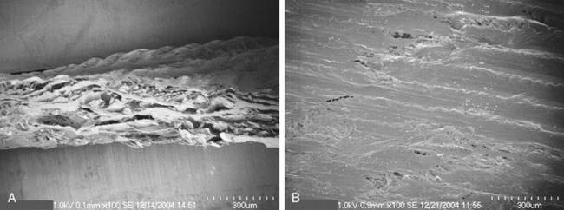
Figure 12-15. A and B, Scanning electron microscopic views of Cytoplast RTM collagen guided tissue regeneration membrane. Note the multilayered structure, forming an effective barrier to the migration of epithelium and gingival connective tissue cells.
(A, From Fonseca RJ: Oral and maxillofacial surgery, ed 2, vol 1, St Louis, 2009, Saunders.)

A Rationale and Technique for Ridge Preservation Using dPTFE Membrane
A technique developed by one of the authors that uses high-density PTFE (dPTFE) as a membrane for extraction site grafting can be used for either immediate implant placement into extraction sites or ridge preservation following tooth extraction (Figures 12-16 and 12-17). The procedure is designed to provide the implant surgeon with the predictability and control of a nonresorbable membrane combined with the simplicity and ease of use typical of a resorbable membrane. Further, the submicron porosity (<2.0 µm) of dPTFE allows the clinician flexibility with regard to achieving primary closure. Historically, achieving and maintaining primary closure over GTR membranes has been a major problem associated with immediate grafting of extraction sites. Even when primary closure is achieved, subsequent membrane exposure occurs approximately one third of the time.^{79,81} Depending on the timing and extent of the exposure, the outcome may or may not be affected; however, complications such as infection, particle loss, and even overt graft failure are frequently reported. To avoid the perceived complications associated with the use of an occlusive membrane, alternative techniques have been suggested that use a rapidly resorbing material such as Gelfoam, a collagen sponge, or calcium sulfate as a temporary barrier over the graft material instead of using an occlusive membrane.^{72,78} Although clinical success may be achieved using these techniques in single, relatively intact sockets, the use of a membrane is required for more demanding cases such as those with a buccal plate defect.⁹¹
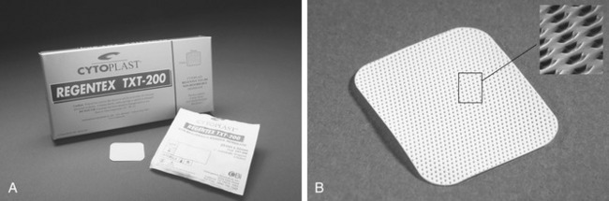
Figure 12-16. A, Cytoplast TXT 200 high-density PTFE GTR membrane was designed specifically for extraction site grafting and ridge preservation procedures where exposure to the oral cavity is common. B, The microtextured surface increases the surface area for improved soft tissue attachment compared to smooth PTFE, yet is resistant to bacterial invasion due to the nanoscale level porosity. The result of this unique approach to membrane design is that the membrane can be left exposed in the oral cavity without complications.
(B, From Fonseca RJ: Oral and maxillofacial surgery, ed 2, vol 1, St Louis, 2009, Saunders.)
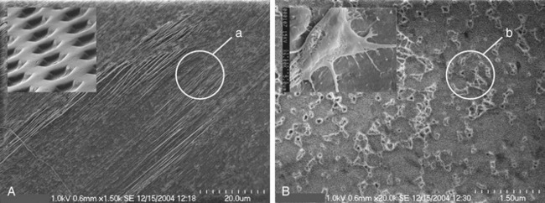
Figure 12-17. A and B, Scanning electron microscopic views of Cytoplast TXT 200 textured high-density polytetrafluoroethylene membrane. The hex-shaped dimples increase the surface area available for soft tissue attachment (inset SEM at 100×). Although the membrane grossly appears to be nonporous, the ultrastructural surface features are quite interesting. Parallel grooves and fibrils, 1 to 3 microns in diameter (a), are important in cell attachment and migration (SEM 1500×). At high power, nanoscale pores (b) can be visualized (SEM 20000×). Pores smaller than 2 microns prevent the migration of bacteria and undesirable cells into the membrane, yet allow diffusion of small organic molecules and oxygen, and are important in facilitating cellular adhesion and spreading (inset SEM at 6000×).
(Insets from Fonseca RJ: Oral and maxillofacial surgery, ed 2, vol 1, St Louis, 2009, Saunders.)
In contrast, the use of an occlusive nonresorbable membrane, over even an intact socket, ensures predictable exclusion of soft tissue from the healing extraction site. If an associated bone defect is encountered, the margins of the membrane may be easily extended beyond the margins of the defect while simultaneously providing coverage for the socket. Because primary closure is not required, rather than a loss of keratinized tissue width there is the potential for increasing the zone of keratinized tissue.⁸⁴ Finally, due to the submicron porosity of nonresorbable membranes, tissue ingrowth into the membrane does not occur. This feature facilitates simple, nonsurgical removal of the barrier at a time determined by the surgeon.
The procedure is indicated following the extraction of single or multiple adjacent teeth and is equally effective in the aesthetic zone or the posterior quadrants. The procedure is contraindicated in the presence of symptomatic, active infection characterized by erythema, purulence, or pain.

Open Socket Regeneration Technique
Minimally invasive and atraumatic techniques should be used to reduce trauma and resultant postextraction resorption (Figures 12-18 and 12-19). Minimal flap reflection is recommended to preserve blood supply to the thin buccal plate and interdental papilla, but reflection should be adequate for stabilization of the GTR membrane, generally 3-4 mm beyond the socket or defect margins. To minimize microtrauma to thin cortical bone, the use of periotomes and careful surgical sectioning of teeth is suggested, with gentle application of luxation and extraction force (see Figure 12-18, A). Following tooth removal, all soft tissue within the socket and remnants of the periodontal ligament should be removed with sharp curettage (see Figure 12-18, B). Special care should be taken to remove residual soft tissues at the apical extent of the socket of endodontically treated teeth. The apex and walls of the socket should be carefully explored to eliminate the possibility of residual soft tissue, which may harbor pathogenic bacteria. There should be adequate bleeding noted from the socket walls. If not, decortication of the socket wall with a #2 round surgical bur should be done to ensure a source of mesenchymal cells and provide for more rapid revascularization of the site.
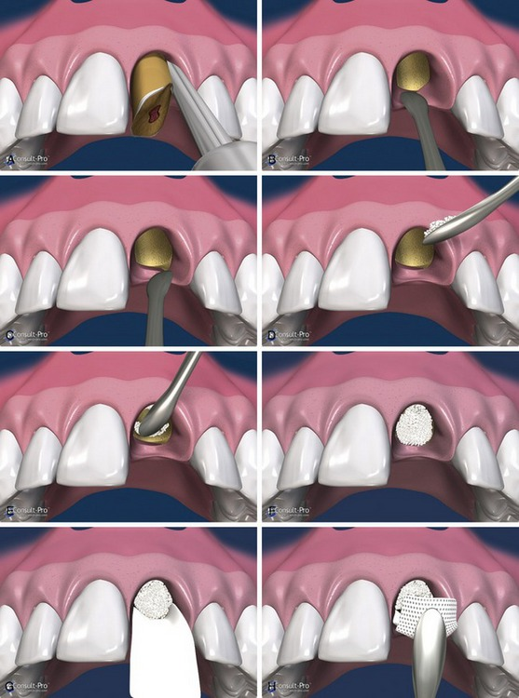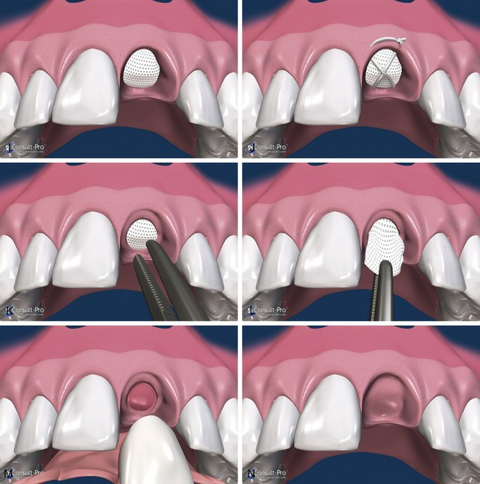
Figure 12-18. The Cytoplast ridge preservation technique. A, The use of periotomes or surgical sectioning to minimize mechanical trauma to the thin cortical bone. B, Removal of all soft tissue remnants using sharp curettage. C, A subperiosteal pocket created with a small periosteal elevator or curette. D to F, Particulate augmentation material placed into the socket with a syringe or curette. The material should be evenly distributed throughout the socket, not condensed or packed too tightly. G and H, The dPTFE membrane trimmed to extend 3-4 mm beyond the socket walls and then tucked subperiosteally under the palatal flap, the facial flap, and underneath the interdental papilla with a curette. The membrane should rest on bone 360 degrees around the socket margins, if possible. Note that minimal flap reflection is necessary to stabilize the membrane.I, Prior to suturing, ensure that there are no folds or wrinkles in the membrane and that it lies passively over the socket. J, The membrane is further stabilized with a crisscross Cytoplast dPTFE suture. K and L, Topical anesthetic is applied, the membrane is grasped with a tissue forceps and removed with a gentle tug. M, A dense, highly vascular, osteoid matrix is observed filling the socket immediately following membrane removal. N, The extraction site at 6 weeks. Thick, keratinized gingival tissue is beginning to form over the grafted socket.
(Courtesy Consult-PRO, Toronto, Canada 416-429-6545, www.consult-pro.com.)
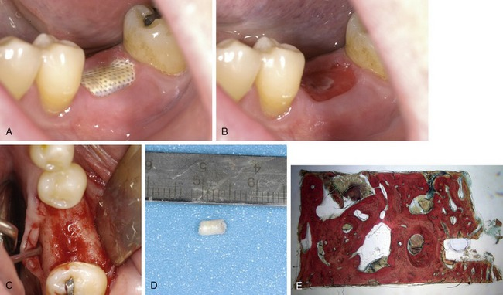
Figure 12-19. Open regeneration (described by author Barry Bartee more than 15 years ago). A, High-density PTFE (Cytoplast TXT200) exposed in the oral cavity. It is impervious to bacteria. Plaque can be seen adhered to the membrane. B, Removal of the membrane 3 weeks after extraction and grafting of the socket with beta-tricalcium phosphate granules (Cerasorb M 500-1000 µm, Curasan Inc., Research Triangle Park, NC). A well-consolidated, well-vascularized connective tissue matrix is visible within the socket, with no loose graft particles visible. C, After 6 months of healing the ridge (as seen at the time of implant surgery) exhibited minimal resorption and very high density with no infiltrating soft tissue. D, A bone core harvested at the time of implant placement. It was sent for histological examination. E, The histomorphometric analysis revealed 65% new vital bone in the core, and a complete absence of residual graft material.
(Histology by Michael Rohrer, DDS, MS, University of Minn, Hard Tissue Research Laboratory.)
A subperiosteal pocket can be created with a small periosteal elevator or curette, extending 3-4 mm beyond the socket margins (or defect margins) on the palatal and facial aspects of the socket. In the aesthetic zone, rather than incising and elevating the interdental papilla, it is left intact and undermined in a similar fashion. The dPTFE membrane will be tucked into this subperiosteal pocket (see Figure 12-18, C). Following preparation of the socket, the appropriate particulate graft material is placed into the socket with a small curette, taking care to evenly distribute the material throughout the socket and any associated defects. However, care should be taken to avoid overpacking the graft particles because this can impede the early ingrowth of blood vessels, which are essential for bone formation (see Figure 12-18, D-F).
The dense PTFE membrane is then carefully trimmed to fit over the site, extending 3-4 mm beyond the margins of the socket and any associated bone defects (see Figure 12-18, G and H). The corners of the membrane should be gently rounded and smooth. The membrane also should be trimmed to provide a minimum of 1 mm of space between the membrane and any adjacent tooth roots. This will allow for rapid reattachment of the interdental papilla and result in the most predictable and aesthetic soft tissue healing.
When properly placed, the membrane should lie passively across the socket and under the adjacent flaps (see Figure 12-18, I). The membrane surface should be smooth, with no wrinkles or folds, which can allow bacterial migration under the flaps. If necessary, the membrane may be stretched slightly over the fingertips or curved over an instrument handle to help achieve a passive fit. Remove any stray bone graft particles that may be present between the membrane and the flap. To prevent bacterial leakage under the membrane, take care to avoid puncturing the membrane. If two pieces of membrane are being used, as in the case of multiple adjacent extraction sites, care should be taken to avoid overlapping segments, particularly in an area where they might become exposed to the oral cavity. Such an overlap will provide ready access for bacterial migration underneath the membrane. In this case, either a larger membrane should be used or two membranes should be placed independently with complete soft tissue coverage between their exposed edges. Immediately prior to final membrane placement, the surgical site should be carefully irrigated with sterile saline with special attention paid to removal of stray graft particles, which may result in infection or provide a conduit for oral bacteria to infiltrate the graft if they are left between the flap and membrane.
Monofilament PTFE suture is recommended for closure. Good, tension-free adaptation of the flap to the membrane and elimination of dead space are required. Care should be taken to avoid puncturing the membrane during suturing maneuvers in any area that is exposed to the oral cavity. A crisscross suture technique (see Figure 12-18, J) may be used in single sockets, or alternatively, two interdental interrupted sutures can be placed across the interdental papilla combined with a horizontal mattress suture placed across the midportion of the socket. Following closure, the surgical site should be carefully examined to ensure adequate blood supply to the flap margins. The temporary prosthesis, if present, should be carefully trimmed to avoid placing any pressure on the surgical site. With this technique an ovate pontic form may be used, but it is not necessary or desirable for the pontic to touch or put pressure on the surgical site. The PTFE sutures, which cause minimal inflammatory response, are left in place for 10 to 14 days.
Postoperatively, the patient is seen in 1 week for observation and confirmation of good oral hygiene. The patient is instructed on local application of chlorhexidine rinse to the exposed membrane as well as gentle cleaning of the exposed membrane surface with a Q-tip. Suture removal is done at 2 weeks, and the membrane is again inspected to ensure complication-free healing. Gentle pressure applied to the exposed membrane with an instrument should reveal a solid, noncompressible and nontender graft site.
The membrane is removed, nonsurgically, in 21 to 42 days. With intact sockets, the membrane may be removed as early as 3 weeks. Socket healing studies have shown that by 21 to 28 days there is a dense, vascular connective tissue matrix in the socket and early osteogenesis is observed in the apical two thirds of the socket. Larger defects, or those missing adjacent walls may require additional time before membrane removal, but in no case is it necessary to leave the membrane in place longer than 6-8 weeks. For removal, topical anesthetic may be applied, and then the membrane is simply removed by grasping the exposed surface with a cotton forceps and gently removing it from the tissue bed (see Figure 12-18, K and L). A glistening, well-vascularized, well-consolidated graft should be observed at that time (see Figure 12-18, M). If loose graft particles are observed, they are simply removed with sterile irrigation. Adjacent gingival epithelium migrates across the osteoid matrix on removal of the membrane. A temporary partial denture may be placed; an ovate pontic form is ideal. It is not necessary or desirable to place vertical pressure on the graft with the pontic. The patient is instructed to keep the surgical site clean and free of debris, and initial re-epithelialization of the underlying tissue will occur in 7-10 days. At 6 weeks thick, keratinized gingival has begun to form over the grafted socket. The natural soft tissue architecture and interdental papilla have been preserved. New bone has filled the socket and is beginning to mineralize and mature into lamellar bone (see Figure 12-18, N).

Advantages
The use of high-density PTFE provides several advantages compared to other available techniques for socket grafting. Because primary closure is not required, the surgical procedure can be done without vertical incisions and complete flap elevation. The thickness and width of keratinized gingiva can actually be increased with the technique, as opposed to the disruption of gingival architecture that occurs with primary closure. Compared to the use of resorbable membranes, which may prematurely degrade when exposed, this technique affords the surgeon predictable control of the regeneration of bone within the socket and a reliable method of ensuring coverage, protection, and retention of particulate graft materials. Finally, the technique may be performed efficiently and inexpensively in a variety of clinical applications, including more advanced techniques such as placement of dental implants into extraction sites.

Case Reports

Case Report 1: Minimally Invasive Socket Reconstruction
A flapless and minimally invasive approach to socket reconstruction, facilitated by the unique characteristics of titanium-reinforced dense PTFE membrane, has been developed by one of the authors (Barry Bartee).
A 50-year-old female patient presented with a severe buccal wall defect secondary to a vertical root fracture (Figure 12-20, A). A chronic fistula was present, but was not actively draining at the time of surgery (Figure 12-20, B). The tooth was removed using an intrasulcular incision without reflecting the interdental papillae (Figure 12-20, C). Upon curettage and exploration of the socket, the entire buccal wall was found to be missing. Granulation tissue, which was adherent to the facial flap, was removed with sharp dissection (Figure 12-20, D) and the socket was irrigated with sterile saline.
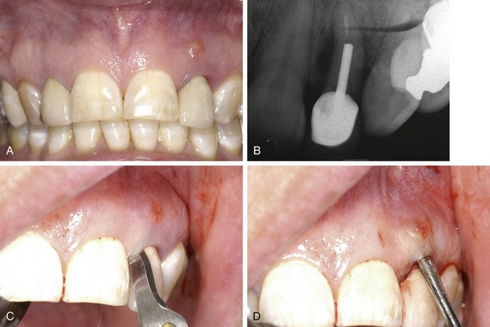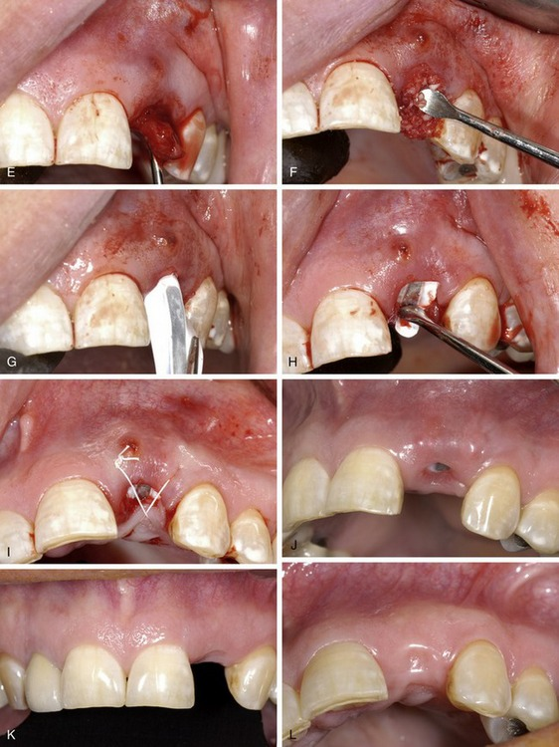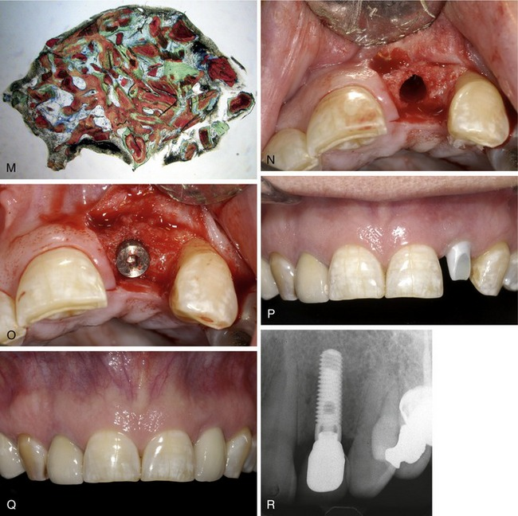
Figure 12-20. A, Clinical photo showing severe buccal wall defect secondary to a vertical root fracture. B, X-ray showing a chronic fistula that was not actively draining at the time of surgery. C, Removal of the tooth using an intrasulcular incision without reflecting the interdental papillae. D, Granulation tissue adherent to the facial flap removed with sharp dissection. E, Subperiosteal pocket developed on the facial and palatal aspect of the socket, extending 3 mm beyond the defect margins. F, Mineralized and demineralized allograft (mixed with approximately 25 mg of clindamycin) placed into the socket. A Cytoplast titanium-reinforced dPTFE membrane introduced first into the facial pocket (G) and then under the palatal flap (H). I, Adaptation of the flap to the membrane surface using a single Cytoplast 5-0 PTFE suture. J, After 3 weeks of healing, soft tissue around the exposed membrane exhibits no inflammation. K and L, Adequate ridge width for placement of a dental implant and maintenance of the soft tissue architecture after 6 months of healing. M, Biopsy taken at the time of implant placement revealed the presence of 80% vital bone. (Histology by Michael Rohrer, DDS, MS, University of Minnesota, Hard Tissue Research Laboratory.) N, Complete regeneration of the socket and facial bone contour evident at the time of implant placement (6 months following the grafting procedure). The implant exposed (O) at four months, restored with a zirconium abutment (P) and all-ceramic restoration (Q). R, Posttreatment radiograph showing bone total regeneration of the socket defect and maintenance of the interproximal height of bone.
(From Fonseca RJ: Oral and maxillofacial surgery, ed 2, vol 1, St Louis, 2009, Saunders.)
Next, a subperiosteal pocket was developed on the facial and palatal aspect of the socket, extending 3 mm beyond the defect margins (Figure 12-20, E). A combination (50 : 50 ratio) of mineralized and demineralized allograft was mixed with approximately 25 mg of clindamycin and placed into the socket (Figure 12-20, F). A Cytoplast titanium-reinforced dPTFE membrane in single-tooth configuration was shaped to completely cover the facial defect and coronal aspect of the socket, overlapping the defect margins by 3 mm. The membrane was introduced into the facial pocket first (Figure 12-20, G), then under the palatal flap (Figure 12-20, H), and finally, tucked under the interdental papillae, taking care to keep the margins of the membrane at least 1 mm from the roots of the adjacent teeth. The single titanium strut facilitates precise placement and stabilization of the device. Adaptation of the flap to the membrane surface was achieved with a single Cytoplast 5-0 PTFE suture (Figure 12-20, I).
Note that primary closure was not attempted in an effort to preserve the soft tissue architecture of the site. After 3 weeks of healing the soft tissue around the exposed membrane exhibited no inflammation (Figure 12-20, J). After 4 weeks of healing the membrane was removed nonsurgically. At 6 months there was adequate ridge width for placement of a dental implant as well as maintenance of the soft tissue architecture (Figure 12-20, K and L). A biopsy taken at the time of implant placement revealed the presence of 80% vital bone (Figure 12-20, M). Complete regeneration of the socket and facial bone contour was evident at the time of implant placement, 6 months following the grafting procedure (Figure 12-20, N). The implant was exposed (Tapered Screw-Vent, Zimmer Dental, Carlsbad, CA) at 4 months (Figure 12-20, O) and was restored with a zirconium abutment (Figure 12-20, P) and all-ceramic restoration (Figure 12-20, Q). The post-treatment radiograph demonstrates total bone regeneration of the socket defect and maintenance of the interproximal height of bone (Figure 12-20, R).

Case Report 2: Dual-Layered Guided Tissue Regeneration Technique
A male patient presented with a mobile maxillary right central incisor (Figure 12-21, A), desiring a single-tooth replacement. The case was complicated by the fact that the patient did not want any additional restorative work done, but wanted only his mobile tooth replaced. A periapical radiograph (Figure 12-21, B) demonstrated a large bone defect that was confirmed clinically at the time of extraction (Figure 12-21, C). Following extraction and debridement of the defect, it was immediately reconstructed using a combination of mineralized and demineralized freeze-dried bone allograft (Figure 12-21, D). A cross-linked type I collagen membrane (Cytoplast RTM Collagen) was placed over the allograft (Figure 12-21, E). To protect the collagen and underlying particulate graft and prevent the need for primary closure and disruption of the gingival architecture, a textured, high-density PTFE membrane (Cytoplast TXT200) was placed over the collagen membrane, extending subperiosteally 3-4 mm beyond the defect margins (Figure 12-21, F and G). The wound was approximated with Cytoplast 5-0 PTFE sutures. No attempt was made to achieve primary closure. Instead, the intent was to leave the soft tissues as much as possible in the native position (Figure 12-21, H).
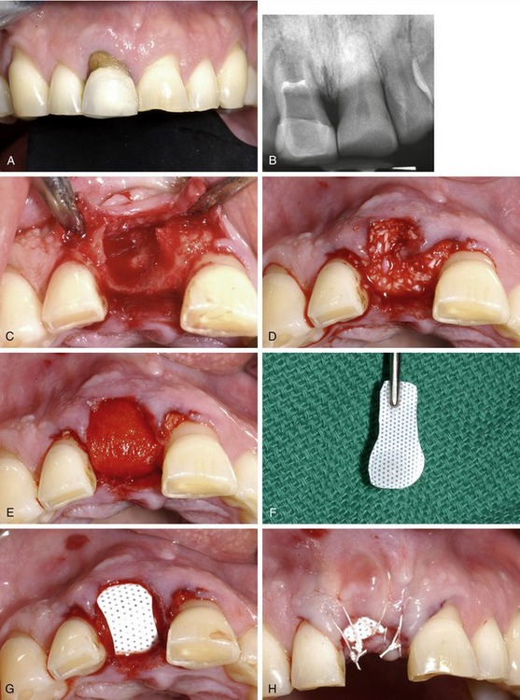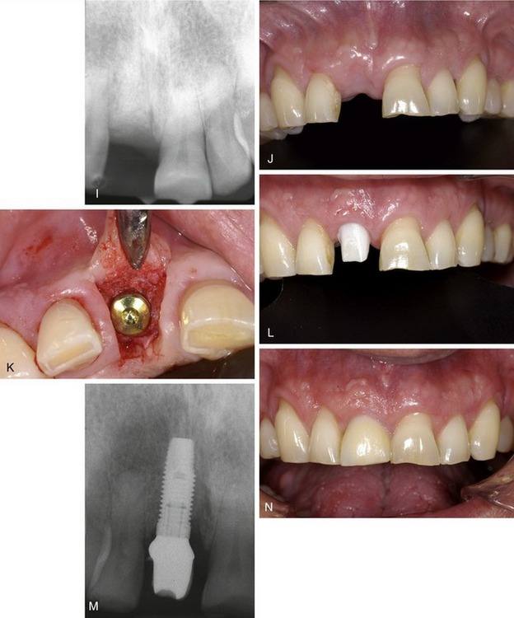
Figure 12-21. A, Mobile maxillary right central incisor. B, Periapical radiograph showing a large bone defect. C, Clinical photo showing large bone defect at time of extraction. D, Reconstruction of the defect using a combination of mineralized and demineralized freeze-dried bone allograft. E, Cross-linked type I collagen membrane (Cytoplast RTM Collagen) placed over the allograft. Textured, high-density PTFE membrane (Cytoplast TXT200) (F) placed over the collagen membrane (G) extending subperiosteally 3-4 mm beyond the defect margins. H, The wound approximated with Cytoplast 5-0 PTFE sutures. Periapical radiograph (I) and clinical photo (J) showing a well-healed ridge with abundant keratinized tissue width and good contour. There is good bone density and restoration of the bone height. K, Titanium implant in ideal restorative position placed without complications. L and M, Clinical photo (L) and radiograph (M) showing zirconia abutment in place. N, Implant restored with an all-porcelain restoration.
The PTFE membrane was removed at 4 weeks according to protocol, and at 4 months the ridge was well healed with abundant keratinized tissue width and good contour. Radiographically and clinically, there was good bone density with apparently good restoration of the bone height (Figure 12-21, I and J). A conservative incision design and flap was used to expose the grafted ridge, and good bone density was observed. A titanium implant was placed into ideal restorative position without complications (Figure 12-21, K). At 4 months a zirconia abutment was placed (Figure 12-21, L and M) and the implant was restored with an all-porcelain restoration (Figure 12-21, N).

Case Report 3: Guided Bone Regeneration Using High-Density Titanium-Reinforced PTFE Membrane
A 55-year-old female patient presented for implant placement in a recent extraction site. Surgical exposure revealed fibrous healing at the buccal and coronal aspects of the site, requiring augmentation simultaneous with implant placement (Figure 12-22, A and B) to regenerate the buccal bone contour.
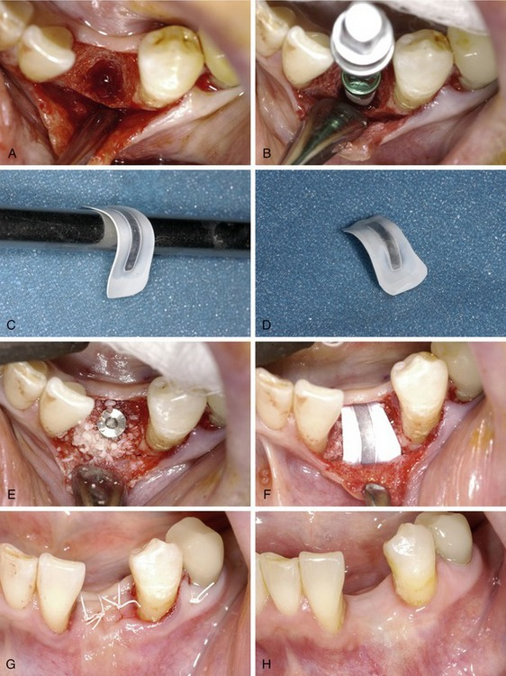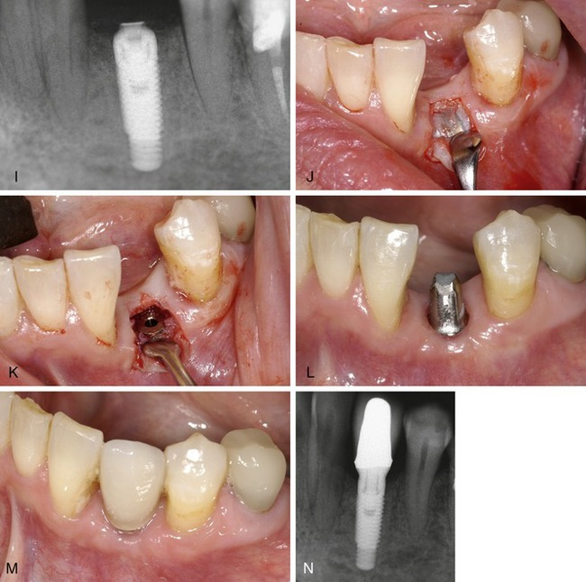
Figure 12-22. A, Surgical exposure showing fibrous healing at the buccal and coronal aspects of the site. B, Augmentation performed simultaneously with implant placement to regenerate the buccal bone contour. C and D, Cytoplast Ti-250 titanium-reinforced PTFE membrane in a single-tooth configuration trimmed to fit over the defect and curved (C) over an instrument handle to provide three-dimensional support and stability. Mineralized bone allograft placed in the defect (E) and covered with the membrane (F). G, Primary closure using Cytoplast CS-05 PTFE suture. Clinical photo showing healthy soft tissue covering the membrane (H) and radiograph (I) showing the PTFE barrier covered with mucosa and regeneration of hard tissue at 4 months of healing. J, Exposure of the barrier using a U-shaped incision with apical advancement of the keratinzed gingiva. K, High-density PTFE membrane is removed easily through a conservative incision due to limited soft tissue ingrowth into the barrier. L, Clinical photo showing restoration of the full width of keratinized gingiva at the time of abutment placement. Three months after implant placement, the restorative components were placed. Clinical photo (M) and radiograph (N) showing implant restored with a porcelain-fused-to-metal restoration.
A Cytoplast Ti-250 titanium-reinforced PTFE membrane in a single-tooth configuration was trimmed to fit over the defect and then curved over an instrument handle to provide three-dimensional support and stability (Figure 12-22, C and D). Mineralized bone allograft was placed into the defect (Figure 12-22, E) and covered with the membrane. The membrane was trimmed to remain 1 mm away from the roots of the adjacent teeth, and to extend 3-5 mm beyond the defect margins (Figure 12-22, F). Primary closure was achieved using Cytoplast CS-05 PTFE suture (Figure 12-22, G).
After 4 months of uneventful healing, the soft tissue covering the membrane appeared healthy prior to implant exposure and abutment placement (Figure 12-22, H). Four months after implant placement, the PTFE barrier remained covered with mucosa and regeneration of hard tissue was evident radiographically (Figure 12-22, I).
Exposure of the barrier was accomplished using a U-shaped incision with apical advancement of the keratinzed gingiva (Figure 12-22, J), and the high-density PTFE membrane was easily removed through a conservative incision due to limited soft tissue ingrowth into the barrier (Figure 12-22, K). Clinically, restoration of the full width of keratinized gingiva was observed at the time of abutment placement (Figure 12-22, L). Three months after implant placement the restorative components were placed and the implant was restored with a porcelain-fused-to-metal restoration (Figure 12-22, M and N).
This case demonstrates the successful augmentation of a localized defect involving the entire buccal plate of a recent extraction site. The use of a titanium-reinforced high-density PTFE membrane provides predictable space-making and regenerative function without the risks associated with highly porous, expanded PTFE devices.

Case Report 4: Implant Site Development Using Bovine Collagen Membrane and Allogeneic Bone
A 48-year-old female patient presented for implant replacement of the maxillary right first molar, which had been extracted 6 months previously. There was a substantial hard tissue defect requiring augmentation prior to implant placement (Figure 12-23, A and B). The original plan was to augment the site in two stages. First, a particulate graft would be used to expand the soft tissue envelope, then an autogenous block graft would be placed.
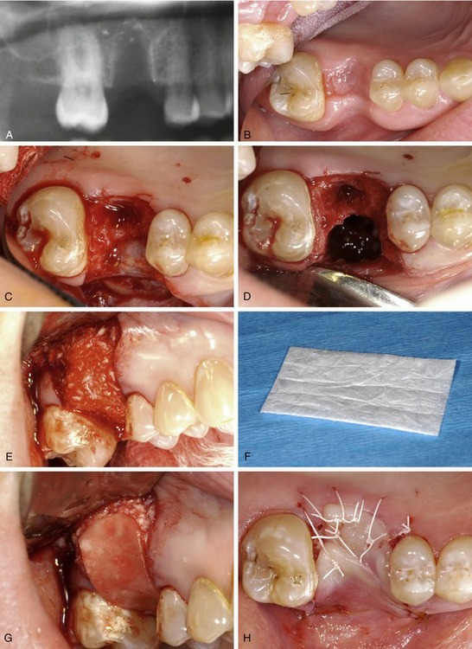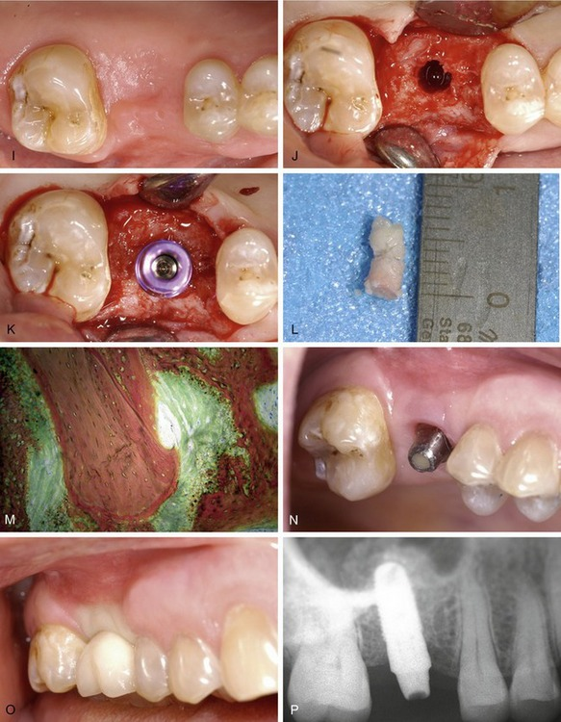
Figure 12-23. Radiograph (A) and clinical photo (B) showing site of maxillary right first molar extraction. There was a substantial hard tissue defect that required augmentation prior to implant placement. C, Initial surgical exposure of the healing socket revealing soft tissue extending up to and including the antral floor. D, Antral membrane, palatal wall, mesial wall, and distal bony wall are intact. The buccal plate and floor of the socket are missing. E, Allogeneic bone putty (Regeneform) placed into the defect and shaped to restore the contour of the ridge. A bovine collagen GTR membrane (Cytoplast RTM Collagen) (F) trimmed to fit over the graft (G). H, Cytoplast CS-05 PTFE sutures used to achieve closure of the membrane and graft. I, Clinical photo showing healing after 6 months. There was excellent healing with minimal loss of graft volume. J, Surgical exposure showing good bone density. K, A 4.7 × 11.5-mm implant placed. L, Bone core harvested from the implant site. M, Microscopic view showing 42% vital bone with active remodeling and active new bone formation evident in association with the demineralized and mineralized components of the graft. (Histology by Michael D. Rohrer, DDS, MS, University of Minnesota, Hard Tissue Research Laboratory.) N, Abutment in place 4 months after implant placement. O, The implant successfully restored. P, Periapical radiograph showing good bone density in the grafted area.
The initial surgical exposure of the healing socket revealed soft tissue extending up to and including the antral floor (Figure 12-23, C). After removal of the soft tissue, the antral membrane was found to be intact, as well as the palatal wall and the mesial and distal bony walls. The buccal plate and floor of the socket were missing (Figure 12-23, D).
Allogeneic bone putty (Regeneform Exactech, Inc., Gainesville, FL) was mixed according to the manufacturer’s directions, placed into the defect, and shaped to restore the contour of the ridge (Figure 12-23, E). A bovine collagen GTR membrane (Cytoplast RTM Collagen Membrane) was trimmed to fit over the graft (Figure 12-23, F and G). Primary closure was achieved over the membrane and graft using Cytoplast CS-05 PTFE sutures (Figure 12-23, H).
After 6 months there was excellent healing with minimal loss of graft volume (Figure 12-23, I). Surgical exposure (Figure 12-23, J) revealed good bone density, and a 4.7 × 11.5 mm implant was placed (Figure 12-23, K). A bone core, harvested with a trephine drill from the implant site (Figure 12-23, L) and examined microscopically, revealed 42% vital bone (Figure 12-23, M), with active remodeling and active new bone formation evident in association with both the demineralized and mineralized components of the graft.
This case demonstrates the successful reconstruction of a large three-walled defect in the maxilla, including loss of the antral floor. The use of a cross-linked bovine collagen membrane in conjunction with mineralized and demineralized allograft putty resulted in regeneration of vital bone of sufficient volume and density to accommodate a wide diameter implant. This was accomplished in a single surgical procedure, eliminating the need for autogenous block grafting. Histological analysis revealed vital bone with remodeling of the allograft particles and continued bone formation at 6 months.
Four months after placement, the abutment was placed and the implant was successfully restored (Figure 12-23, N and O). After 16 weeks in a provisional restoration, the periapical radiograph demonstrated good bone density in the grafted area (Figure 12-23, P).

Case Report 5: The Use of Tenting Screws With Titanium-Reinforced High-Density PTFE Membrane
A 45-year-old male presented with a substantial loss of buccal bone contour and in need of an endosseous implant to replace the maxillary left lateral incisor (Figure 12-24, A-C). The alveolar ridge was surgically exposed and decorticated in preparation for bone grafting (Figure 12-24, D). A titanium tenting screw 5 mm in length and specifically designed for guided tissue regeneration (JLR Tenting Screw Kit, KLS Martin L.P., Jacksonville, FL) was placed to augment the ridge to a predetermined contour (Figure 12-24, E). A composite particulate graft consisting of demineralized bone putty combined with beta-tricalcium phosphate granules was then placed, covered with a titanium-reinforced dense PTFE membrane (Cytoplast Ti-250 PL), and primary closure was achieved using Cytoplast 5-0 dense PTFE monofilament sutures (Figure 12-24, F and G).
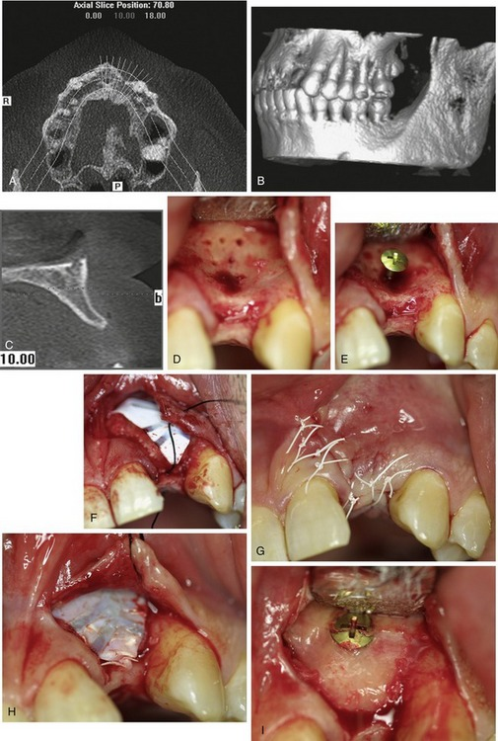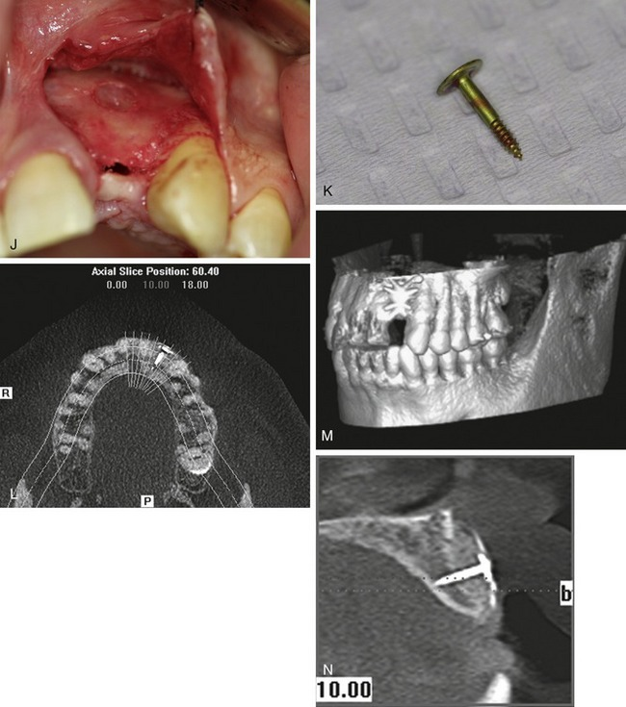
Figure 12-24. A to C, Pretreatment CT scans showing substantial loss of buccal bone contour and the need for an endosseous implant to replace the maxillary left lateral incisor. D, Alveolar ridge exposed and decorticated in preparation for bone grafting. E, Titanium tenting screw 5 mm in length placed to augment the ridge to a predetermined contour. F, Composite particulate graft covered with a titanium-reinforced dense PTFE membrane (Cytoplast Ti-250 PL). G, Primary closure using Cytoplast 5-0 dense PTFE monofilament sutures. H, Augmented site exposed after 6 months of healing. I, Membrane was removed, revealing dense cortical bone. J and K, Tenting screw removed. Total reconstruction of the ridge contour, up to the height predetermined by the tenting screw and membrane, achieved. L to N, CT scans (taken prior to the removal of the tenting screw and membrane) show a substantial increase in width, from 2.9-8.5 mm, facilitating implant placement in the proper three-dimensional position.
(Courtesy Joel L. Rosenlicht, DMD.)
After 6 months of healing the augmented site was exposed (Figure 12-24, H) and the membrane was removed (Figure 12-24, I), revealing dense cortical bone under the membrane. Upon removal of the tenting screw (Figure 12-24, J and K) it was apparent that total reconstruction of the ridge contour, up to the height predetermined by the tenting screw and membrane, had been achieved. A CT scan taken prior to the removal of the tenting screw and membrane revealed a substantial increase in width, from 2.9-8.5 mm, greatly facilitating implant placement in the proper three-dimensional position. (Figure 12-24, L-N).
REFERENCES
1. Karring T, Nyman S, Gottlow I, Laurell L. Development of the biological concept of guided tissue regeneration: animal and human studies. Periodontology 2000. 1993;1:26.
2. Caffesse RG, Quinones CR. Guided tissue regeneration: biologic rationale, surgical technique, and clinical results. Compend Contin Educ Dent. 1992;13(3):166.
3. Lang NP, Karring T: Proceedings of the 1st European workshop on periodontology, 1994, London.
4. Melcher AH. On the repair potential of periodontal tissues. J Periodontol. 1976;47(5):256.
5. Gottlow J. Guided tissue regeneration using bioresorbable and nonresorbable devices: initial healing and long-term results. J Periodontol. 1993;64:1157.
6. Caton J, Greenstein G. Factors related to periodontal regeneration. Periodontology 2000. 1993;1:9.
7. Rowe D, Leung W, DeCarlo D. Osteoclast inhibition by factors from cells associated with regenerative tissue. J Periodontol. 1996;67:414.
8. Payne J, et al. Migration of human gingival fibroblasts over guided tissue regeneration barrier materials. J Periodontol. 1996;67:236.
9. Lindhe A, et al. Osteopromotion: a soft-tissue exclusion principle using a membrane for bone healing and bone neogenesis. J Periodontol. 1993;64:1116.
10. Mellonig JT, Triplett RG. Guided tissue regeneration and endosseous dental implants. Int J Periodon Rest Dent. 1993;13(2):109.
11. Magnusson I, Stenberg WV, Batich C, et al. Connective tissue repair in circumferential periodontal defects in dogs following use of a biodegradable membrane. J Clin Periodontol. 1990;17:243.
12. Blumenthal NM. A clinical comparison of collagen membranes with e-PTFE membranes in the treatment of human mandibular buccal class II furcation defects. J Periodontol. 1993;64:925.
13. Hardwick R, Hayes BK, Flynn C. Devices for dentoalveolar regeneration: an up-to-date literature review. J Periodontol. 1995;66:495.
14. Scantlebury T. 1982-1992: A decade of technology development for guided tissue regeneration. J Periodontol. 1993;64:11-29.
15. Meffert R. Guided tissue regeneration/guided bone regeneration: a review of the barrier membranes. Pract Periodont Aesthet Dent. 1986;8:142.
16. Becker W, et al. A prospective multi-center study evaluating periodontal regeneration for Class II furcation invasions and intrabony defects after treatment with a bioabsorbable barrier membrane: 1-year results. J Periodontol. 1996;67:641.
17. Bartee BK. The use of high-density polytetrafluoroethylene membrane to treat osseous defects: clinical reports. Implant Dent. 1995;4(1):21.
18. Yukna CN, Yukna RA. Multi-center evaluation of bioabsorbable collagen membrane for guided tissue regeneration in human Class II furcations. J Periodontol. 1996;67:650.
19. Nyman S, Lindhe J, Karring T, Rylander H. New attachment following surgical treatment of human periodontal disease. J Clin Periodontol. 1982;9:290.
20. Gore-Tex® regenerative material manual. Flagstaff, AZ: WL Gore, 1986.
21. Sigurdsson T, Hardwick W, Bogle G, Wikesjo U. Periodontal repair in dogs: space provision by reinforced ePTFE membranes enhances bone and cementum regeneration in large supra-alveolar defects. J Periodontol. 1994;65:350.
22. Schenk R, Buser D, Hardwick W, Dahlin C. Healing pattern of bone regeneration in membrane-protected defects. Int J Oral Maxillofac Implants. 1994;9:13.
23. Anson D. Calcium sulfate: a 4-year observation of its use as a resorbable barrier in guided tissue regeneration of periodontal defects. Compend Contin Educ Dent. 1996;17:895.
24. Gunatillake PA, Adhikari R. Biodegradable synthetic polymers for tissue engineering. Eur Cell Mater. 2003;5:1.
25. Freed LE, Vunjak-Novakovic G, Biron RJ, et al. Biodegradable polymer scaffolds for tissue engineering. Biotechnology (N Y). 1994;12:689.
26. Marijnissen WJ, van Osch GJ, Aigner J, et al. Alginate as a chondrocyte-delivery substance in combination with a non-woven scaffold for cartilage tissue engineering. Biomaterials. 2002;23:1511.
27. Hyder PR, Dowell P, Dolby AE. Freeze-dried, cross-linked bovine type I collagen: analysis of properties. J Periodontol. 1992;63:182.
28. Greenstein G. Caton l: Biodegradable barriers and guided tissue regeneration. Periodontology 2000. 1993;1:36.
29. Pitaru S, et al. Partial regeneration of periodontal tissues using collagen barriers. Initial observations in the canine. J Periodontal. 1988;59:380.
30. Pitaru S, Tal H, Soldinger M, Noff M. Collagen membranes prevent apical migration of epithelium and support new connective tissue attachment during periodontal wound healing in dogs. J Periodontol Res. 1989;24:247.
31. Pitaru S, et al. Heparan sulfate and fibronectin improve the capacity of collagen barriers to prevent apical migration of the functional epithelium. J Periodontol. 1991;62(10):598.
32. Blumenthal N, Steinberg J. The use of collagen membrane barriers in conjunction with combined demineralized bone-collagen gel implants in human infrabony defects. J Periodontol. 1990;61:319.
33. BioMend absorbable collagen membrane manual. Calcitek: Colla-Tec, Inc, 1995.
34. Roccuzzo M, Lungo M, Corrente G, Gandolfo S. Comparative study of a bioresorbable and non-resorbable membrane in the treatment of human buccal gingival recessions. J Periodontol. 1996;67:7.
35. Lundgren D, et al. The influence of the design of two different bioresorbable barriers on the results of guided tissue regeneration therapy. An intra-individual comparative study in the monkey. J Periodontol. 1995;66:605.
36. Laurell L, et al. Clinical use of a bioresorbable matrix barrier in guided tissue regeneration therapy. Case series. J Periodontol. 1994;65:967.
37. Gottlow J, et al. New attachment formation in the monkey using Guidor, a bioresorbable GTR-device (abstract 1535). J Dent Res. 1992;71:298.
38. Gottlow J, et al. Clinical results of GTR-therapy using a bioabsorbable device (Guidor) (abstract 1537). J Dent Res. 1992;71:298.
39. Laurell L, et al. Gingival response to Guidor, a bioresorbable device in GTR-therapy (abstract 1536). J Dent Res. 1992;71:298.
40. Magnusson I, Batich C, Collins BR. New attachment formation following controlled tissue regeneration using biodegradable membranes. J Periodontol. 1988;9:290.
41. Warrer K, Karring T, Nyman S, Gogolewski S. Guided tissue regeneration using biodegradable membranes of polylactic acid or polyurethane. J Clin Periodontal. 1992;19:633.
42. Laurell L, et al. Gingival response to GTR therapy in monkeys using two bioresorbable devices (abstract 824). J Dent Res. 1993;72:206.
43. Hugoson A, et al. Treatment of Class II furcation involvements in humans with bioresorbable and nonresorbable guided tissue regeneration barriers. A randomized multi-center study. J Periodontol. 1995;66:624.
44. Gottlow J, et al. Treatment of infrabony defects in monkeys with bioresorbable and nonresorbable GTR devices (abstract 823). J Dent Res. 1993;72:206.
45. Vuddhakanok S, et al. Histologic evaluation of periodontal attachment apparatus following the insertion of a biodegradable copolymer barrier in humans. J Periodontol. 1993;64:202.
46. Simion M, Scarano A, Gionso L, Piattelli A. Guided bone regeneration using resorbable and nonresorbable membranes: a comparative histologic study in humans. Int J Oral Maxillofac Implants. 1996;11:735.
47. Poison AM, et al. Guided tissue regeneration in human furcation defects after using a biodegradable barrier: a multi-center feasibility study. J Periodontal. 1995;66:377.
48. Poison AM, et al. Initial study of guided tissue regeneration in Class II furcation after use of a biodegradable barrier. Int J Periodon Rest Dent. 1995;15:43.
49. Poison AM, et al. Periodontal healing after guided tissue regeneration with Atrisorb barriers in beagle dogs. Int J Periodon Rest Dent. 1995;15(6):575.
50. Fleisher N, Waal HD, Bloom A. Regeneration of lost attachment apparatus in the dog using Vicryl absorbable mesh (polyglactin 910). Int J Periodon Rest Dent. 1988;8:45.
51. Sottosanti J. Calcium sulfate: a valuable addition to the implant/bone regeneration complex. Dent Implantol Update. 1997;8:25.
52. Maze GI, Hinkson DW, Collins BH, Garbin C: Bone regeneration capacity of a combination calcium sulfate-demineralized freeze dried bone allograft, 1994, Presented at the AAP Meeting.
53. LifeCore biomedical manual. Woodland, TX: LifeCell Corporation, 1995.
54. Sottosanti J. Calcium sulfate-aided bone regeneration. A case report. Periodont Clin Invest 1. 1995;7:10.
55. Livesey S, et al: An acellular dermal transplant processed from human cadaver skin retains normal extracellular components and ultrastructural characteristics, New Orleans, 1994, Presented at the American Association of Tissue Banks Conference.
56. Alloderm universal soft tissue graft manual, Woodland, TX, LifeCell Corporation.
57. Shulman J. Clinical evaluation of an acellular dermal allograft for increasing the zone of attached gingiva. Pract Periodont Aesthet Dent. 1996;8:201.
58. Mishkin D, Shelly LJr, Neville B. Histologic study of a freeze-dried skin allograft in a human. A case report. J Periodontol. 1993;54:534.
59. Galgut P. Oxidized cellulose mesh used as a biodegradable barrier membrane in the technique of guided tissue regeneration. A case report. J Periodontol. 1990;61:766.
60. Degenshoin G, Hurwitz A, Ribaceff S. Experience with regenerative oxidized cellulose. N Y State J Med. 1963;63:18.
61. Selvig KA, et al. Scanning electron microscopic observations of cell population and bacterial contamination of membranes used for guided periodontal tissue regeneration in humans. J Periodontol. 1990;61:515.
62. Nowzari H, Slots J. Microorganisms in polytetrafluoroethylene barrier membranes for guided tissue regeneration. J Clin Periodontol. 1994;21:203.
63. Yumet IA, Poison AM. Gingival wound healing in the presence of plaque induced inflammation. J Periodontol. 1985;56:107.
64. Fritz ME, Eke PI, Malmquist J, Hardwick R. Clinical and microbiological observations of early polytetrafluoroethylene membrane exposure in guided bone regeneration. Case reports in primates. J Periodontol. 1996;67:245.
65. Wang H, et al. Adherence of oral microorganisms to guided tissue membranes. An in vitro study. J Periodontol. 1994;65:211.
66. Ricci G, Rasperini G, Silvestri M, Cocconcelli PS. In vitro permeability evaluation and colonization of membranes for periodontal regeneration by Porphyromonas gingivalis. J Periodontol. 1996;67:490.
67. Clafin RS. Healing of disturbed and undisturbed extraction wounds. J Am Dent AssoADA. 1936;23:945-959.
68. Amler MH. The sequence of tissue regeneration in human extraction wounds. Oral Surg Oral Med Oral Path. 1969;27:309-318.
69. Pietrokovski J, Massler M. Alveolar ridge resorption following tooth extraction. J Prosthet Dent. 1967;17:21-27.
70. Carlsson GE, Bergman B, Hedegard B. Changes in contour of the maxillary alveolar process under immediate dentures. Acta Odontol Scand. 1967;25:45-75.
71. Johnson K. A study of the dimensional changes occurring in the maxilla following tooth extraction. Aust Dent J. 1969;14:241-244.
72. Sottosanti JS. Aesthetic extractions with calcium sulfate and the principles of guided tissue regeneration. Pract Periodontics Aesthet Dent. Jun-Jul 1993;5(5):61-69.
73. Nemcovsky CE, Serfaty V. Alveolar ridge preservation following tooth extraction of maxillary anterior teeth. Report on 23 consecutive cases. J Periodontol. 1996;67:390-395.
74. Dies F, Etienne D, Abboud NB, Ouhayoun JP. Bone regeneration in extraction sites after immediate placement of an ePTFE membrane with or without a biomaterial. A report on 12 consecutive cases. Clin Oral Implants Res. Sept 1996;7(3):277-285.
75. Lekovic V, Kenney EB, Weinlaender M, et al. A bone regenerative approach to alveolar ridge maintenance following tooth extraction. Report of 10 cases. J Periodontol. 1997;68:563-570.
76. Bartee BK. Evaluation of a new polytetrafluoroethylene guided tissue regeneration membrane in healing extraction sites. Comp Cont Ed Dent. 1998;19:1256-1264.
77. Lekovic V, Camargo PM, Klokkevold PR, et al. Preservation of alveolar bone in extraction sockets using bioabsorbable membranes. J Periodontol. 1998;69:1044-1049.
78. Sclar AG. Preserving alveolar ridge anatomy following tooth removal in conjunction with immediate implant placement. The Bio-Col technique. Atlas Oral Maxillofac Surg Clin North Am. Sep 1999;7(2):39-59.
79. Camargo PM, Lekovic V, Weinlaender M, et al. Influence of bioactive glass on changes in alveolar process dimensions after exodontia. Oral Surg Oral Med Oral Pathol Oral Radiol Endod. Nov 2000;90(5):581-586.
80. Fowler EB, Breault LG, Rebetski G. Ridge preservation using an acellular dermal allograft and demineralized freeze-dried bone allograft: Part I. A report of 2 cases. J Periodontol. Aug 2000;71(8):1353-1359.
81. Iasella JM, Greenwell H, Miller RL, et al. Ridge preservation with freeze-dried bone allograft and a collagen membrane compared to extraction alone for implant site development: a clinical and histologic study in humans. J Periodontol. Jul 2003;74(7):990-999.
82. Vance GS, Greenwell H, Miller RL, Hill M, Johnston H, Scheetz JP. Comparison of an allograft in an experimental putty carrier and a bovine derived xenograft used in ridge preservation; a clinical and histological study in humans. Int J Oral Maxillofac Implants. Jul-Aug 2004;19(4):491-497.
83. Nevins M, Camelo M, De Paoli S, et al. A study of the fate of the buccal wall of extraction sockets of teeth with prominent roots. Int J Periodon Rest Dent. Feb 2006;26(1):19-29.
84. Barber HD, Lignelli J, Smith BD, Bartee BK. Using a dense PTFE membrane without primary closure to achieve bone and tissue regeneration. J Oral Maxillofac Surg. Apr 2007;65(4):748-752.
85. Neiva RF, Tsao YP, Eber R, et al. Effects of a putty-form hydroxyapatite matrix combined with the synthetic cell-binding peptide P-15 on alveolar ridge preservation. J Periodontol. Feb 2008;79(2):291-299.
86. Becker W, Urist M, Becker BE, et al. Clinical and histologic observations of sites implanted with intraoral autologous bone grafts or allografts. 15 human case reports. J Periodontol. Oct 1996;67(10):1025-1033.
87. Covani U, Cornelini R, Barone A. Bucco-lingual bone remodeling around implants placed into immediate extraction sockets: a case series. J Periodontol. Feb 2003;74(2):268-273.
88. Covani U, Bortolaia C, Barone A, Sbordone L. Bucco-lingual crestal bone changes after immediate and delayed implant placement. J Periodontol. Dec 2004;75(12):1605-1612.
89. Schropp L, Wenzel A, Kotopoulos L, Karring T. Bone healing and soft tissue changes following single-tooth extraction: a clinical and radiographic 12-month prospective study. Int J Periodon Rest Dent. Aug 2003;23(4):313-323.
90. Botticelli D, Berglundh T, Lindhe J. Hard tissue alterations following immediate implant placement in extraction sites. J Clin Periodontol. Oct 2004;31(10):820-828.
91. Sclar AG. Strategies for management of single tooth extraction sites in aesthetic implant therapy. J Oral Maxillofac Surg. 2004;62(Suppl 2):90-105.

