Chapter 32 Stage II Surgery: Uncovery and Treatment of Healing Complications
Carl E. Misch
The loss of implants from initial surgery to prosthetic loading has gradually decreased over the last decade and is often less than 5%.^{1,2} These failures may be explained to the patient as caused by local conditions or intraoral healing responses, and they are usually well accepted by the patient. Failures from stage II uncovery until prosthesis connection have also been identified and range from 2.5% to 5.9%.¹⁻⁶ These early loading or “late failures” are more of a problem because the restoring dentist has begun the restoration, accompanied by laboratory and chair time costs. The patient often blames the restoring dentist for this complication, relating it to some clinical event such as the final impression or removal of the transitional prosthesis.

NOMENCLATURE FOR IMPLANT FAILURES
With the development of many different implant systems and the advent of such techniques as single-stage surgery, immediate loading, and direct implant placement of the prosthesis, implant failure terminology can be confusing. A review of the literature shows inconsistency in its classification of implant failures relative to time. In particular, the terms late failure or later failure have not been precisely defined in regard to the timing of the failure. Late failure may be used to describe early loading failures after stage II uncovery or complications after several years to decades after implant loading.
Misch and Jividen have published a classification for implant failure, based on the unusual events of an implant history.⁷ The suggested terminology of failures relative to time includes surgical failure, which may be used to describe the inability to place the implant at the time of surgery (e.g., from fracture of bone, failure to obtain initial rigid fixation)(Table 32-1).
Table 32-1 Implant Failure Terminology
TYPE OF FAILURE | TIMING
Surgical | At surgery
Osseous healing failure | Between stages I and II
Early loading | Abutment placement to first year
Intermediate | First-year loading to 5 years
Late | 5 to 10 years
Long term | >10 years
Osseous healing failure may describe the period from implant placement to abutment connection of the implant and is related to the healing ability of bone. Early loading failure describes the period from the abutment placement to the first year the implant serves as a prosthetic abutment. When immediate loading is performed, the osseous healing period and early loading time frame are similar. Early implant failure is more likely caused by inadequate surface area of the implant for the magnitude of the load or quality of bone that is not sufficient to support the load. Intermediate implant failure is the period after the first year of loading and includes up to the subsequent 5 years of function. Late implant failure is used to describe the condition after the implant and prosthesis have been loaded for longer than 5 years and shorter than 10 years. Long-term failure may be used to describe failures after 10 years. Peri-implant disease and fatigue fracture are more common causes of long-term failures. This nomenclature is therefore proposed to facilitate future research efforts and interpretation.
The initial surgery and healing process ideally result in a rigidly fixated implant, absence of crestal bone loss around the implant, adequate zones of nonmobile keratinized tissue (>2 mm), soft tissue thickness less than 4 mm, and an absence of tenderness or discomfort under vertical or lateral forces (Box 32-1). A second-stage implant (uncovery) surgery permits the direct evaluation of these criteria and the corrections necessary to lay the groundwork for long-term success. An opportunity exists at the stage II surgery to correct poor implant placement, inadequate crestal bone healing, soft tissue defects, or poor soft tissue relationships. The final restoration should not be placed in long-term jeopardy at the expense of compromised initial healing conditions.
Box 32-1 Criteria for Evaluation of Successful Implants at Stage II Uncovery
Rigid fixation
Absence of crestal bone loss
Absence of pain
Adequate zone of keratinized gingiva
Sulcus depth 4 mm
Absence of inflammation
Proper hard and soft tissue contour
Prosthetic abutment allows implant loading under physiologic conditions
A second-stage surgery most often is used by the profession for an implant that is completely covered by soft tissue during the initial healing period. However, even when the implant was inserted with a one-stage surgical approach or became exposed during the healing process, a second-stage surgery may be of benefit to evaluate the surrounding bone and soft tissue conditions.
The goal of a two-stage surgical approach, as presented by Brånemark in 1977, is to have the implant covered with soft tissue for 3 to 6 months while the bone remodels around the implant.⁸ The primary reasons cited were to reduce the risk of infection and prevent the apical migration of tissue around the implant. In addition, the implant was countersunk below the bone to reduce the risk of loading or movement during initial healing. If the implant became prematurely exposed during the first 6 weeks, the soft tissue would be surgically repositioned to recover the implant once again.

SPONTANEOUS EARLY EXPOSURE
The implant covered with soft tissue may spontaneously become partially or completely exposed prior to stage II uncovery (Figure 32-1). The spontaneous early exposure of submerged implants has been found, on occasion, to be accompanied by early exudate, inflammation, and crestal bone loss. In a 15-year report by Adell et al., 4.6% of 2768 implants presented early perforations.⁹ These implants had an external hex and were countersunk, level with the bone.
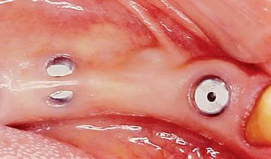
Figure 32-1 Spontaneous exposure of implants during the initial healing period occurs 5% to 15% of the time, depending on the hard and soft tissue conditions at the initial surgery.
When Rosenquist and Grenthe¹⁰ placed implants into extraction sockets, 11% of the implants had early exposures. Tal et al.¹¹⁻¹⁴ observed early exposure in 16.1% of external hex implants and 11% with internal hex implants. Therefore it appears the risks of early exposure occurs approximately 5% to 15% of the time and is dependent on the profile of the implant at surgery and the hard and soft tissue conditions.
When the implant has an early exposure, the epithelium may become hyperplastic, with cells exhibiting hyperparakeratosis and acanthosis (Figures 32-2, 32-3). The connective tissue may also be infiltrated by chronic inflammatory cells, mainly lymphocytes and plasma cells.¹³ Toljanic reported 3.9 times more bone loss in premature exposures, with a mean bone loss of 2.71 mm (standard deviation [SD] ±1.78 mm) for prematurely exposed implants versus 0.43 mm (SD ±1.08 mm) for nonexposed implants. It may be argued that the exposure of the implant triggers the “biological width” phenomenon, which would occur regardless after stage II uncovery. In 1996, Ericsson et al. found in a dog study the amount of marginal bone loss initially was similar, but after 6 months of exposure, both the one-stage and two-stage implant bone levels were similar (Figures 32-4, 32-5).¹⁶
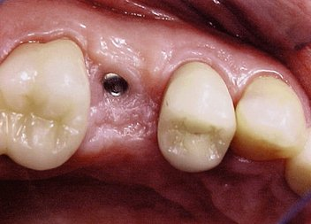
Figure 32-2 The epithelium over the implants of a spontaneous exposure, on occasion may be associated with chronic inflammatory cells.
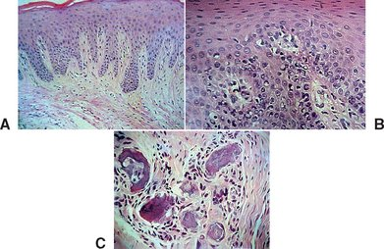
Figure 32-3 Histologic evaluation of the patient in Figure 32-2 (A) revealed connective tissue with infiltrated chronic inflammatory cells (B,C).
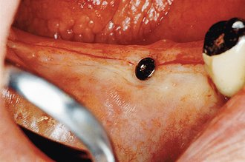
Figure 32-4 Spontaneous exposure during healing may occur to only one implant of multiple sites.
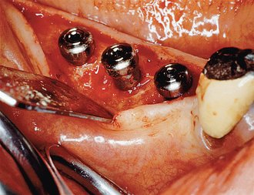
Figure 32-5 At the uncovery, the implant with premature exposure has more crestal bone loss than the implants completely covered during initial healing. This initial difference may be related to the “biological width” after the implant becomes exposed. Most often the overall crestal bone is similar during the next 6 months.
Tal et al. evaluated 115 early exposures of submerged endosteal implants.¹⁴ Of this group, 11% had significant bone loss, with 2 implants >4 mm; 2 implants, 3 to 4 mm; and 10 implants, 2 mm of bone loss. Although most often premature exposure was not a complication, on occasion the condition may lead to significant bone loss. Barboza et al. compared crestal bone loss for one-stage surgery versus a two-stage surgery in 10 patients with 56 implants.¹⁷ She found more crestal bone loss around exposed implants and also found a higher incidence of Prevotella intermedia, Streptococcus beta hemolysin, and Fusobacterium sp. The exposure of the implant cover screw seems to create a potential focus for bacterial plaque which may contribute to crestal bone loss (Figures 32-6, 32-7). Therefore it is indicated to monitor patients from stage I surgery to stage II surgery every 4 to 8 weeks to access and treat appropriately premature exposure of implants.
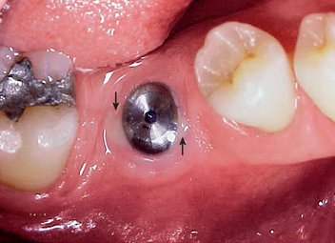
Figure 32-6 In approximately 10% of implants with spontaneous premature exposure, the implant has exudate or significant bone loss.
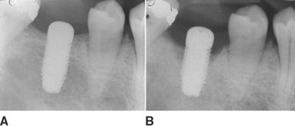
Figure 32-7 The periapical radiograph of the previous implant at implant placement (A) and 3 months later after spontaneous premature exposure (B). Note the 4 mm of marginal bone loss.
(Courtesy E. Barboza, São Paulo, Brazil.)
It has been observed by several authors that the risk of exudate or inflammation is increased when the implant is only partially exposed (Figure 32-8).¹¹⁻¹⁶ The contaminated crevice of the cover screw is more likely to be in a septic environment under these conditions. Therefore whenever the implant cover screw is partially exposed, the first action is to completely expose the implant (Figure 32-9). The cover screw is then removed and the implant body irrigated with chlorhexidine 0.12%. A permucosal extension (PME) is then inserted into the implant. After the implant is completely exposed in the oral environment, a daily oral hygiene regimen is in order. This consists of twice-daily plaque removal with a soft toothbrush and the direct application of chlorhexidine 0.12%. If the patient is wearing an overlaying removable prosthesis, it should be modified so that no direct force is applied to the implant until after the bone interface is ready for occlusal loading.
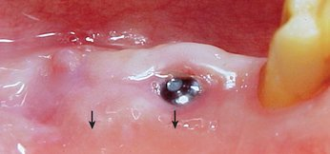
Figure 32-8 The two implants have become partially exposed during the initial healing process. The smaller the exposure (implant on left has pain point exposure), the greater the risk of marginal bone loss.
(Courtesy E. Barboza, São Paulo, Brazil.)
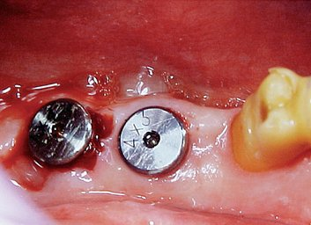
Figure 32-9 The implants in the previous picture have been completely exposed and flushed with chlorhexidine 0.12%, and the permucosal extension has been inserted.
(Courtesy E. Barboza, São Paulo, Brazil.)
There are most likely three reasons to explain the greater crestal bone loss around a prematurely exposed implant. The first is related to the microgap. Bone is able to grow over the cover screw crevice when covered by soft tissue. However, after the cover screw (or PME) is exposed in the oral environment, the oral epithelium most often repositions itself 0.5 to 1.0 mm below the crevice of the cover screw, usually within a few weeks. A second cause of marginal bone loss is related to the crest module design. When smooth metal is placed below the bone and the implant is exposed to the oral environment, the marginal bone loss extends apically until it reaches a rough surface or a groove (or thread) on the implant body. This process also occurs within the first month. As a consequence, submerged healing implants have less bone loss than implants, which becomes prematurely exposed.
It should be mentioned that after the implant is uncovered and used for prosthetic support, the phenomena described occur and bone loss becomes evident. Although submerged implants exhibit less marginal bone loss after initial healing, the overall marginal bone loss of two-stage and one-stage implants may be similar by the time the prosthesis is delivered to the patient.¹⁷
In addition to marginal bone loss from the microgap and the biological width, additional bone loss may occur from bacterial plaque. Rams and Link noted the bacterial environment becomes at greater risk of an anaerobic component when the probing depth is greater than 5 mm.¹⁸ The anaerobic condition may be established around a prematurely exposed implant in two ways: A partial exposure of the implant has a greater risk of an anaerobic environment, and the cover screw is not tightened to 10 to 30 N-cm and may be loose, making the implant internal structure more likely anaerobic. Either of these conditions increases the risk of exudate or inflammation with greater marginal bone loss. It should be noted this cause of marginal bone loss could be corrected by uncovering the implant completely and flushing the region with chlorhexidine 0.12%. However, the bone loss that occurred before this event would not be corrected at this point.
Another factor to contribute greater marginal bone loss is that the implant may have become prematurely loaded through the soft tissue, causing tissue dehiscence. The premature load may cause the cover screw to loosen (increasing the anaerobic environment) and overload the developing crestal bone-implant interface.

UNCOVERY PROCEDURE
When more than three implants are uncovered, the patient is prepared for surgery in a manner similar to the original stage I procedure. In general, discomfort, swelling, and risk of infection occur to a lesser degree than at the original surgery. However, if corrective procedures are indicated during surgery, they should not be compromised by poor patient preparation. This chapter primarily addresses uncovery of multiple implants out of the primary esthetic zones. Maxillary anterior implants in patients with high lip lines are treated similar to anterior single tooth replacements, which are discussed in Chapter 33.

Soft Tissue Incision
The initial incision for stage II surgery is as important as in the first stage. When a one-stage surgical approach is used, attention to the soft tissue is similar to the following procedure. The incision is designed to place keratinized tissue on each side of the permucosal abutment. Therefore the full-thickness incision bisects the attached tissue on the crest of the ridge (Figure 32-10). The attached tissue and incision are usually more lingual than the actual implant site. As a result, a tissue punch is rarely used, because it usually eliminates the facial attached tissue around the implant site. The incision continues at least 5 to 10 mm distal to the last implant placed. A full-thickness envelope flap design permits reflection of the periosteum for direct implant-bone interface observation. A tissue punch may be used to uncover the implant when there is 1.5 mm or more of attached keratinized tissue facial to the implant site. This occurs more often in the posterior maxilla or when an implant was immediately inserted after the tooth was extracted.
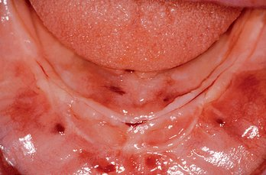
Figure 32-10 At stage II uncovery, the crestal incision bisects the keratinized tissue, ensuring that the facial tissue has more than 1.5 mm of attached tissue.
The periosteal elevators should not be levered against the endosteal implant body or first-stage cover screw during this procedure. Instead, the lingual or palatal bone is used for leverage, and the facial tissues are gently pulled off the healed implant sites. Adequate reflection of the soft tissue completely exposes the crestal bone around the implant site and allows repositioning of the attached tissue at the conclusion of the procedure (Figure 32-11). If the healing cover screw became exposed during the healing phase, the primary crestal incision is made along the lingual aspect of the healing cover, and a sulcular incision is placed around the rest of the implant. A mucoperiosteal flap is then reflected in a fashion similar to that previously described. A lack of attached tissue is common on the facial aspect of the implant when it becomes exposed during initial healing and may require a tissue graft or acellular tissue graft on the facial to restore attached or immobile tissue.
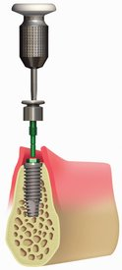
Figure 32-11 The soft tissue reflection is extensive enough to reposition the keratinized tissue around the permucosal extension of the implants or to correct any bone defect around the implants.

Bone-to-Implant Interface Evaluation
After the soft tissues are reflected, the first-stage cover screws are identified and the surrounding area is closely evaluated. Many implant abutments are wider than the first-stage cover screw and may require as much as 1 mm of horizontal space around the implant platform on the crest module (Figure 32-12). Any bone growth on the cover screws or over the surrounding region is removed with surgical curettes or low-speed rotary uncovery burs designed to remove excess bone, accompanied by cooled sterile saline irrigation (Figure 32-13).
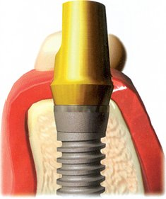
Figure 32-12 The abutment or permucosal extension may be larger in diameter than the crest module of the implant. As such, when bone is over or adjacent to the cover screw, the marginal bone must be recontoured to allow complete seating of the abutment.
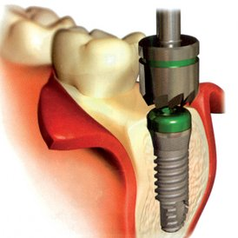
Figure 32-13 A bone profile drill in a low-speed hand piece, with copious irrigation, may remove the bone over or adjacent to the crest module and permit the abutment to be seated completely on the implants.

Bony Defects
On occasion, a vertical or horizontal defect may be revealed around the uncovered implant. The causes for this defect are often similar to those of premature implant exposure and include crestal bone trauma during surgery, excess torque from implant insertion (especially with wider crest modules), bone flexure or torsion in the posterior mandible, local patient habits that load the implants during healing, incision line opening, postoperative infection, implant surface contamination, idiopathic bone loss, or healing factors related to systemic disease. In a study by Kline et al., the average crestal bone loss was 0.2 mm at stage II uncovery, but the range was −5 mm to +2 mm (Figure 32-14) (Box 32-2).²
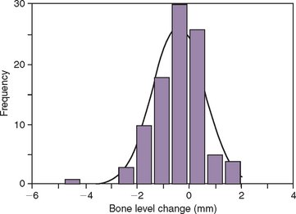
Figure 32-14 The range of bone loss in the Kline et al. study at stage II uncovery was from −5 mm to +2 mm. The average bone loss was 0.2 mm.
(Kline R, Hoar JE, Beck GH et al: A prospective multicenter clinical investigation of a bone quality-based dental implant system, Implant Dent 11:332-334, 2002.)
Box 32-2 Causes for Bone Loss at Stage II Uncovery
• Premature implant exposure
• Crestal bone trauma at surgery
• Excess torque at implant insertion
• Bone flexure/torsion in posterior mandible

Vertical Defects
If a vertical defect filled with soft tissue is identified anywhere around the implant, a curette is used to eliminate it (Figure 32-15). When soft tissue is removed from around a tooth, the root is scraped because the tissue attaches to the cementum. The fibrous tissue in a vertical defect around an implant is not attached to the implant. Therefore the bone is scraped, not the implant. This loosely bound and unorganized tissue is relatively easy to remove at this time. The implant surface should not be scratched or contaminated during this procedure. The extent of bone loss is assessed and should be less than 3 mm if the implant is to be uncovered at this appointment (Table 32-2).
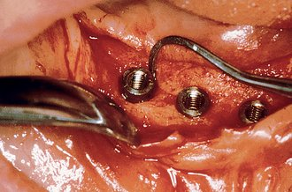
Figure 32-15 A soft tissue in a vertical defect is removed by using a curette that scrapes the surrounding bone, not the implants.
Table 32-2 Resolution of Bone Loss at Uncovery
DEFECT | MANAGEMENT | OPTIONS
Vertical <3 mm | Osteoplasty | Convert into horizontal defect by leveling off bone
Vertical >3 mm | Less than half of implant height | Graft with autogenous bone wedge or membrane if deep defect
Vertical >3 mm | More than half of implant height | Remove implant
Horizontal | Less than half of implant height | Position soft tissue apically; graft autogenous bone
Horizontal | More than half of implant height | Remove implant
If the vertical defect around the implant is of moderate depth (greater than 3 mm) for more than 25% of the circumference, a barrier membrane is placed over the grafted defect and the soft tissue is reapproximated. This prevents soft tissue ingrowth into the defect and provides an improved environment for the bone graft healing time against the implant surface. In this scenario, the second-stage uncovery is delayed for approximately 2 to 4 months, depending on the size of the defect.
When bone loss exposes the threads of the implant body, the ability to reform bone in the defect when the implant is uncovered and loaded is reduced. When the implant has not been exposed before the uncovery procedure, the implant body is usually not contaminated by microorganisms because it has been under soft tissue. The full-thickness reflection of the region has exposed areas of vital bone not involved in the implant support. This bone may be harvested and packed into the vertical defect (after the soft tissue in the defect has been thoroughly removed). The defect and surrounding area are overpacked. When the implant defect is larger than 3 mm, the most predictable method to correct the condition is with a particulate autologous bone graft covered by a resorbable membrane (i.e., Alloderm, Biomend), and the soft tissue is reapproximated over the membrane, bone graft, and implant for an additional 8 to 12 weeks of healing (Figures 32-16, 32-17). A vertical defect greater than 3 mm is usually grafted, unless it represents half or more of the total implant height, in which case the implant should be removed (see Table 32-2).
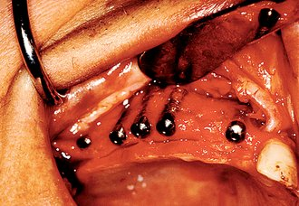
Figure 32-16 The defect at implant uncovery is greater than 3 mm and threads are exposed on the implant body. A particulate autograft covered with a membrane and primary closure is suggested.
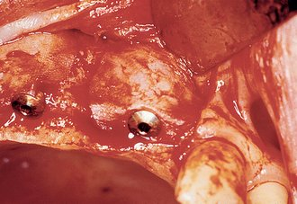
Figure 32-17 At the uncovery 8 to 12 weeks later, bone is now present over the threads of the implants.
When the vertical bone defect around an implant is less than 3 mm, the implant may be uncovered and used in the current condition for the prosthetic abutment. After the soft tissue is removed from a defect, the surrounding bone is again evaluated. In the case of a vertical bone defect of less than 3 mm, there are three surgical options. An osteoplasty may eliminate the vertical defect when the reduced bone-implant interface does not compromise the prosthetic support or esthetics. The PME is placed at the same appointment (Figure 32-18). A second method to correct a vertical defect less than 3 mm is to curette the defect and overfill the region with an autograft (Figure 32-19). The PME may be added at the same appointment and the tissue approximated around the site (Figure 32-20). When there is a desire to have thicker soft tissue around the site, a barrier membrane (e.g., Alloderm) may be used over the implant site and covered with soft tissue.
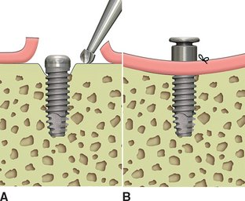
Figure 32-18 When the defect is less than 3 mm (A), the implant may be uncovered. An osteoplasty to eliminate the defect (B) is the most predictable method, but modifies it into a horizontal defect. This may be inappropriate in the esthetic zone.
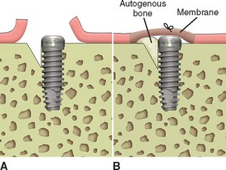
Figure 32-19 A second method to correct a vertical defect less than 3 mm (A) is to curette the defect and fill the region with an autograft (B). The implant may be exposed with a permucosal extension or covered by a membrane when additional soft tissue thickness is desired.
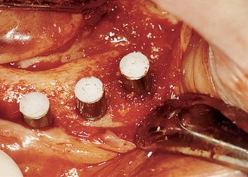
Figure 32-20 The implant on the right has a vertical defect less than 3 mm. The permucosal extension is added to the implant; autograft is collected from the surrounding area and overfills the defect. The implant may then be uncovered.
A third alternative to correct a vertical defect on the mesial and distal region is to drive a wedge into the bone several millimeters away from the implant body. Tapping a wedge-shaped osteotome into the distal bone compresses vital bone up against the implant body (Figures 32-21, 32-22). The wedge-shaped defect created in the ridge as a result of the osteotome is several millimeters away from the implant and surrounded by bone; therefore this defect will heal without consequence. A facial or lingual vertical defect may be corrected by taking a blunt instrument with a mallet and compressing the facial or lingual bone against the implant body. This technique also places living bone adjacent to the implant body (Figure 32-23). The PME is placed at this appointment.
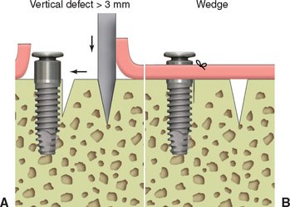
Figure 32-21 A, The implant on the left has a vertical defect less than 3 mm deep. B, A wedge is driven into the bone in the appropriate side, and vital bone is pushed up against the implant.
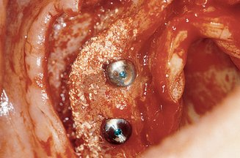
Figure 32-22 An implant in the canine region has a defect on the facial and distal aspects.
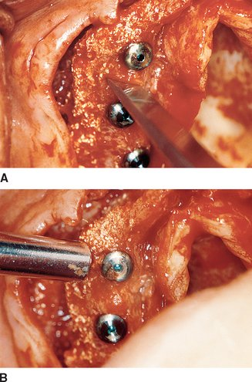
Figure 32-23 A, A wedge is created on the distal aspect of the implant and tapped into place. The distal wedge bone is pressed against the distal defect of the implant. B, A blunt instrument placed on the facial aspect is tapped with a mallet and compresses the facial bone against the implant, which eliminates the defect.

Horizontal Defects
A horizontal bony defect of bone around the implant body may also be treated in several ways. When horizontal bone loss around an implant is more than half of the implant body, the implant should be surgically removed and the site grafted at the uncovery.
The most predictable method to treat horizontal bone loss that is less than 50% of the implant body is to reduce the soft tissue thickness to decrease the probing depth around the implant. The soft tissue may be apically repositioned, exposing a portion of the implant body into the oral cavity. If threads or a rough surface are present above the bone, an aluminum oxide (“white”) stone and rubber wheel are used under copious irrigation to smooth the region and limit plaque accumulation. Cement-retained prosthesis on an implant with horizontal bone loss may be placed on the implant body in esthetic regions.
Another option to address horizontal bone loss is to grow bone above the defect, and this method is used when the final prosthesis is FP-1 or additional bone-implant interface is required to withstand the forces exerted on the prosthesis. To improve the amount of bone formation, several steps may be taken. The first is to use autogenous bone for the graft. In most cases, bone is harvested and placed on the crest, after the region has been curetted to increase blood supply and increase the regional acceleratory phenomenon. A barrier membrane is also placed over the site to prevent fibrous tissue ingrowth into the region. Anaerobic bacteria are often growing on the implant body when bone loss is present and should be mechanically removed. In addition, before grafting, the first-stage cover screws are removed, and the internal cavity of the implant body is thoroughly flushed with chlorhexidine 0.12% before replacing the screws into the implant body. The tissues are reapproximated over the bone graft and membrane with primary closure. The second-stage uncovery is delayed for approximately 3 to 4 months, depending on the size of the horizontal defect and bone graft.
On occasion, the facial aspect of the implant is exposed for several millimeters. This more often occurs when the implant was placed in the maxilla and the ridge was less than 5 mm in width or bone expansion was performed to insert the implant. Although the implant has rigid fixation, the lack of facial bone places the implant at an increased risk. The implant site may be improved at the uncovery surgery by performing an onlay graft. Most often, the easier method to accomplish the augmentation is the layered, particulate, membrane graft technique described in Chapter 37. The ridge is decorticated on the facial, mesial and distal aspects to the implant. Autologous bone is harvested with a trephine bur from above and lateral to the implant site. The autograph is particulated in 3 × 3-mm pieces and laid over the facial aspect of the implant. A mixture of 30% demineralized, freeze-dried bone cortical fibers (Grafton) and 70% mineralized, freeze-dried bone allograft (MinerOss) is mixed with the platelet-rich plasma from 10 to 20 mL of whole blood. A resorbable membrane (i.e., Biomend) or acellular tissue (AlloDerm) covers the graft.
Because the implant is already integrated, a PME may be placed into the implant body and the tissue approximated around the implant. Before soft tissue closure, the labial flap should be expanded with tissue scissors (i.e., Metzenbaum scissors). The final prosthesis should be delayed for more than 3 months when this procedure was performed at the uncovery appointment to allow maturation of the tissues.

RIGID FIXATION DETERMINATION
If the bone level is acceptable around the crest module of the implant, the first-stage cover screws are removed, the internal chamber of the implant body is thoroughly flushed, and the top of the crest module is closely evaluated to make sure it is free of any bone or soft tissue over the edges. A 3- to 5-mm-high, second-stage PME is then seated with finger pressure into the implant body (Figure 32-24).
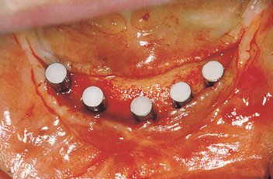
Figure 32-24 If the bone levels are acceptable, a 3- to 5-mm-high permucosal extension is threaded into the implant body.
The rigid fixation of the implant body is then tested for resistance to the torque required to place the permucosal extension with 10 N-cm torque (less than half the final force for the abutment). This may be accomplished by freehand pressure and a short insertion tool. The clinician must use caution when tightening the PME because the torque force required to remove the permucosal extension at the next appointment is similar to the force needed to tighten it. Reverse torquing is more critical when applied to the implant body in D4 bone at this stage of healing, because it may traumatize the bone-implant interface.

REVERSE TORQUE TESTING
Reports in the literature have suggested reverse torque testing (RTT) at stage II surgery or to assess an implant suitability for immediate loading.¹⁹ Two alleged advantages are its use as a biomechanical measure of initial stability and its use as a definitive verification of initial osteointegration.
RTT has been used as a research tool for many years. Several research studies have been performed to ascertain the nature and strength of the bone-implant interface using both push-out and RTT techniques.²⁰⁻²⁸ These findings have been useful for the development of implant body designs and surface coatings. A strong and stable bone-implant interface has always been intuitively desirable. Interest in resistance of bone-implant interface to torsional forces has been heightened as a result of the increased awareness that specific (and higher than previously believed necessary) torquing preload forces are needed to reduce the incidence of abutment screw loosening. From a clinical standpoint, it is desirable to determine whether the bone-implant interface can withstand the preload torque forces needed to tighten abutment screws.
Several reports³-^{5,29} have reported on the phenomenon of early loading or late failures, whose incidence ranges from 2.5% to 5.9%. The term late failure in these reports refers to implants that have failed in the time between an apparently successful stage II surgery and before the completion of prosthetic restoration. In the Misch and Jividen classification, this is an early loading failure. The rationale for RTT is based on the premise that most, if not all, late failures are the result of an inconspicuous nonintegration, which is a condition whereby an implant passes current assessments for the evaluation of rigid fixation (manual mobility, radiographs) at uncovery, yet it is insufficiently integrated to indefinitely remain in that state. These implants are said to have a subclinical micromovement that is not visible or detectable with existing techniques. RTT was suggested to subject implants to early objective testing before undergoing prosthetic reconstruction.
RTT, used as verification for rigid fixation, involves placing a defined reverse torque (counterclockwise) to the implant (via mount) at stage II uncovery surgery. The level of applied torque ranges from 10 to 20 N-cm. In a study using a primate model, Carr et al.²⁴ found that 5.4% of the metallic implants could not withstand a reverse torque level of 35 N-cm. Implants failing such testing are presumed to be nonintegrated, likely to become early loading failures, and are therefore not recommended for use as prosthetic abutments.
It has been suggested that RTT is not advisable or necessary in D1 or D2 bone.¹⁹ Concerns of stripping of the external hex in implants made of grade I titanium, because of the higher bone strength and presumed lower incidence of early failures lessen or obviate the need for RTT for these bone types. However, a multicenter clinical trial involving 2131 implants in 707 patients found the highest stage II failure rate was actually for the most dense bone.³⁰ As a result, it appears that implants in all quality bone would also have high enough incidence of early failures to justify the evaluation of every implant. In addition, if the same N-cm torque is used in all bone densities, the hex components are at similar risk.
The strength of trabecular bone before fracture in the jaws is directly related to its density. The densest bone (D1) is 10 times stronger than the least dense (D4). The RTT is suggested to be most beneficial in less dense bone, yet this density bone is most at risk of failure during the RTT evaluation. In addition, bone is often only 60% mineralized at stage II uncovery after the surgical trauma from stage I surgery. According to computer densitometry reports, bone may be more dense and the bone interface stronger on the day of surgery, compared with the stage II uncovery date.^{8,31,32} It takes 52 weeks after initial surgery for bone to be completely mineralized. The mineralization of bone is related to its strength. Therefore using RTT at stage II uncovery evaluates the interface when it is weak and more at risk to fracture from overload. In addition, at 4 months, the bone is often still histologically woven bone, rather than lamellar bone. Woven bone is unorganized and weaker than the load-bearing lamellar bone, which is more desirable at the implant interface.³³ An RTT at uncovery does not permit this improved interface to develop before testing. RTT of implants too early in the healing process (relative to bone density) is more likely to lead to the removal of implants that would otherwise be integrated.
RTT protocol requires a clinician to detect even small micromovements that would indicate failure. Sullivan states that “on initial activation of the electronic torque control unit, the illusion of movement can be ascertained when slack is taken out of the system.”^{6,19} This movement is subtle enough that the use of magnifying loops is recommended. The amount of implant movement of successful rigid fixated implants is variable²¹ and dependent on bone density.³⁵ An implant in D4 bone may move 60 to 80 μm. In comparison, a lateral incisor tooth in health moves 97 μm, which can be seen with the naked eye. The illusion of movement may be attributed to bone density, not to a lack of rigid fixation or fibrous encapsulation.
Torque-to-failure trials in human dental applications have been limited to only two studies. Tjellstrom²¹ measured the removal torque of osseointegrated titanium implants placed in the mastoid bone and found a range from 26 to 60 N-cm. The mastoid bone is cortical externally and coarse trabecular internally. This corresponds to a D2 bone description. Sullivan et al.¹⁹ recorded that removal torque values for three implants in a human volunteer were between 45 and 58 N-cm. However, the implants for Sullivan were surrounded by “extremely dense marble-like bone quality.” Therefore the RTT values to failure of these implants cannot be used to simulate the RTT of implants in D3 or D4 bone, which is not surrounded by a marble-like structure.
Bone, as a structure, exhibits significant variations in strength depending on the types of forces acting on it. These forces may take the form of compression, tension, or shear. Research has shown that cortical bone is strongest in compression, 70% as strong in tension, and only 35% as strong in shear.^{36,37} An RTT places primary shear forces on root form implants with a round cross-section design. The only region of compression for RTT would be the bone grown into the apical hole at the bottom of the healed site. Therefore the force type (shear) is the weakest to the RTT method of testing.
The RTT may also be affected by implant design. Implant bodies, such as hollow basket designs or those with flat sides to resist shear forces, may exhibit greater RTT values to failure. An RTT on a threaded implant uses the mechanical advantage of a screw to break the implant-bone adhesion. The screw would also convert the shear force to some tensile force. An RTT attempts to lift the implant from the crypt, using the screw design to assist this aim.
Occlusal loads aim at being primarily compressive in origin. Implant bodies are not designed for pure shear loads; therefore RTT applies forces that do not correspond to clinical loads. Failure of an implant during RTT does not necessarily mean that it could not have functioned as a successful implant under (primarily) compressive loads.
The stated need for RTT is to help reduce the number of early loading failures, with the assumed cause being a subclinical nonintegration at stage II surgery. A more likely cause of these failures is early implant loading beyond the bone strength present around the implant. Progressive bone loading studies have demonstrated the density (and related strength) of bone increases after loading.^{38,39} Early implant failures may be reduced to less than 1% when progressive loading is performed on implants of adequate size, design, and number. Reverse torque testing has been represented as a possible means to predict early implant failure that most likely has a fibrous tissue interface. However, these failures are more likely from excessive stress at the bone-implant interface and excessive occlusal loading.
The criteria suggested for a clinical verification standard are that it be objective, be easy to administer, use available armamentaria, be as definitive as possible within the available knowledge base, and possess an adequate level of safety so that damage to the implant-bone interface does not occur. This is not found in RTT evaluation.
In the author’s opinion, RTT presents too many subjective variables. Misjudgment can damage the bone-implant interface and prolong treatment and increase costs associated with the extra reparative treatment. The desire for objective standards for clinical verification of osteointegration is understandable. The most common methods of clinical verification used today, radiographs and manual mobility testing, have an admittedly subjective component. However, they do not place the implant at risk and have stood the test of time.
When the root form implant has a fibrous tissue interface, there is little resistance to rotation in either a clockwise or counterclockwise direction. Therefore if fibrous tissue surrounds the implant, and a permucosal extension is threaded into the implant body with a 10 N-cm force, the implant will visibly turn and the insertion and tightening of the healing cap can be used to evaluate the complete lack of integration with the bone. In addition, a 10 N-cm force on the permucosal healing cap places a screw implant under shear tension and compression on the bone. The clockwise turn on a screw will more likely resist these forces, even in very soft bone.
A vertical force places more compressive forces on the implant-bone interface. The mobility test with a lateral force applied to the side of the permucosal extension also places some compressive forces on the implant-bone interface. Therefore the implant is initially evaluated for rigid fixation with the torque test to thread the permucosal healing cap into position and then evaluated similar to a natural tooth mobility test, with a 5-lb axial and lateral load.
The Periotest (or resonance) is a nondestructive, objective, and useful test to determine implant micromovement. A study by van Steenberghe and Quirynen⁴⁰ suggests that the prognostic value of the Periotest remains unproven with regard to implants because too few failures have been studied and reported in the literature. However, several studies exist that describe the usefulness and sensitivity of this instrument.⁴¹⁻⁴⁵ Furthermore, a large-scale study of 1838 implants by Truhlar et al.⁴⁵ and 4-year evaluation by Misch⁴⁶ found the Periotest to be capable of assessing the status of the implant-bone interface. It is sensitive to slight differences in the implant dampening effect (mobility) and provides baseline Periotest values that can be helpful in evaluating improvement or degradation of the implant-bone complex.⁴⁷⁻⁴⁹ However, a disadvantage is that many clinicians do not have access to these instruments.

IMPLANT POSITION
After the implant is uncovered and a PME is seated into the implant body, the prosthetic template is inserted and the implant position evaluated. An implant body in a position that compromises the prosthesis should not be maintained. The inappropriate implant may often be removed by reverse torquing with a hand ratchet. Luxation, as with a tooth, is not indicated because it places compression forces on the implant-bone interface and usually leads to the fracture of either the bone or the implant before its removal. A trephine drill may be required to remove an implant in denser bone qualities. A trephine drill can create a small space all around the implant to its base (Figure 32-25). A forcep then is used to rotate and shear the base of bone at the apex.
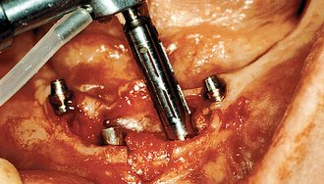
Figure 32-25 When the implant is in too poor a position to be restored or more than 50% of the bone is missing, a trephine bur may be used to remove the implant.
The implant is removed if its position places the final prosthesis at risk or if more than one half of the implant has lost bone in a vertical dimension. Several options exist if implant removal is indicated: (1) the implant may be removed, and if enough implants remain, the prosthesis may still be fabricated; (2) the prosthesis may be converted from a fixed restoration to a removable RP-4 or RP-5 restoration to decrease forces to the superstructure in amount or duration; (3) an additional implant may be placed in an optional implant location at the same time as the implant removal; (4) the implant may be removed and a larger-diameter implant simultaneously inserted with a different angulation or deeper within the osteotomy; and (5) the implant may be removed, the site augmented, and an additional implant placed months later. The treatment of choice attempts to best satisfy the conditions for the patient and prosthesis without compromise.

TISSUE THICKNESS
The thickness of the overlaying crestal tissue is evaluated once it is reflected. Soft tissue thicker than 4 mm will result in a less than ideal pocket depth around the implant (Figure 32-26).^{47,48} The tissue is relieved from the periosteal surface especially in the labial flap, until it is less than 3 mm thick (Figures 32-27 and 32-28). If abundant attached tissue is present in the palatal region of the maxillary implants, a gingivoplasty may be performed (Figure 32-29).
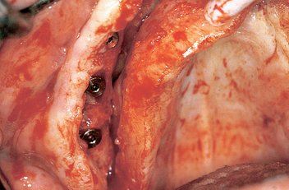
Figure 32-26 When the overlying tissue is greater than 4 mm thick, the soft tissue should be reduced in thickness, thus reducing the sulcus around an implant.
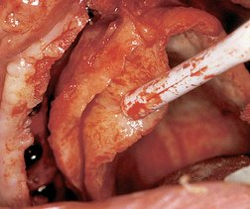
Figure 32-27 An incision is made on the periosteal side of the palatal flap, and the excessive connective tissue is excised to decrease the overall palatal tissue thickness.
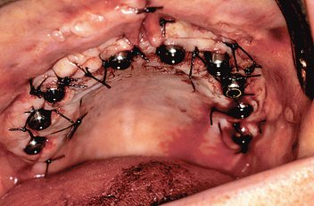
Figure 32-28 The tissue with a reduced thickness may then be approximated around permucosal extensions 3 to 5 mm in height.
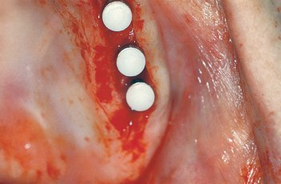
Figure 32-29 A gingivoplasty is often performed in abundant areas of keratinized, attached tissue, such as on the palate, to reduce sulcus depth around the implant.

Permucosal Abutment Selection
The 4-mm permucosal healing cap should extend at least 1 mm above the tissue after suturing to help prevent tissue overgrowth during the next few weeks (Figure 32-30). An enlarged permucosal extension may be designed as part of the healing abutment (e.g., Maestro, BioHorizons) or attached to the healing abutment (e.g., Nobel Biocare). This larger contour helps maintain the apically positioned tissue in place, or it may support a periodontal dressing to maintain the tissue in place.
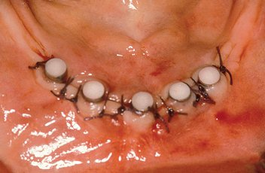
Figure 32-30 The permucosal extension should extend at least 1 mm above the soft tissue after it is approximated around the implants.
A suture groove, 3 to 5 mm above the platform connection, may be incorporated in the healing abutment (e.g., Maestro, BioHorizons) (Figure 32-31). When the tissue requires apical repositioning or when it is 3 to 4 mm thick and may grow over the healing abutment, the suture groove may be used (Figure 32-32). A suture is placed next to the healing abutment. Tissue forceps lifts the suture from the incision line, and the suture is then rotated to form a loop. The loop is placed over the enlarged healing abutment and into the suture groove or under the healing cap. The suture may then be tied, securing the tissue at the height of the suture groove (Figure 32-33). A similar technique is used on the other side of the healing abutment. These two sutures (one on each side) hold the tissue at the level of the suture groove and prevent it from lifting up and over the healing cap during soft tissue healing (Figures 32-34, 32-35).
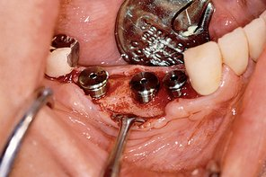
Figure 32-31 A suture groove in the permucosal extension may be positioned 3 to 5 mm above the bone.
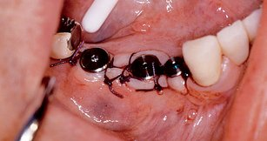
Figure 32-32 The suture groove helps to apically reposition the tissue, so it will remain less than 3 to 5 mm thick, to reduce the sulcus depth.
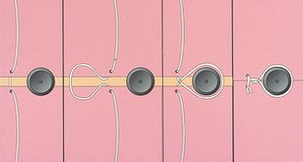
Figure 32-33 The suture groove in the permucosal extension may be used to loop the suture around the groove and tie the tissue at a more apical position.
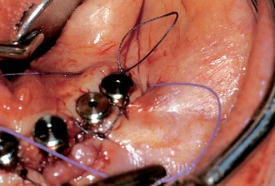
Figure 32-34 The most distal implant to the right has mobile tissue around it, which is difficult to reposition apically. The suture is placed on the distal aspect and looped over the suture groove to act as a soft tissue retainer.
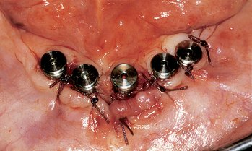
Figure 32-35 When the suture is tied around the permucosal extension, it apically positions the tissue around the implants.
A healing abutment wider than the implant crest module may be selected when the implant is not countersunk below the bone, with the following advantages:
1. The perimucosal tissue heals with a larger diameter than the final abutment. As a result, when the final abutment is added after healing, the risk of entrapping soft tissue between the final abutment and the implant body is eliminated.
2. The wider space remains around the abutment for less than 30 minutes. Subgingival abutment preparations, impression, placement of retraction cord, and development of an emergence profile for the crown may all be facilitated when the space around the abutment is present.
The bacterial flora is similar around teeth and implants. Probing depth averages between 1.5 and 4 mm provide an environment that is conducive primarily to aerobic bacteria. As the sulcus depth increases beyond 5 mm, the incidence of anaerobic bacteria increases.⁵⁰ When 75% of the bacteria are anaerobes, an active process places the region at risk for disease. A dental probe next to a natural tooth is stopped by the connective tissue attachment zone. Unlike teeth, there is no connective tissue attachment next to an implant. In addition, the junctional epithelial attachment is less tenaciously bound to the implant compared with teeth. As a result, the same probing force used for a tooth will proceed almost to the crestal bone next to an implant. In addition, when plaque is allowed to accumulate next to an implant, the number of inflammatory cells infiltrating the connective tissue are found to be much larger and more extensive.⁵¹ As a result, it has been suggested to maintain tissue thickness around the implant abutment less than 4 mm to decrease the risk of bacterial contributed bone loss.^{52,53}
The sulcus depth next to an implant is directly related to the thickness of the tissue over the bone. The tissue thickness before implant placement is variable and may be greater than 6 mm, especially in the maxilla. During stage I implant placement surgery, excessive tissue thickness may be reduced. However, tissue thickness may be of benefit during initial healing to act as a cushion over the implant and reduce the risk of implant micromovement during healing. One of the goals of stage II uncovery surgery is to reduce the tissue thickness and therefore the final abutment sulcus depth to less than 4 mm. A 4- to 5-mm-tall PME is often selected at stage II uncovery to ensure that less than 4 mm of tissue exists. Otherwise the tissue will be higher than the healing cap. In addition, when taller healing caps are used, a soft tissue–borne transitional prosthesis must be sufficiently relieved over the abutments (to prevent excessive loads on the immature interface), and a greater moment of force is transmitted to the implant crest region under lateral loads.

Soft Tissue Support–Ridge Augmentation
When the maxillary lip or pontic position requires greater support or contour for esthetics, dense hydroxyapatite (HA) may be added to the labial bone surface for fixed prostheses. The prosthetic template is placed over the implant site and should represent the desired lip support region to determine the amount of labial HA graft required (Figure 32-36). The augmentation aims at providing an improved esthetic result and should not be attempted to increase the bone volume. Another alternative is the use of connective tissue or acellular tissue grafts (Alloderm, Lifecell, Branchburg, NJ), which may have the same goal. The advantage of HA for this intent is that limited long-term tissue shrinkage is observed. In addition, an increase in bone density is often observed in regions where the particulate HA attaches to the bone.
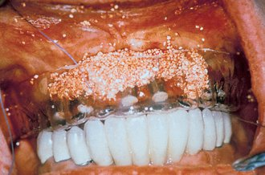
Figure 32-36 A prosthetic template of the labial flange of the denture indicates how much dense hydroxylapatite is required to support the lip above the fixed-implant prosthesis.

KERATINIZED TISSUE

Keratinized Tissue Concerns
The absence or presence of a zone of keratinized gingiva around a natural tooth or an oral implant is controversial. No direct evidence confirms or denies the need for nonmobile keratinized tissue next to natural teeth. Lang and Loe⁵⁴ advocate a minimum 2 mm of keratinized gingiva and 1 mm of attached gingiva to maintain gingival health. In longitudinal studies, however, Wennstrom⁵⁵ and Kennedy et al.⁵⁶ demonstrated that the lack of adequate keratinized and attached tissue does not compromise the long-term health of soft and hard tissue as long as patients maintain good oral hygiene. Moreover, Stetler and Bissada⁵⁷ concluded that if subgingival restorations were to be placed in areas of minimally keratinized gingiva and less than optimal plaque control, augmentation to widen the zone of keratinized tissue may be warranted. They also noted that in unrestored teeth, the difference in the inflammatory status of sites with or without a wide zone of keratinized tissue was not significant. The tooth with the least amount of keratinized tissue is often the mandibular first premolar. Yet this tooth is rarely the first tooth lost from periodontal disease. If all other periodontal indexes are normal, the amount or absence of keratinized gingiva has little to do with the expected longevity of the tooth.
The need for keratinized tissue around dental implants seems more controversial than around teeth.⁵⁸⁻⁶⁴ Several reports demonstrate the long-term implant survival in the absence of keratinized tissue. Although reports are more cautious with mobile mucosa next to an implant, nonmobile tissue appears to be the primary criterion relative to tissue type.
Although keratinized tissue around a tooth may not be mandatory for long-term health, a number of benefits are present with keratinized mucosa. The color, contour, and texture of the soft tissue drape should be similar around implants and teeth. The interdental papillae should ideally fill the interproximal spaces. A high smile line often exposes the free gingival margin and interdental papillae zones. The keratinized tissue is more resistant to abrasion. Hygiene aids are more comfortable to use. The degree of gingival recession appears related to the absence of keratinized gingiva. Root sensitivity and esthetic concerns may be associated with gingival recession. From a restorative dental aspect, keratinized mucosa is more manageable during the retraction and impression-making process. Subgingival margin placement is more precise, as is long-term stability, in the presence of keratinized tissue.
The presence of keratinized tissue next to an oral implant may present even greater benefits than those with natural teeth (Figure 32-37). Some reports indicate the lack of keratinized tissue may contribute to implant failure. Kirsch and Ackermann⁶⁰ reported that the most important criterion for implant health in the posterior mandible was related to the absence or presence of keratinized gingiva. Mobile, nonkeratinized mucosa exhibits greater probing depths, which has been confirmed histologically. A study by Warrer et al.⁵⁹ in monkeys found that an absence of keratinized mucosa increases the susceptibility of peri-implant regions to plaque-induced destruction.
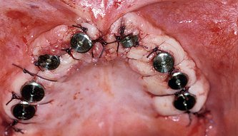
Figure 32-37 The presence of keratinized, attached tissue around implants provides even greater benefits than around natural teeth.
Keratinized gingiva has more hemidesmosomes; therefore the junctional epithelial attachment zone may be of benefit when in keratinized tissue. The orientation of collagen fibers in the connective tissue zone of an implant often appears perpendicular to the implant surface, whereas these fibers in mobile, nonkeratinized tissue run parallel to the surface of the implant. Schroeder et al.,⁵⁸ James and Schultz,⁶³ and Lisgarten et al.⁶⁴ have suggested that mobile mucosa may disrupt the implant-epithelial attachment zone and contribute to an increased risk of inflammation from plaque.
In addition to general advantages, keratinized tissue around implants may be beneficial in several other ways. In a two-stage protocol, the implant is less likely to become exposed during the healing process. The formation of interdental/implant papillae is completely unpredictable with mobile unkeratinized tissues. However, no clinical or histologic benefits are reported with unkeratinized nonmobile mucosa. When the unkeratinized tissue is mobile, several reports state that this is unsatisfactory.
The question relative to the need for keratinized tissue around implants should be modified to “which would you prefer?” No one has stated that the unkeratinized tissue is better than keratinized tissue for any reason. Therefore the controversy has abated. Some authors prefer keratinized mucosa more intensely than others. If one side of controversy demonstrates benefits and the other side states that keratinized tissue is not mandatory, both sides may be correct.
In specific clinical instances, attached keratinized gingiva is more often desirable. For example, an FP-1 (fixed prosthesis type 1) restoration in the esthetic zone requires keratinized mucosa to develop the soft tissue drape around the implant crowns. A second prime example is a mandibular overdenture, which benefits from a vestibule and zone of nonmobile tissue around the implant abutments.
Ono et al.⁶⁵ have proposed a classification of attached gingiva and surgical alternatives to improve soft tissue types in edentulous sites for implant placement. Meffert et al.⁶⁶ prefer to obtain keratinized tissue before implant placement.
Around natural teeth there are two main tissue types: attached, keratinized tissue and unattached, nonkeratinized tissue. These tissue types become more obscure around implants. When the tissue in a maxillary arch is thick before implant placement, the implant surgery often results with mobile, keratinized tissue that is several millimeters thick around the implant abutments. This type of tissue should be reduced in thickness to form a probing depth less than 4 mm.
When the implant is placed into a residual ridge that has lost overall width or had an iliac crest graft, the implant often has mobile, unattached nonkeratinized tissue in the facial aspect (Figure 32-38). This nonkeratinized tissue must become nonmobile, nonkeratinized tissue by placing either noncellular tissue graft (Alloderm) or hydroxyapatite below it (Figure 32-39). Although the tissue does not become keratinized with this technique, it does become nonmobile and provides a mass of tissue that may remain in health for the long term (Figure 32-40).
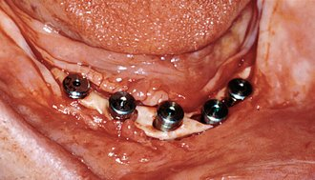
Figure 32-38 The anterior mandible was augmented with an iliac crest graft before implant placement. The crestal tissue presented little attached keratinized mucosa. An acellular tissue graft (AlloDerm) is placed around the implants.
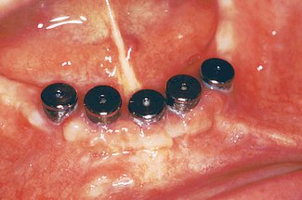
Figure 32-39 After several weeks, the tissue (although not keratinized) is not mobile around the implants.
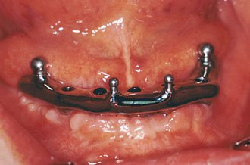
Figure 32-40 Long term, the tissue has remained attached around the implants.
There are four types of oral mucosa that may be found around an implant: (1) keratinized, nonmobile tissue; (2) nonkeratinized, nonmobile tissue; (3) keratinized, mobile tissue; and (4) nonkeratinized, mobile tissue. In esthetic areas that expose the soft tissue, keratinized, nonmobile tissue is the best option. In nonesthetic regions, either keratinized, nonmobile, or nonkeratinized, nonmobile tissue is acceptable. Keratinized, mobile tissue may usually be made nonmobile by gingivoplasty techniques. Nonkeratinized, mobile tissue usually requires a soft tissue procedure to create a zone of keratinized tissue (i.e., free tissue graft) or a subdermal procedural to modify the mobile tissue base.
The width of keratinized tissue is evaluated before the initial incision and, if inadequate, is increased at the conclusion of the procedure. If less than 3 mm of keratinized gingiva is present and the crestal bone is cortical and in excellent condition around the implant bodies, the incision bisects the thin zone of attached tissue and the labial portion is approximated to the sole facial aspect of each implant. The lingual flap approximates the lingual aspect of each PME (Figure 32-41). Loose, interrupted figure-eight sutures are placed between the healing abutments. The section between the incision line is allowed to heal by secondary intention. In this manner, attached gingiva forms between the implants and the original attached tissue width is now divided between the facial and the lingual surfaces of the implants (Figure 32-42). The risk of this procedure involves the loss of crestal bone during soft tissue healing. The risk is reduced in the mandible, because the crestal bone is more cortical.
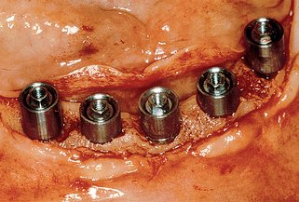
Figure 32-41 The quantity of keratinized tissue may be increased by allowing the margins of the tissue to granulate over the ridge.
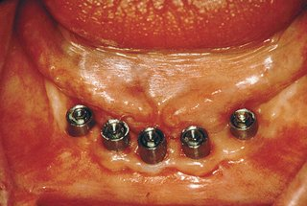
Figure 32-42 The tissue that heals by secondary intention between the margins of the original keratinized tissue creates attached, keratinized tissue around the implants.
A second option to increase the zone of keratinized tissue at the stage II surgery is to use a split-thickness incision at the time of uncovery. After the implant body is evaluated (as previously addressed), a connective tissue or keratinized tissue graft harvested from the palate may be placed and sutured around the stage II PMEs.
A third option to increase the zone of keratinized tissue is to harvest a 6- to 8-mm doughnut-shaped gingival collar from the palate. The open region of this collar is 4 mm in diameter and is inserted over the top of the PME and on top of the underlying bone or split-thickness incision.
A fourth option to increase a zone of mobile tissue is to place dense HA around the permucosal extension before approximating the tissues. This does not increase the zone of attached gingiva, but it makes the nonkeratinized tissue less mobile. However, this technique may also increase the gingival sulcus around the implant.
A fifth treatment option is to place an acellular tissue graft over the implants and directly onto the bone. The acellular tissue may be bound to the bone by tissue tacks. The overlying tissue is approximated around the implants. The tissue is then attached to acellular tissue by sutures or tissue tacks. The overlying tissue attaches to the acellular tissue, and the acellular tissue attaches to the bone. Although a keratinized tissue does not develop, the unkeratinized tissue is nonmobile. The nonmobile tissue has been observed to have benefits similar to nonmobile keratinized tissue.

TRANSITIONAL PROSTHESIS
A noneugenol periodontal dressing may be added over the top of the PMEs, but is usually not required. The complete denture or soft tissue–supported transitional prosthesis is aggressively relieved to prevent premature loading of the permucosal healing abutments. A tissue conditioner several millimeters thick is placed in the prosthesis over the implant healing abutment. The tissue conditioner is then relieved over the PMEs and in any region of desired secondary intention soft tissue healing. In nonesthetic regions of the partially edentulous patient, no transitional restoration is worn until after the sutures are removed.
The sutures are removed 2 weeks postoperatively. The soft tissue is not completely keratinized and healed at this time and may still be slightly inflamed. However, the patient may be referred to the restoring dentist for reconstruction. The final abutments will be selected by the restoring dentist after completion of the soft tissue maturation.
If the tissues appear healthy at the suture removal appointment, the first prosthetic appointment may be held at the same time. The stage II permucosal healing abutments are removed and replaced by the final abutment for screw retention or abutment for cement retention. An indirect impression transfer coping is placed into the abutment for screw retention. Vertical pressure is placed on the implants to ensure lack of tenderness. The surrounding gingiva may be recontoured by gingivoplasty with a diamond bur to shape an interdental papilla around the implant abutments for FP-1 prostheses or to reduce the depth of an implant sulcus.
A preliminary irreversible hydrocolloid or elastic impression is made of the implants. A preliminary impression made with additional silicone or polyether instead of irreversible hydrocolloid eliminates the need for the surgeon to have implant analogs or dental stone readily available. Instead, the impression is sent to the laboratory, where analogs and other materials are selected and used. The indirect impression transfer coping or abutment for cement retention is removed after the impression is made, and the stage II permucosal healing abutment is replaced.
The patient is scheduled to be seen again in 1 to 2 weeks, depending on the extent of soft tissue maturation at the suture removal. The indirect impression transfer coping or implant abutment analog (for screw or for cement) is placed into the preliminary impression, which is poured with dental stone. The purpose of this step is to permit the fabrication of the final impression tray and begin the fabrication of a transitional prosthesis if a fixed restoration is indicated.

SUMMARY
Stage II surgery permits direct evaluation of the hard and soft tissues condition. The fabrication of the final prosthesis should begin with ideal abutment support. This includes an absence of crestal bone loss or defects, rigid fixation, no discomfort on loading, adequate zone of attached gingiva, pocket depths less than 5 mm, and acceptable implant body and abutment position for the intended prosthesis. Stage II surgery is an opportunity to evaluate these criteria and, if not present, restore them before prosthesis fabrication. On occasion, this requires additional time and surgeries. However, the alternative is a higher risk of future complication, which will require even more time, cost, and effort to correct or improve.
References
1 Goodacre CJ, Bernal G, Rungcharassaeng K, et al. Clinical complications with implants and implant prostheses. J Prosthet Dent. 2003;90:121-132.
2 Kline R, Hoar JE, Beck GH, et al. A prospective multicenter clinical investigation of a bone quality-based dental implant system. Implant Dent. 2002;11:332-334.
3 Zarb GA, Schmitt A. The longitudinal clinical effectiveness of osseointegrated dental implant: the Toronto study. Part 1: surgical results. J Prosthet Dent. 1990;63:451-457.
4 Naert I, Quirynen M. A six-year prosthodontic study of 509 consecutively inserted implants for the treatment of partial edentulism. J Prosthet Dent. 1992;67:236-245.
5 Statistical results: implants lost between stage II surgery and prosthesis delivery. Leawood, Kan: Root Laboratory, 1993.
6 Snauwaert K, Duyck J, van Steenberghe D, et al. Time dependent failure rate and marginal bone loss of implant supported prostheses: a 15-year follow-up study. Clin Oral Invest. 2000;4:13-20.
7 Jividen GJr, Misch CE. Reverse torque testing and early loading failures: help or hindrance? J Oral Implantol. 2000;26:82-90.
8 Brånemark PI. Osseointegration and its experimental background. J Prosthet Dent. 1983;50:399-410.
9 Adell R, Lekholm U, Rockler B, et al. A 15-year study of osseointegrated implants in the treatment of the edentulous jaw. Int J Oral Surg. 1981;10:387-416.
10 Rosenquist B, Grenthe B. Immediate placement of implants into extraction sockets: implant survival. Int J Oral Maxillofac Implants. 1996;11:205-209.
11 Tal H. Spontaneous early exposure of submerged implants: classification and clinical observation. J Periodontol. 1999;70:213-219.
12 Tal H, Dayan D. Spontaneous early exposure of submerged implants: histopathology and histomorphometry of non-perforated mucosa covering submerged implants. J Periodontol. 2000;71:1224-1230.
13 Tal H, Dayan D. Spontaneous early exposure of submerged implants: histopathology of perforated mucosa covering submerged implants. J Periodontol. 2000;71:1231-1235.
14 Tal H, Artzi Z, Moses O, et al. Spontaneous early exposure of submerged endosseous implants resulting in crestal bone loss: a clinical evaluation between stage I and stage II surgery. Int J Oral Maxillofac Implants. 2001;16:514-521.
15 Toijanic JA, Banakis ML, Willes LA, et al. Soft tissue exposure of endosseous implants between stage I and stage II surgery as a potential indicator of early crestal bone loss. Int J Oral Maxillofac Implants. 1999;14:436-441.
16 Ericsson I, Randow K, Nilner K, et al. Some clinical and radiographical features of submerged and non-submerged titanium implants: a 5-year follow-up study. Clin Oral Impl Res. 1997;8:422-426.
17 Barboza EP, Caula AL, Carvalho WR. Crestal bone loss around submerged and exposed unloaded dental implants: a radiographic and microbiological descriptive study. Implant Dent. 2002;11:162-169.
18 Rams TE, Link CCJr. Microbiology of failing dental implants in humans: electron microscopic observations. J Oral Implantol. 1983;11:93-100.
19 Sullivan DY, Sherwood RL, Collins TA, et al. The reverse torque test—a clinical report. Int J Oral Maxillofac Implants. 1996;11:179-185.
20 Sennerby L, Thomsen P, Ericson L. A morphometric and biomechanic comparison of titanium implants inserted in rabbit cortical and cancellous bone. Int J Oral Maxillofac Implants. 1992;7:62-68.
21 Tjellstrom A, Jacobsson M, Albrektsson T. Removal torque of osseointegrated craniofacial implant: a clinical study. Int J Oral Maxillofac Implants. 1988;3:287-289.
22 Johnson C, Albrektsson T. Integration of screw implants in the rabbit: a 1-year follow-up of removal torque of titanium implants. Int J Oral Maxillofac Implants. 1987;2:69-73.
23 Carlsson L, Rostlund T, Albrektsson B, et al. Removal torques for polished and rough titanium implants. Int J Oral Maxillofac Implants. 1988;3:21-24.
24 Carr AB, Larson PE, Papazoglou E, et al. Reverse torque failure of screw shaped implants in baboons. Baseline data for abutment torque application. Int J Oral Maxillofac Implants. 1995;10:167-174.
25 Gotfredsen K, Nimb L, Hgorting-Hansen R, et al. Histomorphometric and removal torque analysis for TiO₂-blasted titanium implants: an experimental study on dogs. Clin Oral Implant Res. 1992;3:77-84.
26 Carr AB, Papazoglou E, Larsen PE. The relationship of Periotest values, biomaterial and torque to failure in adult baboons. Int J Prosthodont. 1995;8:15-20.
27 Steigenga J, Al-Snammari K, Misch C, et al. Effects of implant thread geometry on percentage of osseointegration and resistance to reverse torque in the tibia of rabbits. J Periodontol. 2004;75:1233-1241.
28 Cordioli G, Majzoub Z, Piattelli A, et al. Removal torque and histomorphometric investigation of 4 different titanium surfaces: an experimental study in the rabbit tibia. Int J Oral Maxillofac Implants. 2000;15:68-74.
29 Misch CE. Early crestal bone loss etiology and its effect on treatment planning for implants. Postgrad Dent. 1995;2:3-16.
30 Truhlar RS, Morris HF, Ochi S, et al. Second stage failures related to bone quality in patients receiving endosseous dental implants. DICRG interim report #7. Implant Dent. 1994;3:252-255.
31 Albrektsson T, Jacobsson M. Bone-metal interface in osseointegration. J Prosthet Dent. 1987;57:587-607.
32 Brånemark PI. Introduction to osseointegration. In: Brånemark PI, Zarb GA, Albrektsson T, editors. Tissue-integrated prostheses: osseointegration in clinical dentistry. Chicago: Quintessence, 1985.
33 Roberts WE, Helm FR, Marshall KJ, et al. Rigid endosseous implants for orthodontic and orthopedic anchorage. Angle Orthod. 1989;59:247-256.
34 Sekine H, Komiyama Y, Hotta H, et al. Mobility characteristics and tactile sensitivity of osseointegrated fixture supporting systems. In: van Steenberghe D, editor. Tissue integration in oral maxillofacial reconstruction. Amsterdam: Elsevier, 1996.
35 Misch CE. Bone density, its effect on treatment planning, surgical approach, healing and progressive loading. Int J Oral Implantol. 1990;6:23-31.
36 Cowin SL. Bone mechanics. Boca Raton, Fla: CRC Press, 1989.
37 Carter DR, Schwab GH, Spengler DM. Tensile fracture of cancellous bone. Acta Orthop Scand. 1980;5:733.
38 Appleton RS, Nummikoski PV, Pigmo M, et al. Peri-implant bone changes in response to progressive osseous loading. Orlando, Fla: IADR Abs, 1997.
39 Rotter BE, Blackwell R, Dalton G. Testing progressive loading of endosteal implants with the Periotest, a pilot study. Implant Dent. 1996;5:28-32.
40 van Steenberghe D, Quirynen M. Reproducibility and detection threshold of peri-implant diagnostics. Adv Dent Res. 1993;7:191-195.
41 Schulte W, Lukas D. The Periotest method. Int Dent J. 1990;42:433-440.
42 Teerlinck J, Quirynen M, Darius P, et al. Periotest: an objective clinical diagnosis of bone apposition toward implants. Int J Oral Maxillofac Implants. 1991;6:55-61.
43 Olive J, Aparicio C. The Periotest method as a measure of osseointegrated implant stability. Int J Oral Maxillofac Implants. 1990;5:390-400.
44 Tricio J, Laohapand P, van Steenberghe D, et al. Mechanical state assessment of the implant-bone continuum, a better understanding of the Periotest method. Int J Oral Maxillofac Implants. 1995;10:43-49.
45 Truhlar RS, Morris HF, Ochi S, et al. Assessment of implant mobility at second stage surgery with the Periotest, DICRG interim report #3. Implant Dent. 1994;3:153-156.
46 Misch CE: Unpublished data, 1996.
47 Alsaadi G, Quirynen M, Michiels K, et al. A biomechanical assessment of the relation between the oral implant stability at insertion and subjective bone quality assessment. J Clin Periodontol. 2007;34:359-366.
48 Noguerol B, Munoz R, Mesa F, et al. Early implant failure. Prognostic capacity of Periotest: retrospective study of a large sample. Clin Oral Implants Res. 2006;17:459-464.
49 Lachmann S, Laval JY, Jager B, et al. Resonance frequency analysis and damping capacity assessment. Part 2: peri-implant bone loss follow-up. An in vitro study with the Periotest and Osstell instruments. Clin Oral Implants Res. 2006;17:80-84.
50 Newman MG, Flemming TF. Periodontal considerations of implants and implants associated microbiota. J Dent Educ. 1988;52:737-744.
51 Berglundh T, Lindhe J, Marinello C, et al. Soft tissue reaction to de novo plaque formation on implants and teeth. An experimental study in the dog. Clin Oral Impl Res. 1992;3:1-8.
52 Yukna RA. Periodontal considerations for dental implants. In: Block MS, Kent JN, editors. Endosseous implants for maxillofacial reconstruction. Philadelphia: WB Saunders, 1995.
53 Misch CE. The maxillary anterior single tooth implant aesthetic-health compromise. Int J Dent Symp. 1995;3:409.
54 Lang NP, Loe H. The relationship between the width of keratinized gingiva and gingival health. J Periodontol. 1972;43:623-627.
55 Wennstrom JL. Lack of association between width of attached gingiva and development of soft tissue recession: a 5-year longitudinal study. J Clin Periodontol. 1987;14:181-184.
56 Kennedy J, Bird W, Palcanis K, et al. A longitudinal evaluation of varying widths of attached gingiva. J Clin Periodontol. 1985;12:667.
57 Stetler K, Bissada NF. Significance of the width of keratinized gingiva on the periodontal status of teeth with submarginal restoration. J Periodontol. 1987;58:696-700.
58 Schroeder A, Pohler O, Sutter F. Tissue reaction to a titanium hollow cylinder implant with titanium plasma sprayed surface. Schweiz Monatsschr Zahnmed. 1976;86:713-727.
59 Warrer K, Buser D, Lang NP, et al. Plaque-induced peri-implantitis in the presence or absence of keratinized mucosa: an experimental study in monkeys. Clin Oral Implants Res. 1995;6:131-138.
60 Kirsch A, Ackermann KL. The IMZ osteointegrated implant system. Dent Clin North Am. 1989;33:733-791.
61 Adell R, Lekholm U, Rockler G, et al. Marginal tissue reactions at osseointegrated titanium fixtures. I. A 3-year longitudinal prospective study. Int J Oral Maxillofac Implants. 1986;15:39-52.
62 Nevins M, Kenney E, van Steenberghe D, et al, editors. Consensus report: implant therapy II. Proceedings of the 1996 World Workshop in Periodontics. Ann Periodontol. 1996;1:816-820.
63 James RA, Schultz RL. Hemidesmosomes and the adhesion of junctional epithelial cells to metal implants: a preliminary report. J Oral Implantol. 1974;4:294.
64 Listgarten M, Lang NP, Schroeder HE, et al. Periodontal tissues and their counterparts around endosseous implants. Clin Oral Implants Res. 1991;2:81-90.
65 Ono Y, Nevins M, Cappetta M. The need for keratinized tissue for implants. In: Nevins M, Mellonig JT, editors. Implant therapy. Chicago: Quintessence, 1998.
66 Meffert RM, Langer B, Fritz ME. Dental implants: a review. J Periodontol. 1992;63:859-870.

